Laporan Proyek

Pengujian dan Kualitas Perangkat Lunak

|  |  |  |  |  |  |  |  |  |  |  |  |  |  |  |  |
| --- | --- | --- | --- | --- | --- | --- | --- | --- | --- | --- | --- | --- | --- | --- | --- |
| |  |  |  | | --- | --- | --- | | No | NIM | Nama | | 1. | 1130210 | Gabriel Sigalingging | | 2. | 1130210 | Emy Sinambela | | 3. | 1130210 | Bennedict Tambunan | | 4. | 1130210 | Suandika Napitupulu | |
| C:\Users\User\Desktop\itdel.png |

Institut Teknologi Del

Jl. Sisingamangaraja, Sitoluama, Laguboti

Kabupaten Toba, Sumatera Utara

1. Fungsi Login

Scenario

|  |  |
| --- | --- |
| Scenario | Description |
| Open Browser | Alamat yang dituju adalah:  [api_numero_sada.test/login](http://api_numero_sada.test/login) |
| Input Text | Admin memasukkan email |
| Input Text | Admin memasukkan password |
| Click Element | Admin mengklik *button* Masuk |

Test Frame 1 : Test Login with correct username and password

|  |  |  |
| --- | --- | --- |
| Test  Fungsi A | Input | |
| Parameter 1 | Parameter 2 |
| Variasi 1 | Username valid | Password Valid |
| Variasi 2 | Username valid | Password tidak valid |
| Variasi 3 | Username tidak valid | Password valid |
| Variasi 4 | Username tidak valid | Password tidak valid |

* Test Fungsi Login Variasi 1 (*Username* valid dan *Password* valid)

1. Fungsi Login 1

* The scenario

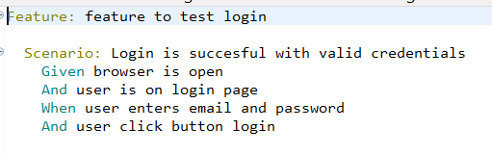

* The step definition

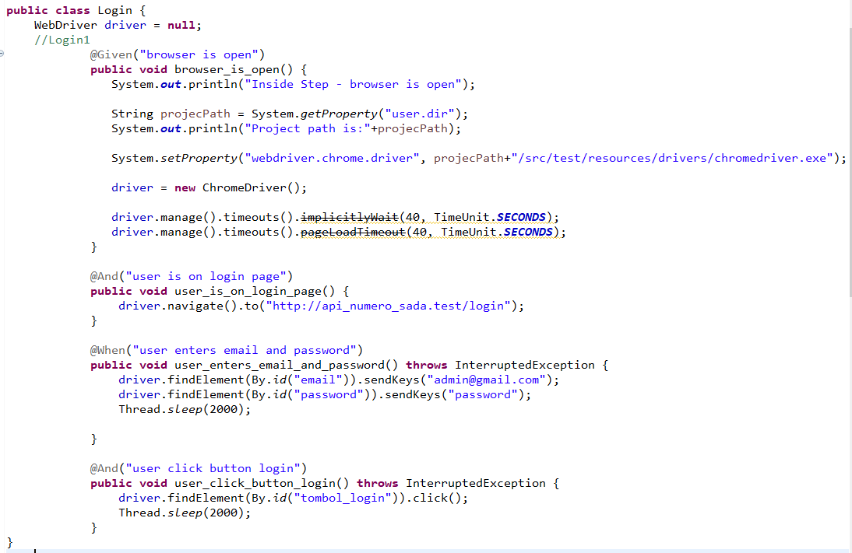

* The test runner

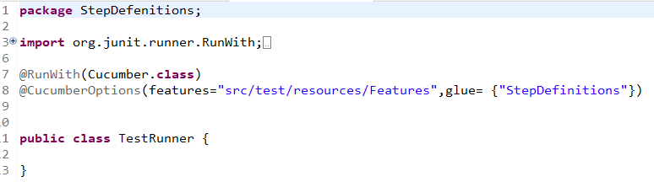

* The console after running

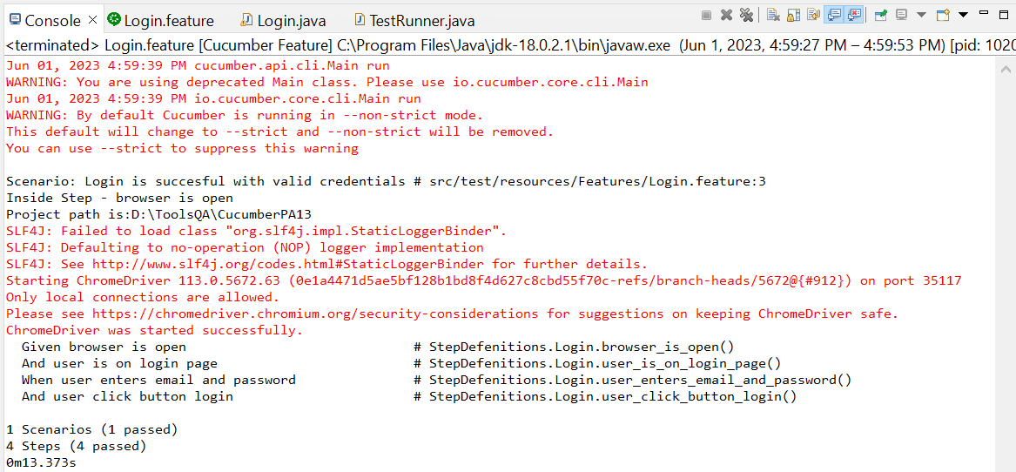

* The browser while testing

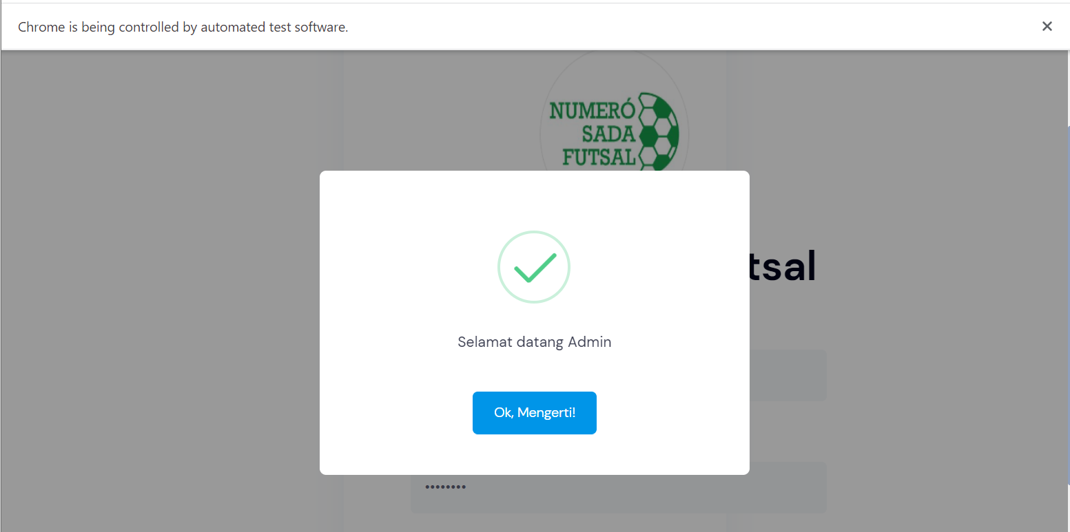

1. Fungsi Login 2

* The scenario



* The step definition

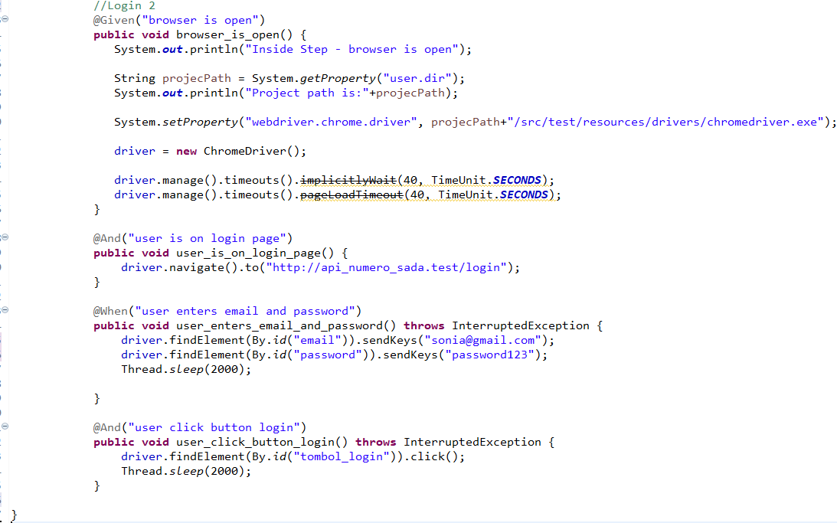

* The test runner

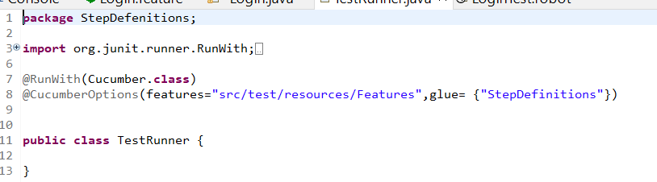

* The console after running

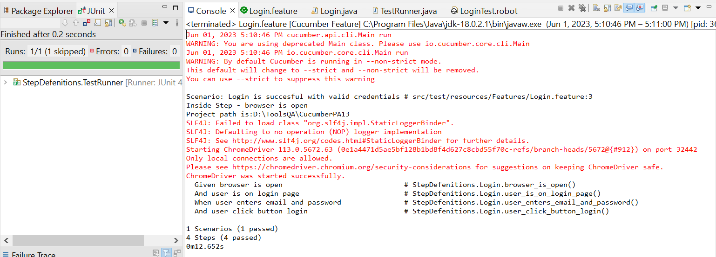

* The browser while testing

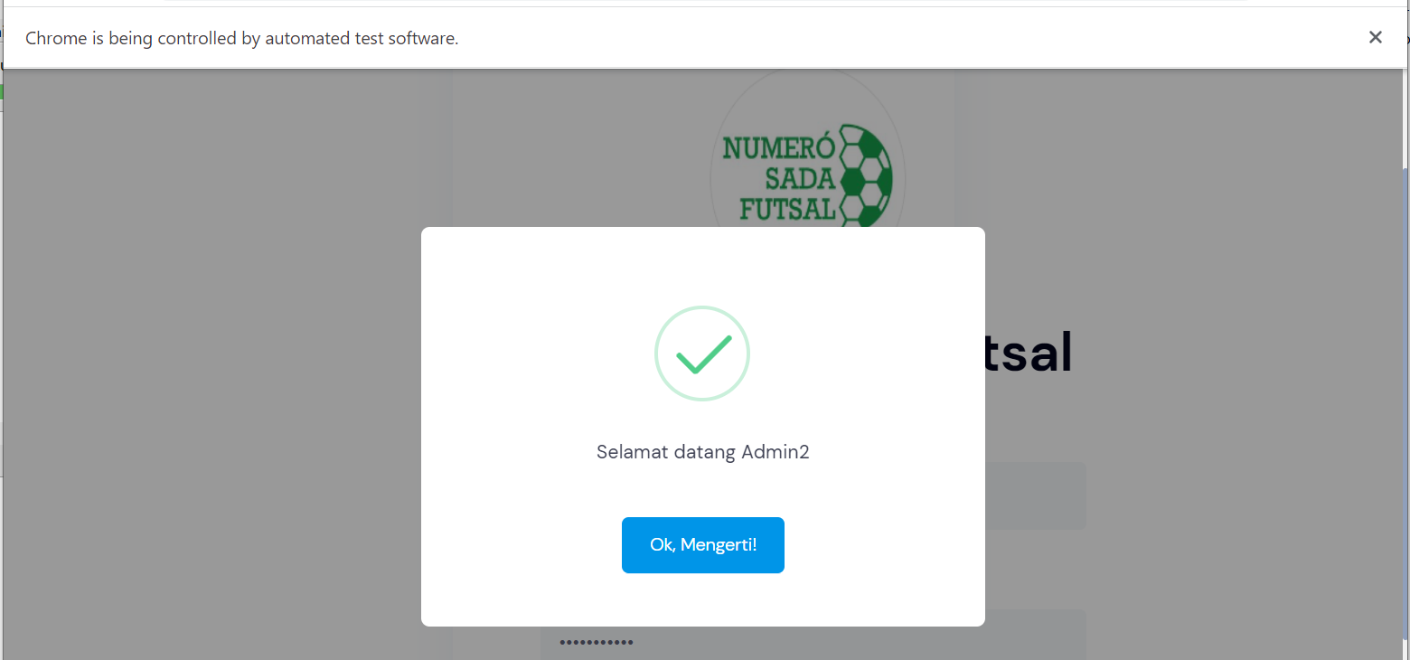

1. Fungsi Login 3

* The scenario

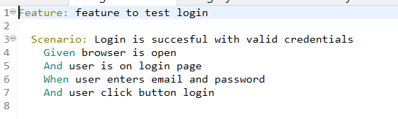

* The step definition

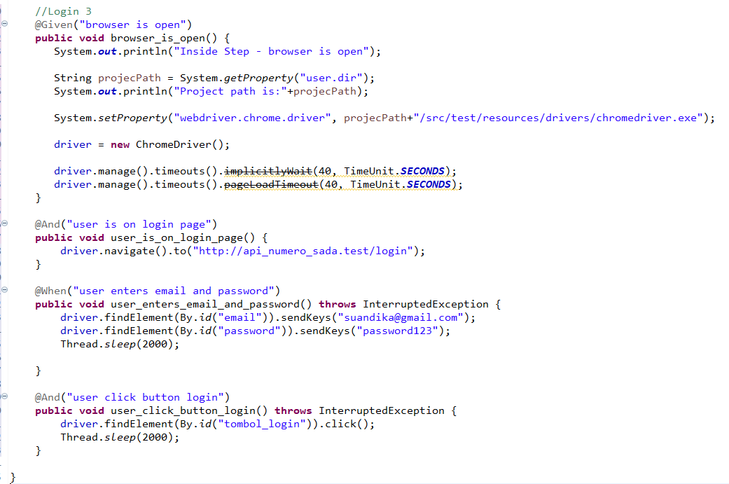

* The test runner



* The console after running

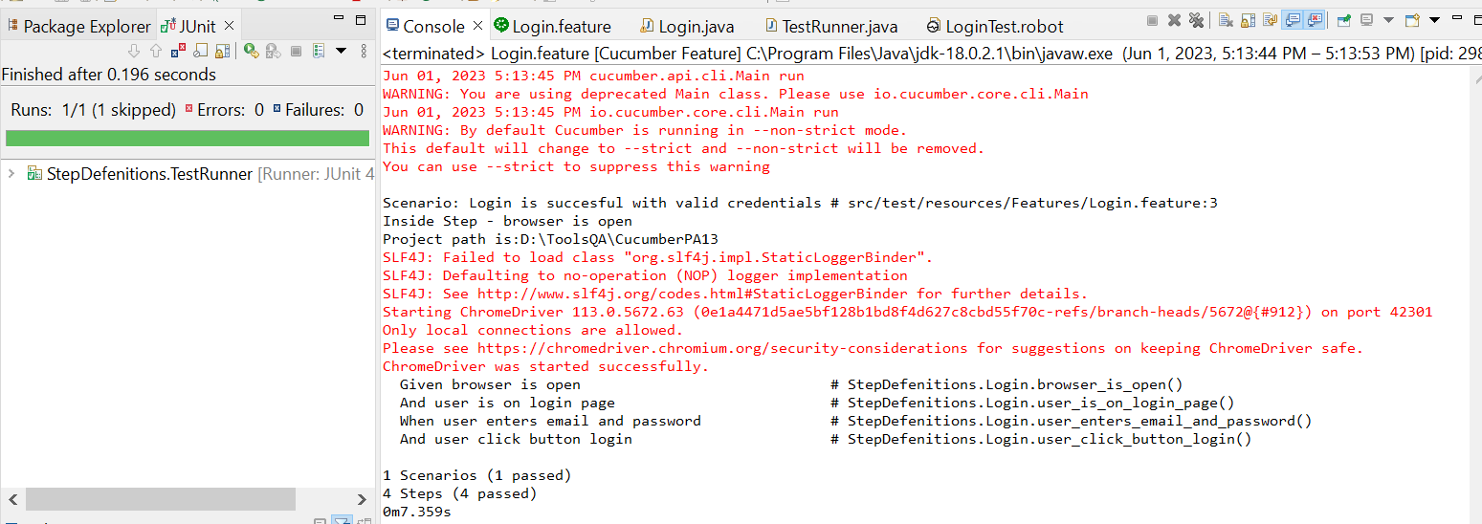

* The browser while testing

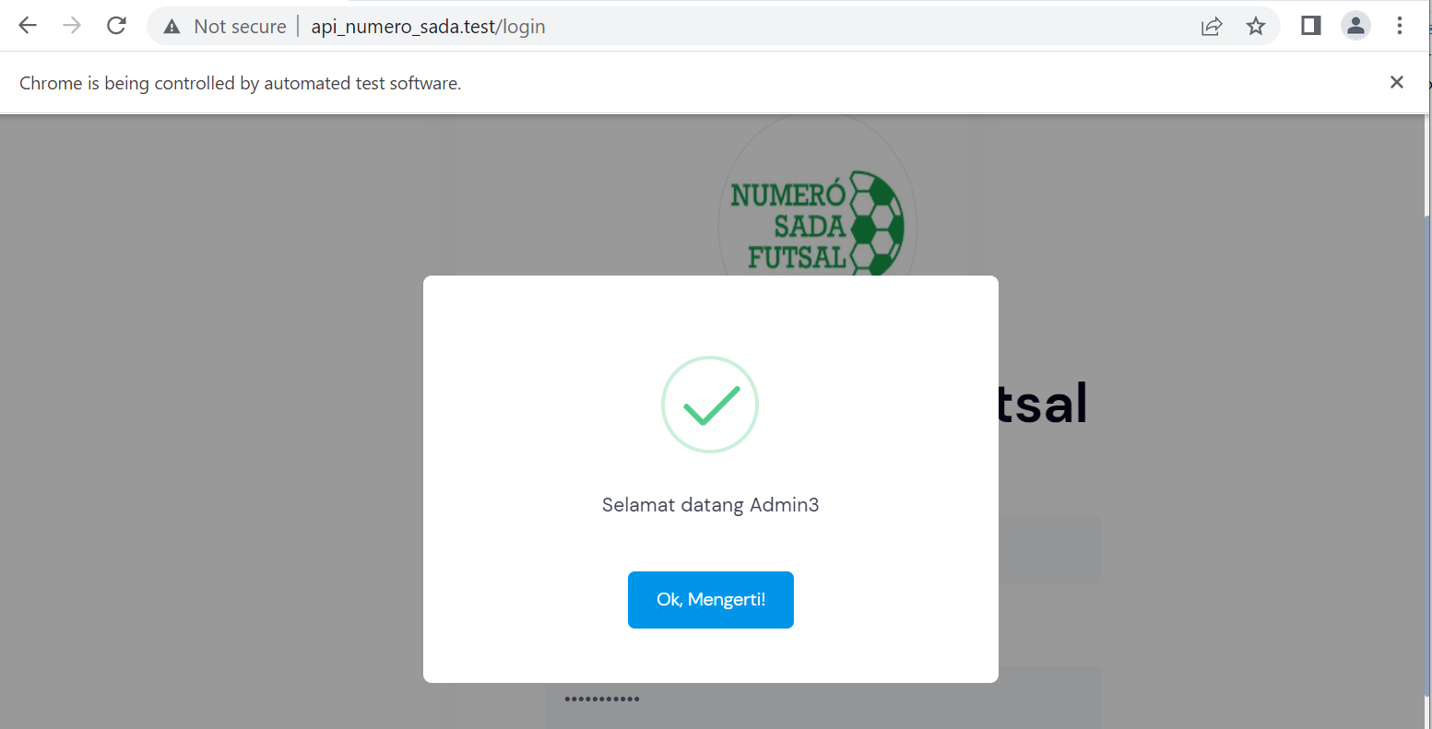

1. Fungsi Login 4

* The scenario

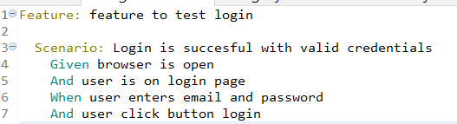

* The step definition

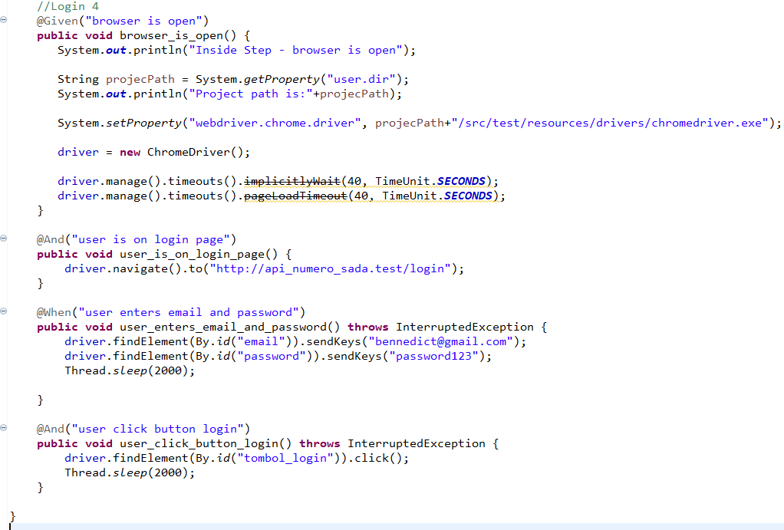

* The test runner



* The console after running

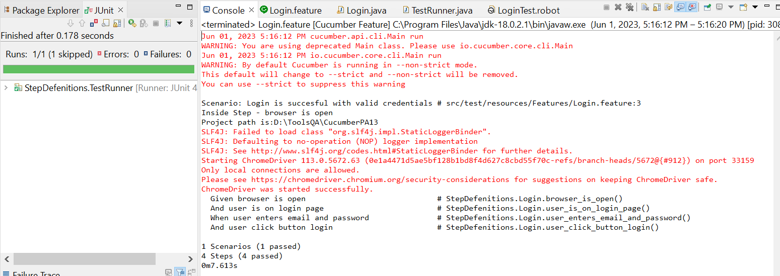

* The browser while testing

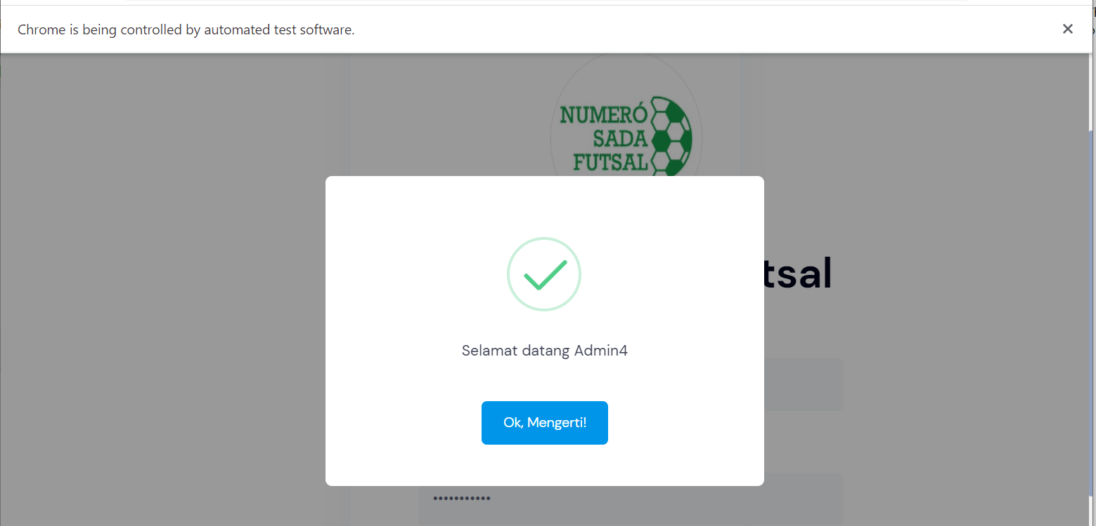

1. Fungsi Login 5

* The scenario



* The step definition

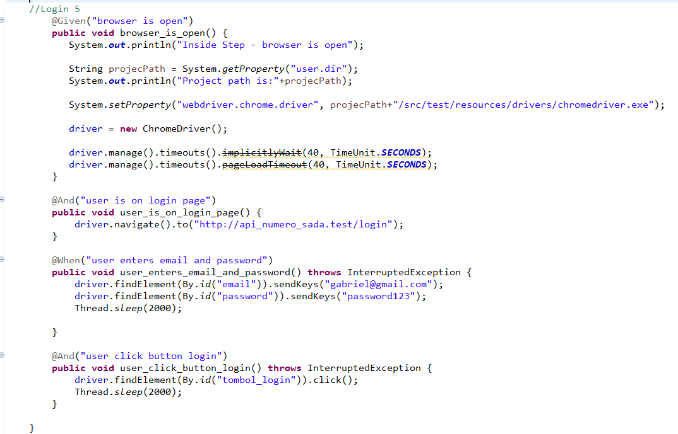

* The test runner



* The console after running

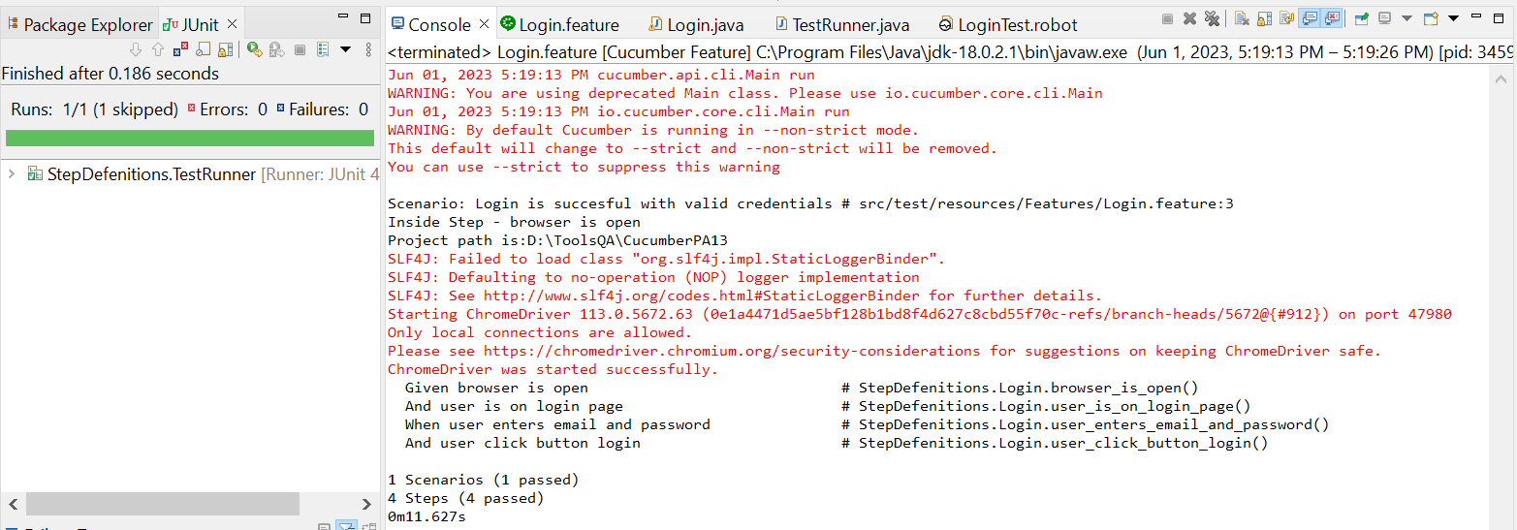

* The browser while testing

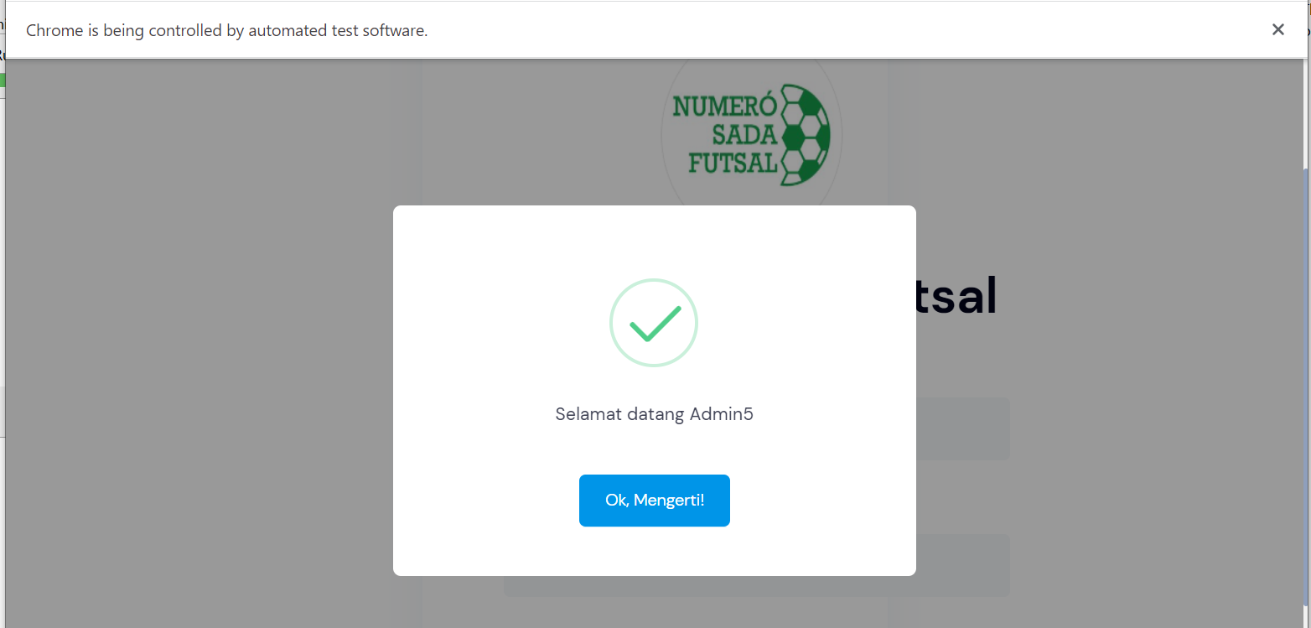

1. Fungsi Login 6

* The scenario



* The step definition
* The test runner



* The console after running

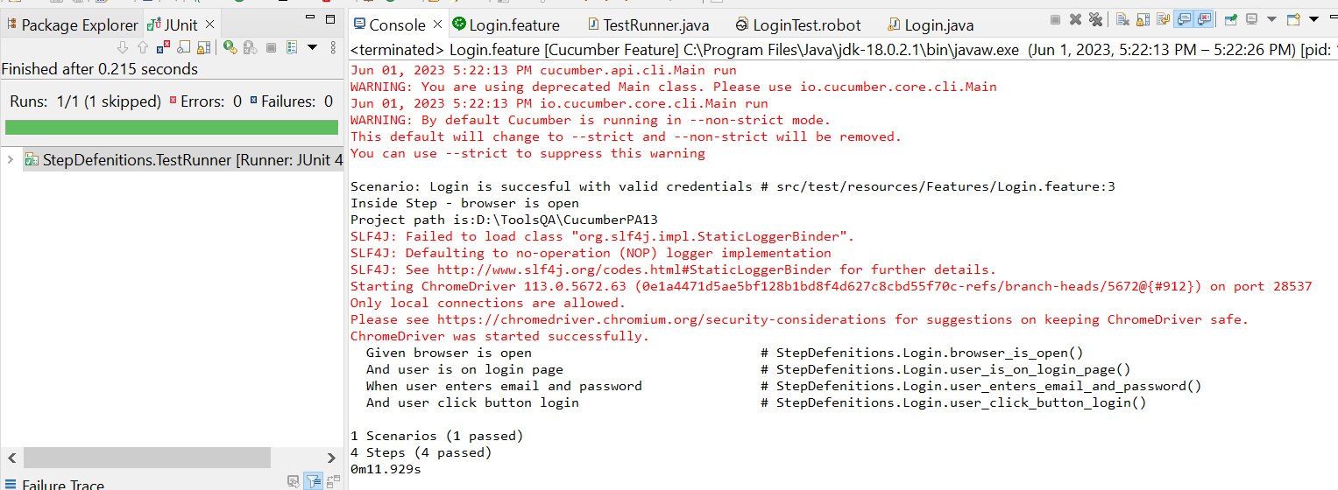

* The browser while testing

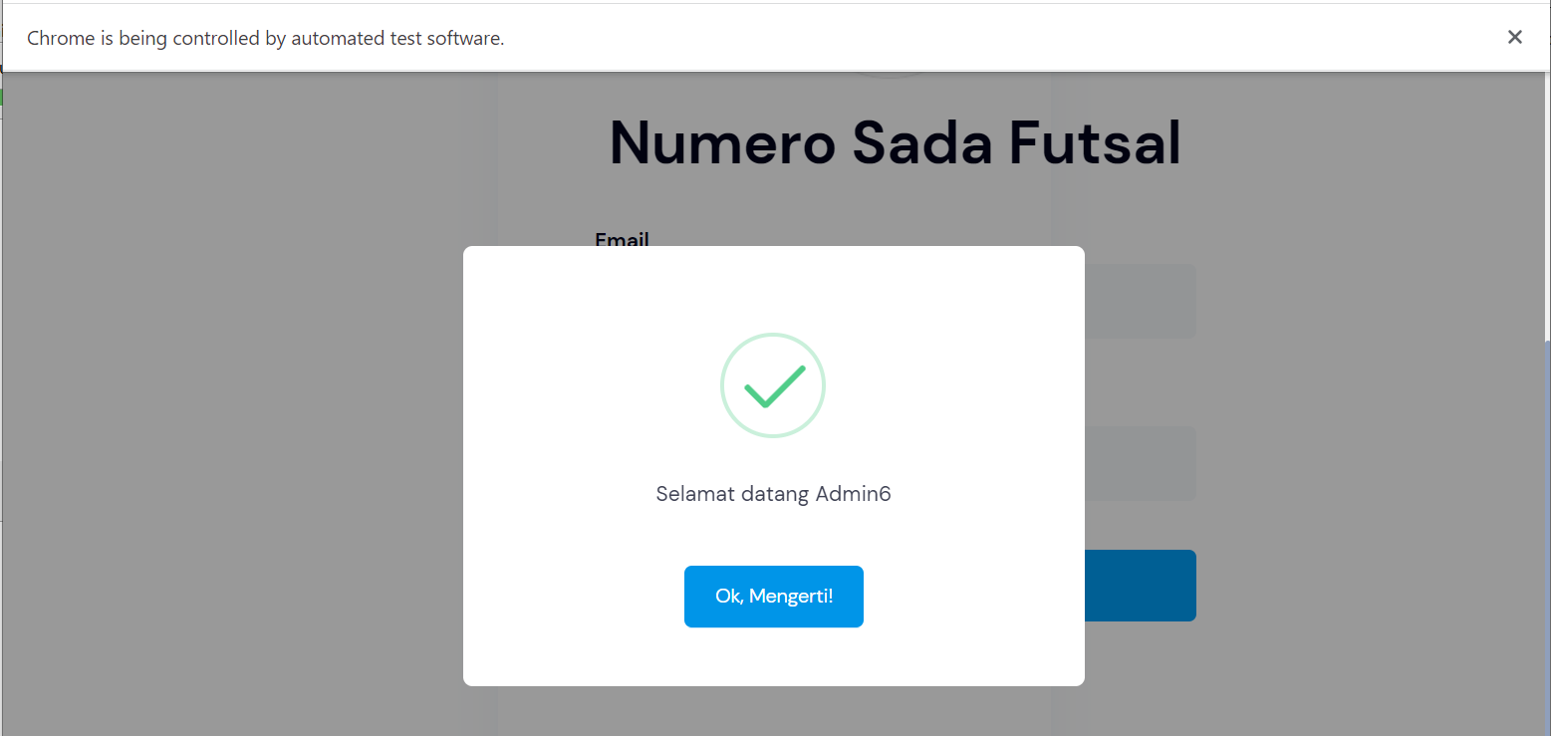

1. Fungsi Login 7

* The scenario



* The step definition

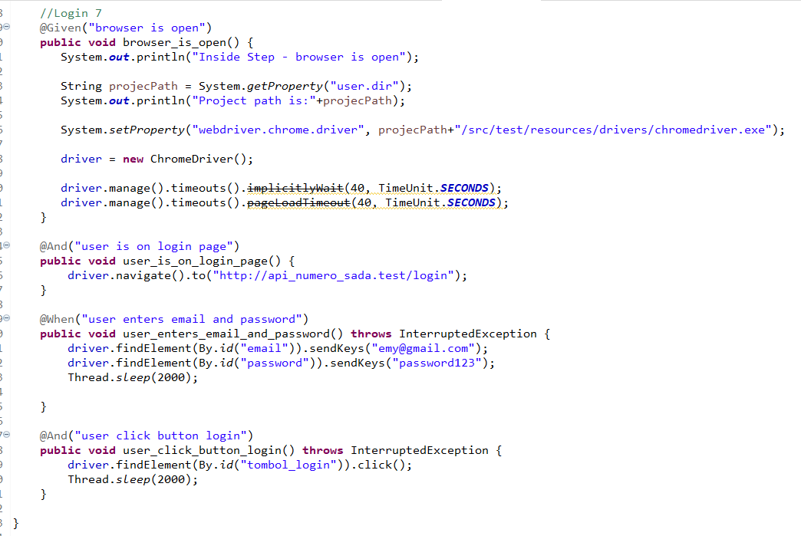

* The test runner



* The console after running

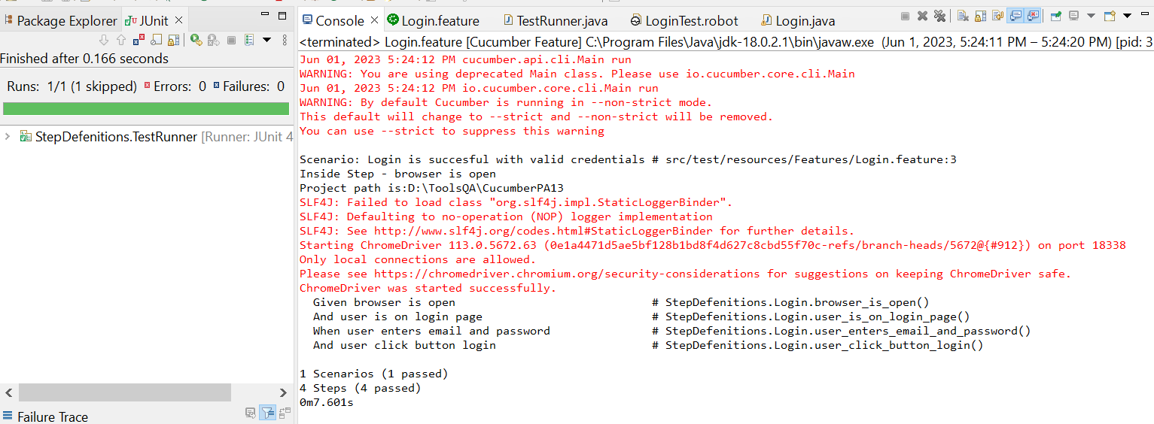

* The browser while testing

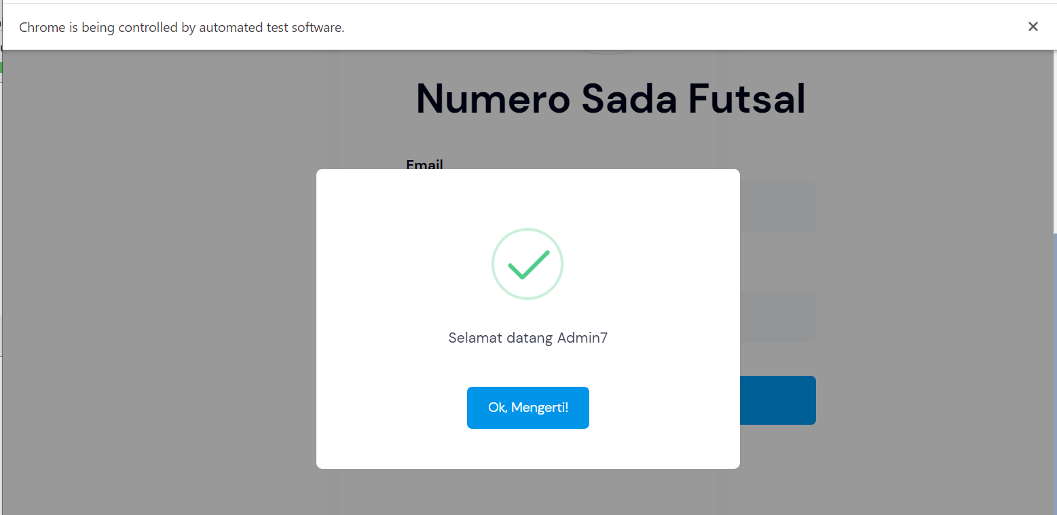

1. Fungsi Login 8

* The scenario



* The step definition

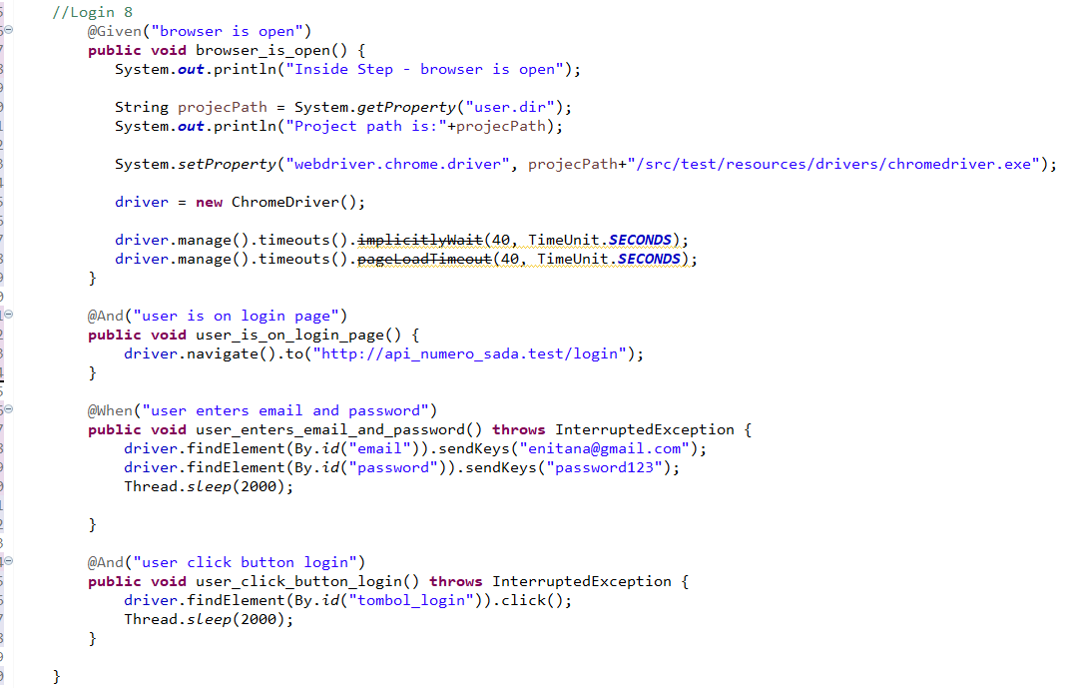

* The test runner



* The console after running

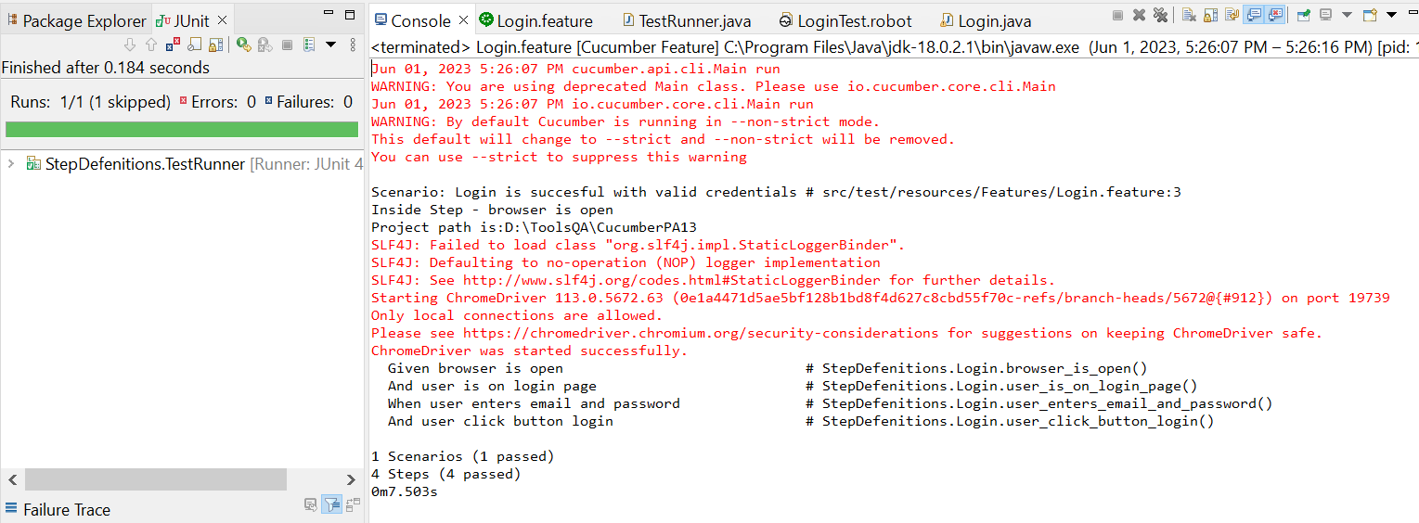

* The browser while testing

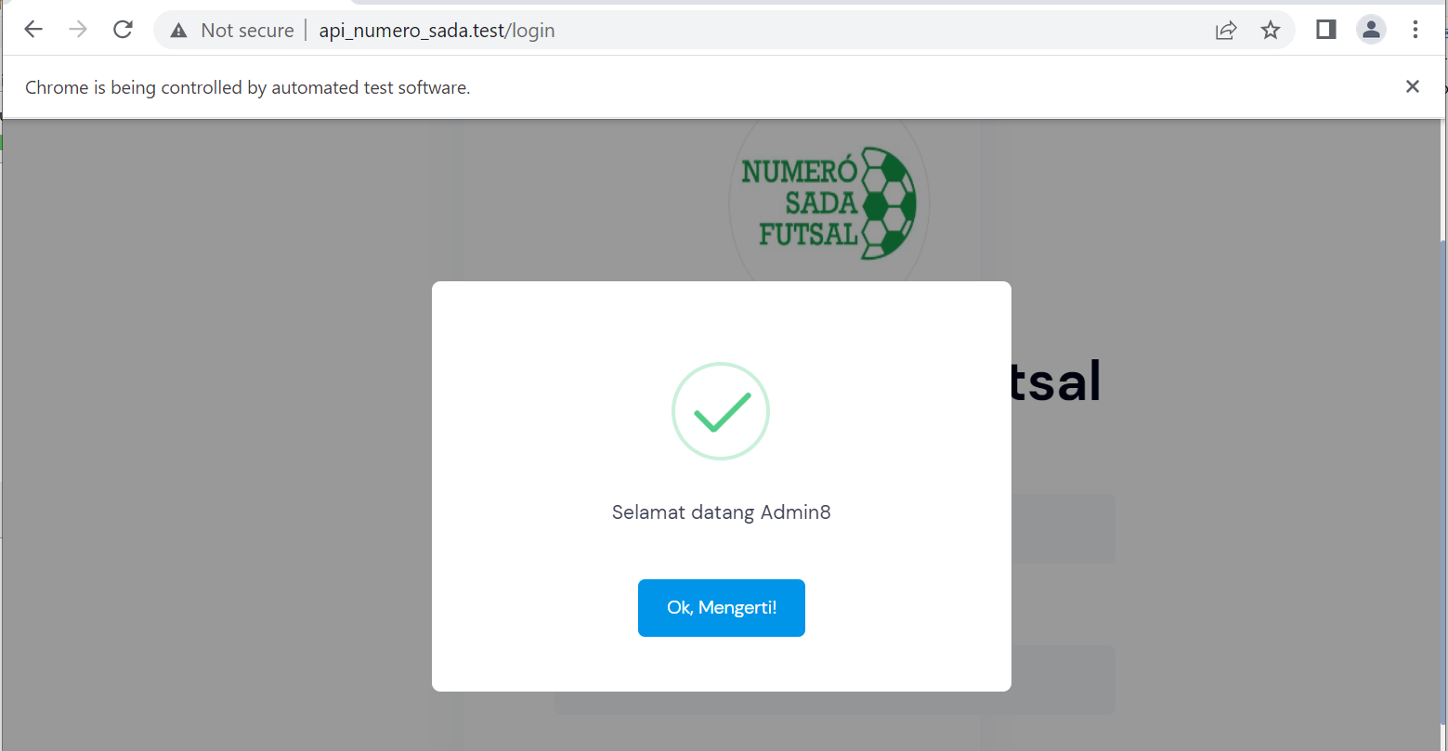

1. Fungsi Login 9

* The scenario



* The step definition

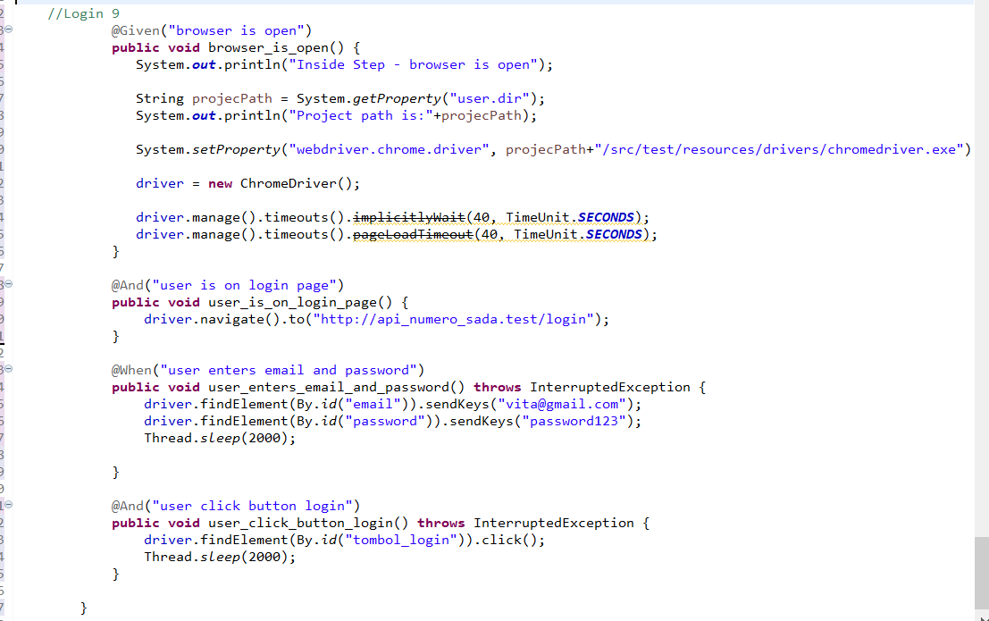

* The test runner



* The console after running

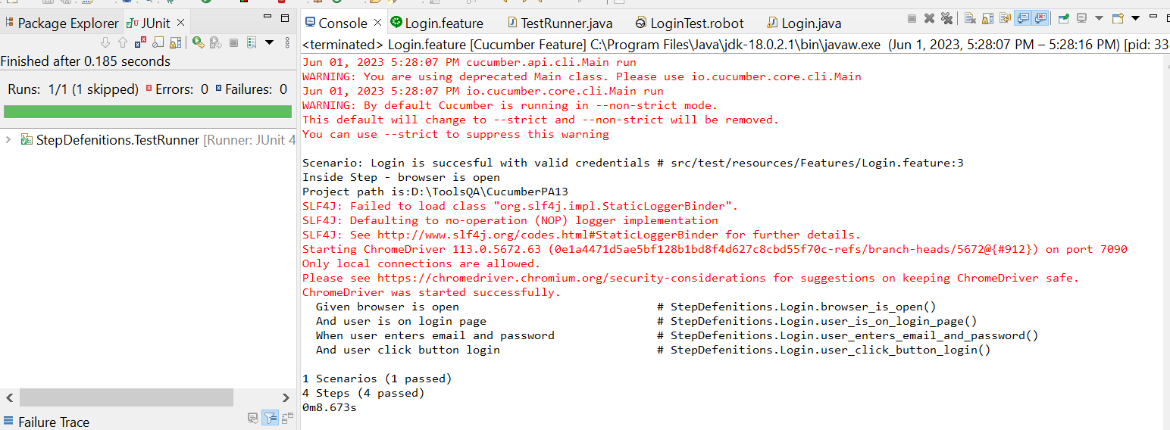

* The browser while testing

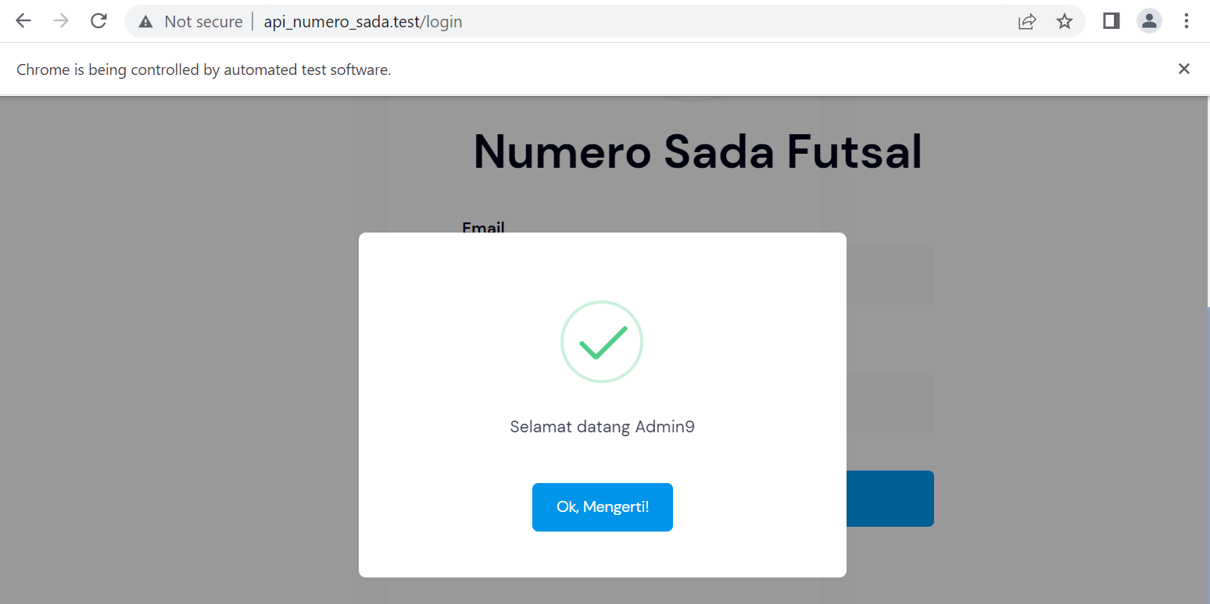

1. Fungsi Login 10

* The scenario



* The step definition

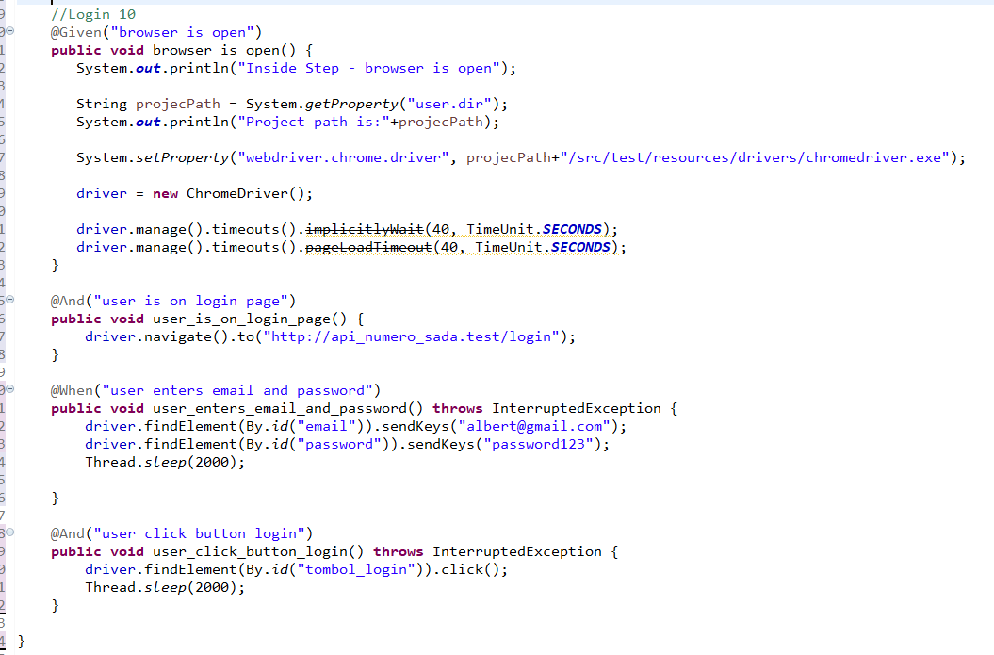

* The test runner



* The console after running

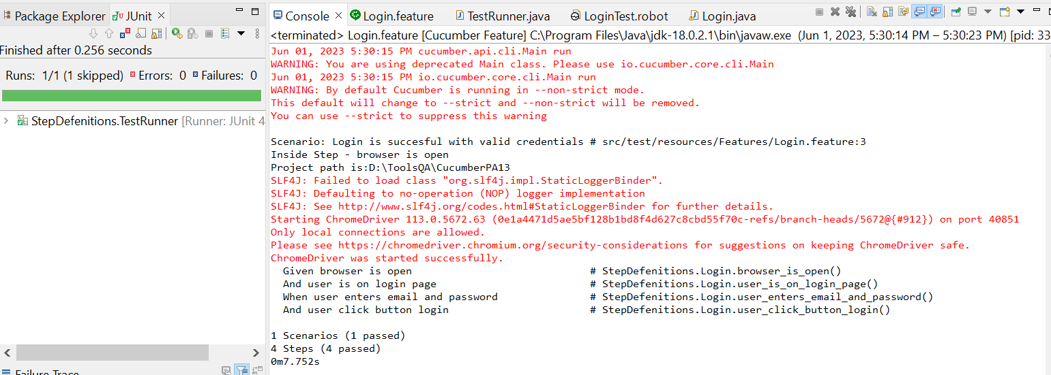

* The browser while testing

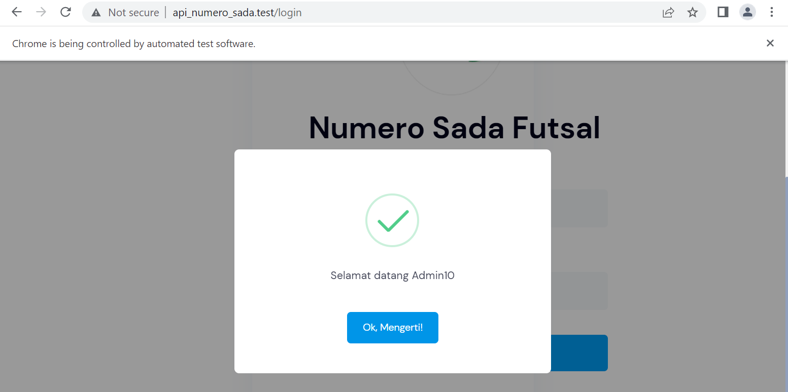

1. Fungsi Login 11

* The scenario



* The step definition

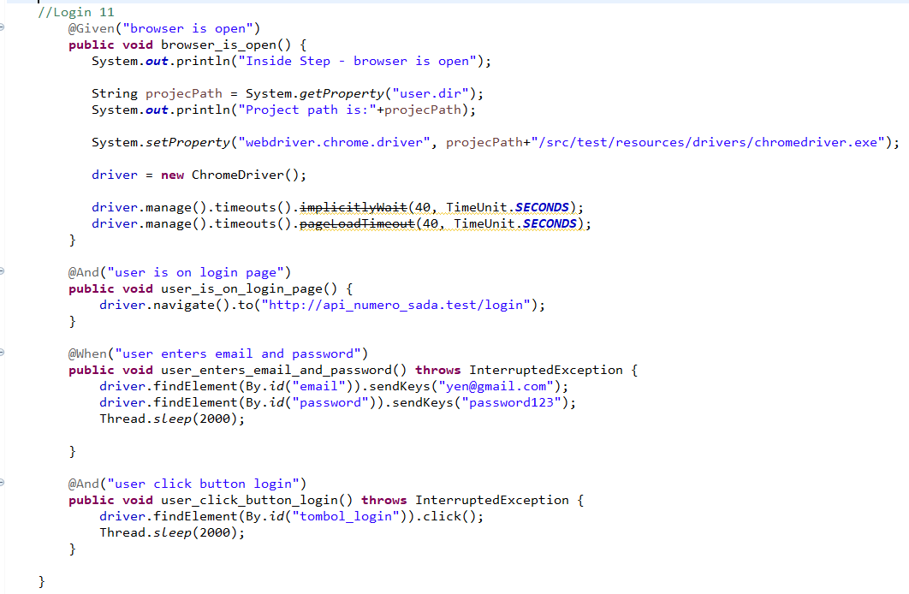

* The test runner



* The console after running

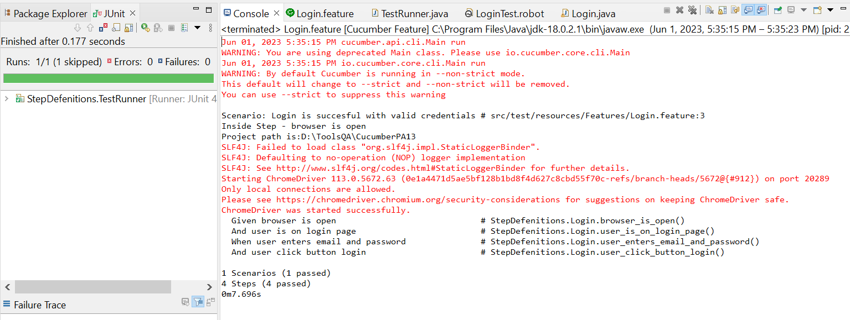

* The browser while testing

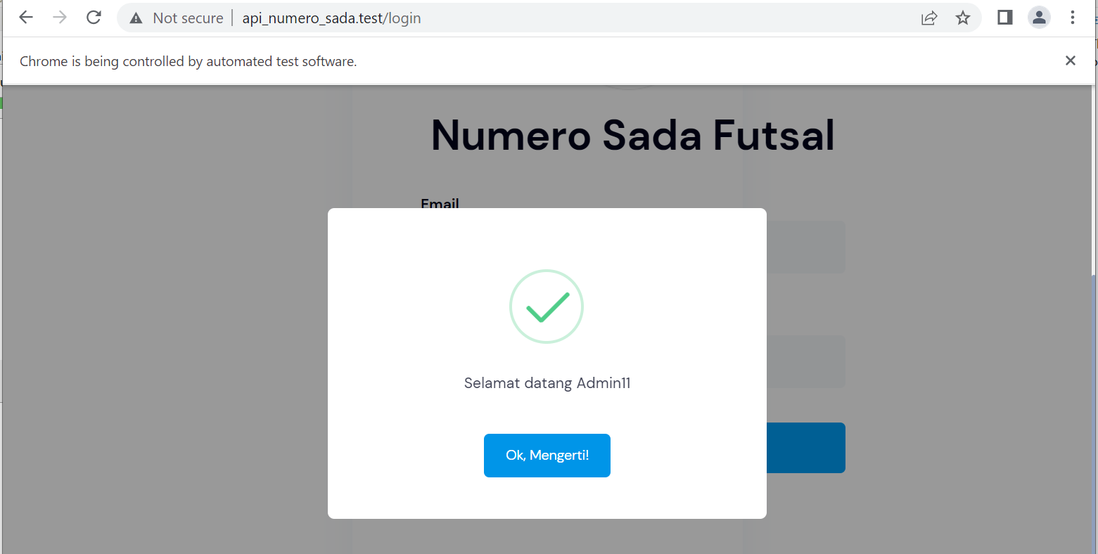

1. Fungsi Login 12

* The scenario



* The step definition

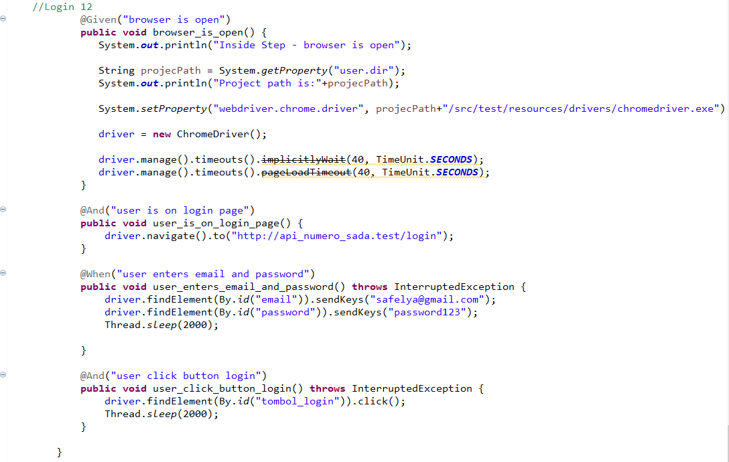

* The test runner



* The console after running

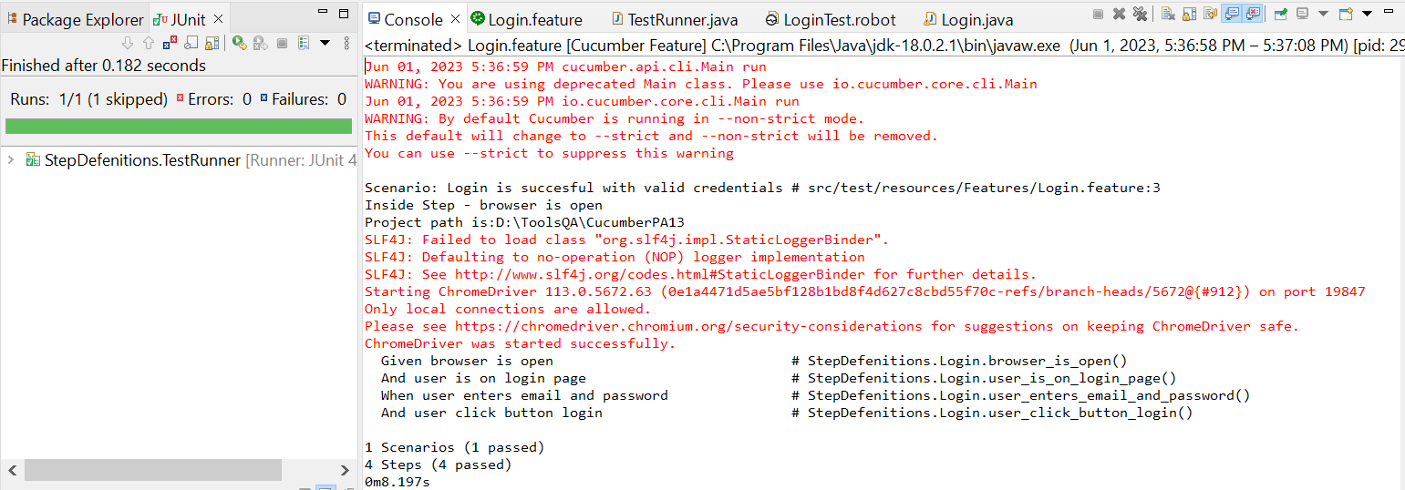

* The browser while testing

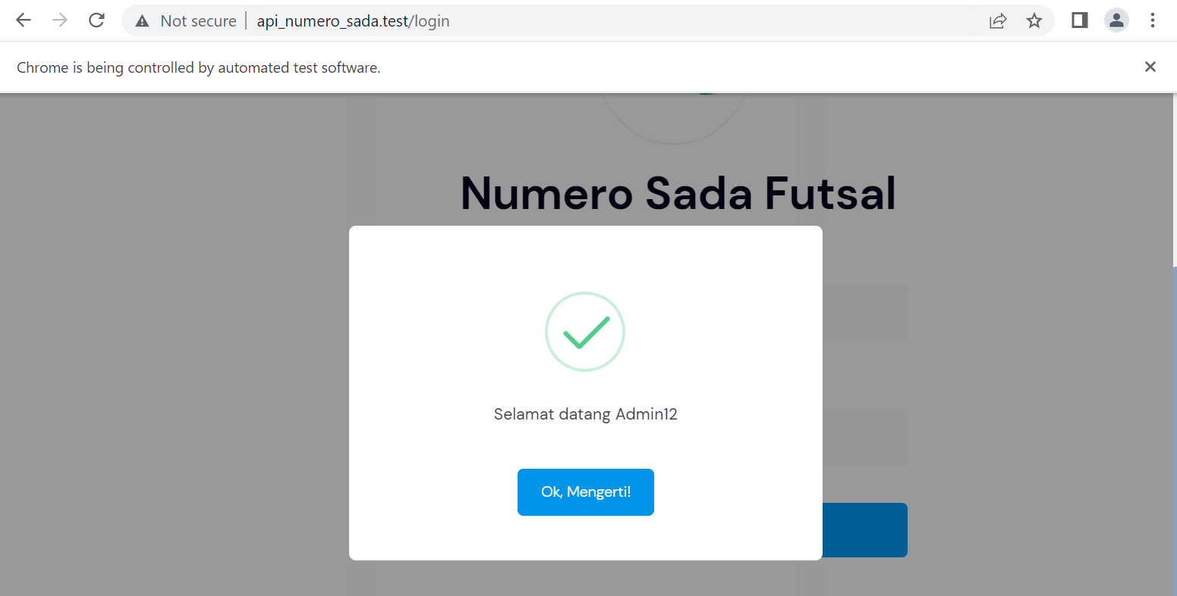

1. Fungsi Login 13

* The scenario



* The step definition

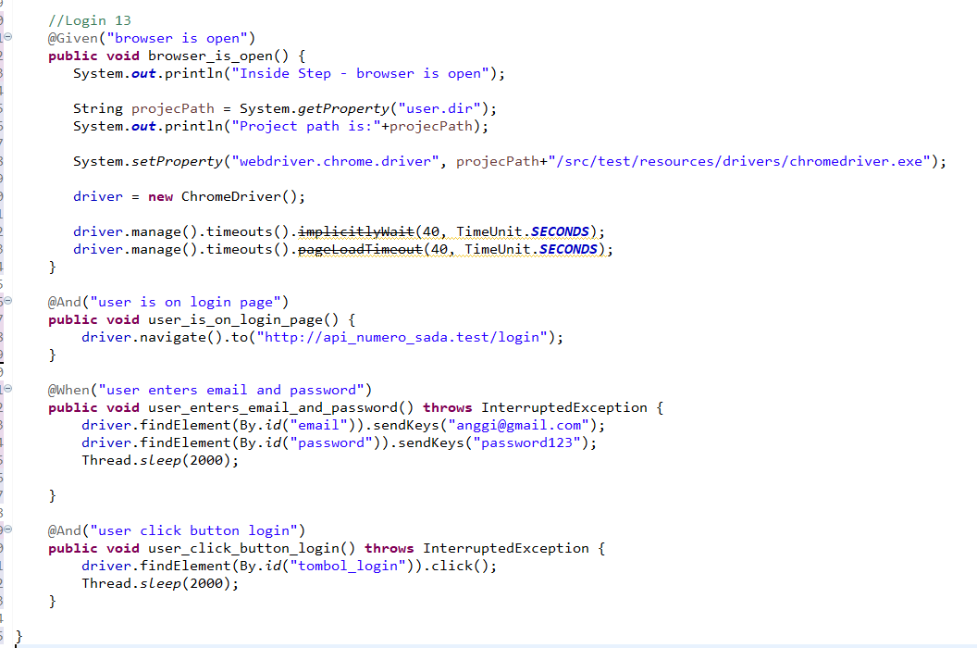

* The test runner



* The console after running

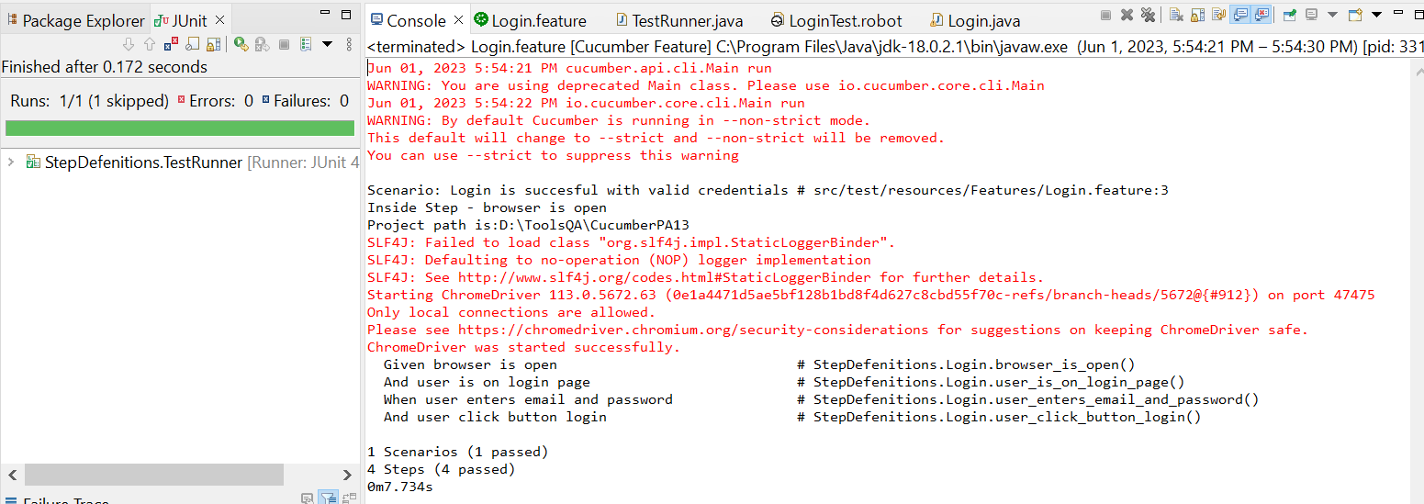

* The browser while testing

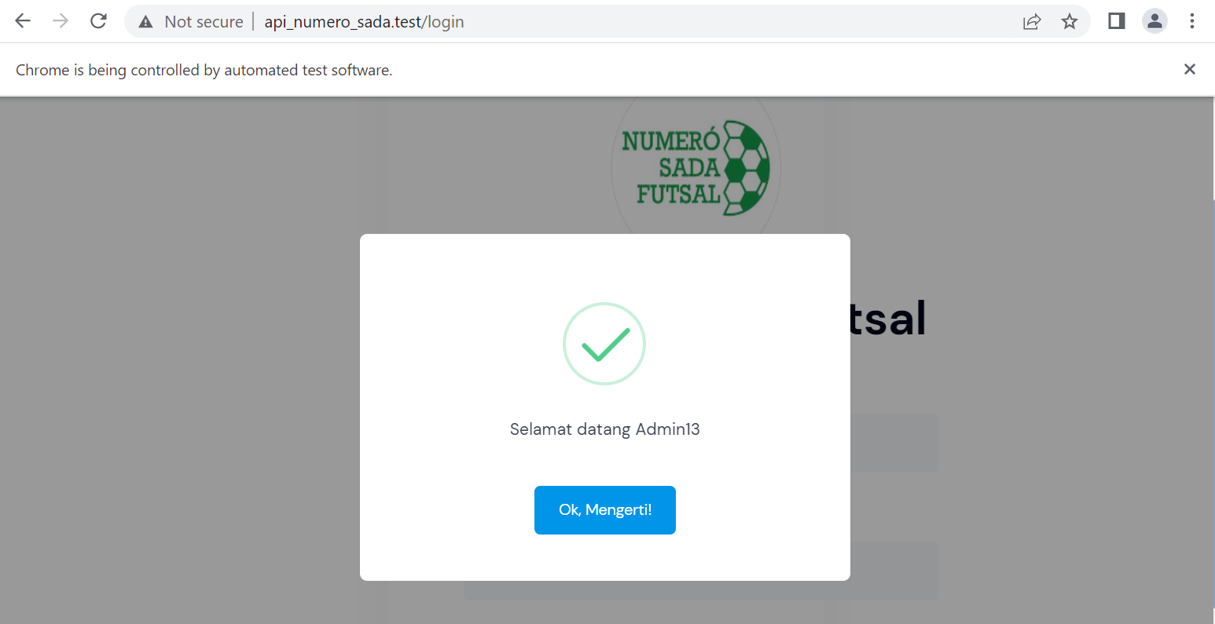

1. Fungsi Login 14

* The scenario



* The step definition

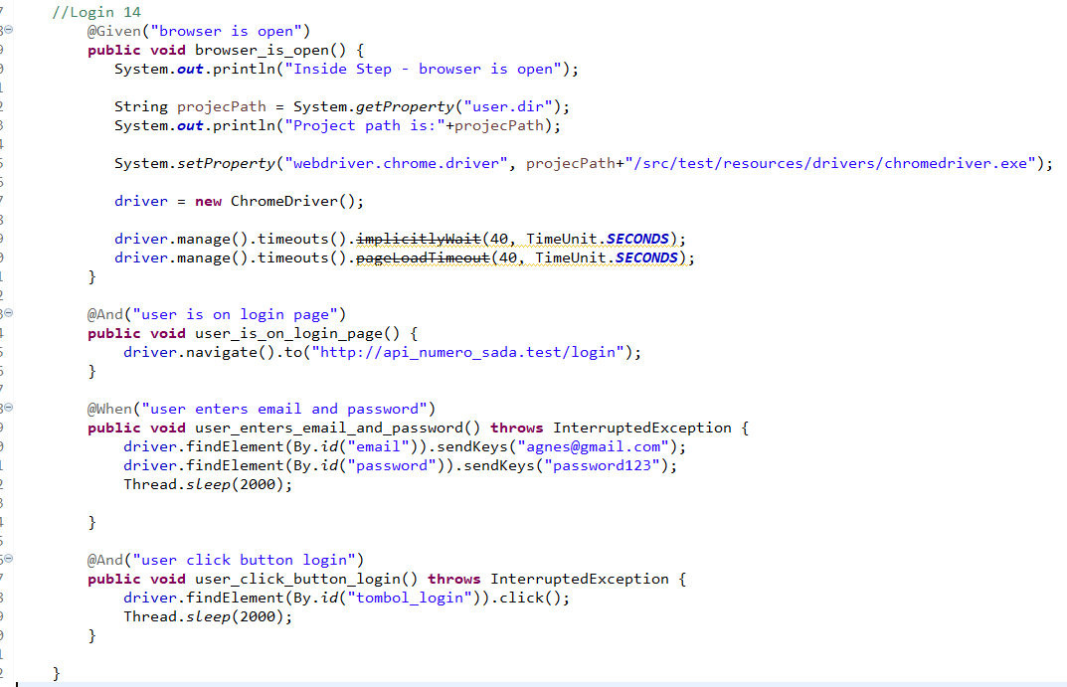

* The test runner



* The console after running

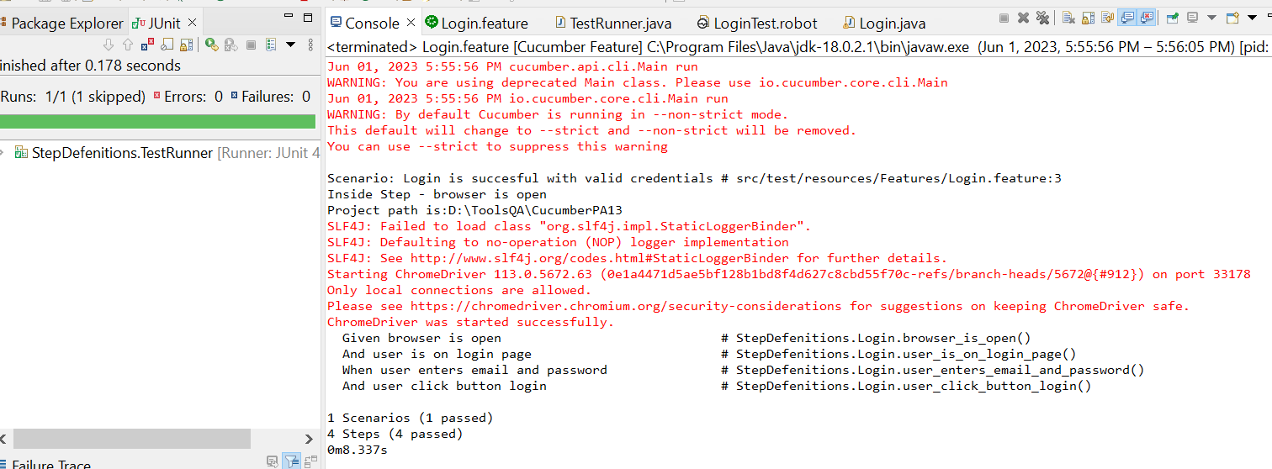

* The browser while testing

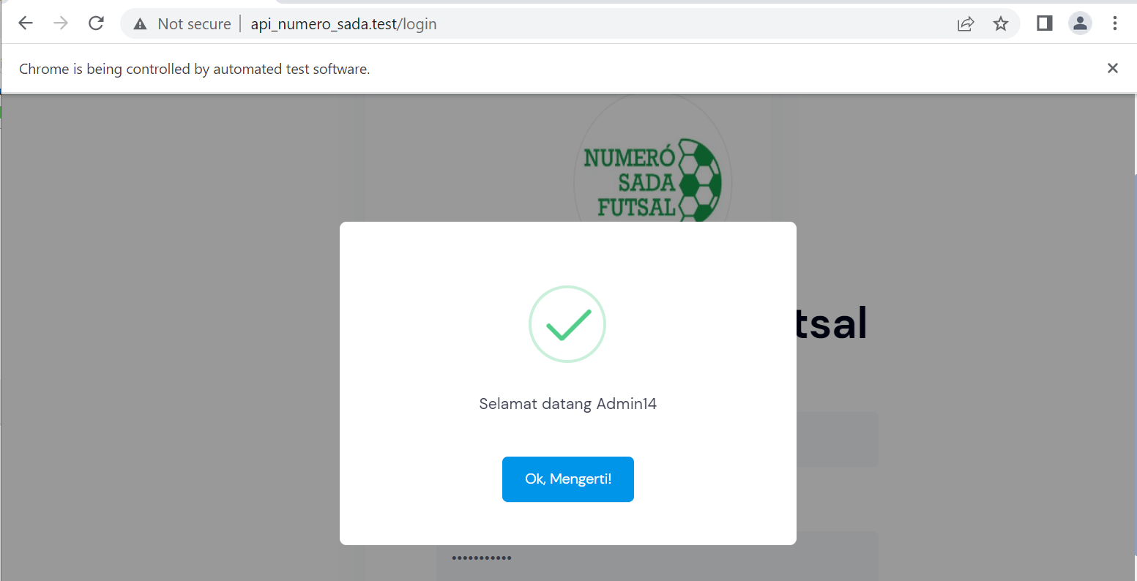

1. Fungsi Login 15

* The scenario



* The step definition

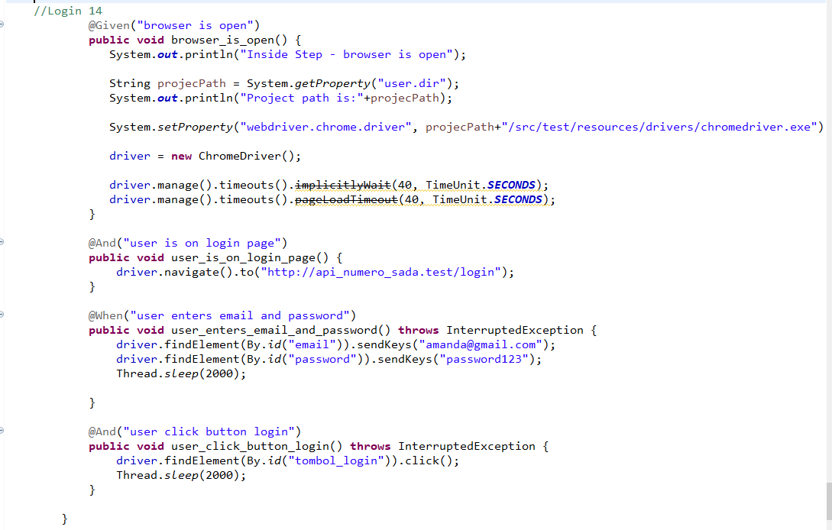

* The test runner



* The console after running

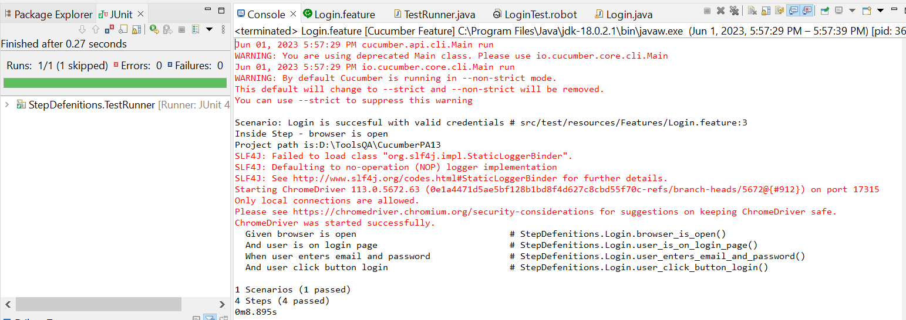

* The browser while testing

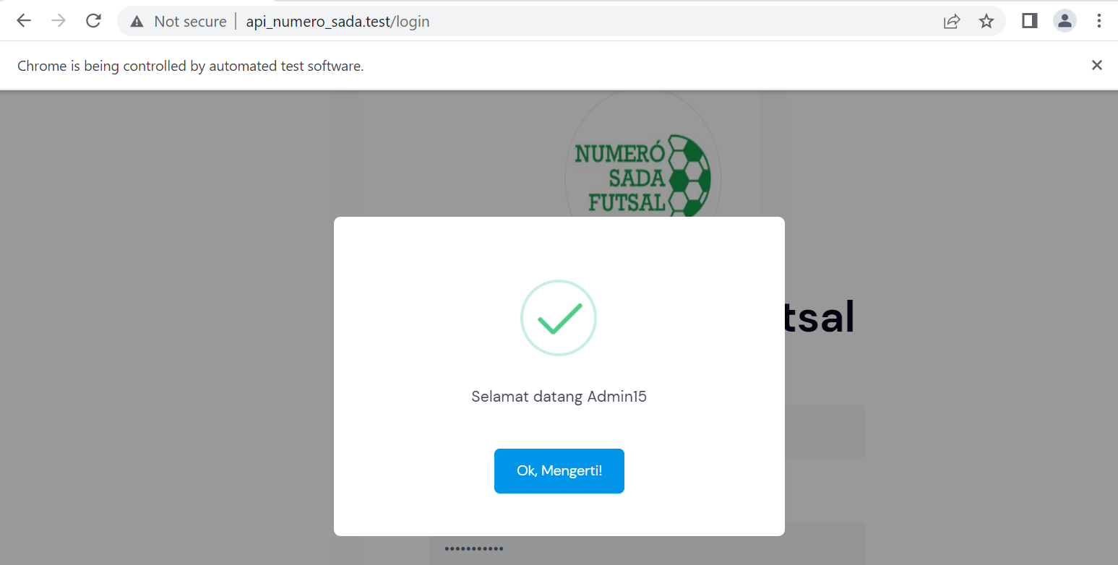

1. Fungsi Login 16

* The scenario



* The step definition

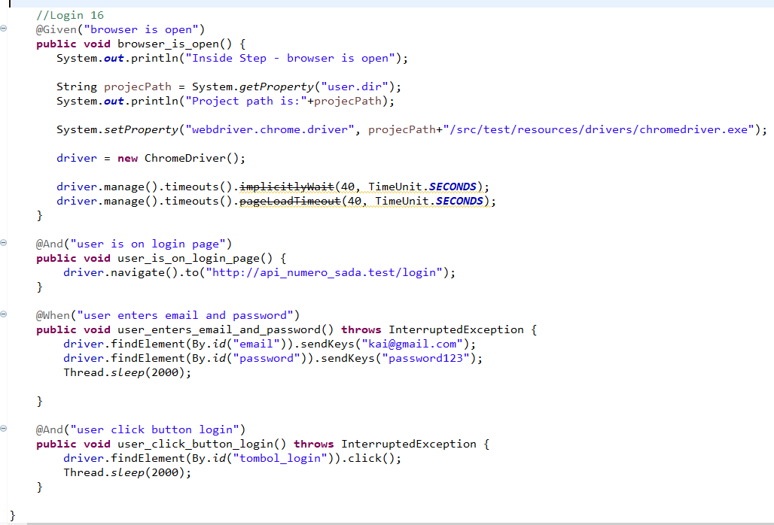

* The test runner



* The console after running

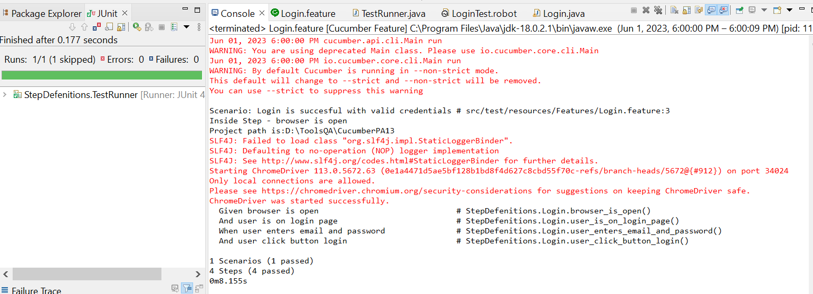

* The browser while testing

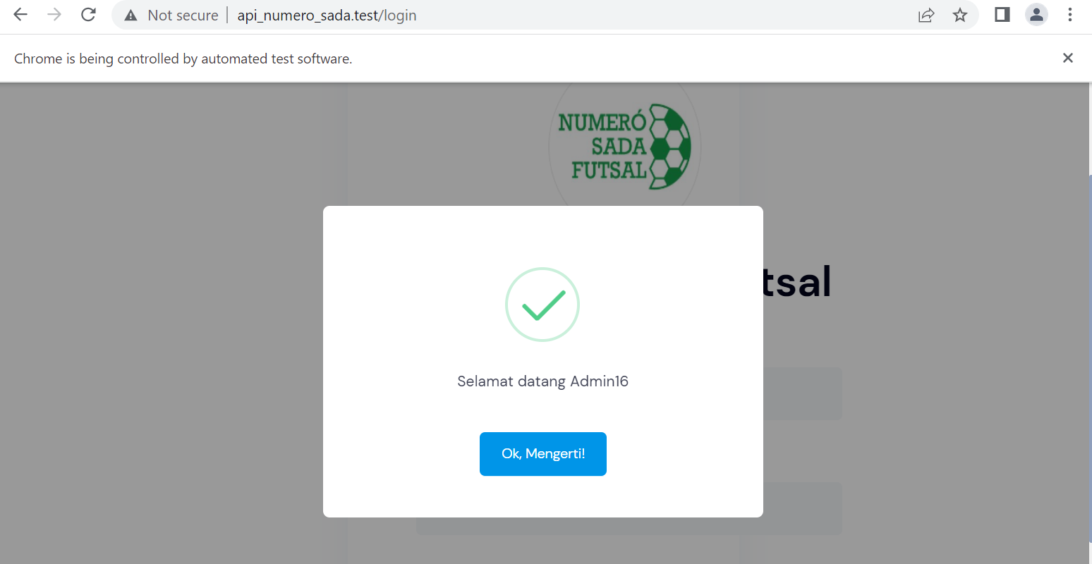

1. Fungsi Login 17

* The scenario



* The step definition

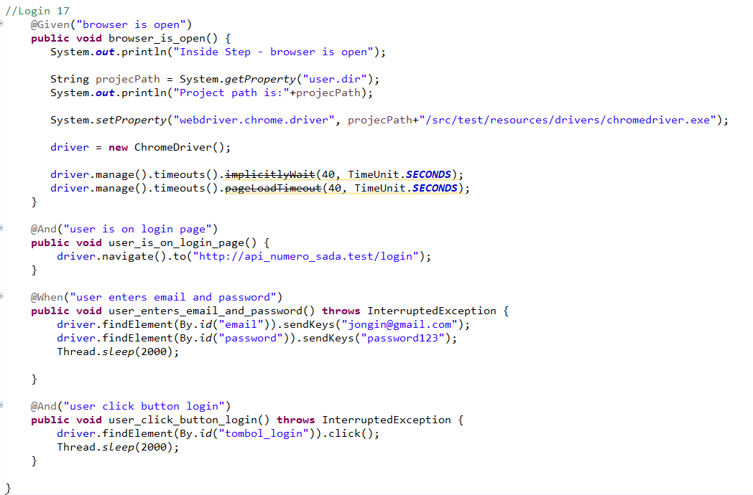

* The test runner



* The console after running

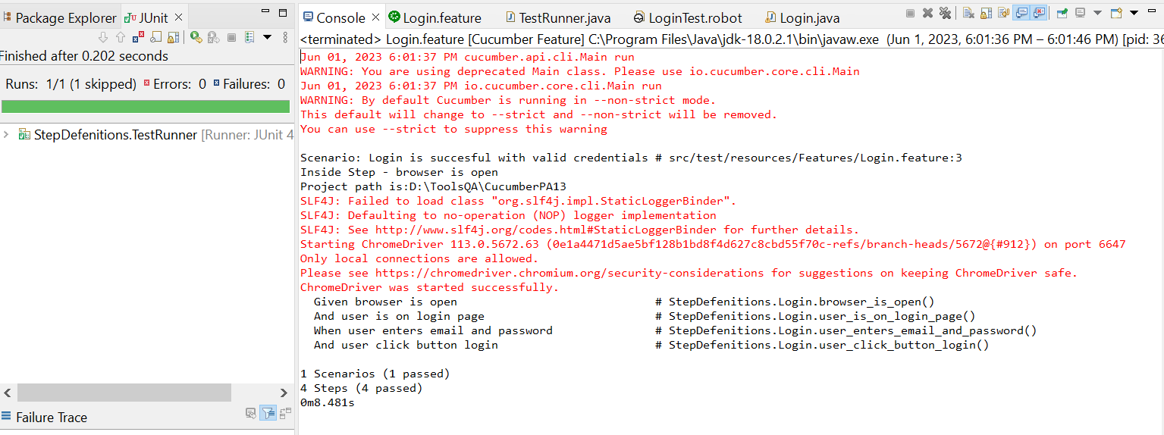

* The browser while testing

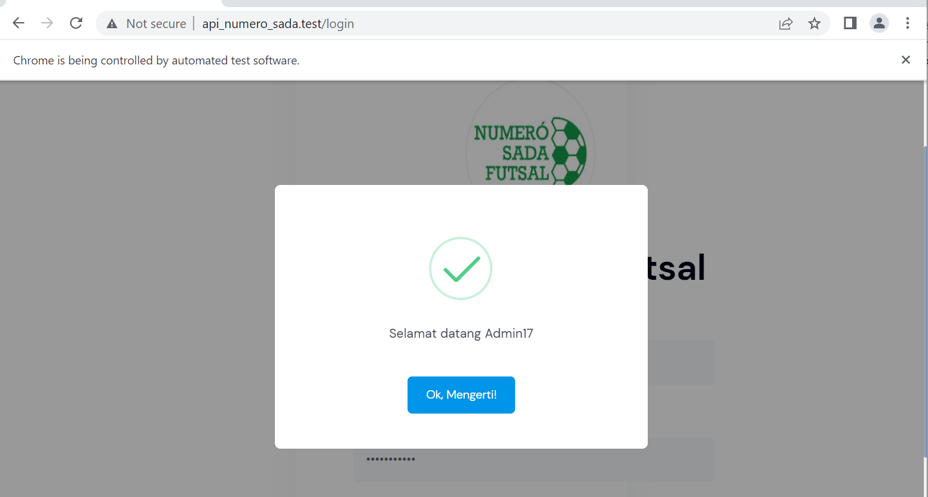

1. Fungsi Login 18

* The scenario



* The step definition

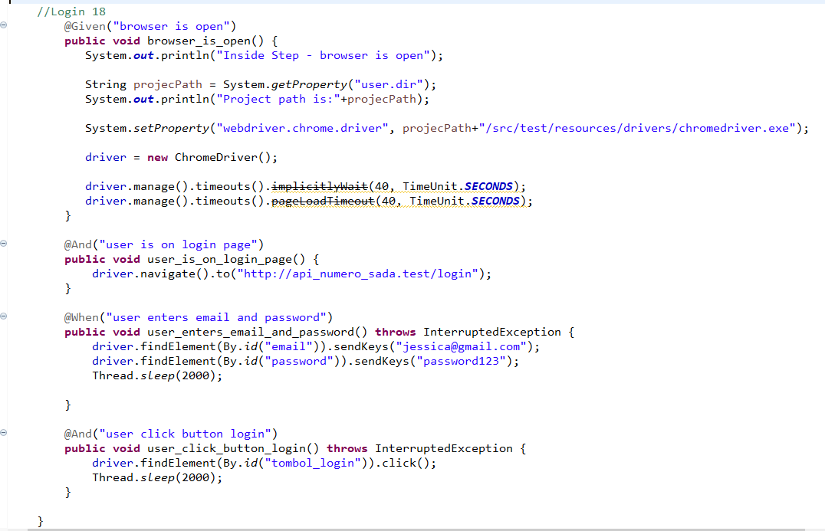

* The test runner



* The console after running

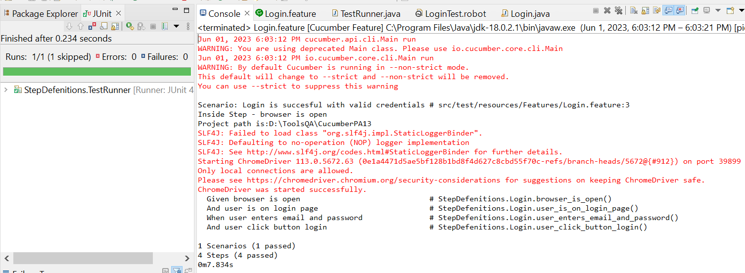

* The browser while testing

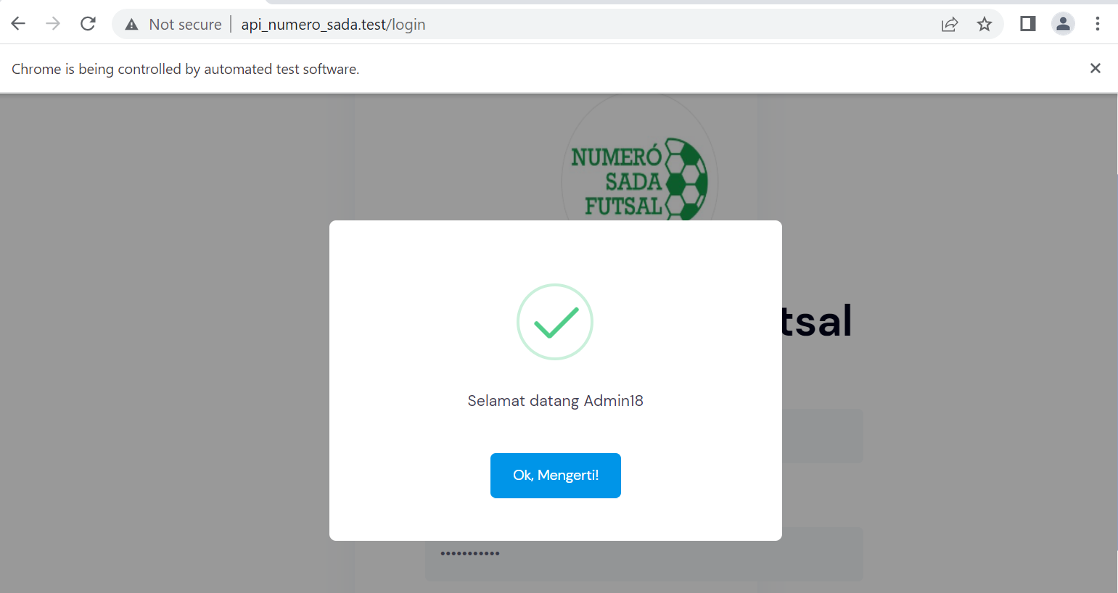

1. Fungsi Login 19

* The scenario



* The step definition

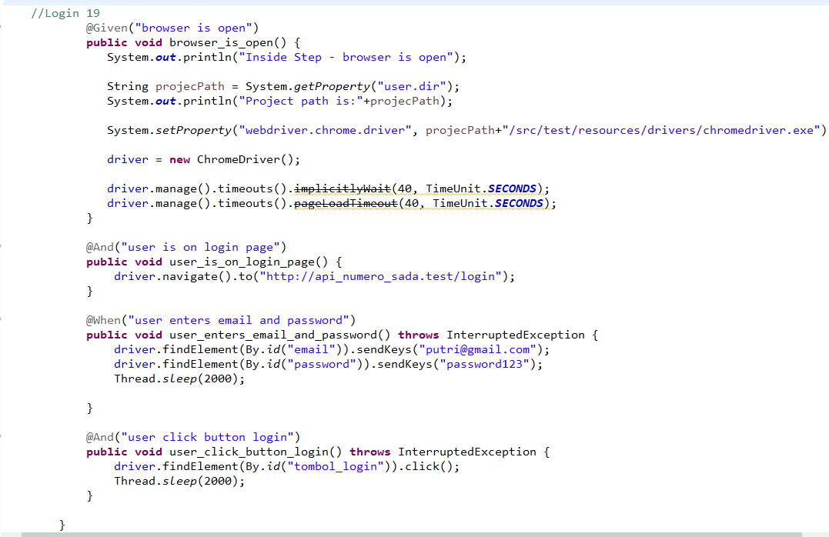

* The test runner



* The console after running

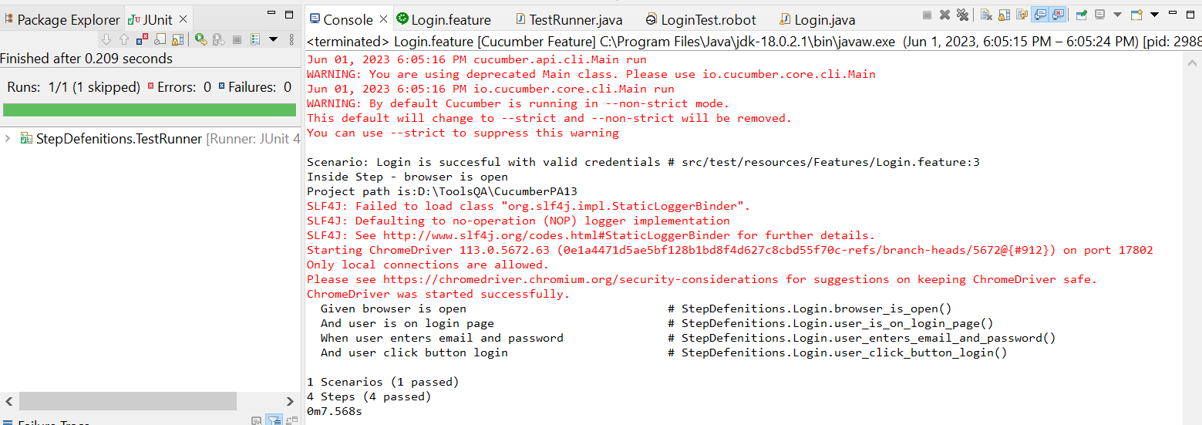

* The browser while testing

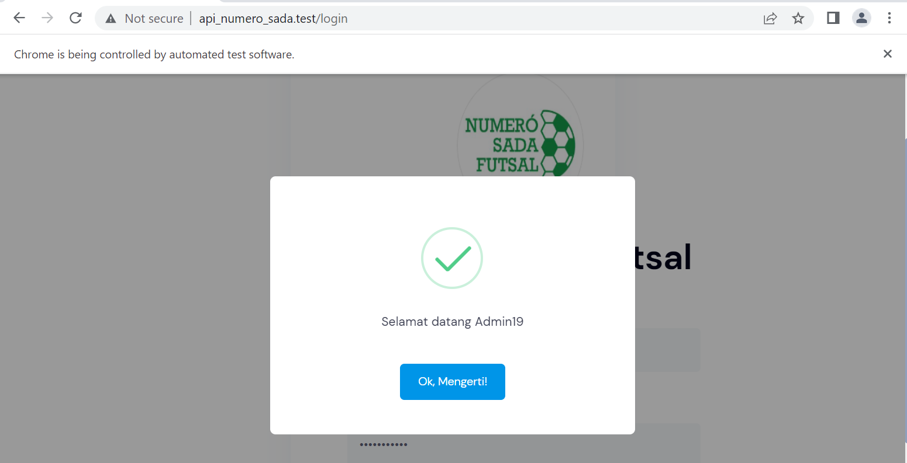

1. Fungsi Login 20

* The scenario



* The step definition

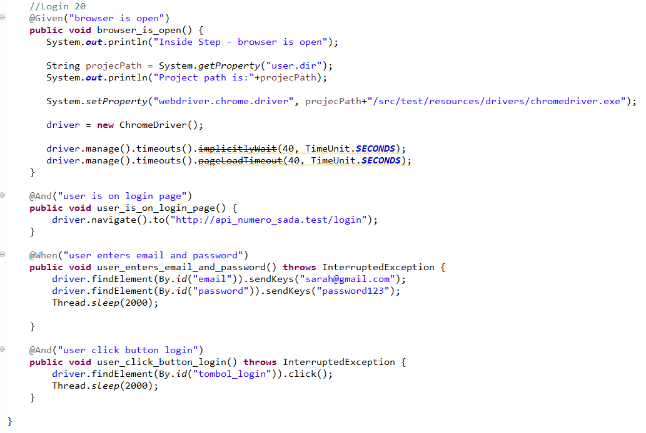

* The test runner



* The console after running

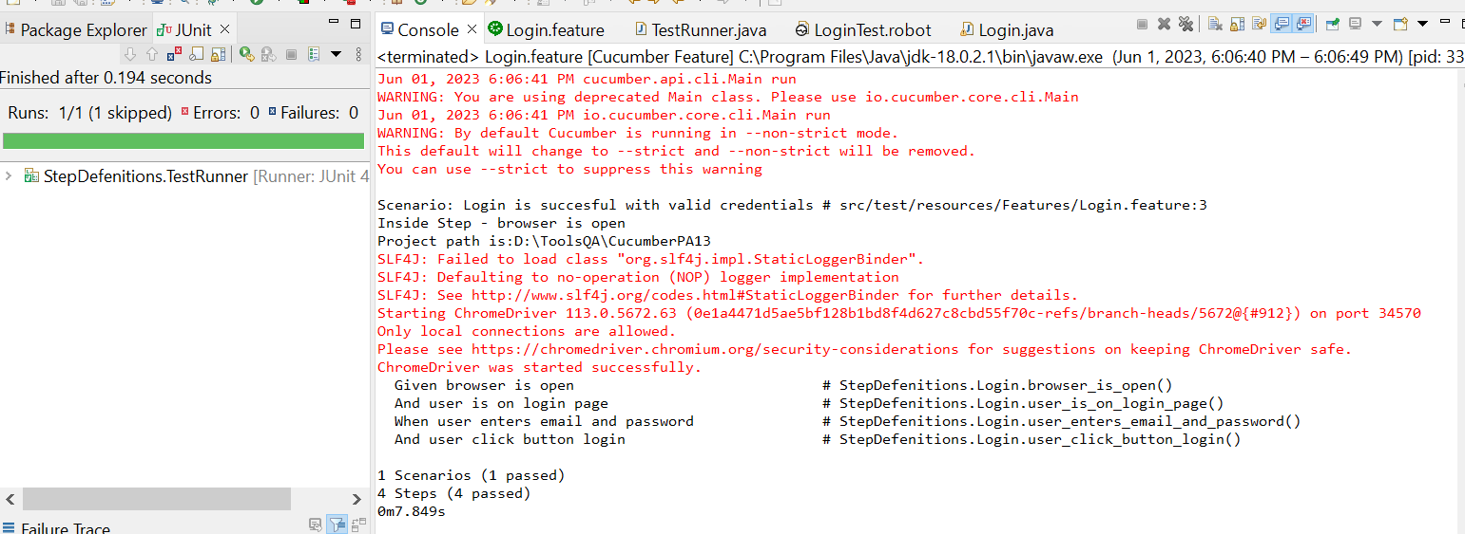

* The browser while testing

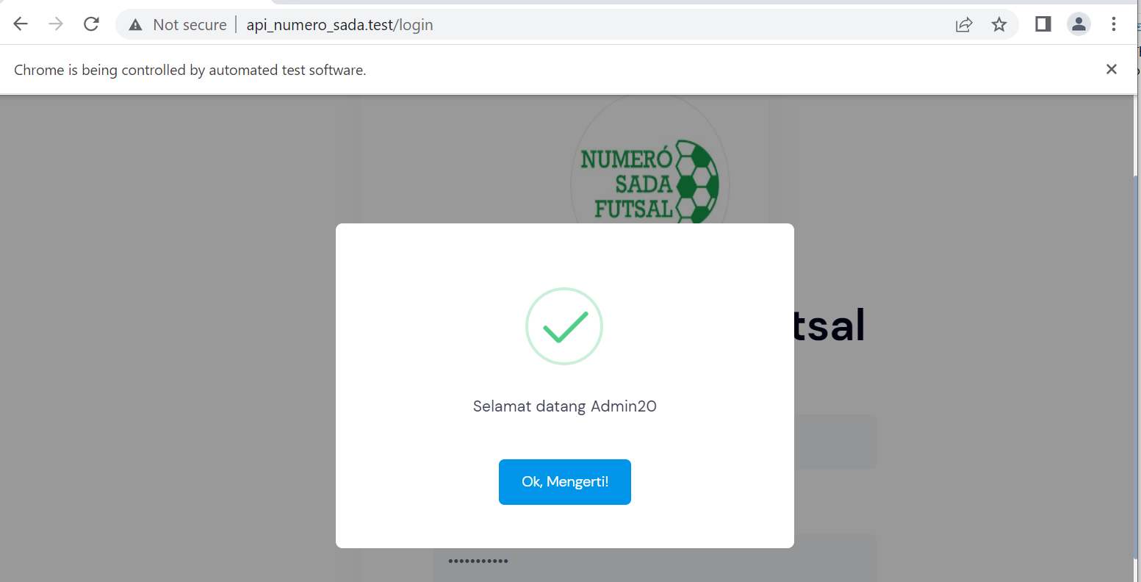

1. Fungsi Login 21

* The scenario



* The step definition

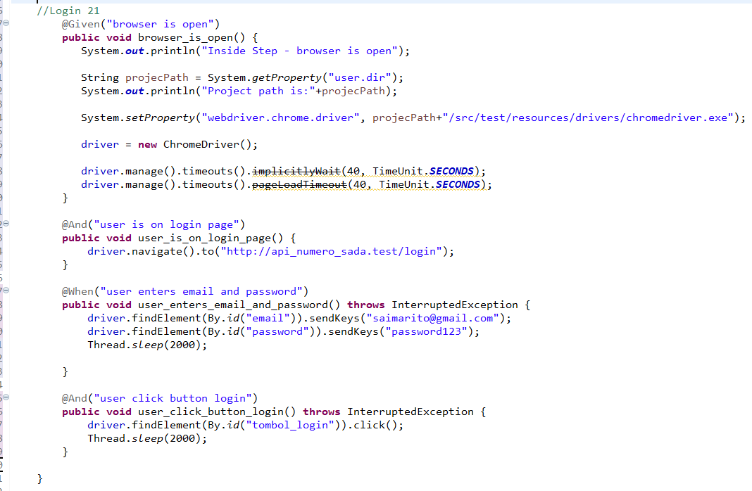

* The test runner



* The console after running

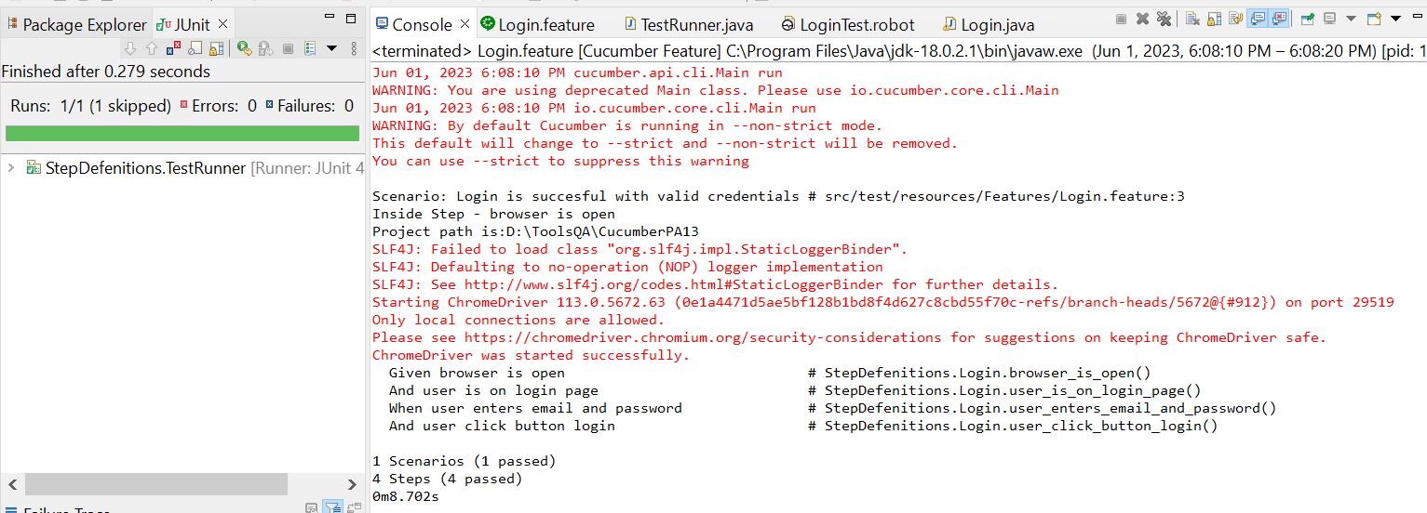

* The browser while testing

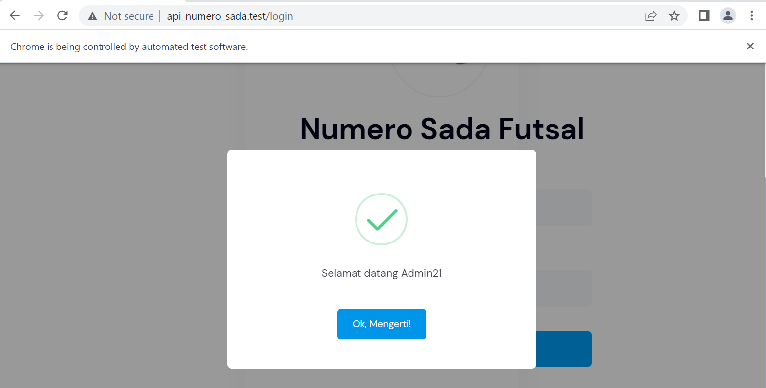

1. Fungsi Login 22

* The scenario



* The step definition

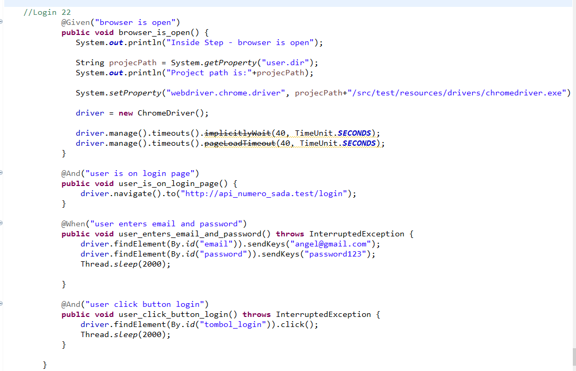

* The test runner



* The console after running

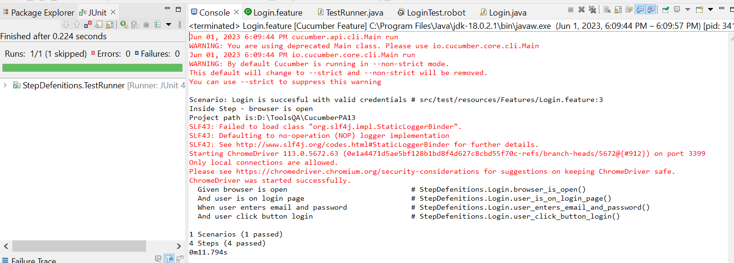

* The browser while testing

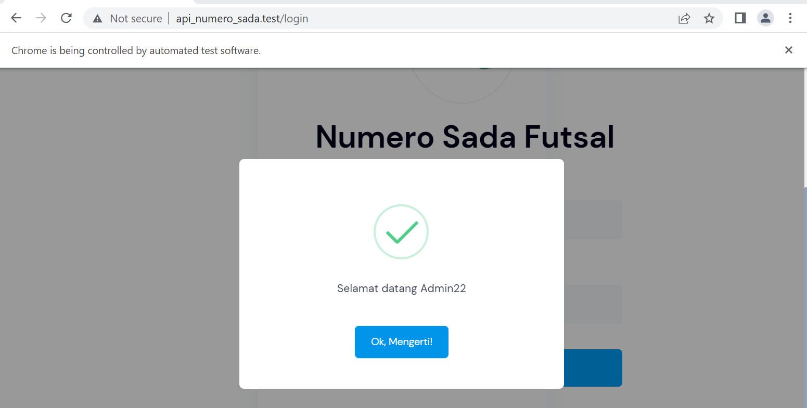

1. Fungsi Login 23

* The scenario



* The step definition

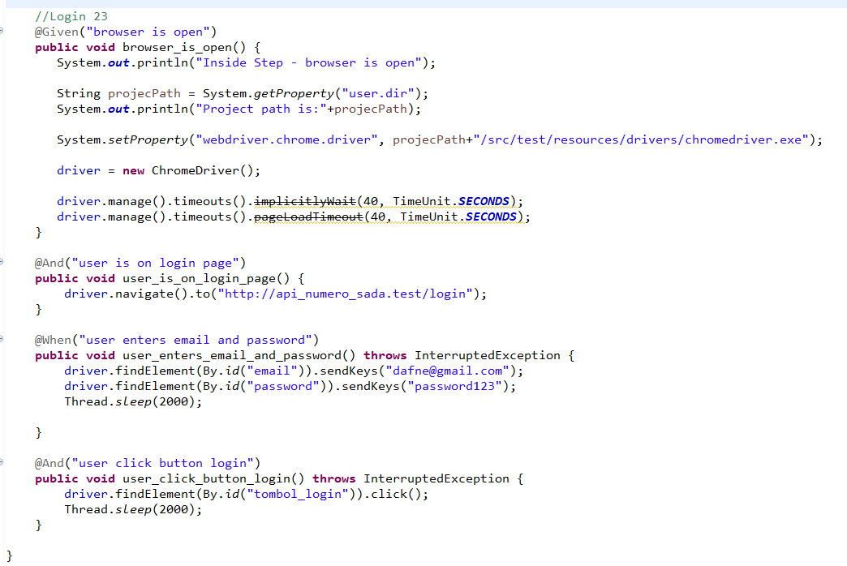

* The test runner



* The console after running

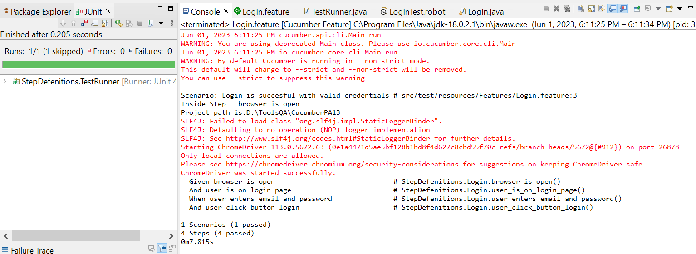

* The browser while testing

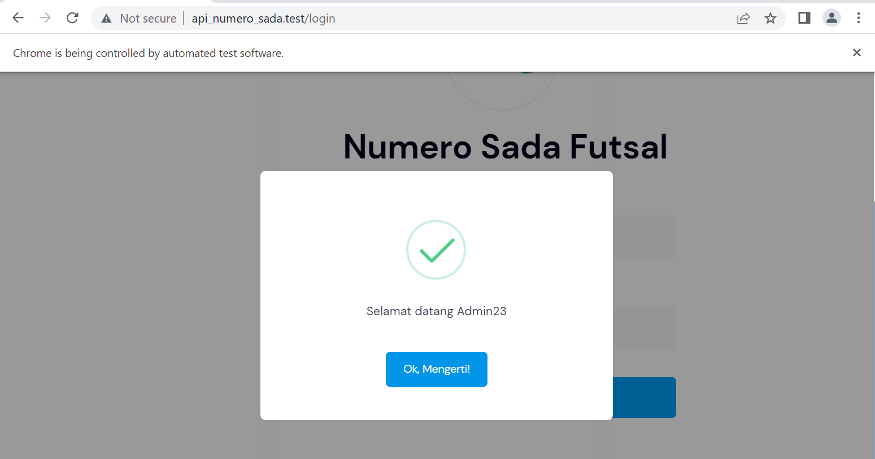

1. Fungsi Login 24

* The scenario



* The step definition

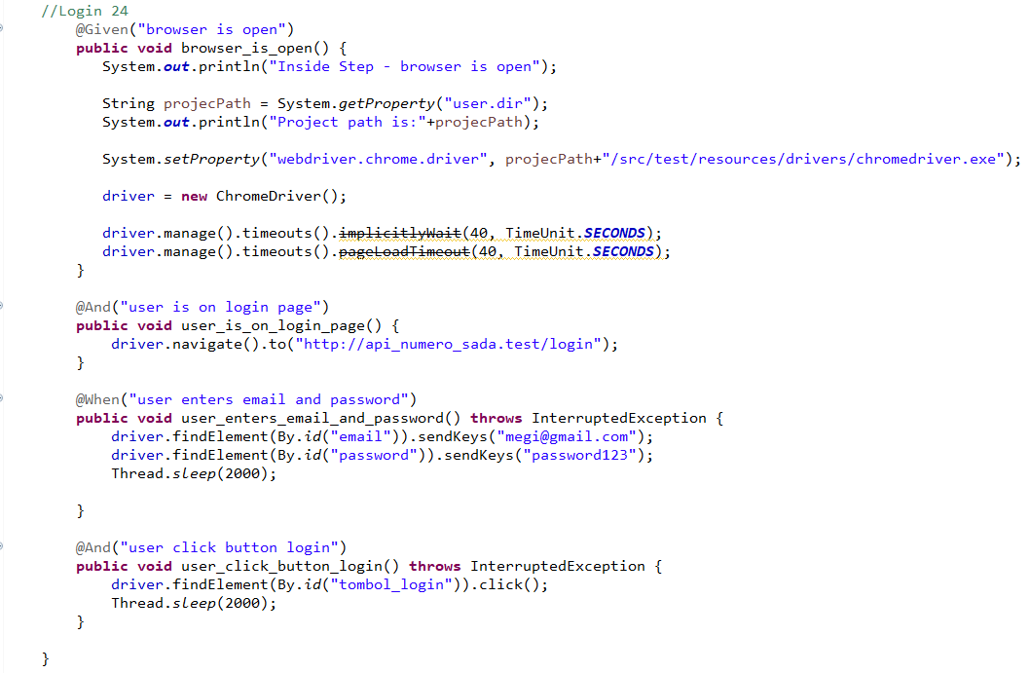

* The test runner



* The console after running

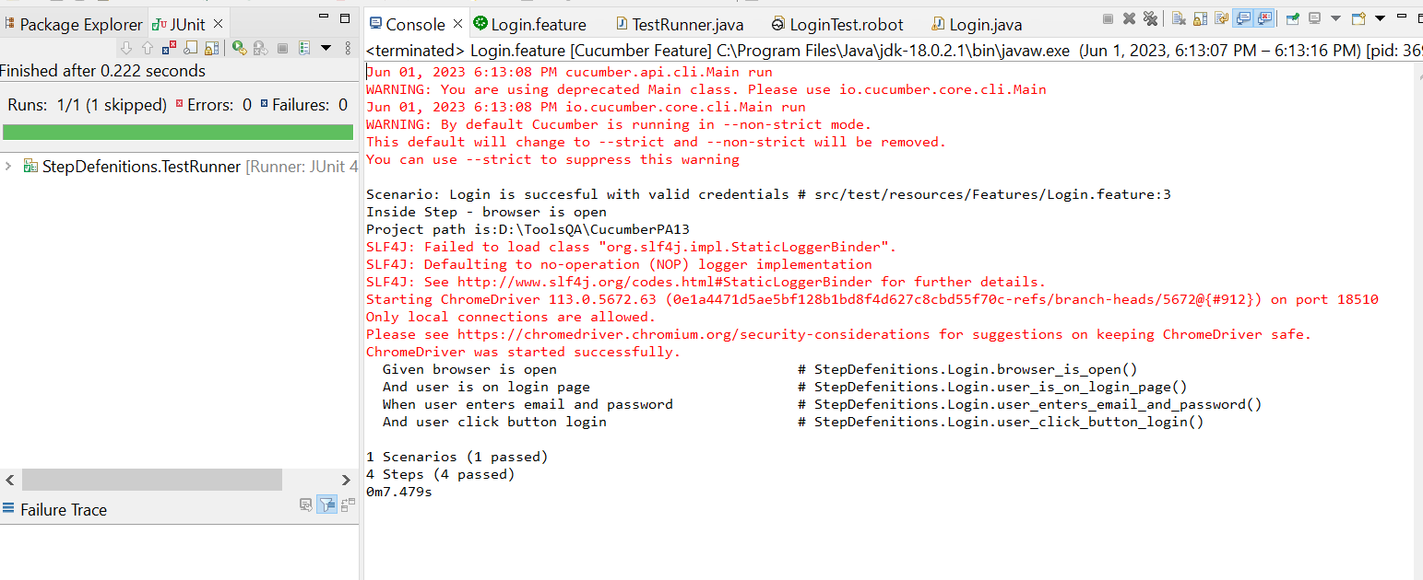

* The browser while testing

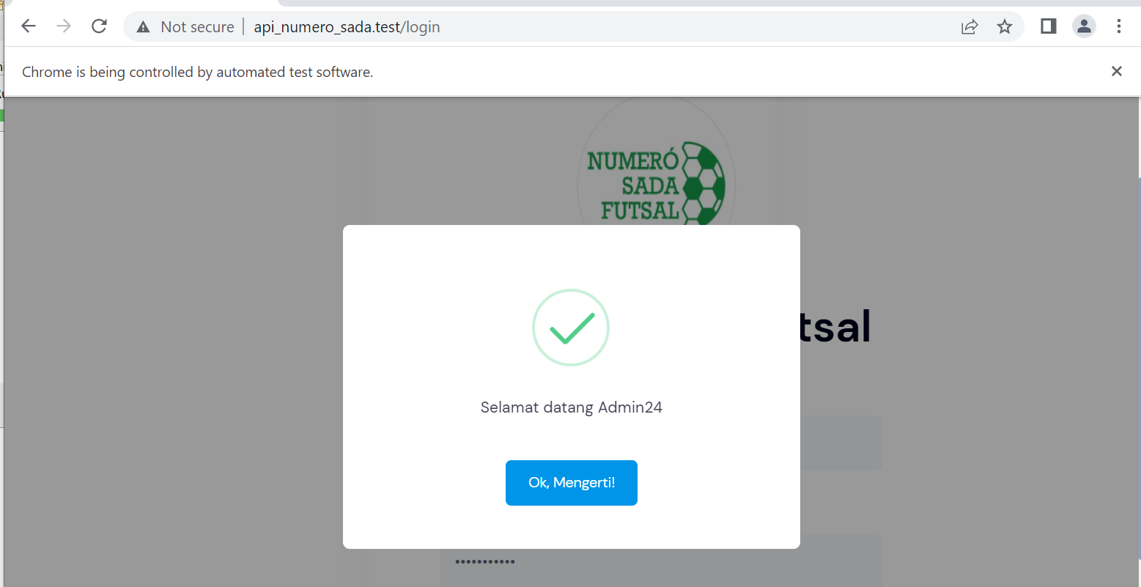

1. Fungsi Login 25

* The scenario



* The step definition

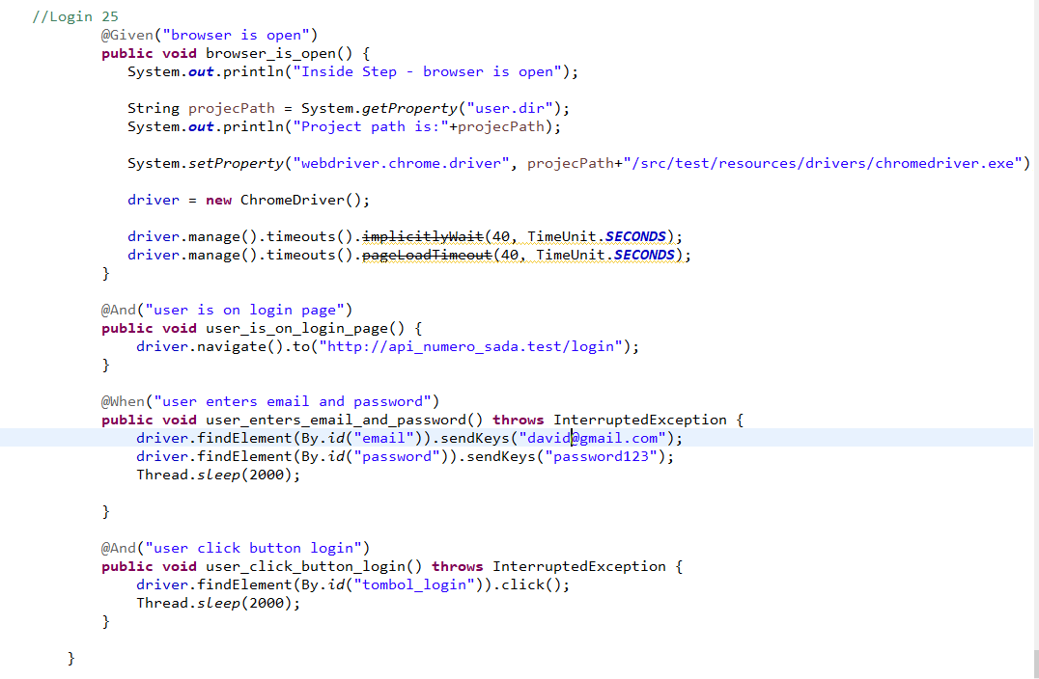

* The test runner



* The console after running

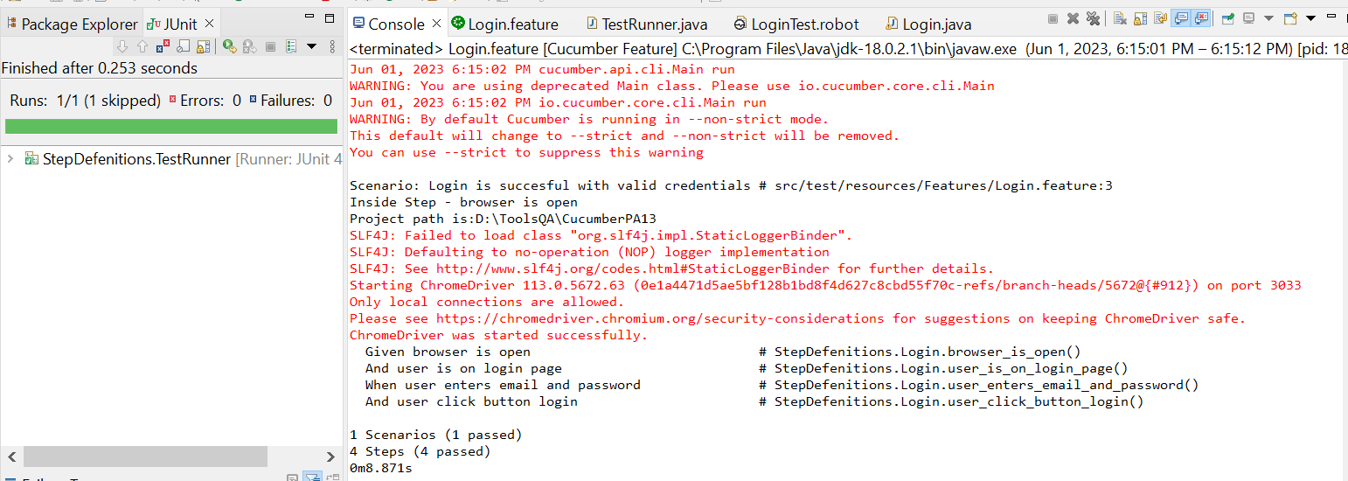

* The browser while testing

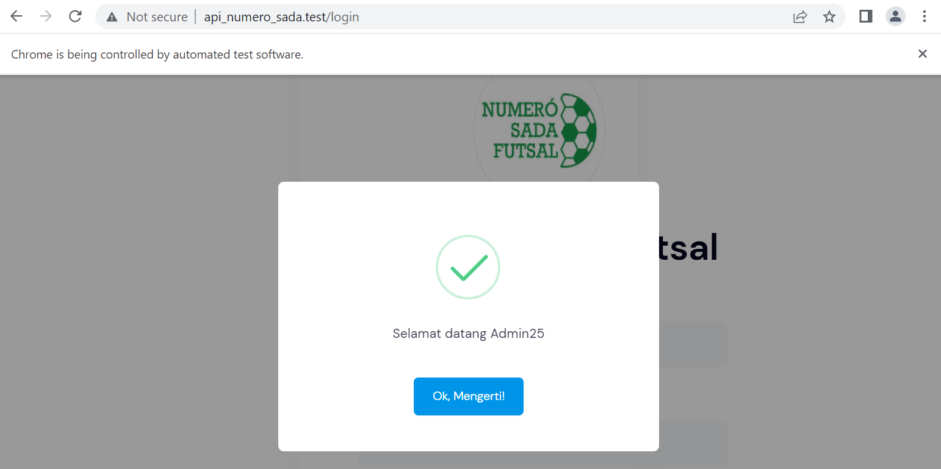

1. Fungsi Login 26

* The scenario



* The step definition

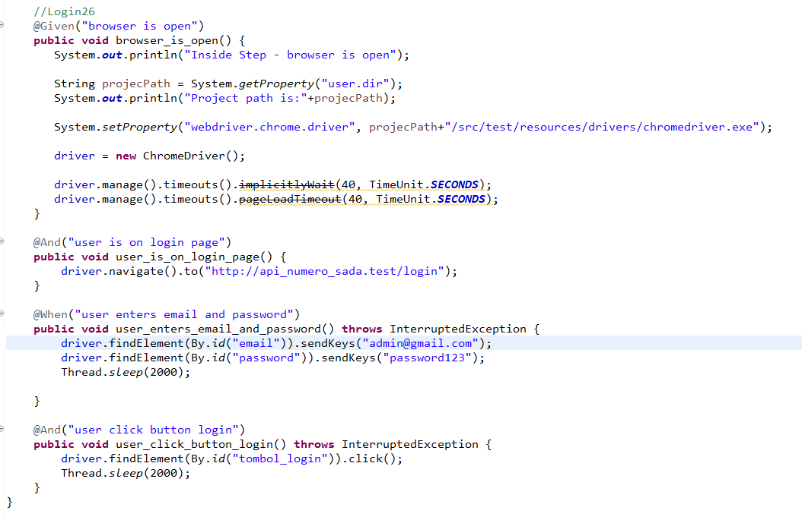

* The test runner



* The console after running

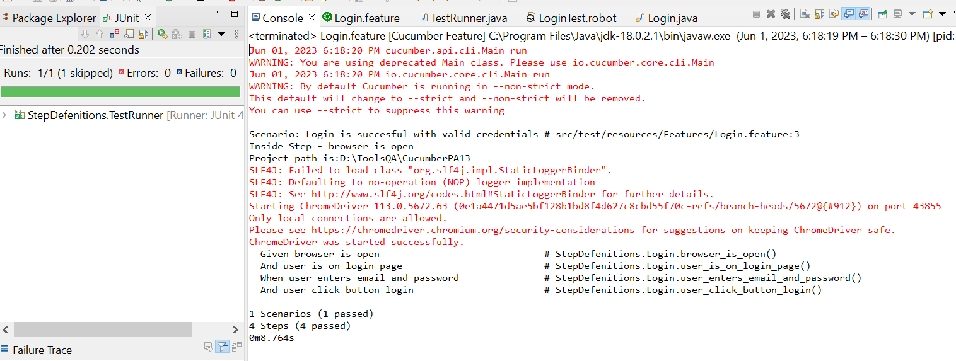

* The browser while testing

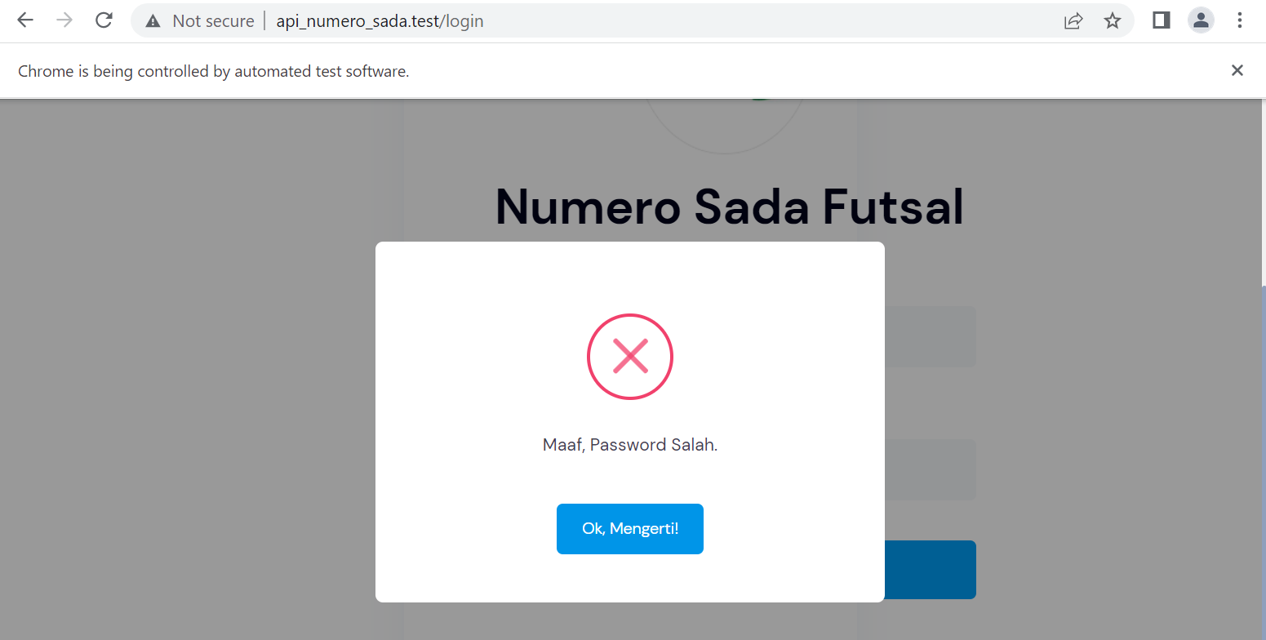

1. Fungsi Login 27

* The scenario



* The step definition
* The test runner



* The console after running

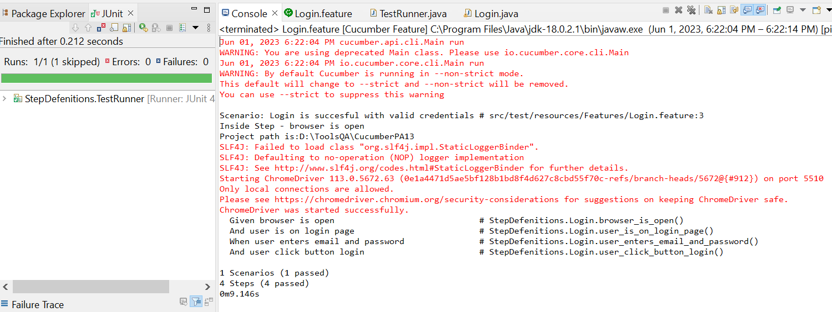

* The browser while testing

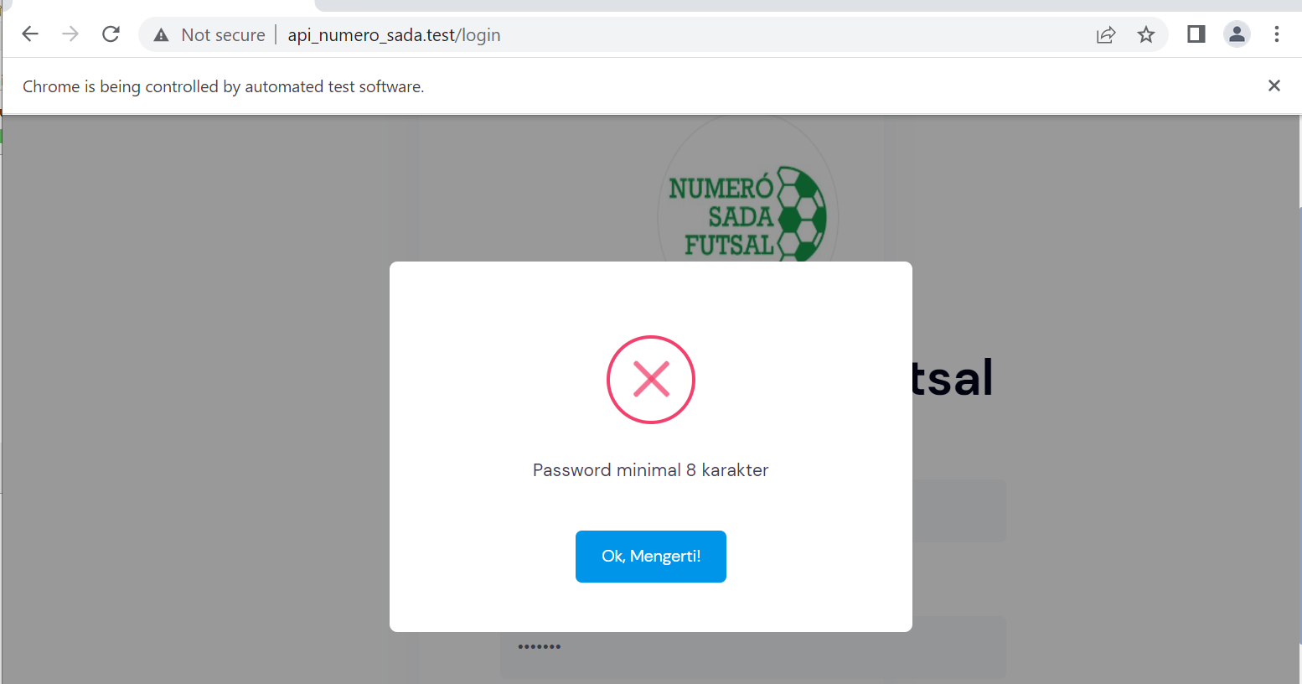

1. Fungsi Login 28

* The scenario



* The step definition

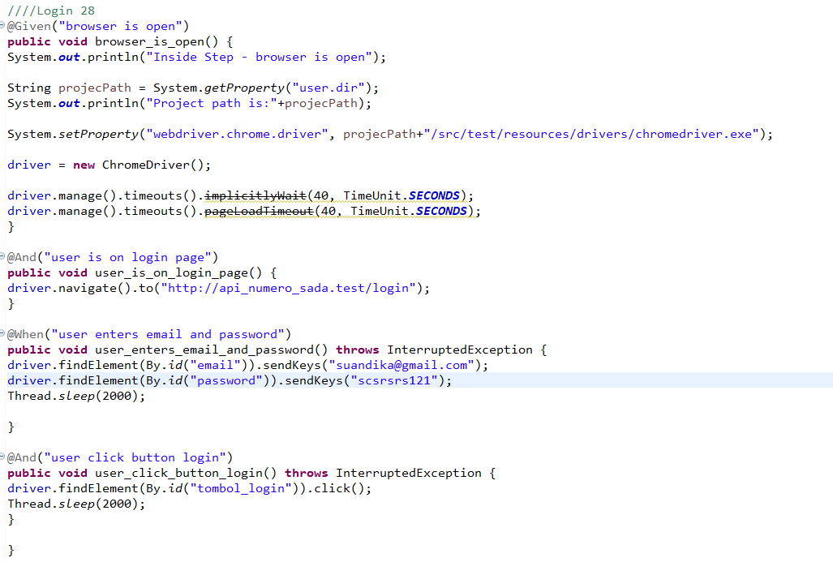

* The test runner



* The console after running

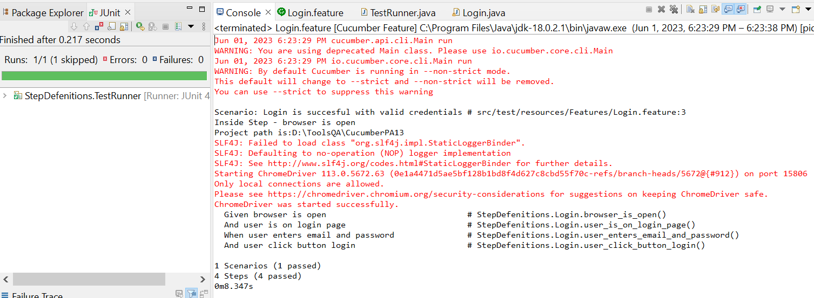

* The browser while testing



1. Fungsi Login 29

* The scenario



* The step definition

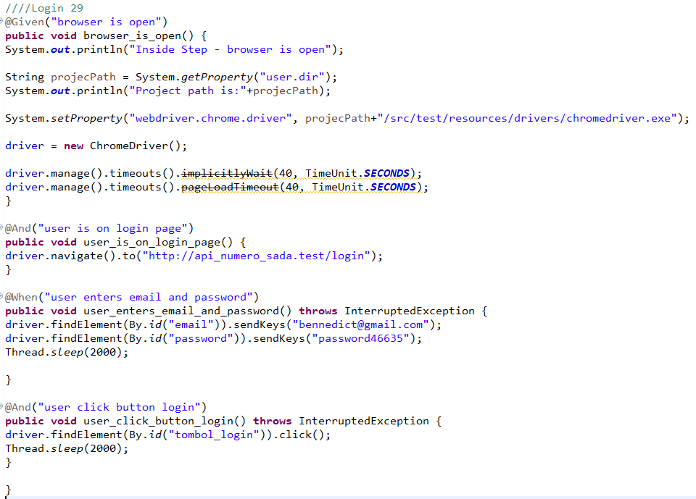

* The test runner



* The console after running

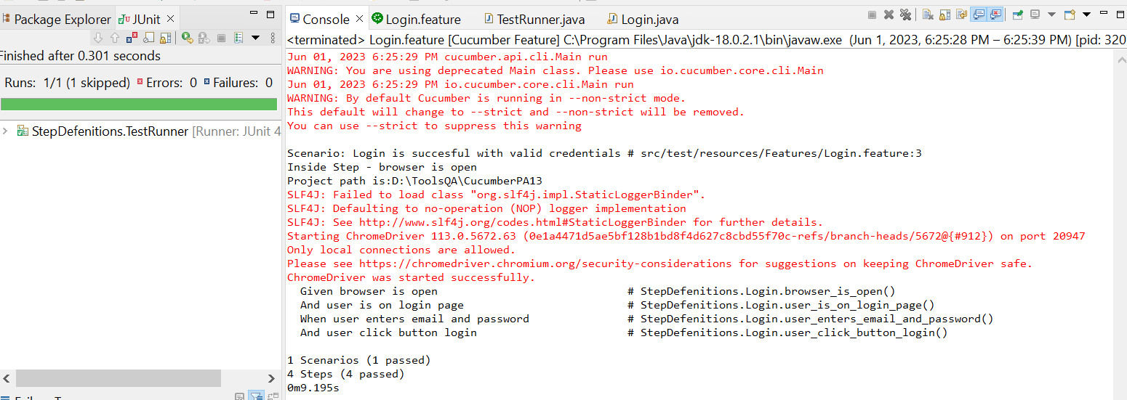

* The browser while testing



1. Fungsi Login 30

* The scenario



* The step definition

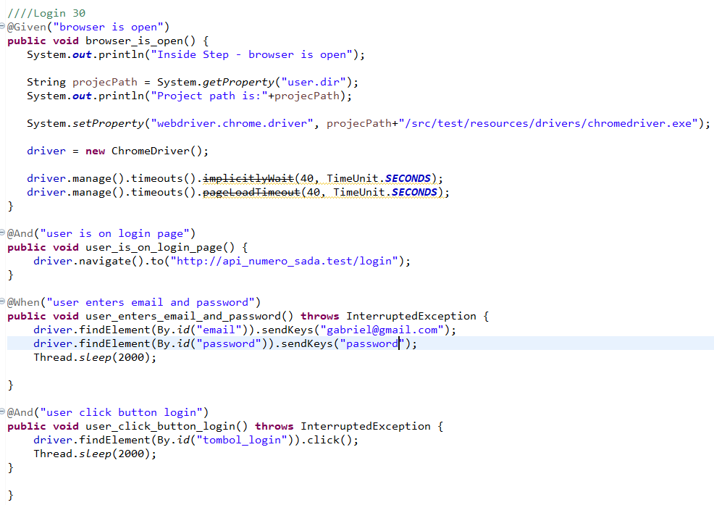

* The test runner



* The console after running

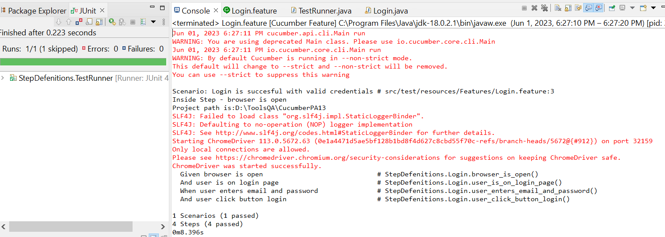

* The browser while testing



1. Fungsi Login 31

* The scenario



* The step definition

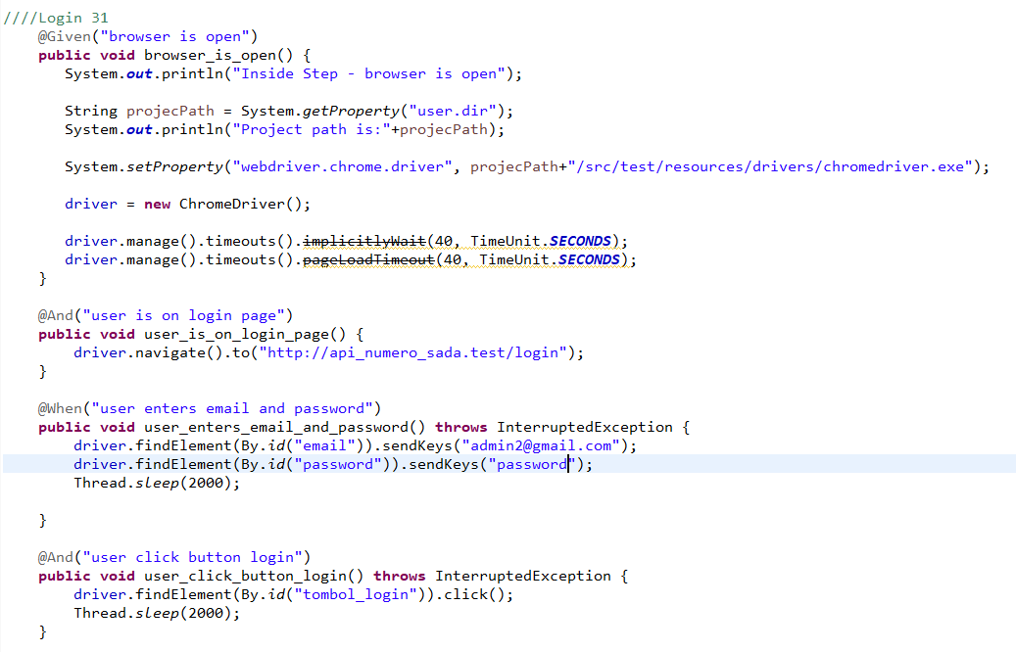

* The test runner



* The console after running

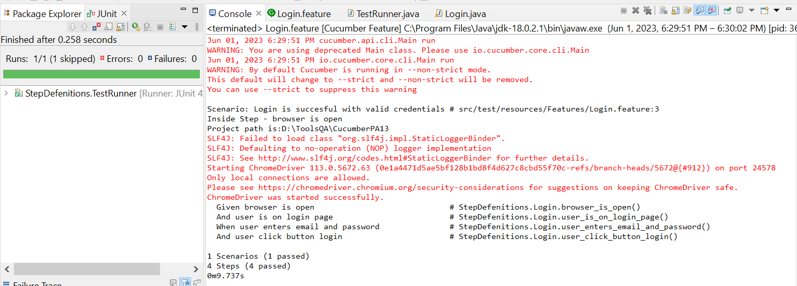

* The browser while testing



1. Fungsi Login 32

* The scenario



* The step definition

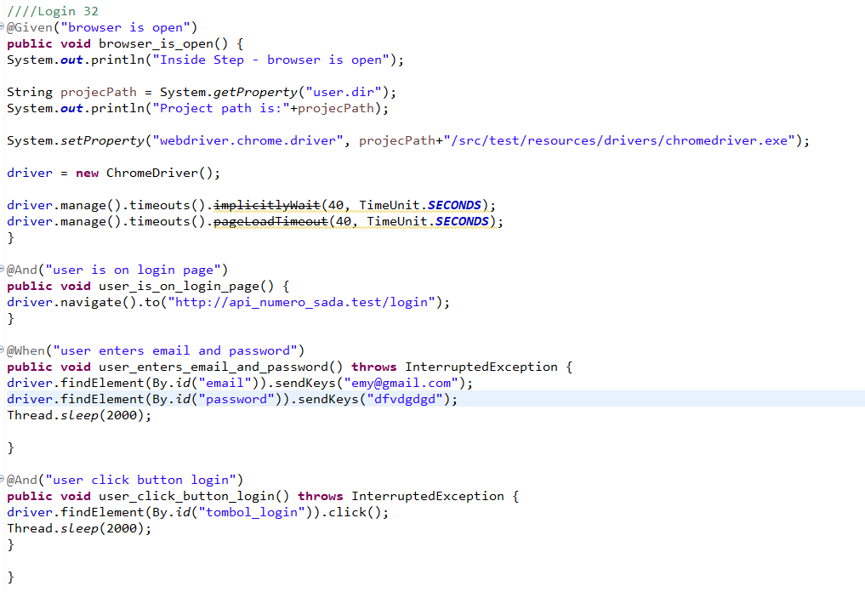

* The test runner



* The console after running

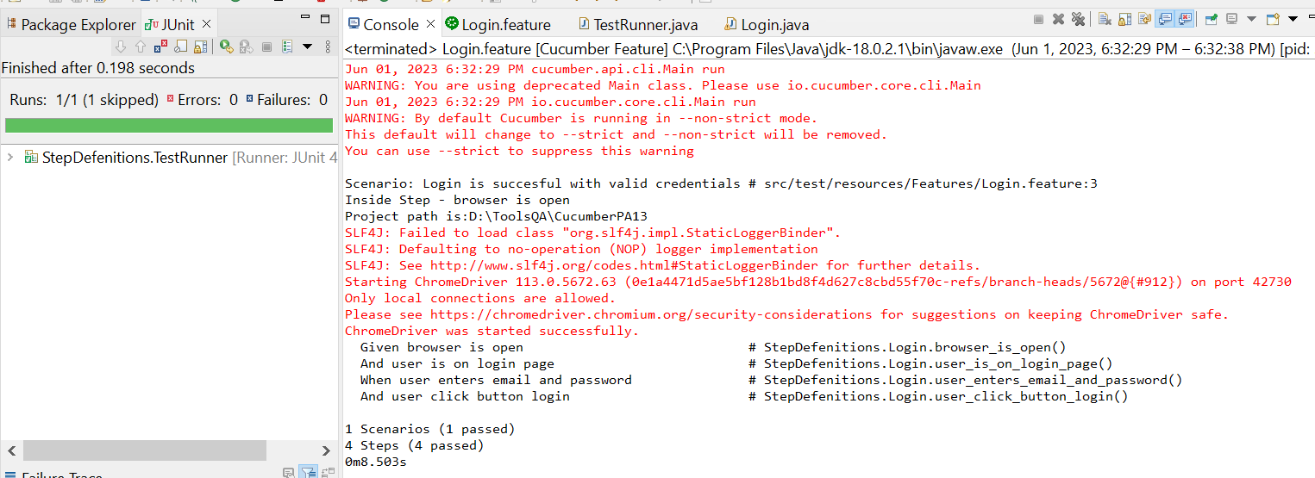

* The browser while testing



1. Fungsi Login 33

* The scenario



* The step definition

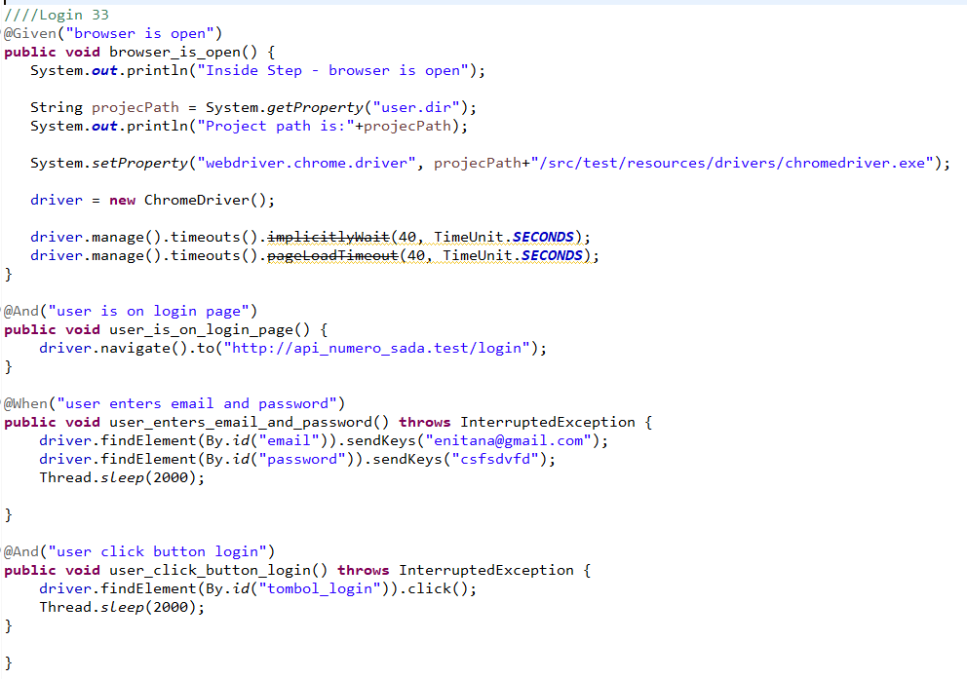

* The test runner



* The console after running

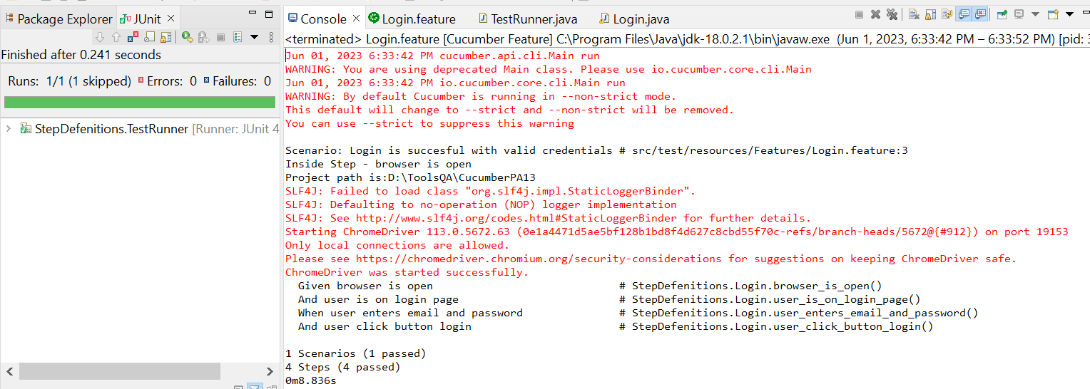

* The browser while testing



1. Fungsi Login 34

* The scenario



* The step definition

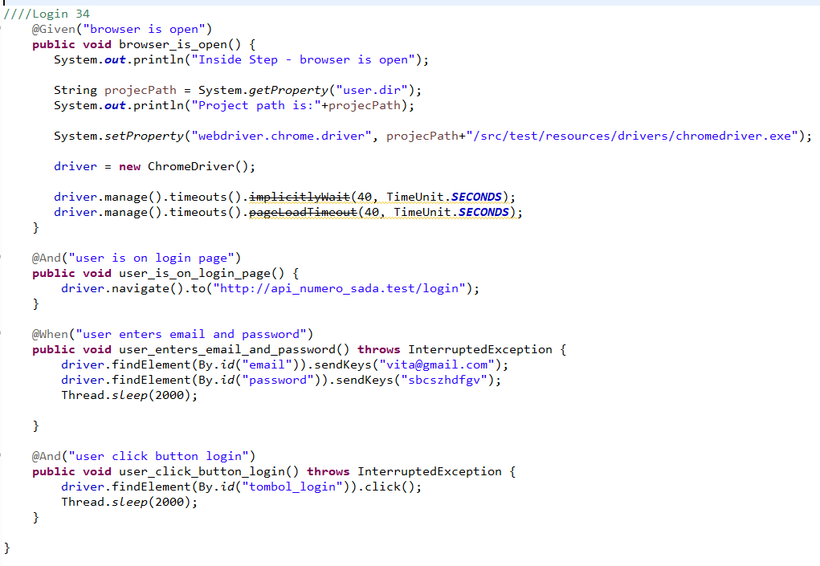

* The test runner



* The console after running

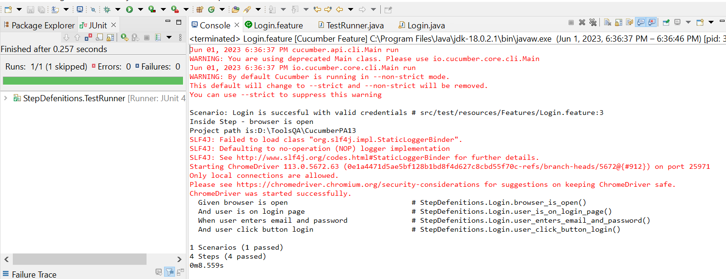

* The browser while testing



1. Fungsi Login 35

* The scenario



* The step definition

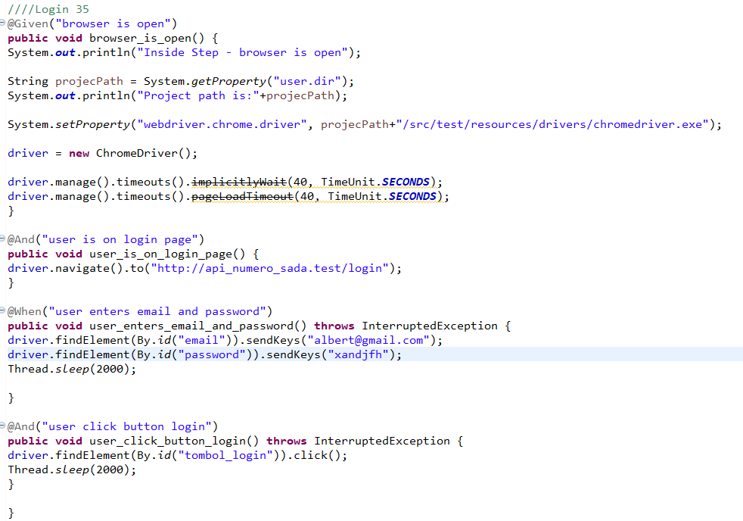

* The test runner



* The console after running

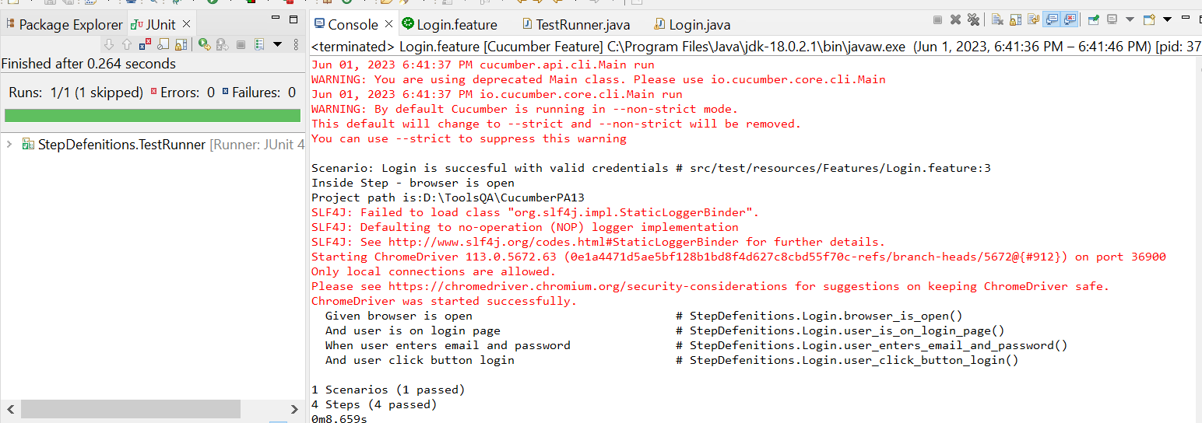

* The browser while testing

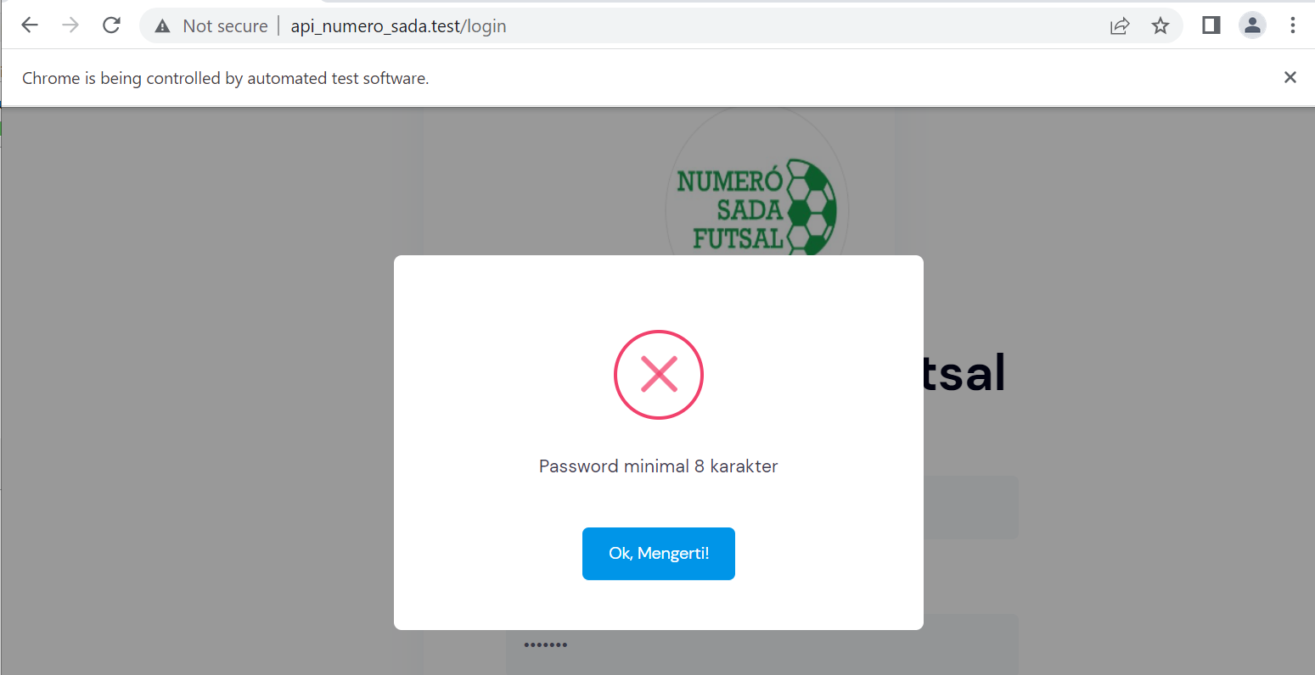

1. Fungsi Login 36

* The scenario



* The step definition

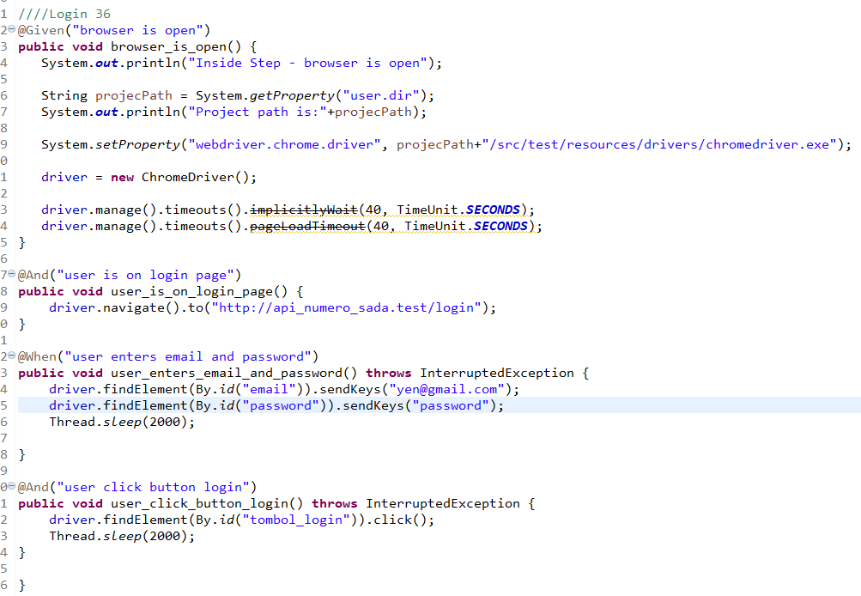

* The test runner



* The console after running

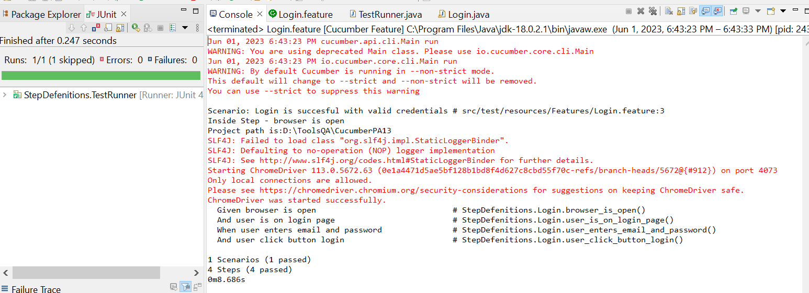

* The browser while testing



1. Fungsi Login 37

* The scenario



* The step definition

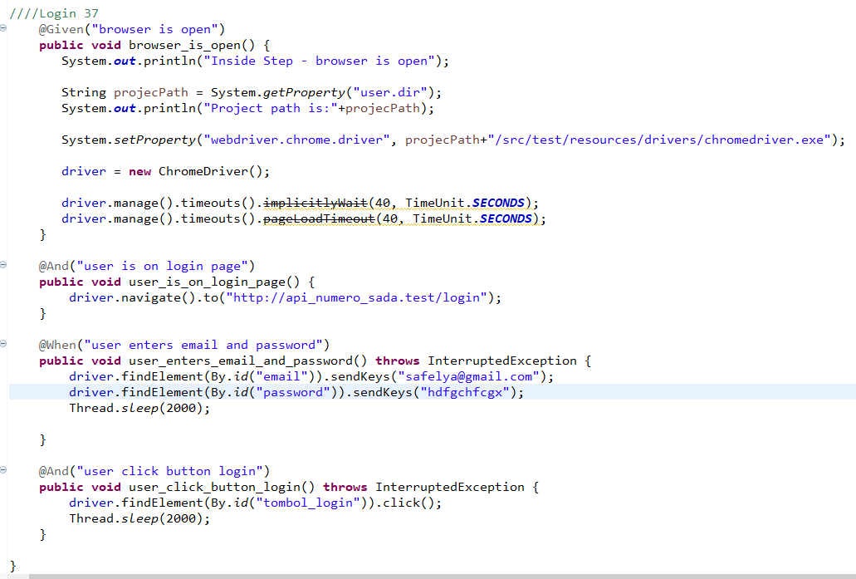

* The test runner



* The console after running

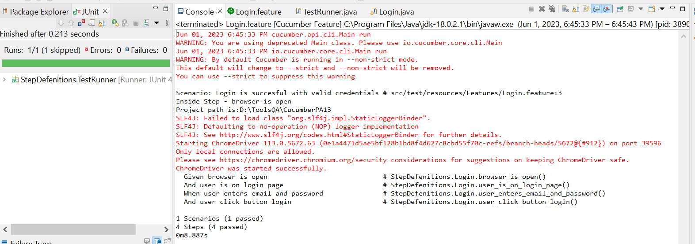

* The browser while testing



1. Fungsi Login 38

* The scenario



* The step definition

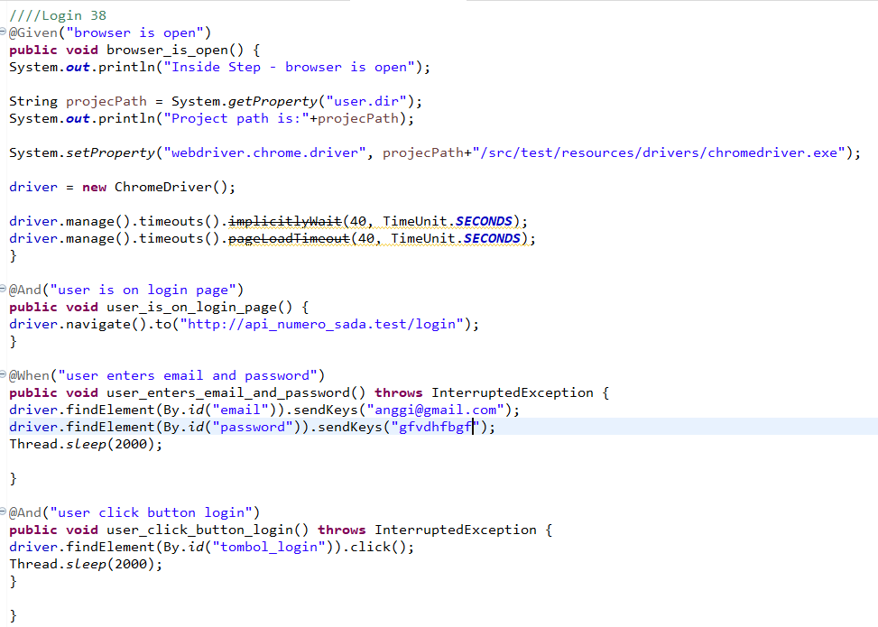

* The test runner



* The console after running

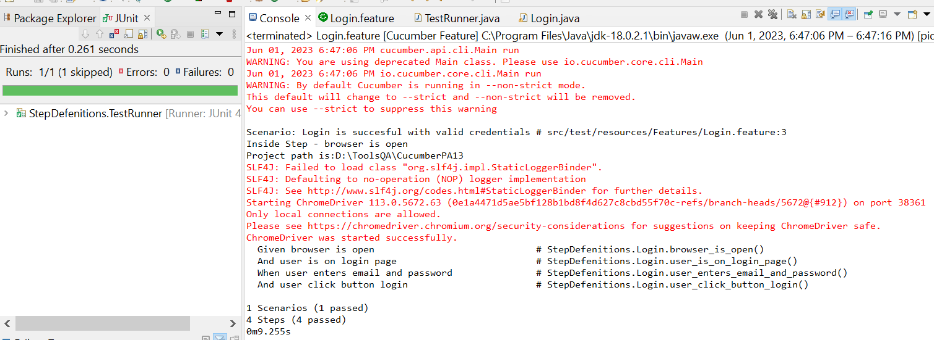

* The browser while testing



1. Fungsi Login 39

* The scenario



* The step definition

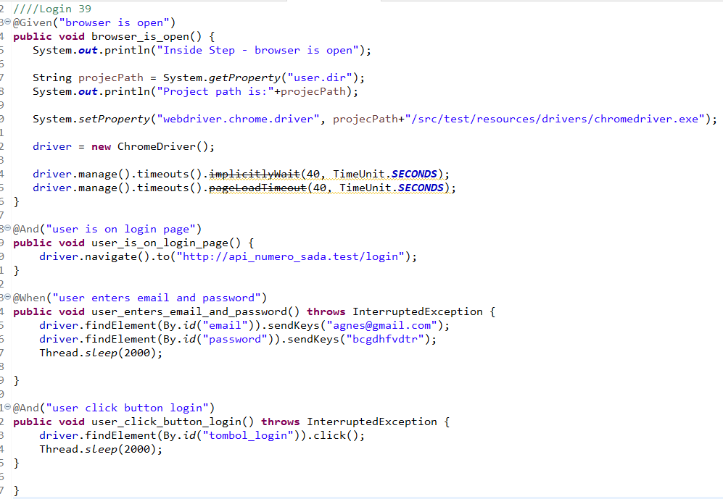

* The test runner



* The console after running

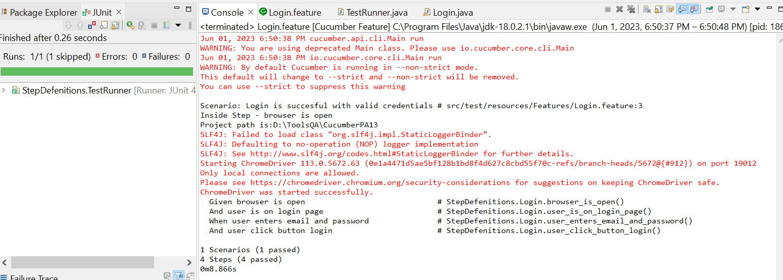

* The browser while testing



1. Fungsi Login 40

* The scenario



* The step definition

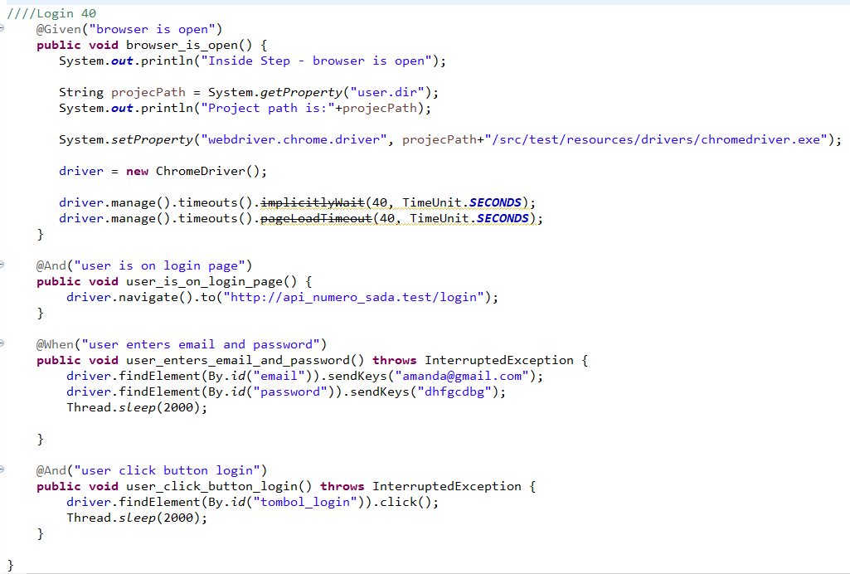

* The test runner



* The console after running

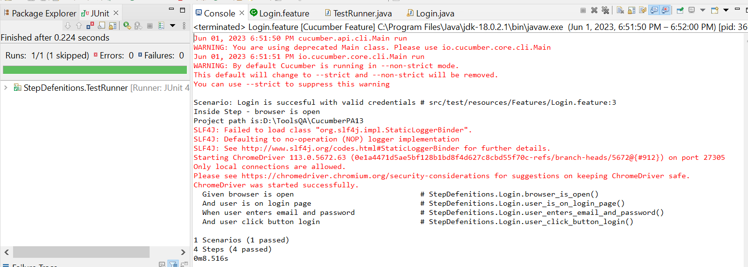

* The browser while testing



1. Fungsi Login 41

* The scenario



* The step definition

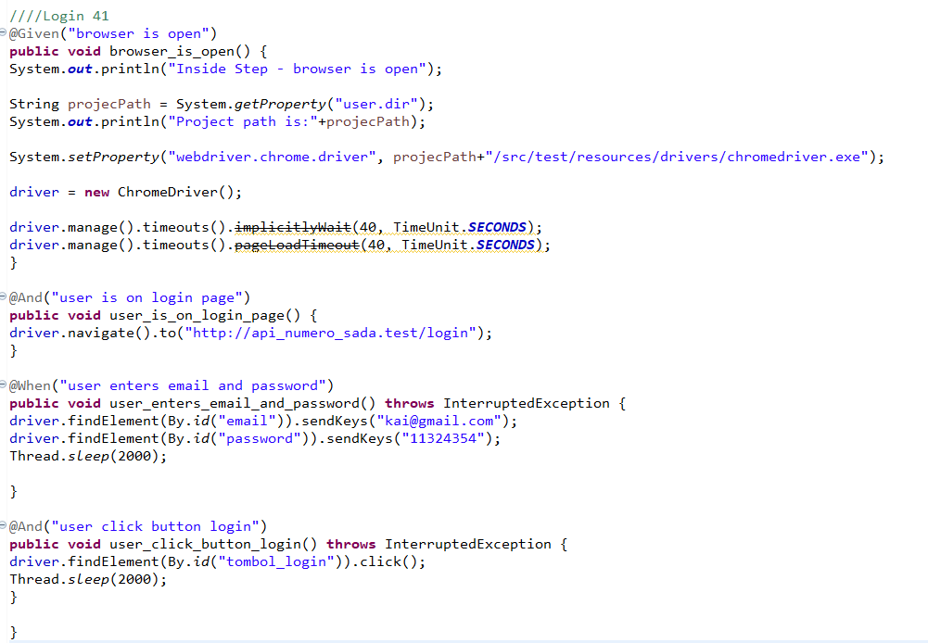

* The test runner



* The console after running

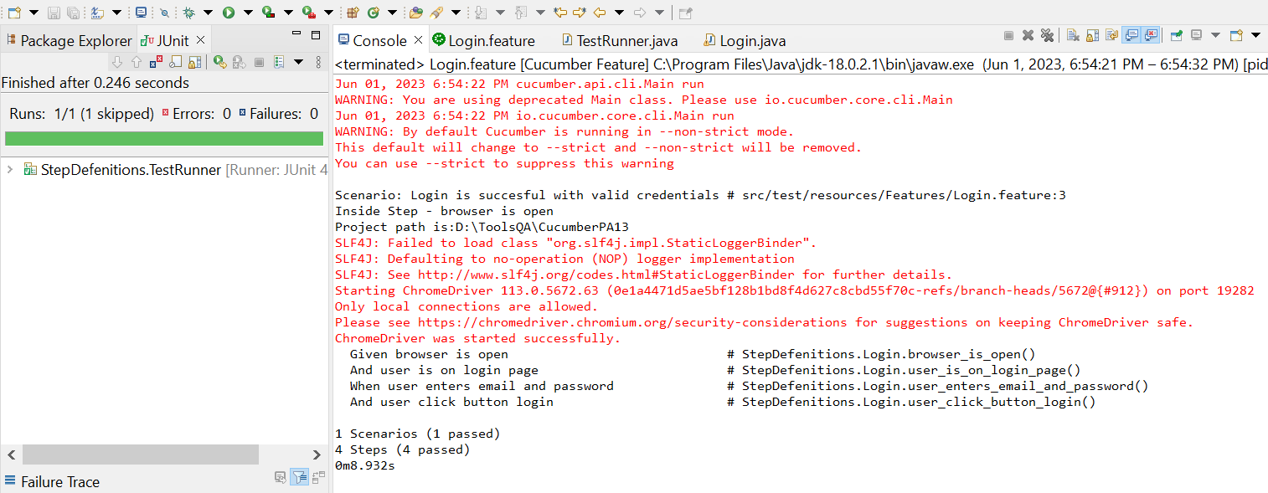

* The browser while testing



1. Fungsi Login 42

* The scenario



* The step definition

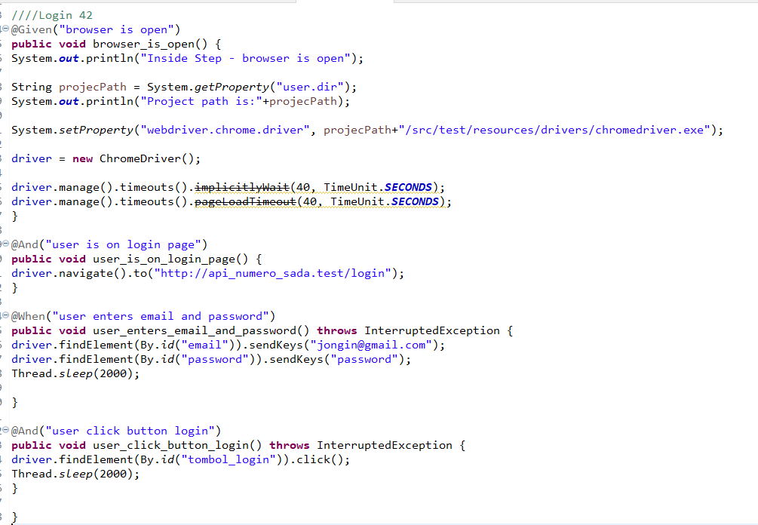

* The test runner



* The console after running

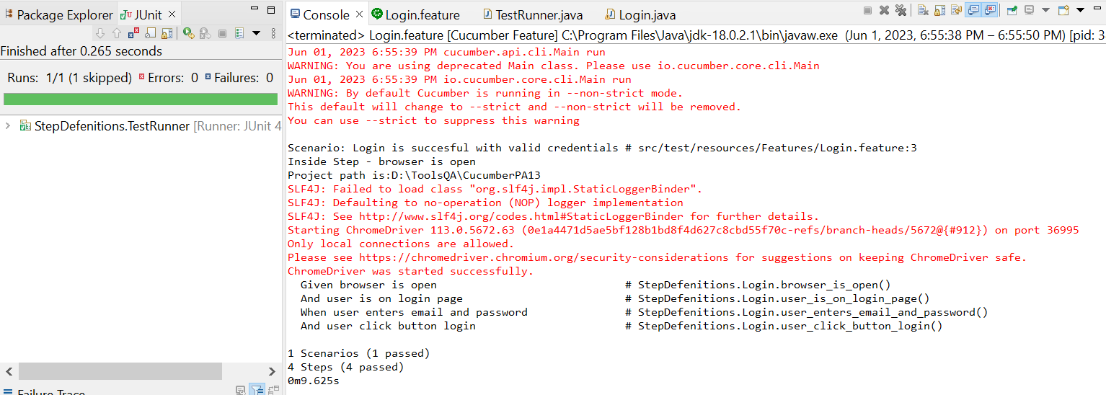

* The browser while testing



1. Fungsi Login 43

* The scenario



* The step definition

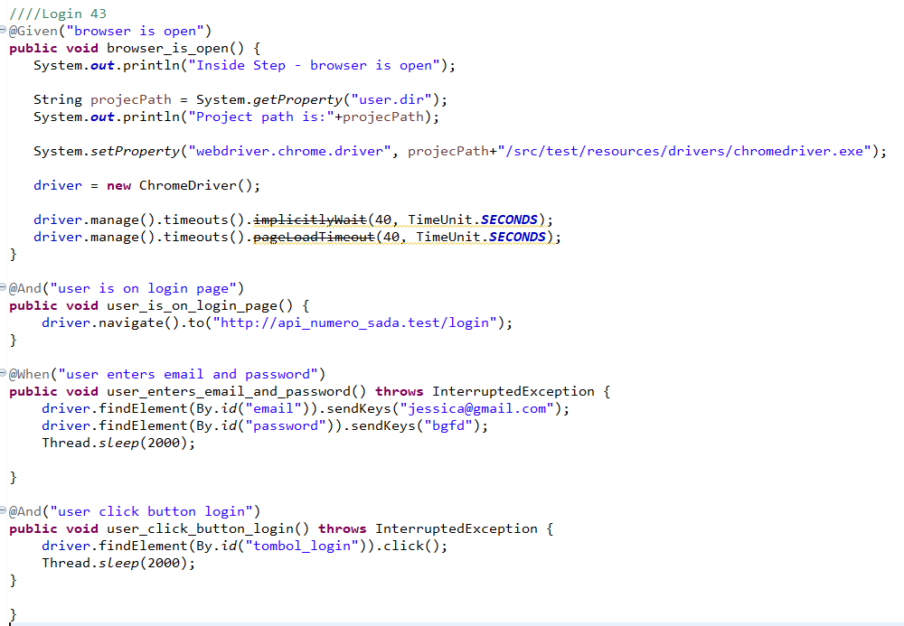

* The test runner



* The console after running

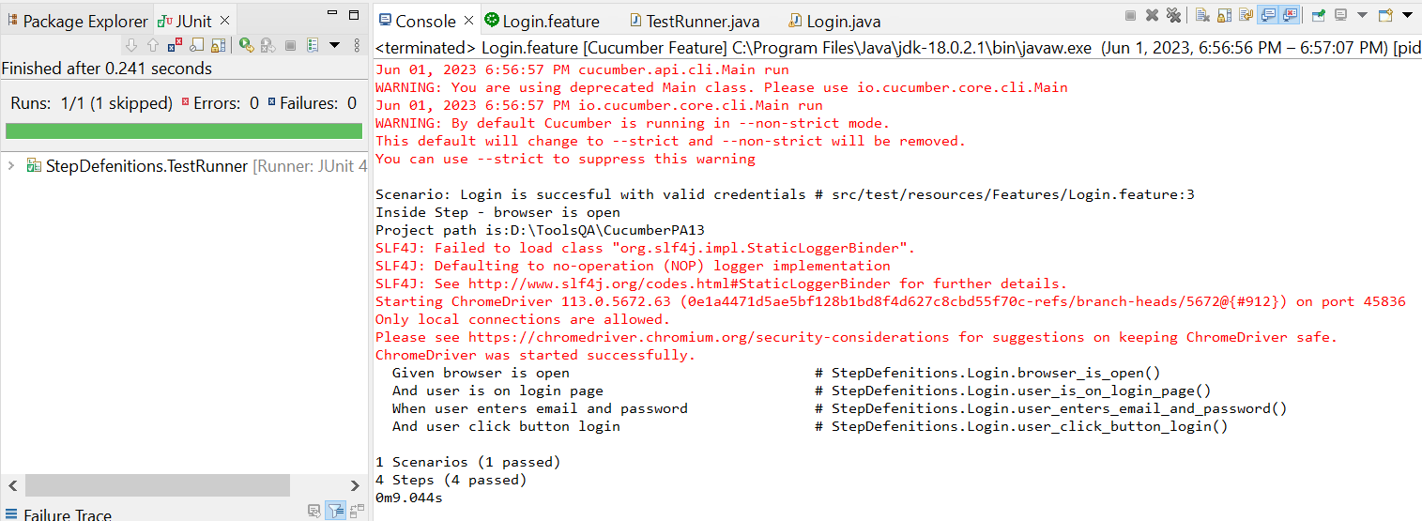

* The browser while testing

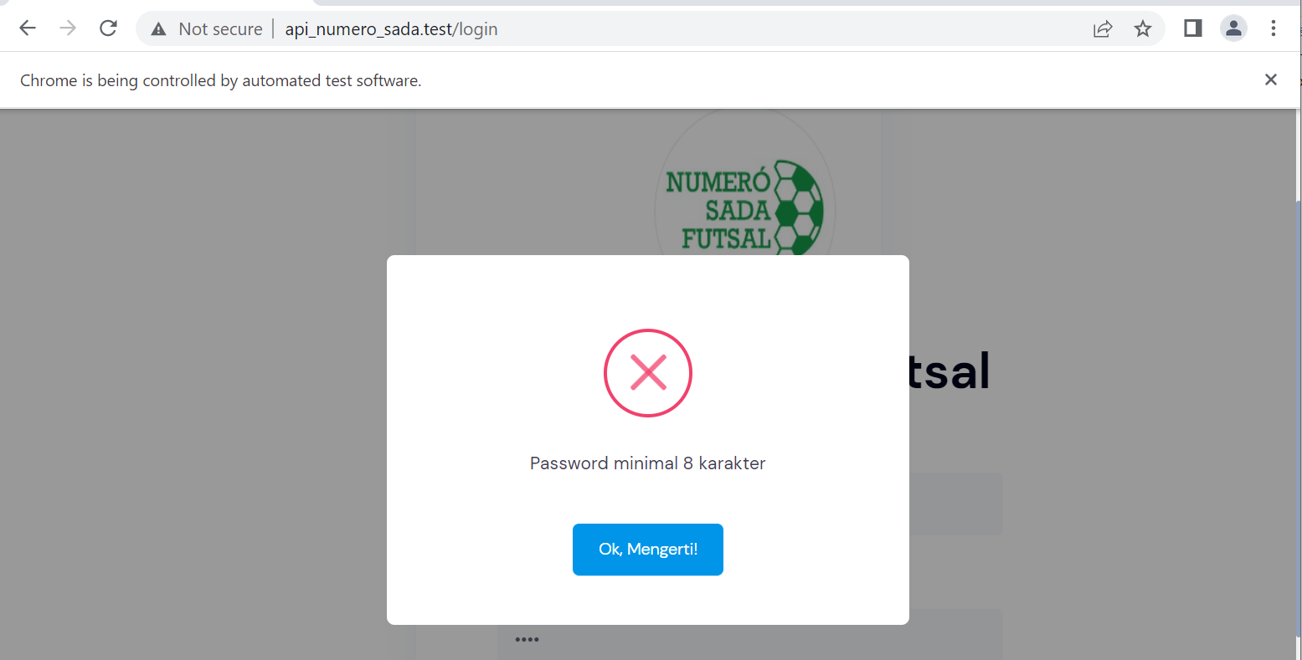

1. Fungsi Login 44

* The scenario



* The step definition

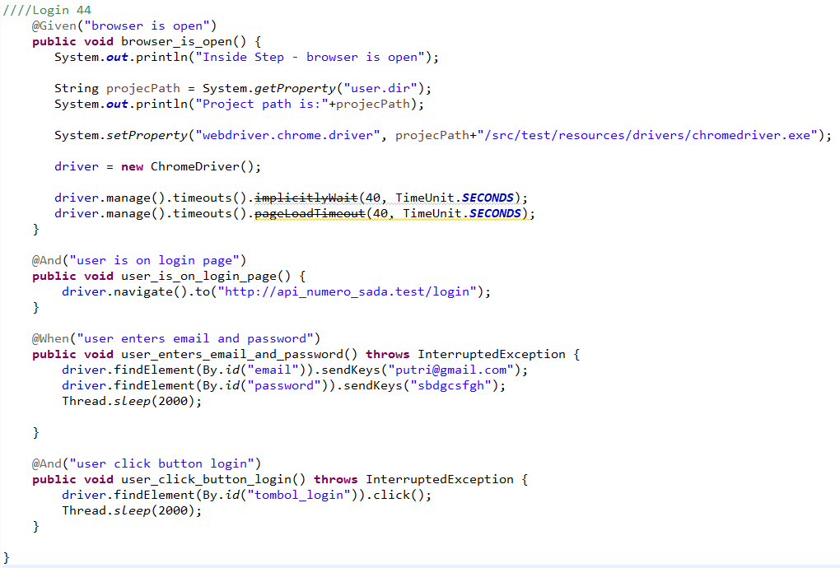

* The test runner



* The console after running

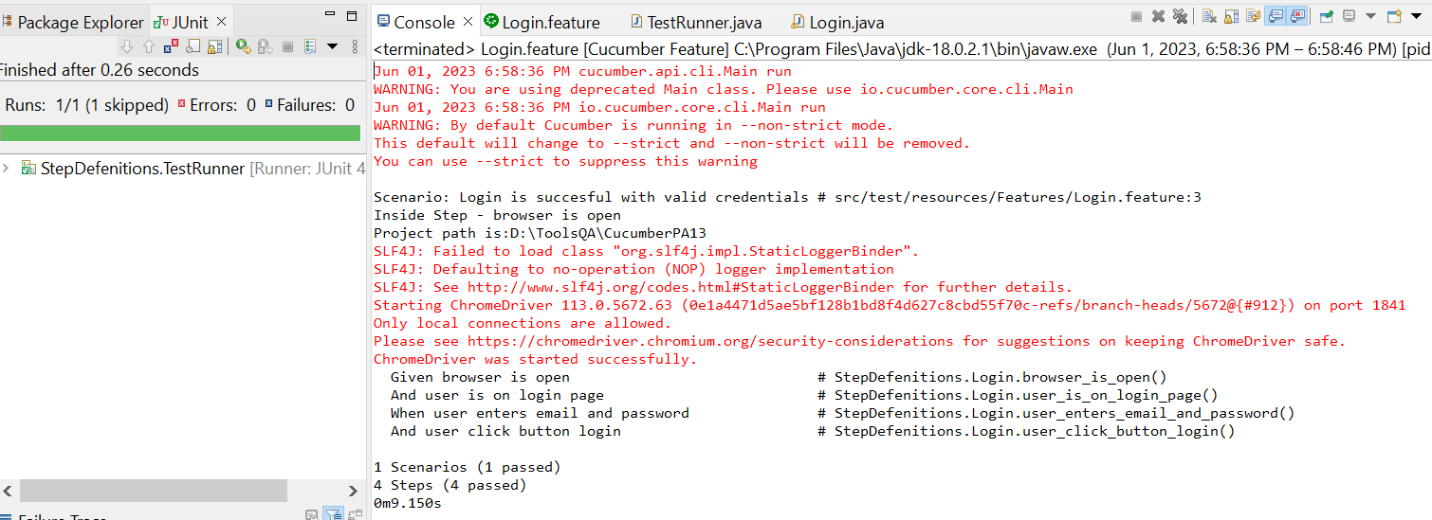

* The browser while testing



1. Fungsi Login 45

* The scenario



* The step definition

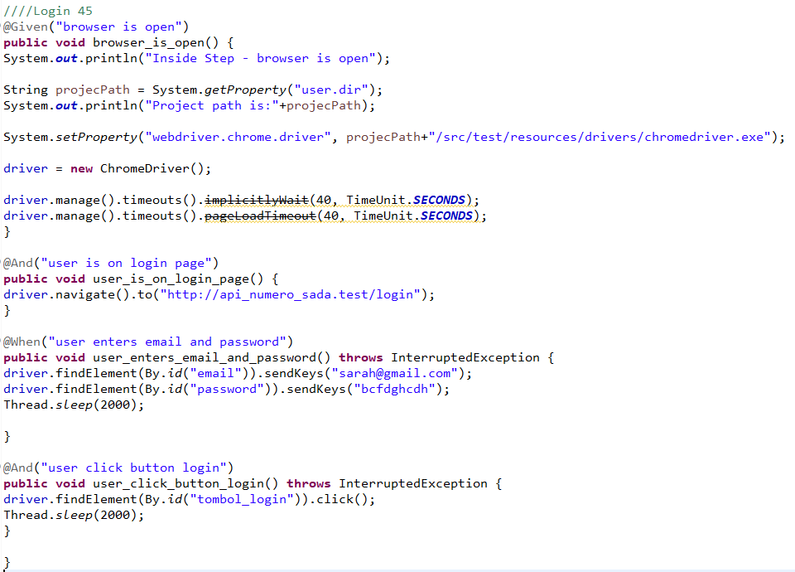

* The test runner



* The console after running

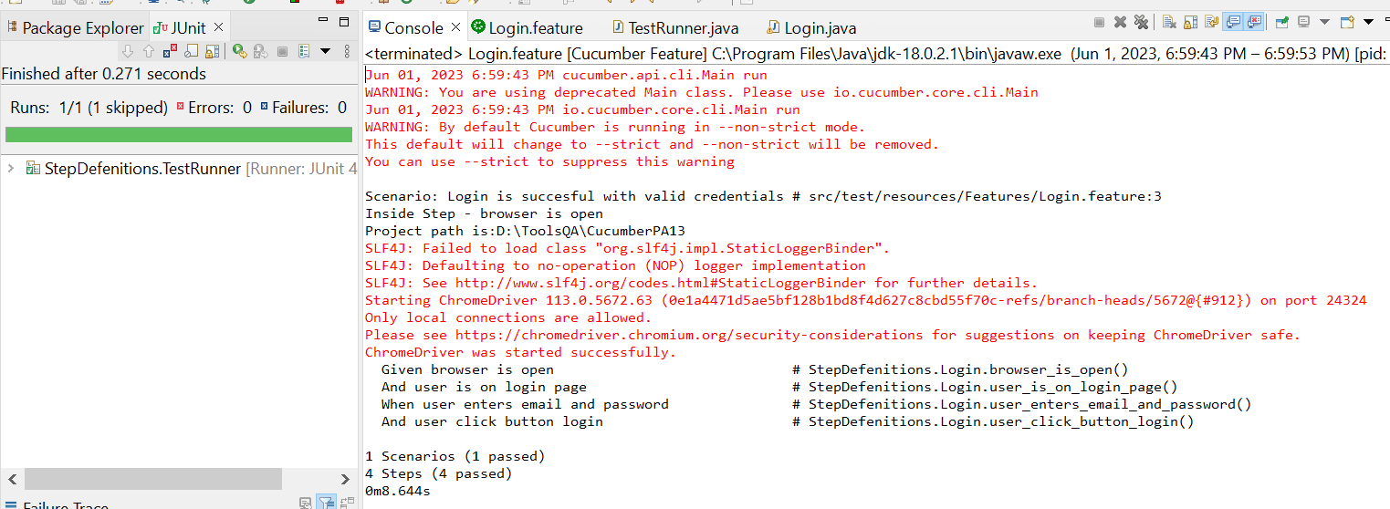

* The browser while testing



1. Fungsi Login 46

* The scenario



* The step definition

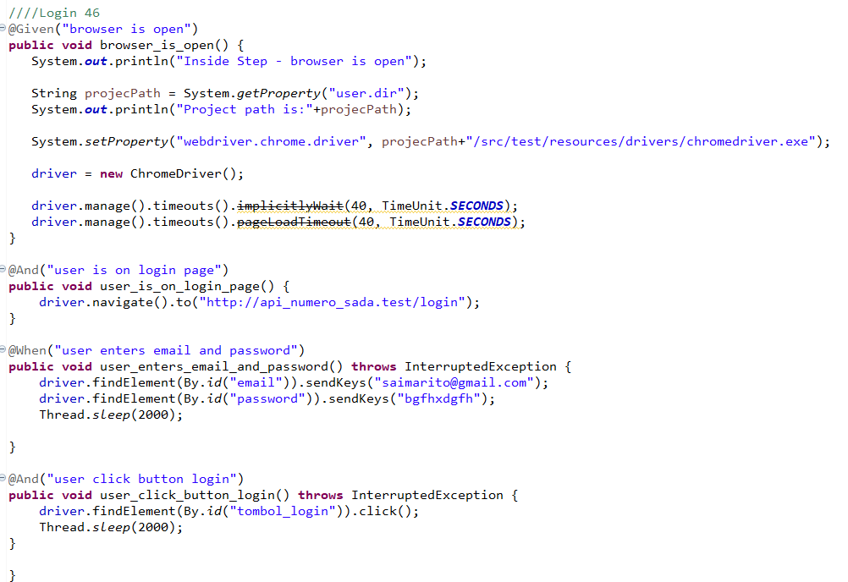

* The test runner



* The console after running

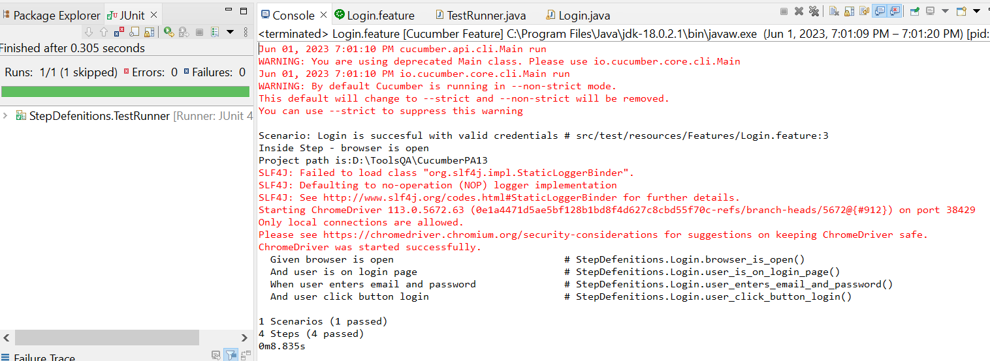

* The browser while testing



1. Fungsi Login 47

* The scenario



* The step definition

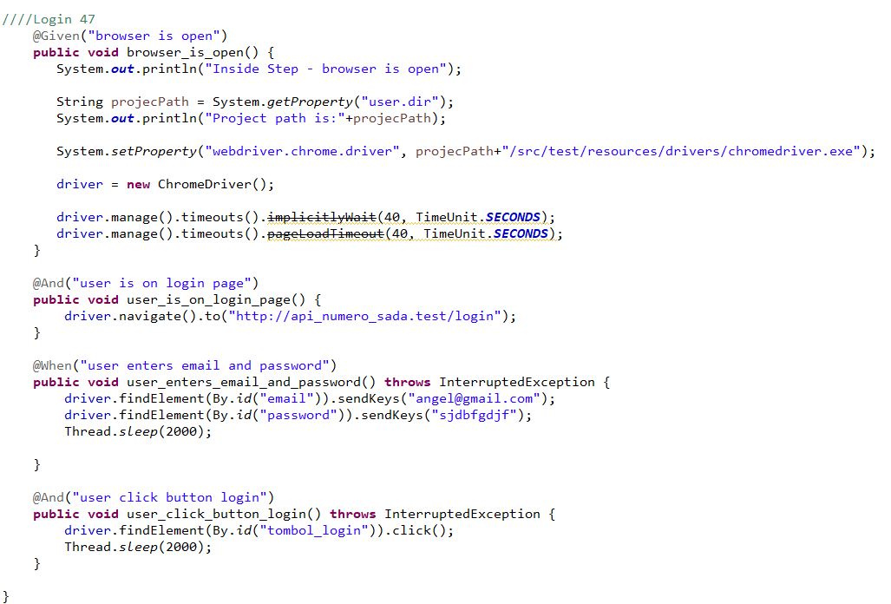

* The test runner



* The console after running

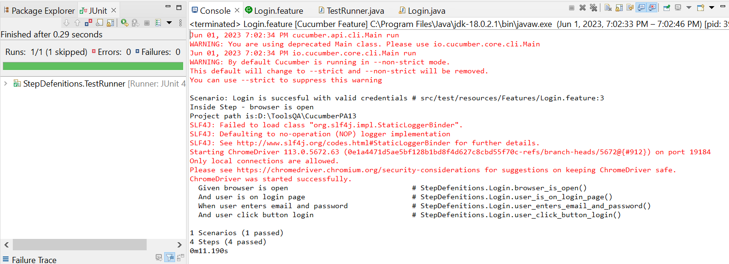

* The browser while testing



1. Fungsi Login 48

* The scenario



* The step definition

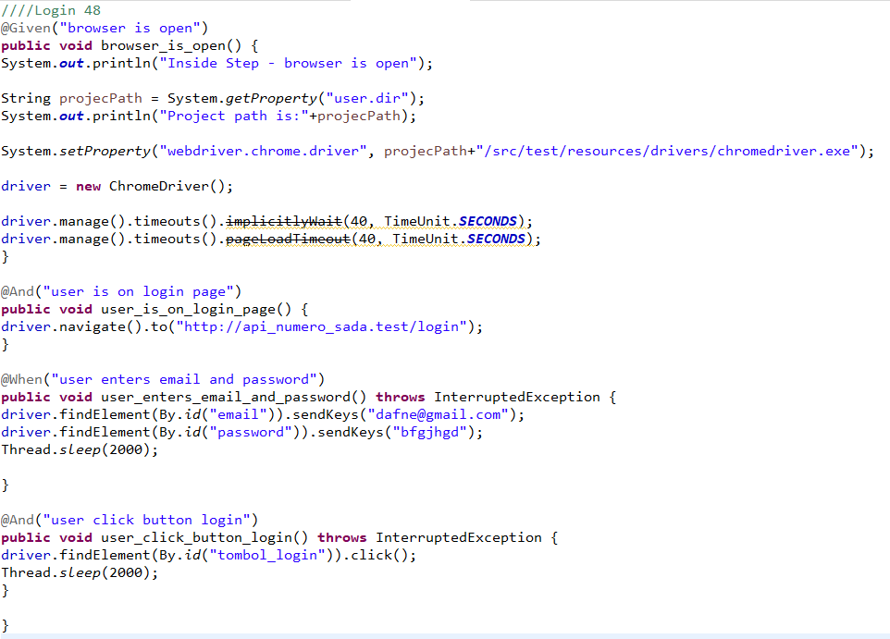

* The test runner



* The console after running



* The browser while testing



1. Fungsi Login 49

* The scenario



* The step definition

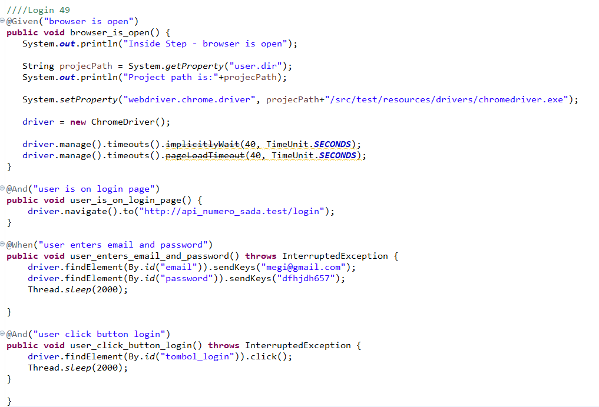

* The test runner



* The console after running



* The browser while testing



1. Fungsi Login 50

* The scenario



* The step definition

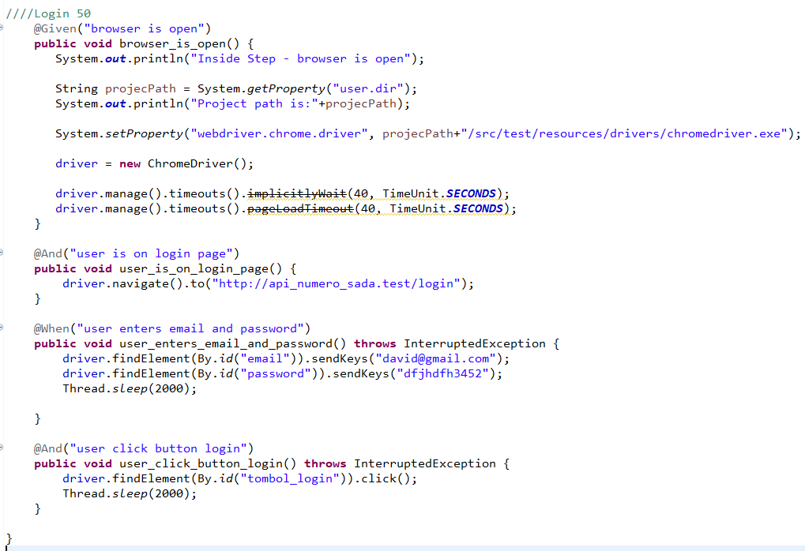

* The test runner



* The console after running



* The browser while testing



1. Fungsi Login 51

* The scenario



* The step definition

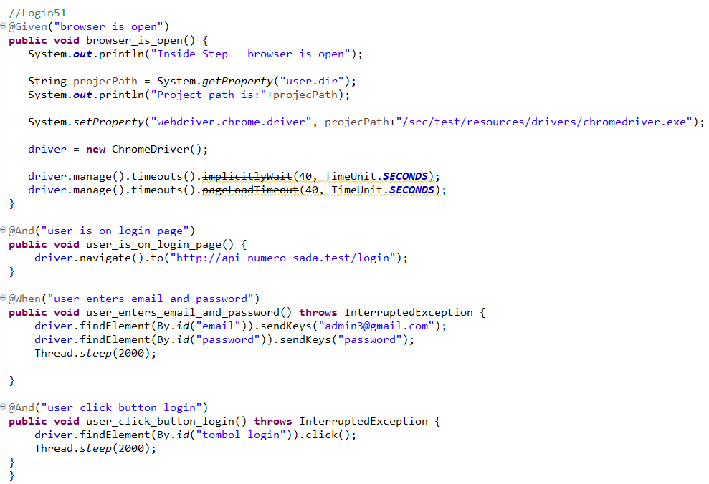

* The test runner



* The console after running

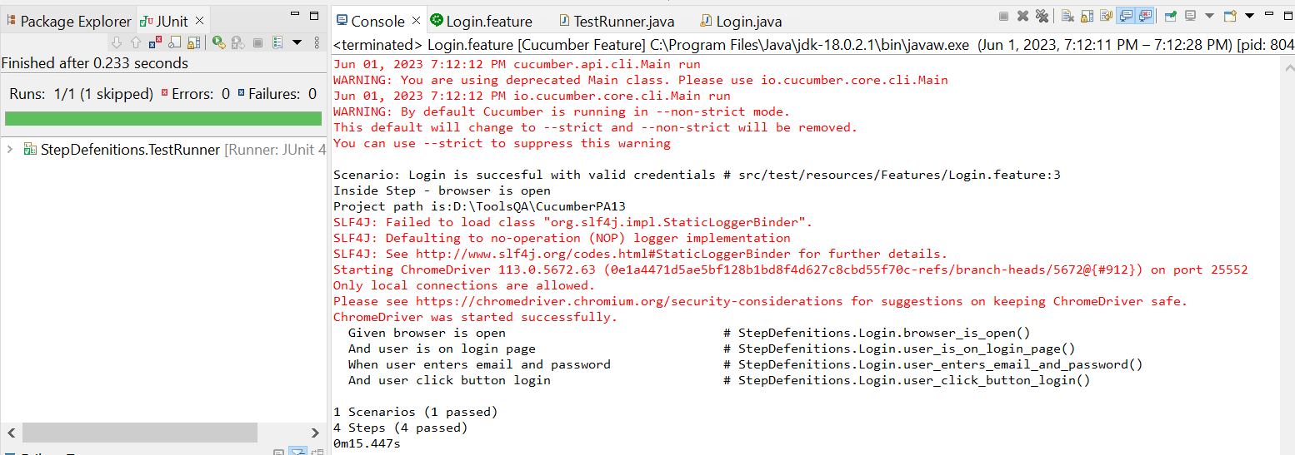

* The browser while testing

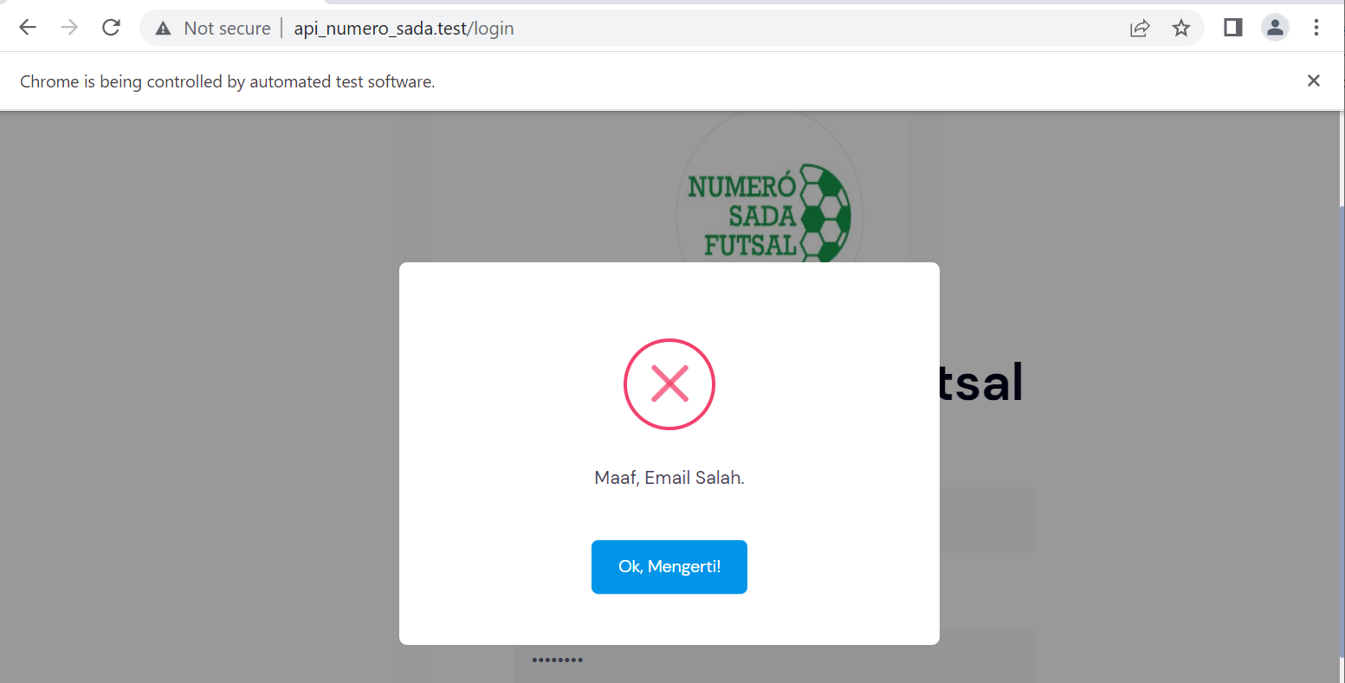

1. Fungsi Login 52

* The scenario



* The step definition

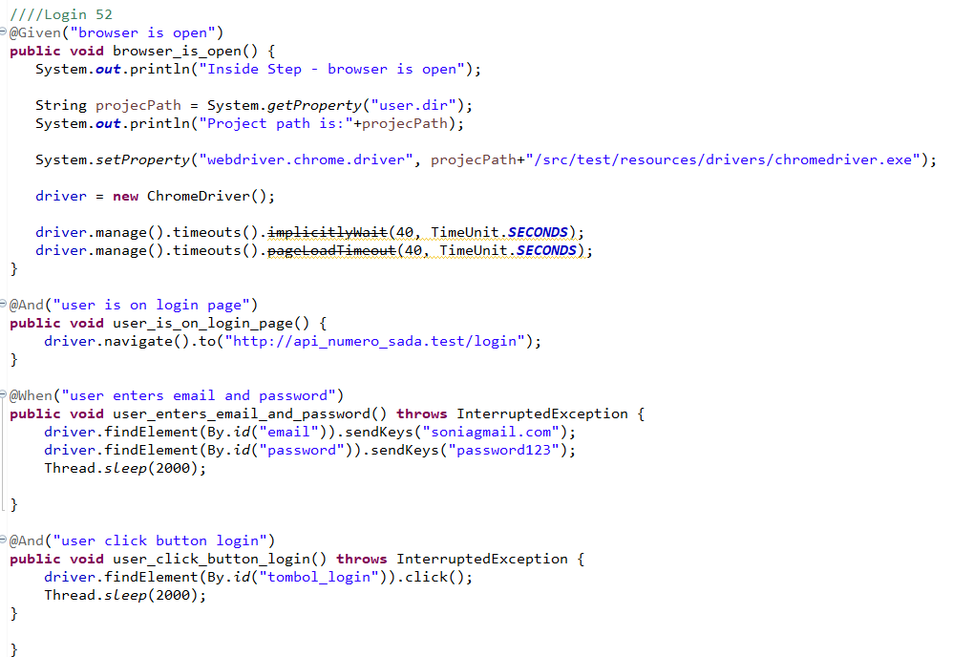

* The test runner



* The console after running

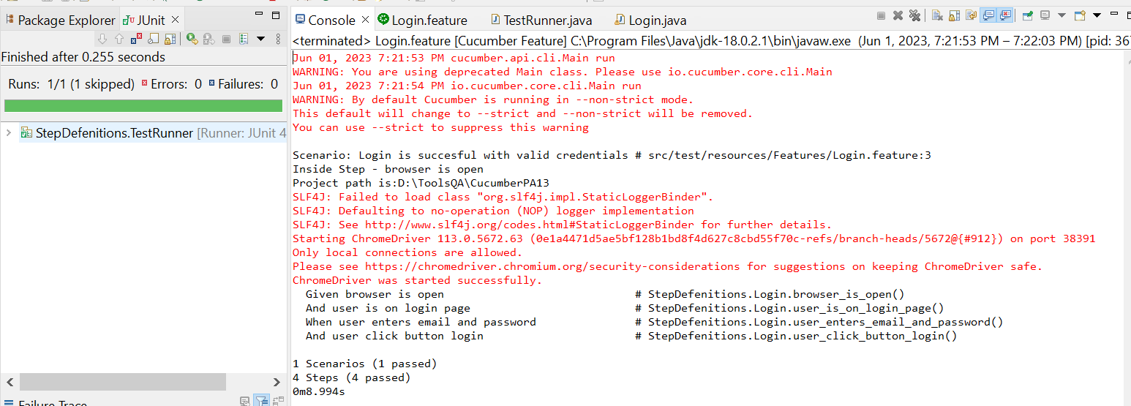

* The browser while testing

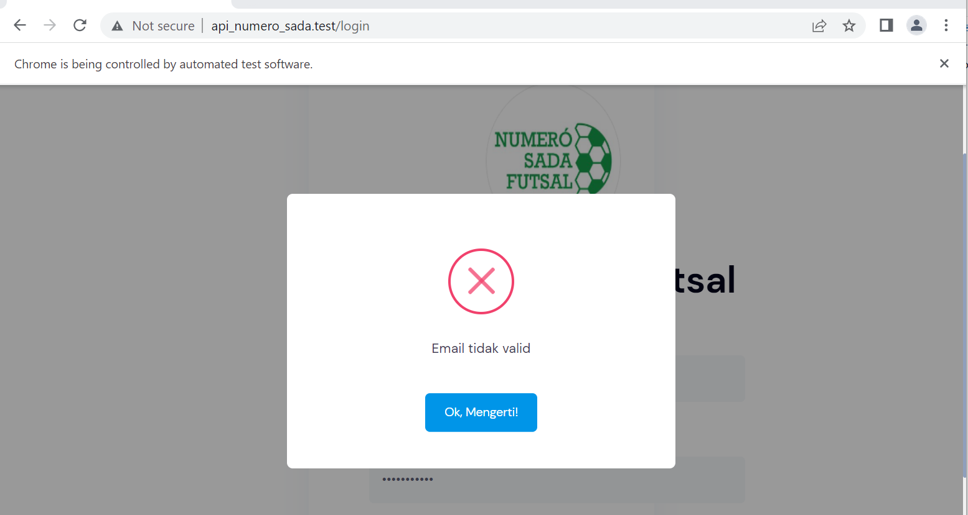

1. Fungsi Login 53

* The scenario



* The step definition

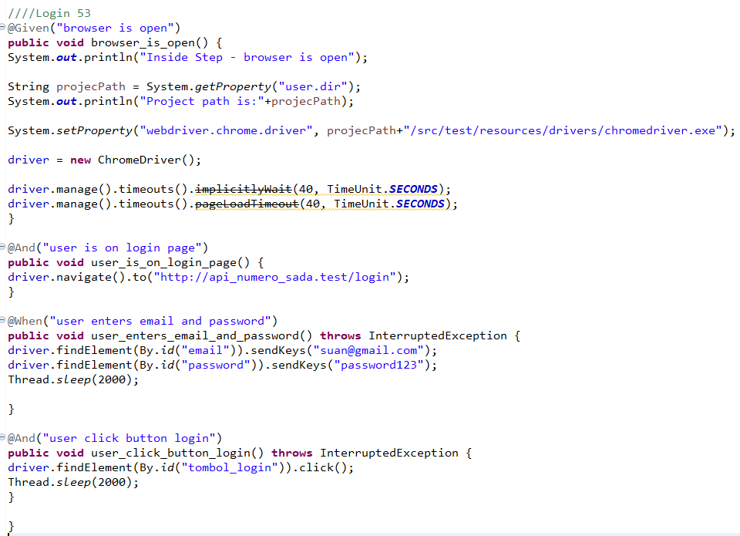

* The test runner



* The console after running

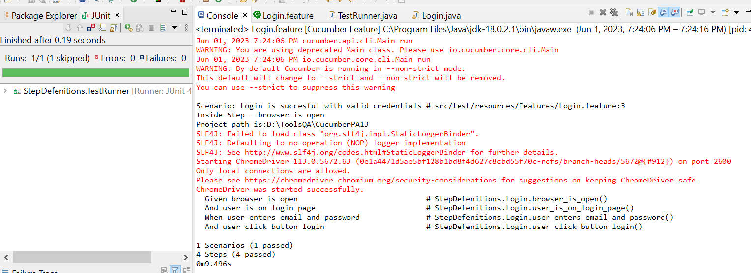

* The browser while testing



1. Fungsi Login 54

* The scenario



* The step definition

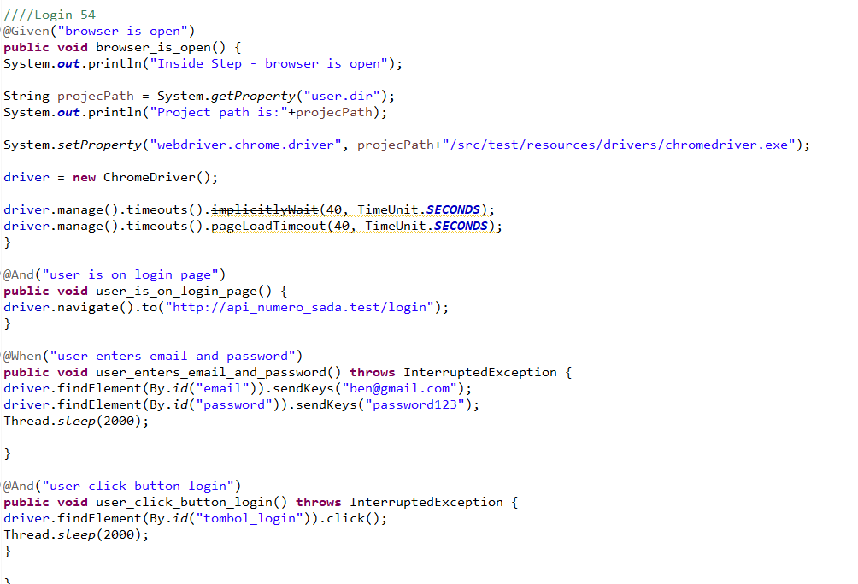

* The test runner



* The console after running

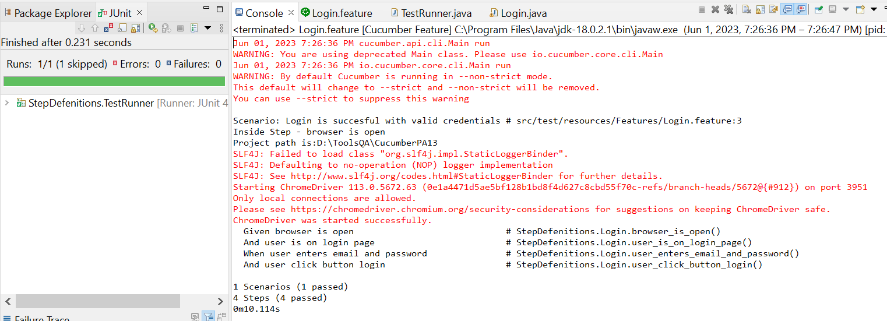

* The browser while testing



1. Fungsi Login 55

* The scenario



* The step definition

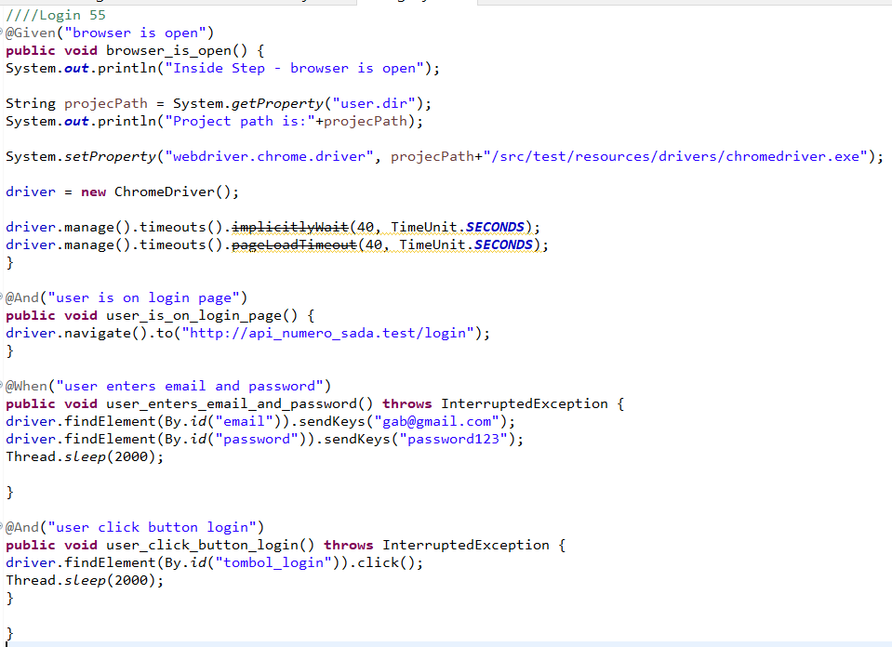

* The test runner



* The console after running

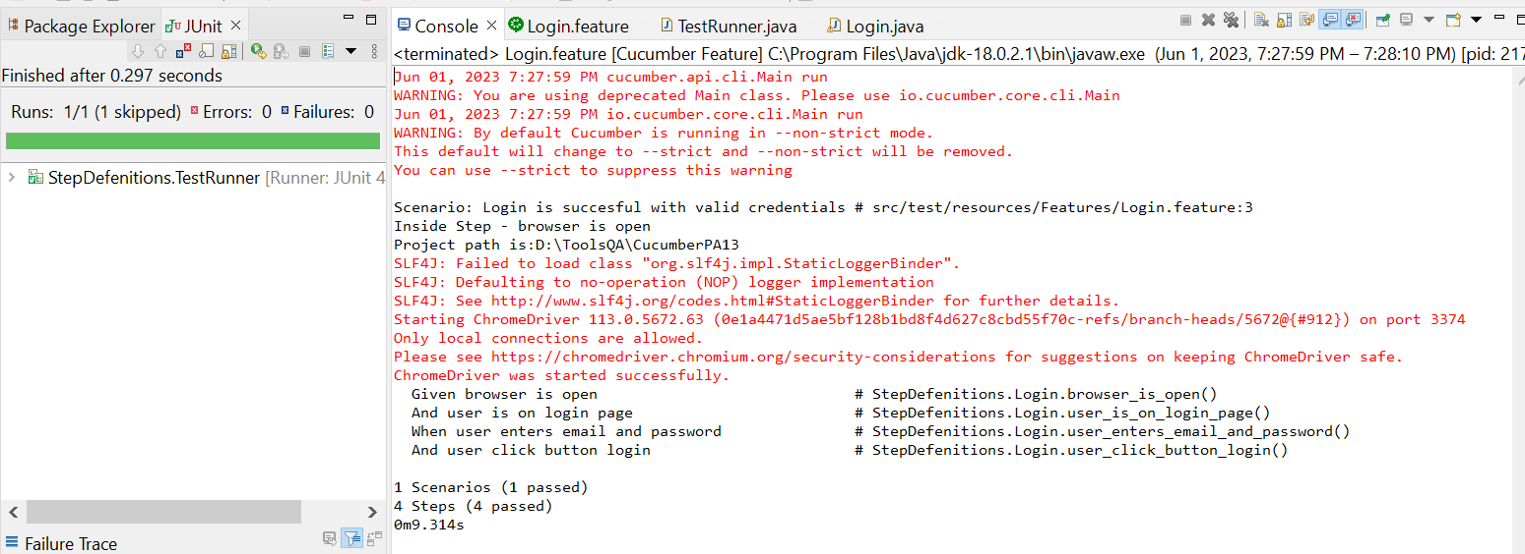

* The browser while testing



1. Fungsi Login 56

* The scenario



* The step definition

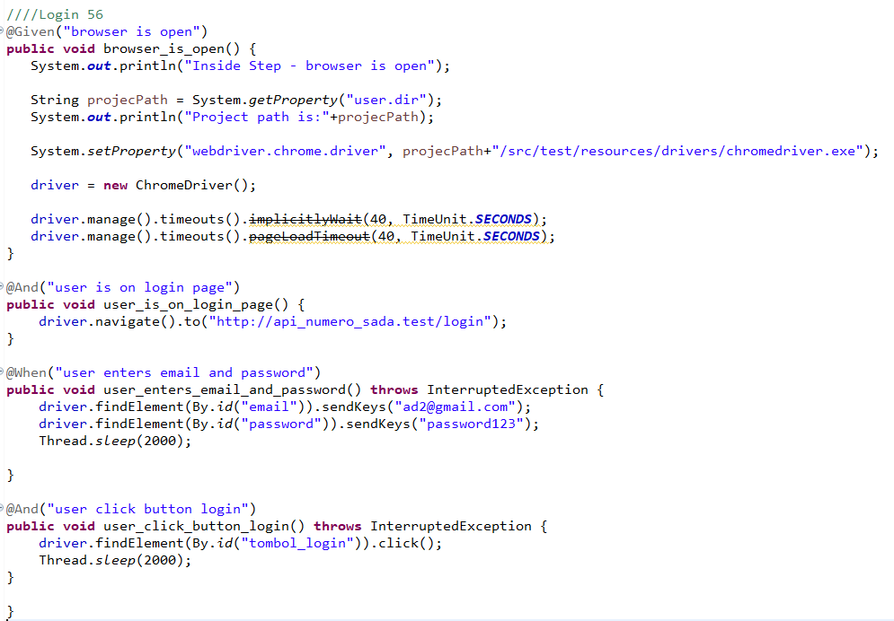

* The test runner



* The console after running

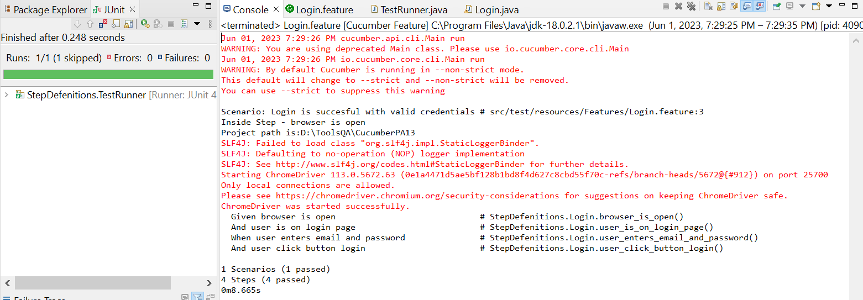

* The browser while testing



1. Fungsi Login 57

* The scenario



* The step definition

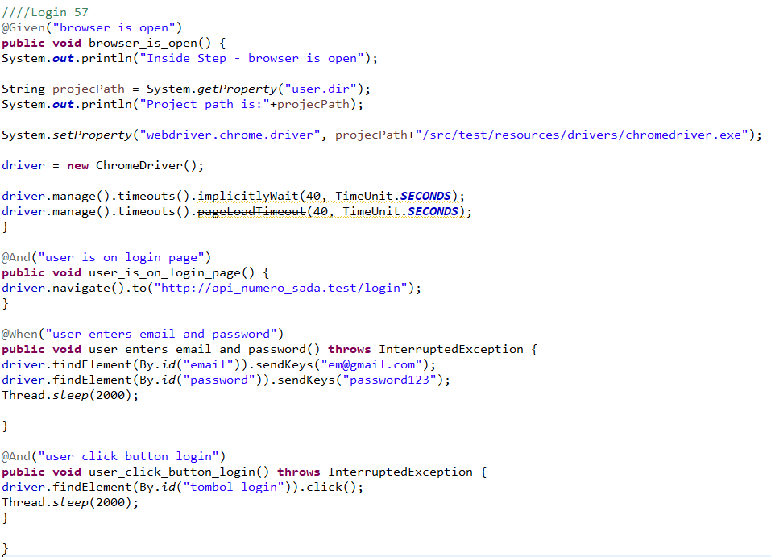

* The test runner



* The console after running



* The browser while testing



1. Fungsi Login 58

* The scenario



* The step definition

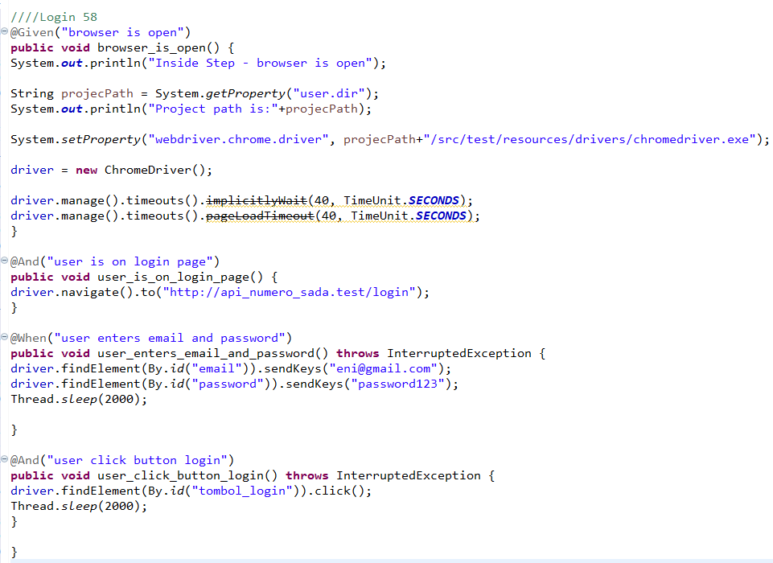

* The test runner



* The console after running



* The browser while testing



1. Fungsi Login 59

* The scenario



* The step definition

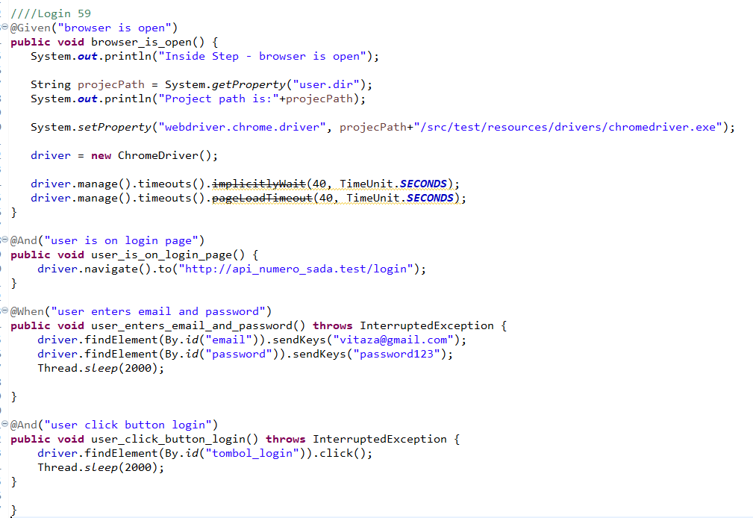

* The test runner



* The console after running



* The browser while testing



1. Fungsi Login 60

* The scenario



* The step definition

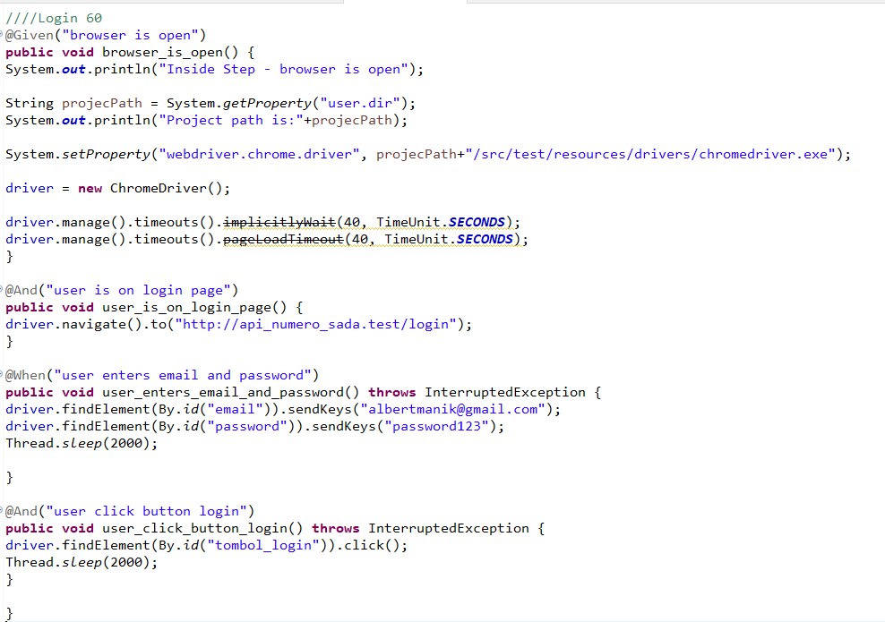

* The test runner



* The console after running



* The browser while testing



1. Fungsi Login 61

* The scenario



* The step definition

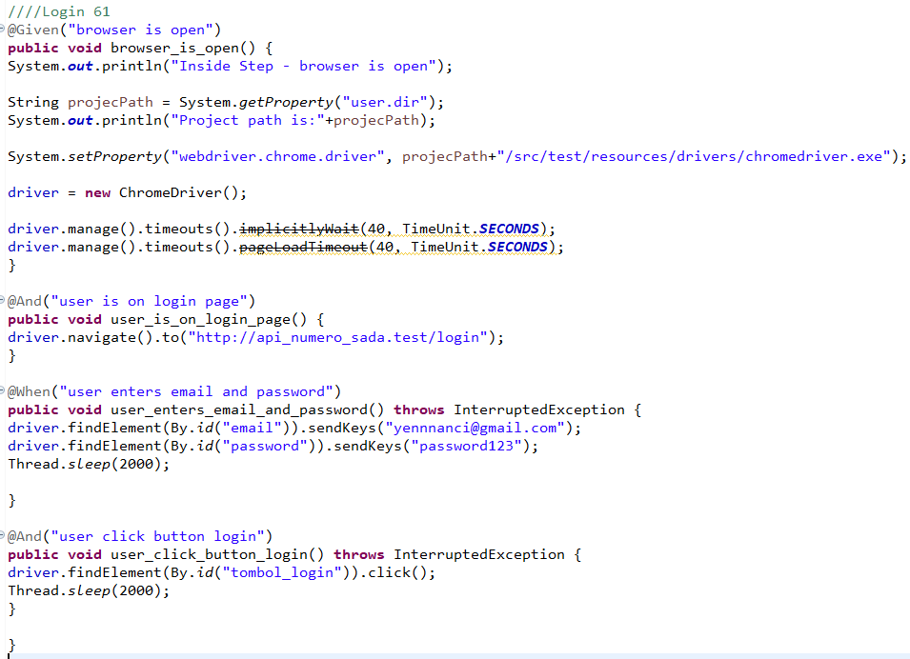

* The test runner



* The console after running



* The browser while testing



1. Fungsi Login 62

* The scenario



* The step definition

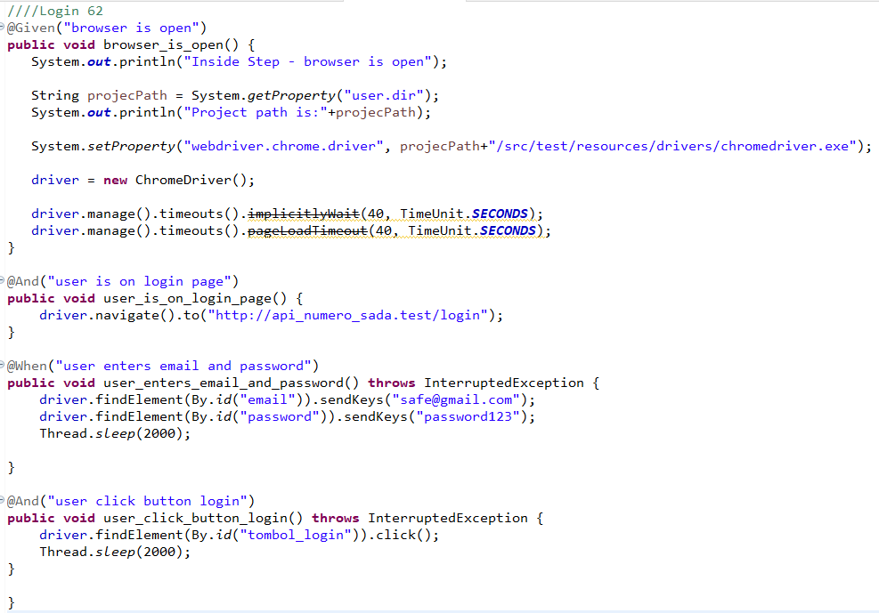

* The test runner



* The console after running



* The browser while testing



1. Fungsi Login 63

* The scenario



* The step definition

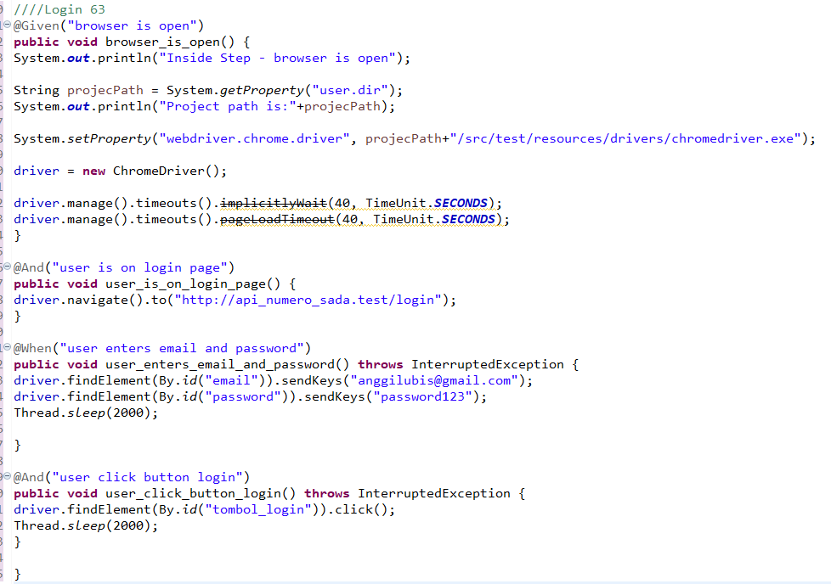

* The test runner



* The console after running



* The browser while testing



1. Fungsi Login 64

* The scenario



* The step definition

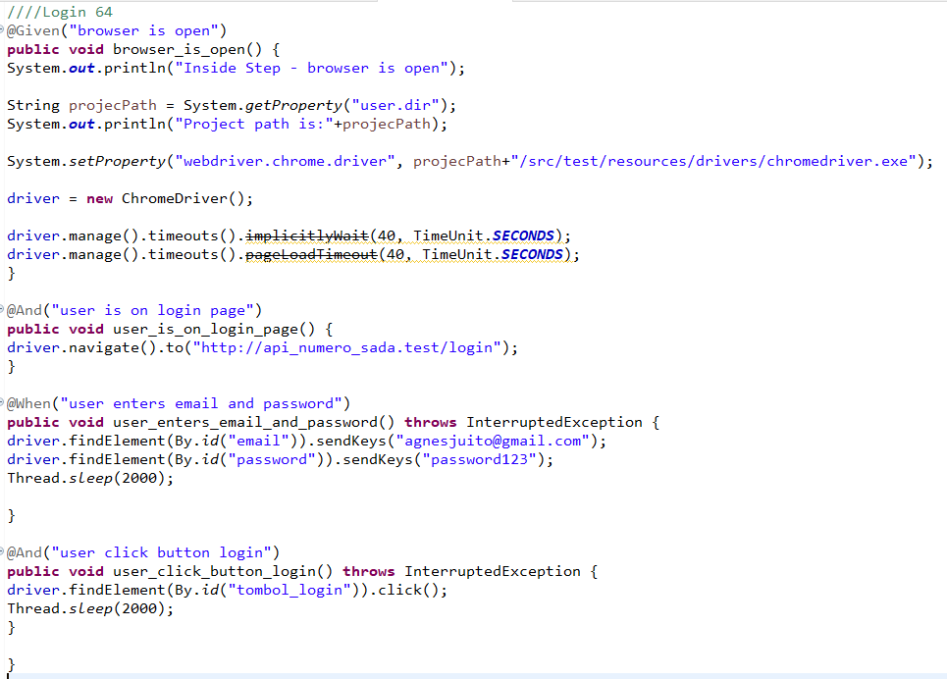

* The test runner



* The console after running



* The browser while testing



1. Fungsi Login 65

* The scenario



* The step definition

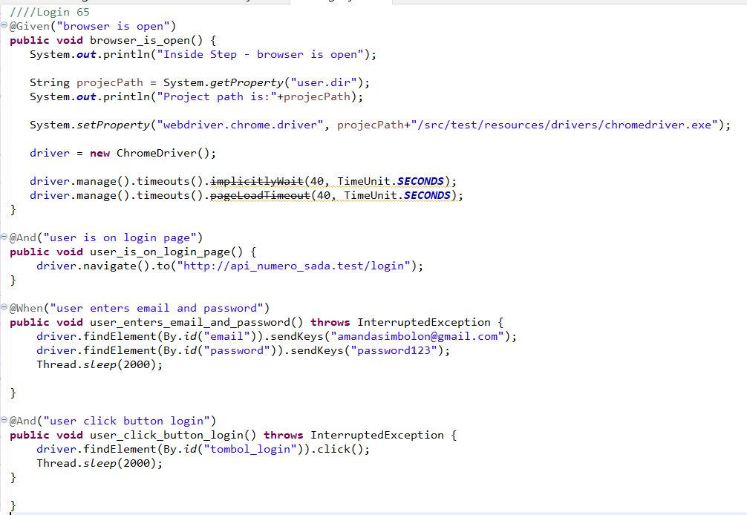

* The test runner



* The console after running



* The browser while testing



1. Fungsi Login 66

* The scenario



* The step definition

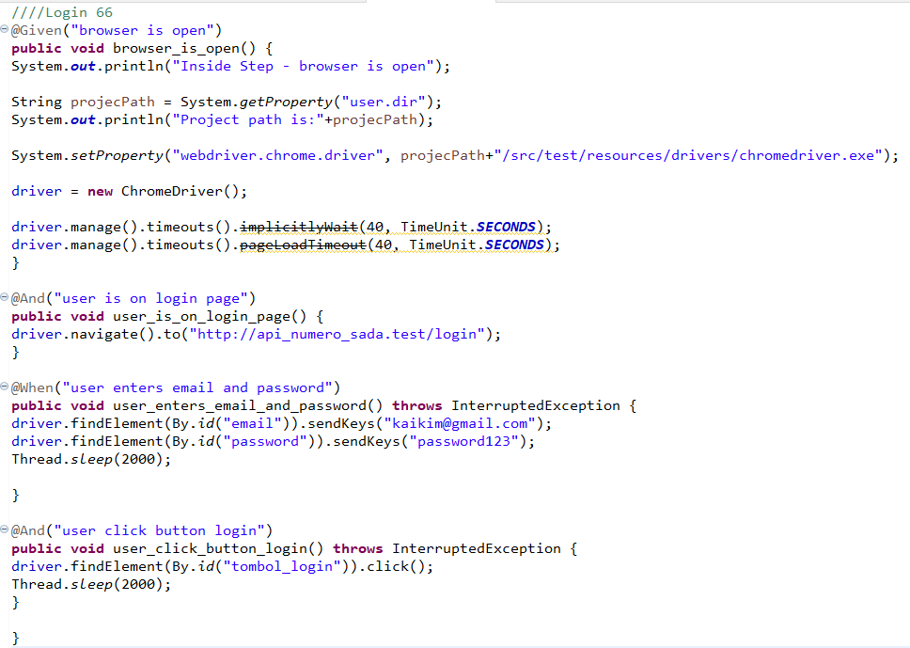

* The test runner



* The console after running



* The browser while testing



1. Fungsi Login 67

* The scenario



* The step definition

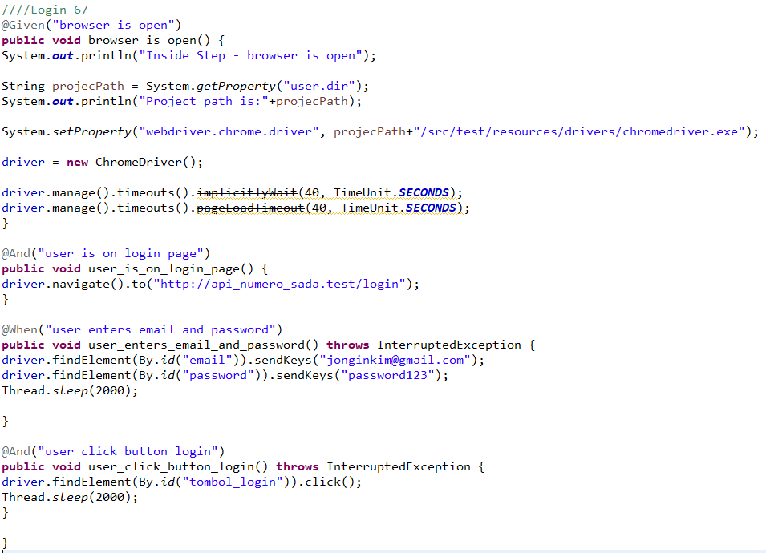

* The test runner



* The console after running



* The browser while testing



1. Fungsi Login 68

* The scenario



* The step definition

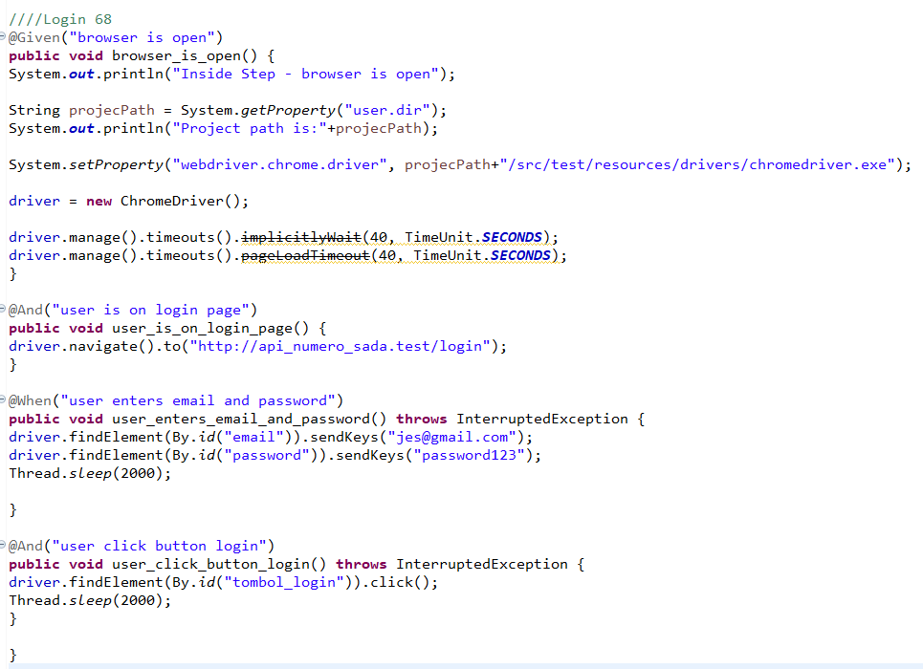

* The test runner



* The console after running



* The browser while testing



1. Fungsi Login 69

* The scenario



* The step definition

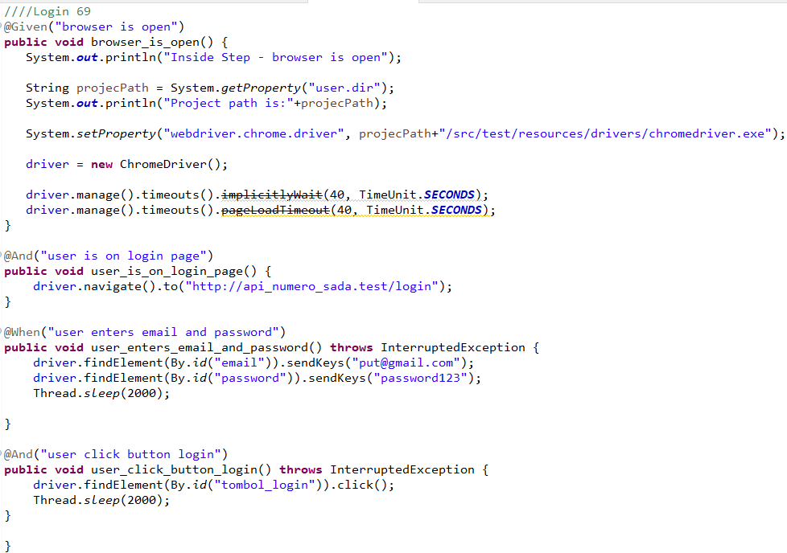

* The test runner



* The console after running



* The browser while testing



1. Fungsi Login 70

* The scenario



* The step definition

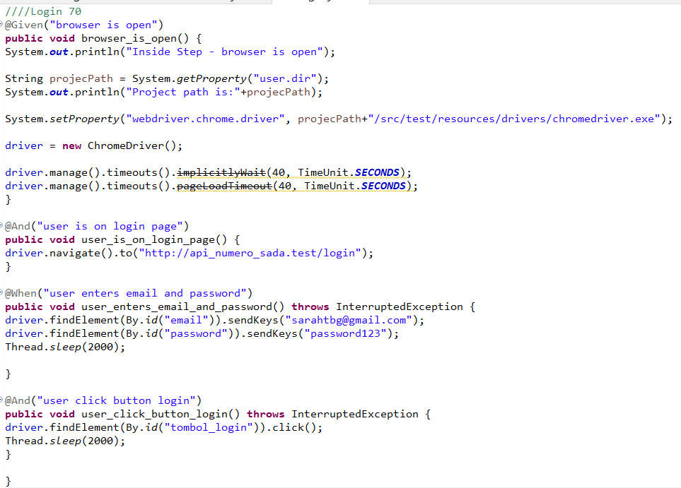

* The test runner



* The console after running



* The browser while testing



1. Fungsi Login 71

* The scenario



* The step definition

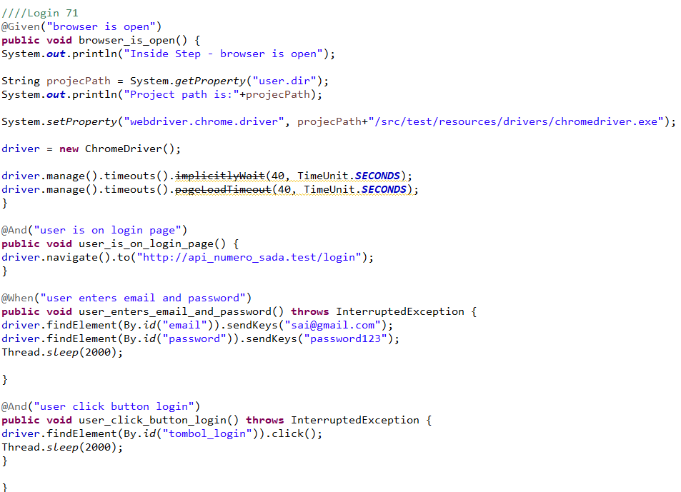

* The test runner



* The console after running



* The browser while testing



1. Fungsi Login 72

* The scenario



* The step definition

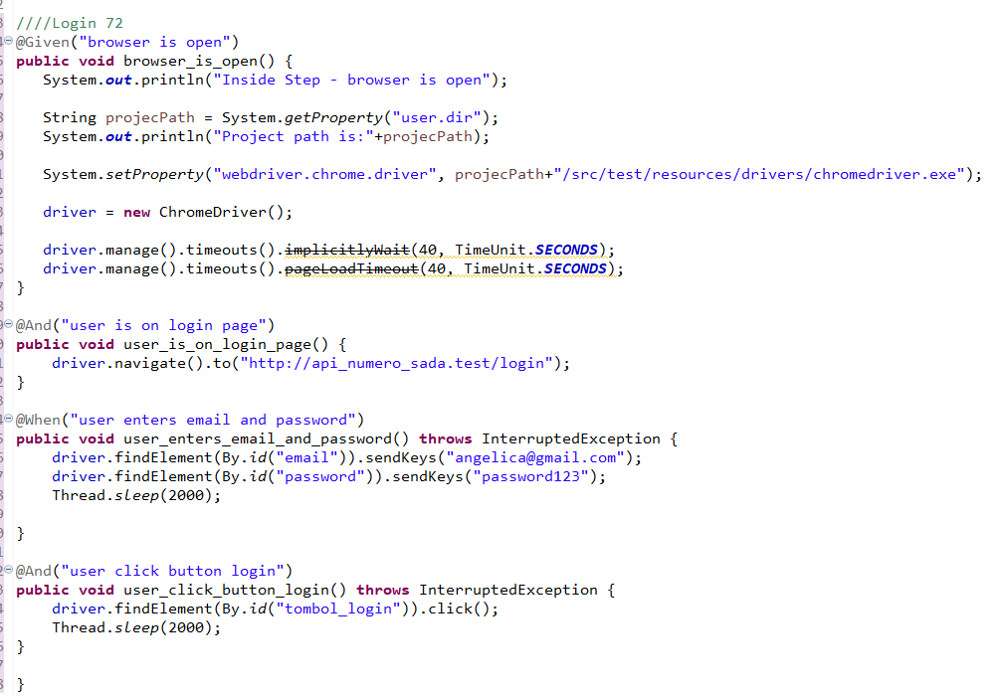

* The test runner



* The console after running



* The browser while testing



1. Fungsi Login 73

* The scenario



* The step definition

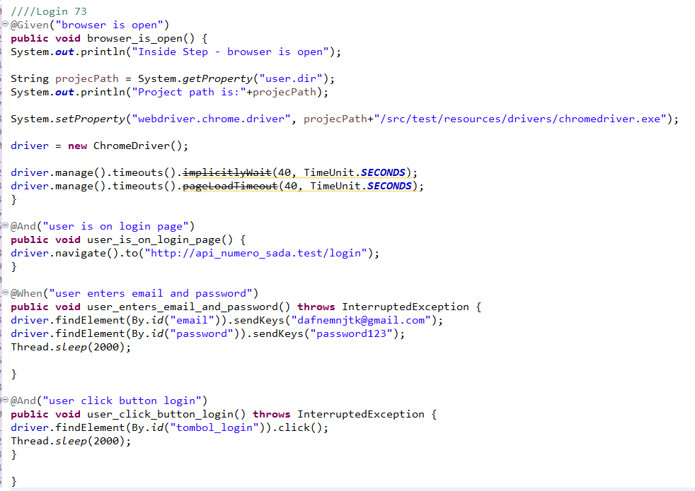

* The test runner



* The console after running



* The browser while testing



1. Fungsi Login 74

* The scenario



* The step definition

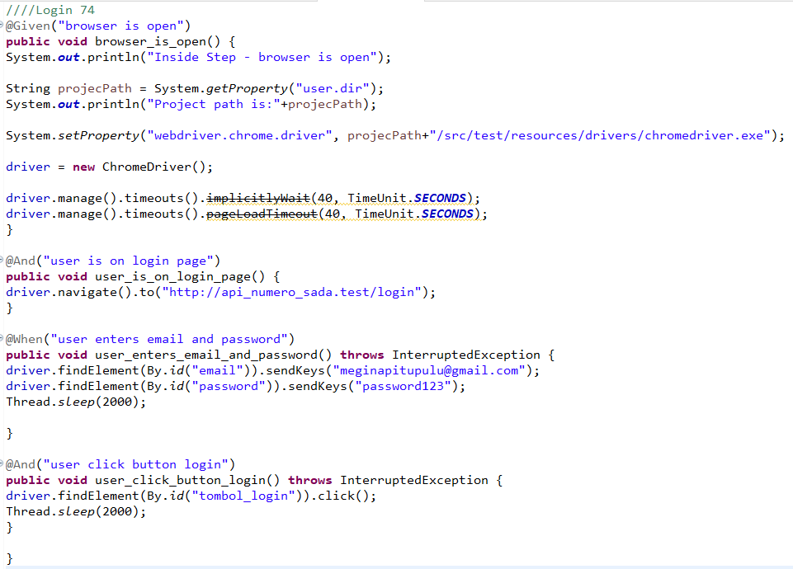

* The test runner



* The console after running



* The browser while testing



1. Fungsi Login 75

* The scenario



* The step definition

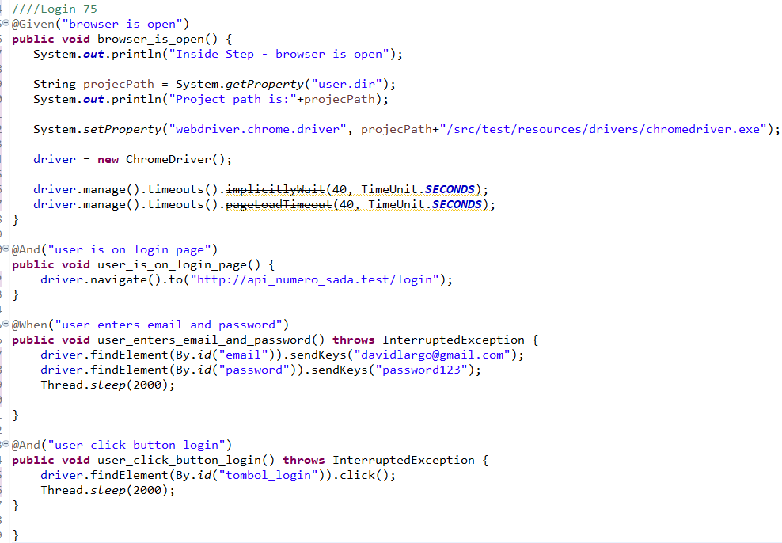

* The test runner



* The console after running



* The browser while testing



1. Fungsi Login 76

* The scenario



* The step definition

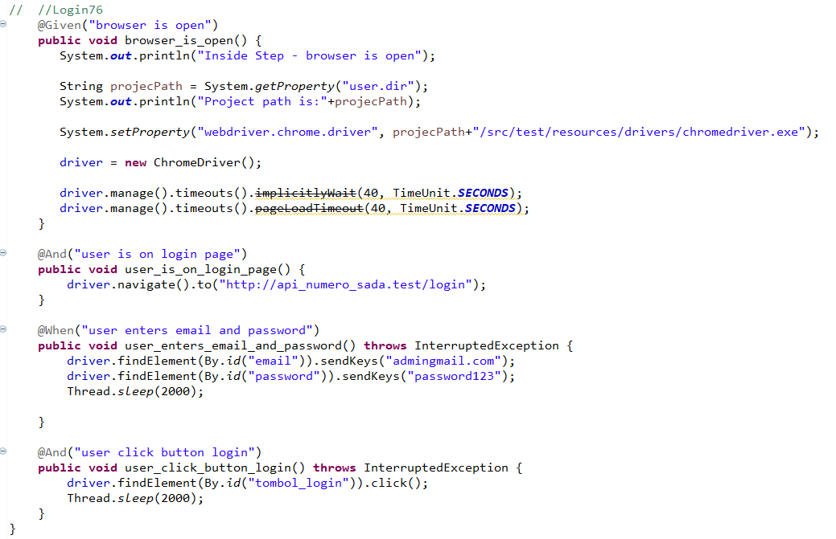

* The test runner



* The console after running

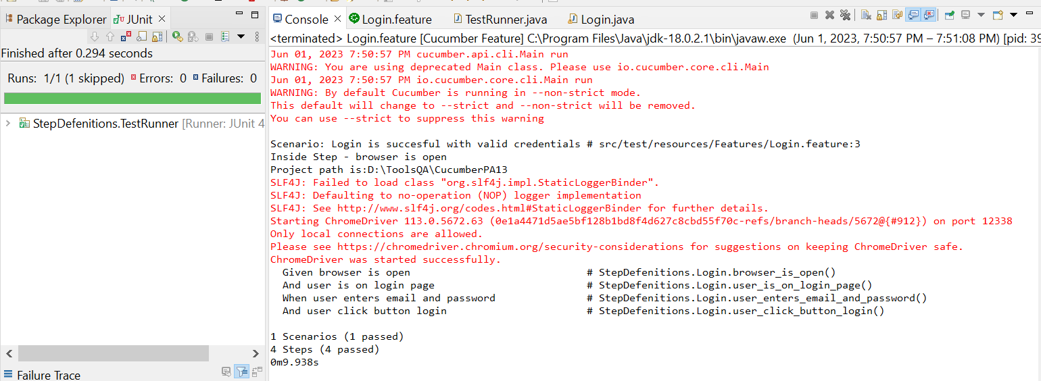

* The browser while testing

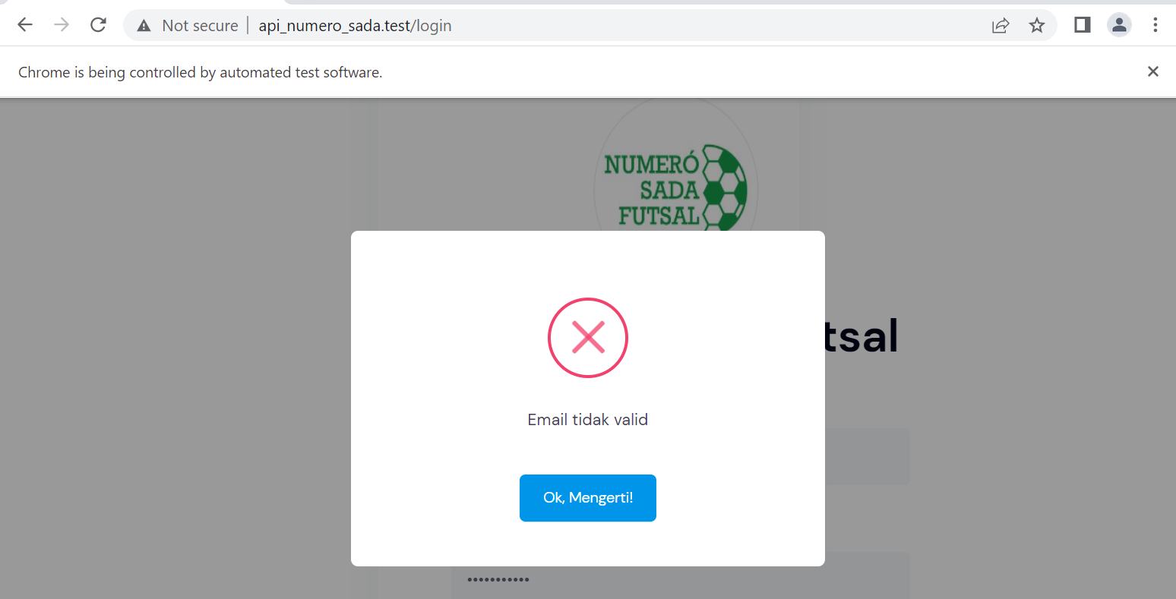

1. Fungsi Login 77

* The scenario



* The step definition

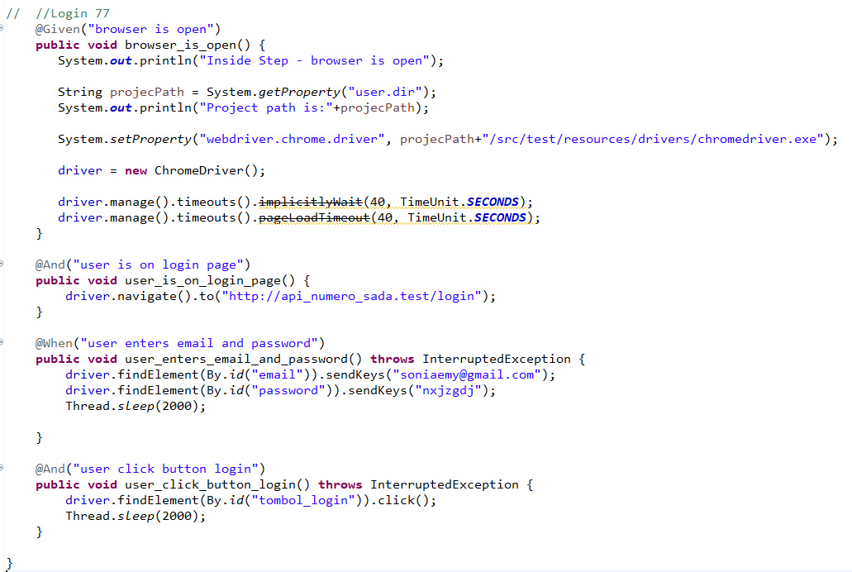

* The test runner



* The console after running

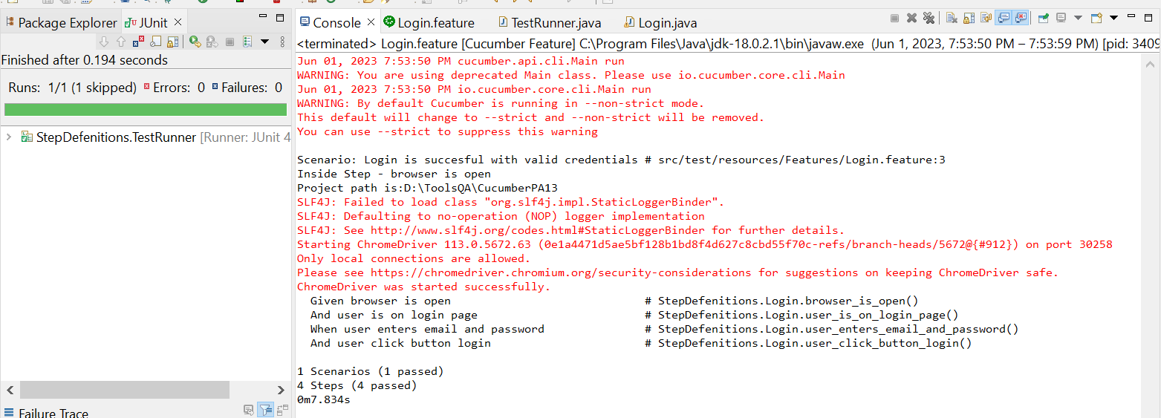

* The browser while testing



1. Fungsi Login 78

* The scenario



* The step definition

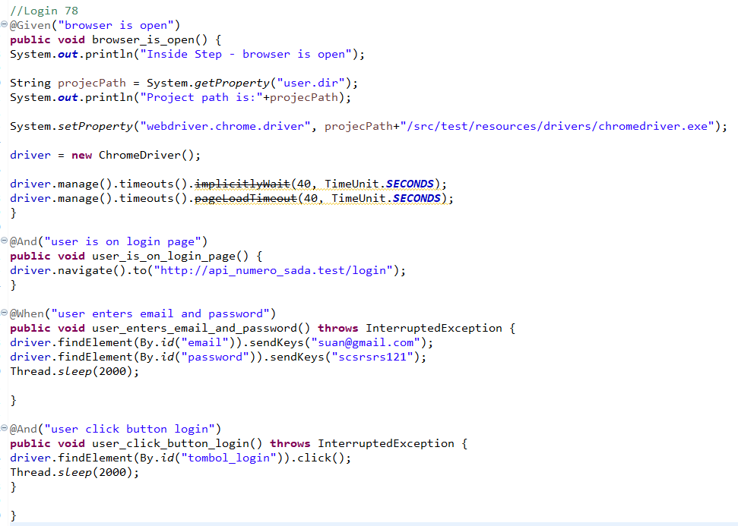

* The test runner



* The console after running



* The browser while testing

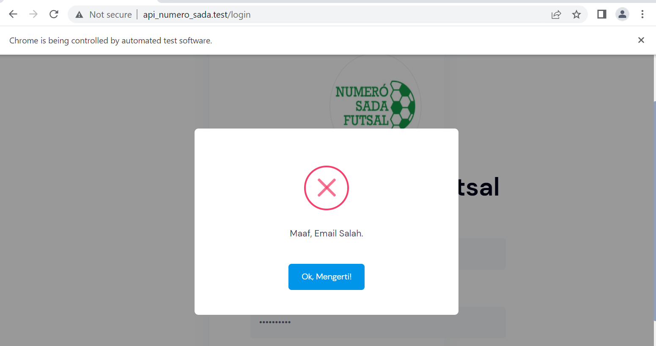

1. Fungsi Login 79

* The scenario



* The step definition

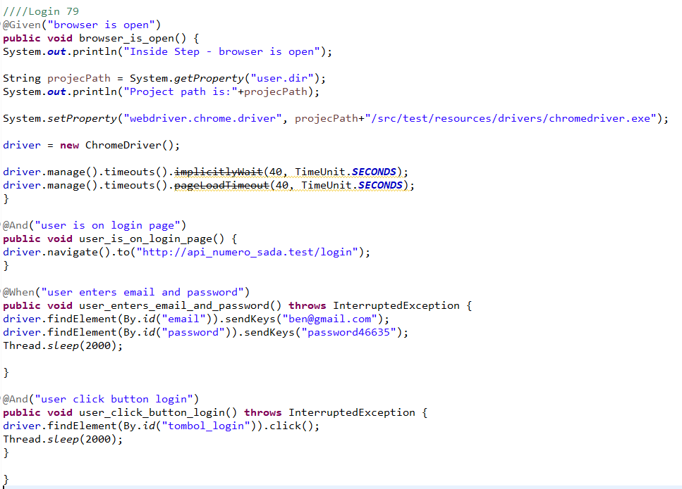

* The test runner



* The console after running



* The browser while testing



1. Fungsi Login 80

* The scenario



* The step definition

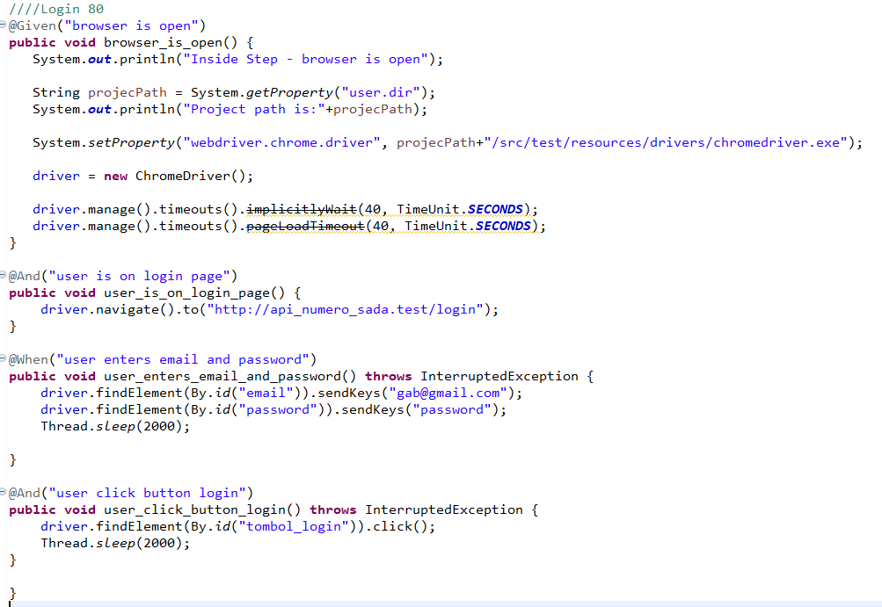

* The test runner



* The console after running



* The browser while testing



1. Fungsi Login 81

* The scenario



* The step definition

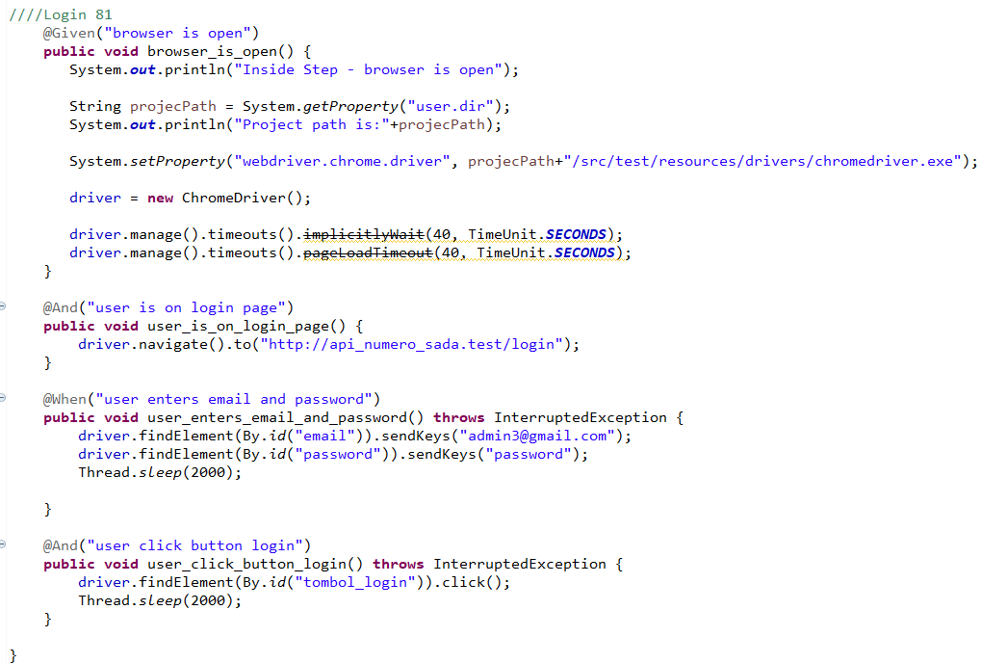

* The test runner



* The console after running



* The browser while testing



1. Fungsi Login 82

* The scenario



* The step definition

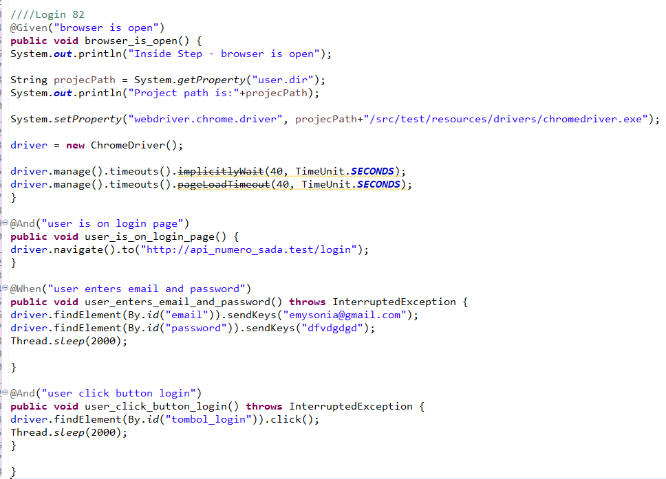

* The test runner



* The console after running



* The browser while testing



1. Fungsi Login 83

* The scenario



* The step definition

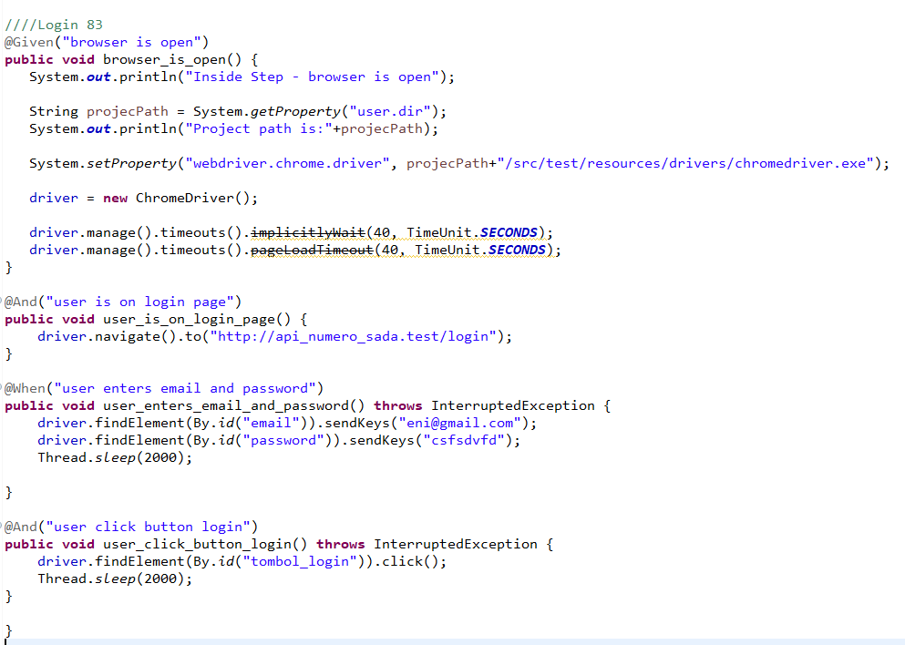

* The test runner



* The console after running



* The browser while testing



1. Fungsi Login 84

* The scenario



* The step definition

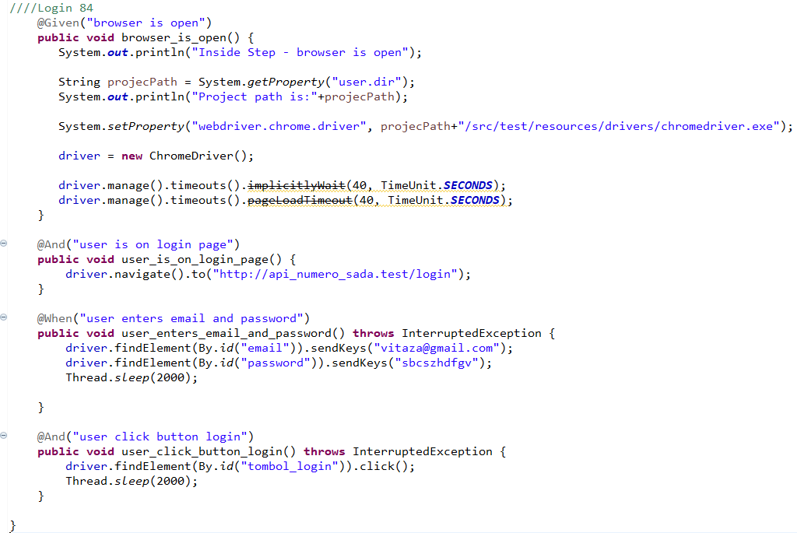

* The test runner



* The console after running



* The browser while testing



1. Fungsi Login 85

* The scenario



* The step definition

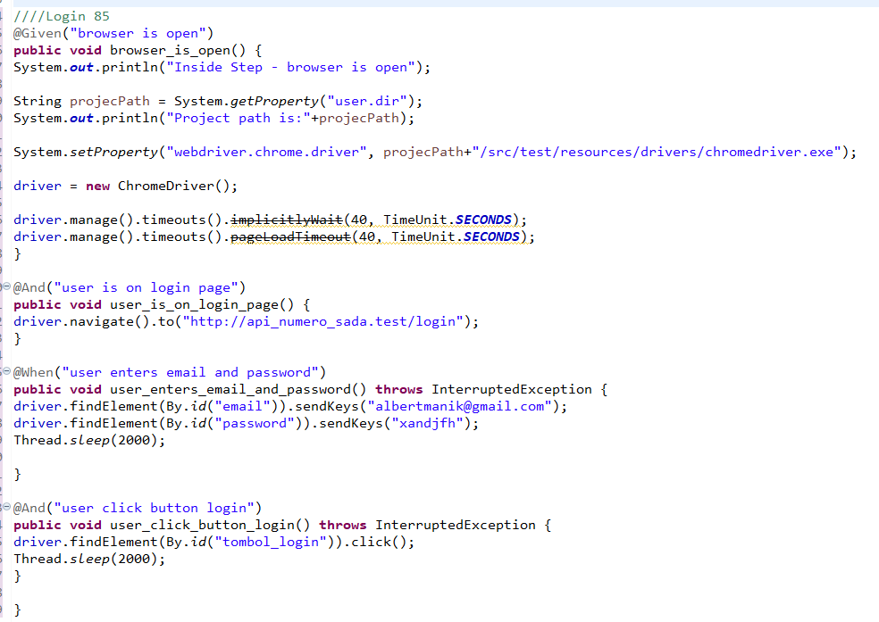

* The test runner



* The console after running



* The browser while testing



1. Fungsi Login 86

* The scenario



* The step definition

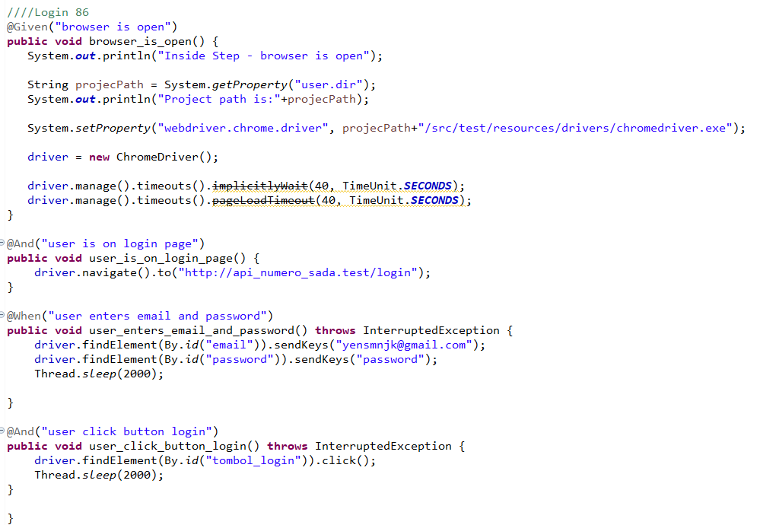

* The test runner



* The console after running



* The browser while testing



1. Fungsi Login 87

* The scenario



* The step definition

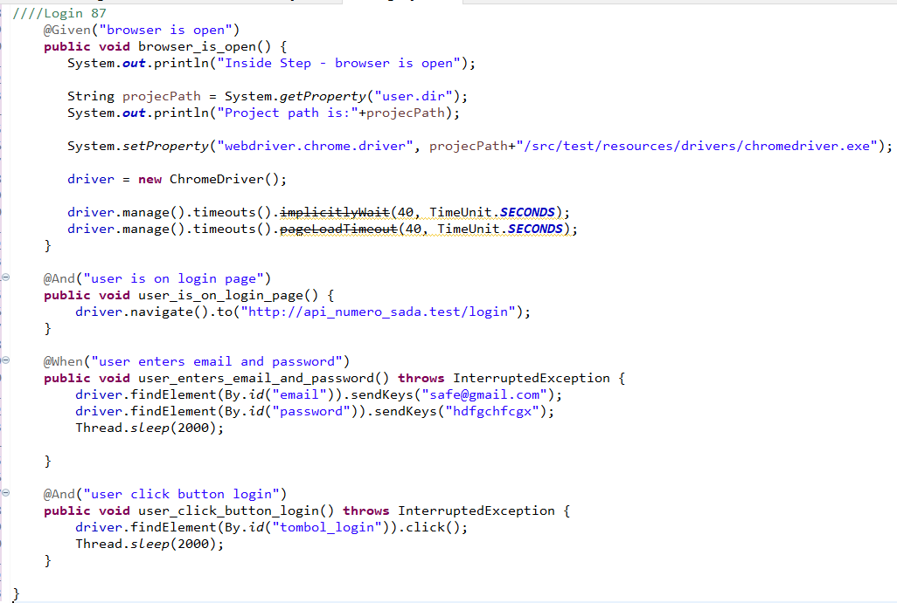

* The test runner



* The console after running



* The browser while testing



1. Fungsi Login 88

* The scenario



* The step definition

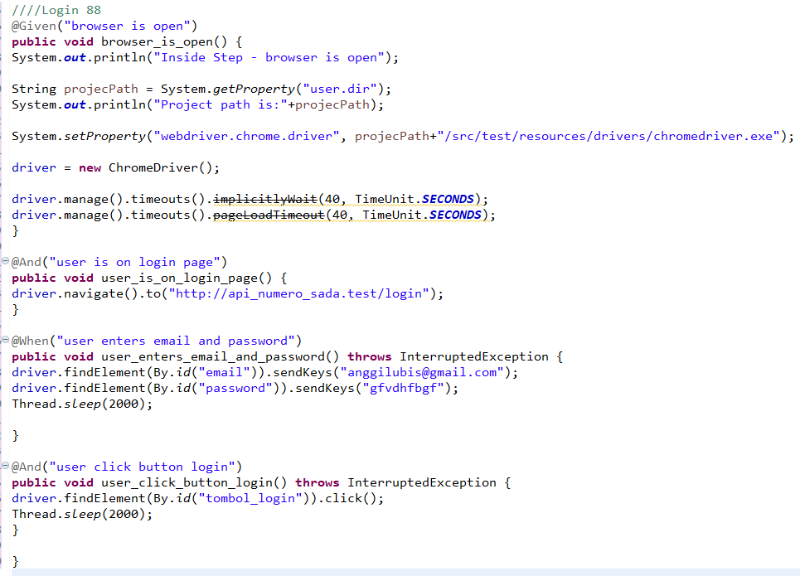

* The test runner



* The console after running



* The browser while testing



1. Fungsi Login 89

* The scenario



* The step definition

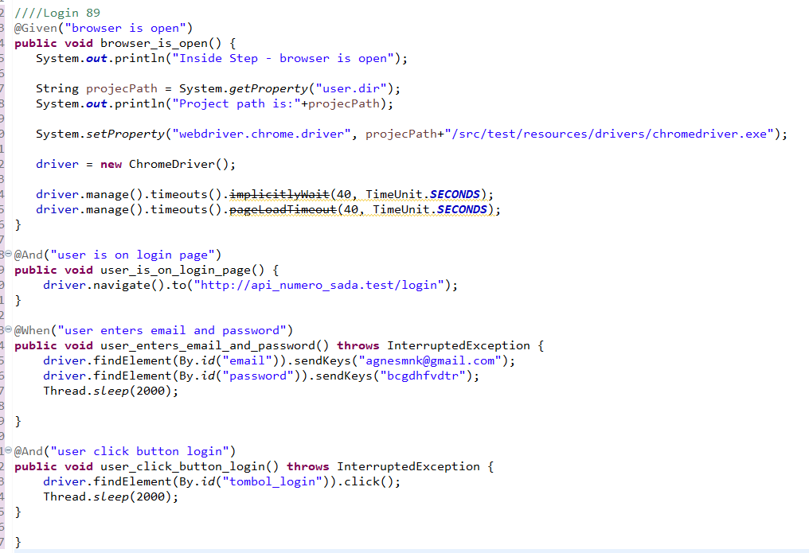

* The test runner



* The console after running



* The browser while testing



1. Fungsi Login 90

* The scenario



* The step definition

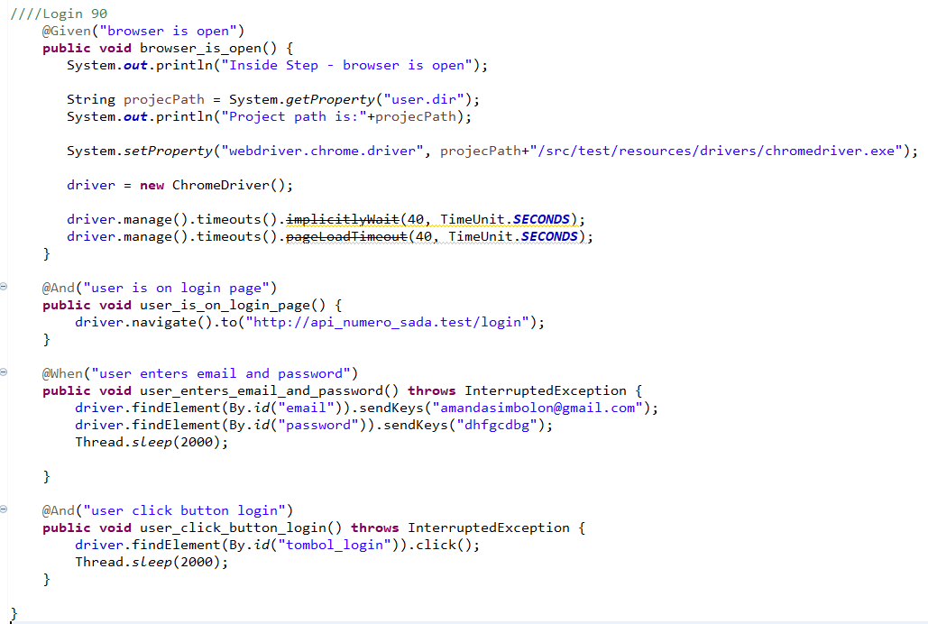

* The test runner



* The console after running



* The browser while testing



1. Fungsi Login 91

* The scenario



* The step definition

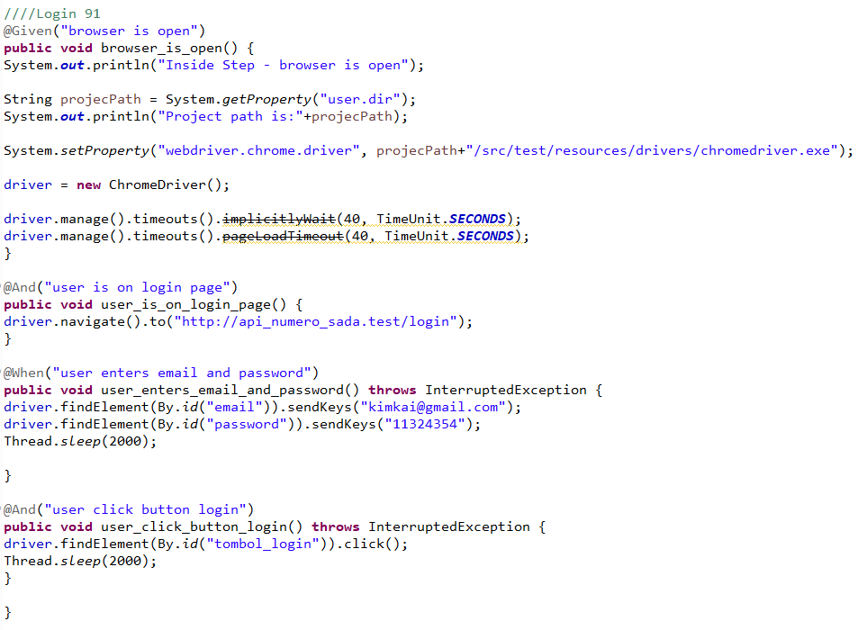

* The test runner



* The console after running



* The browser while testing



1. Fungsi Login 92

* The scenario



* The step definition

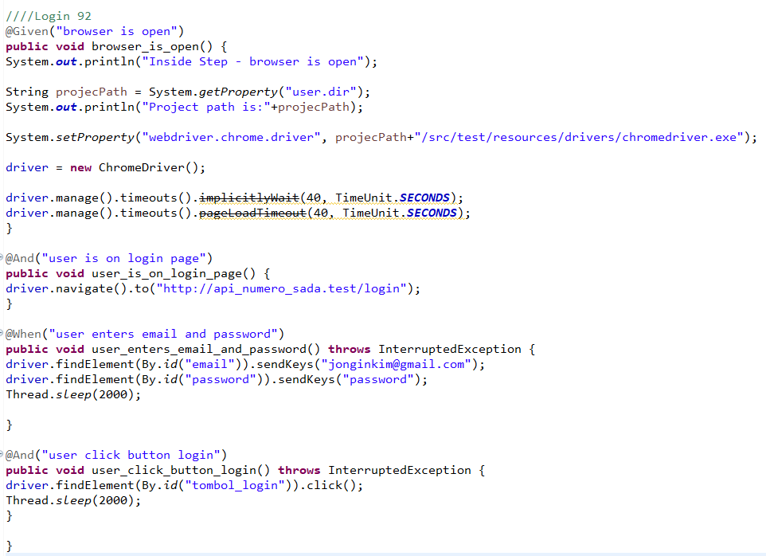

* The test runner



* The console after running



* The browser while testing



1. Fungsi Login 93

* The scenario



* The step definition

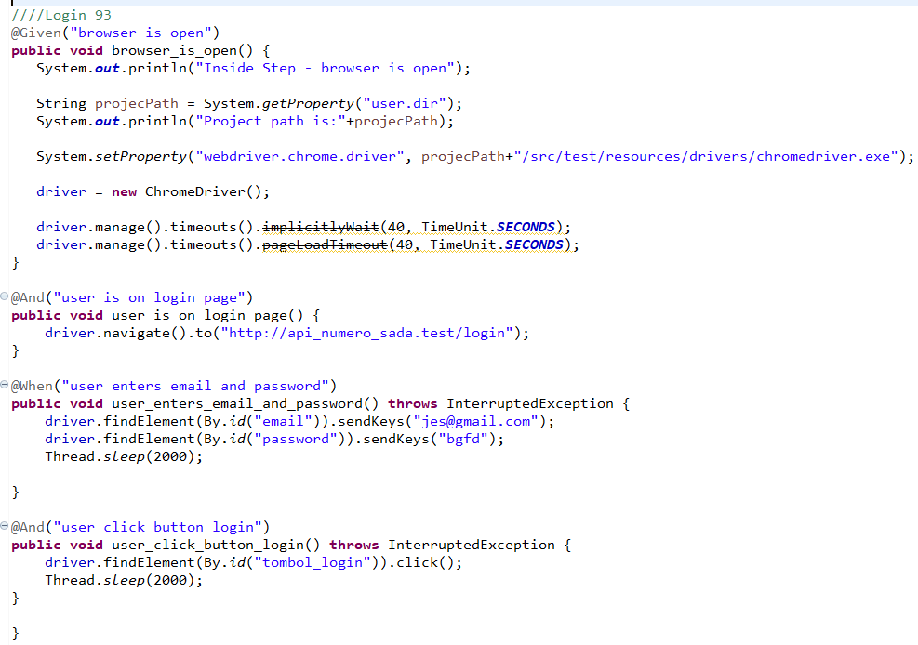

* The test runner



* The console after running



* The browser while testing



1. Fungsi Login 94

* The scenario



* The step definition

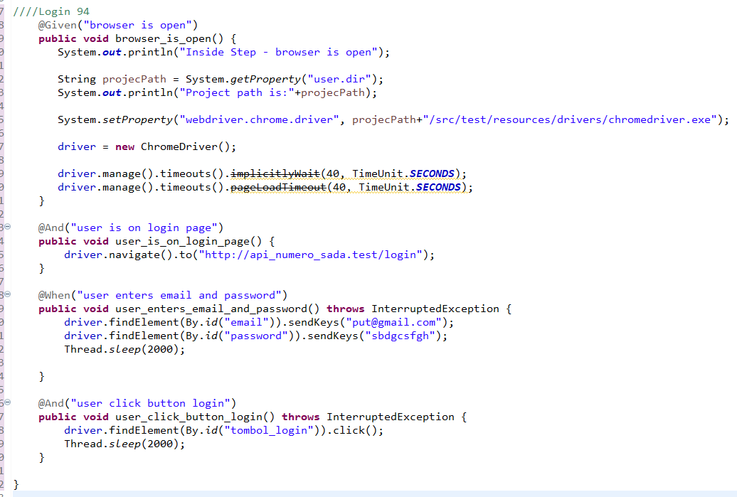

* The test runner



* The console after running



* The browser while testing



1. Fungsi Login 95

* The scenario



* The step definition

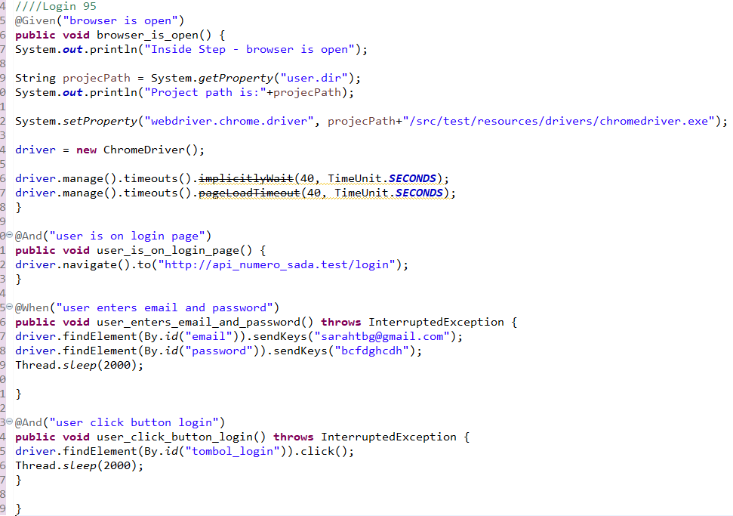

* The test runner



* The console after running



* The browser while testing



1. Fungsi Login 96

* The scenario



* The step definition

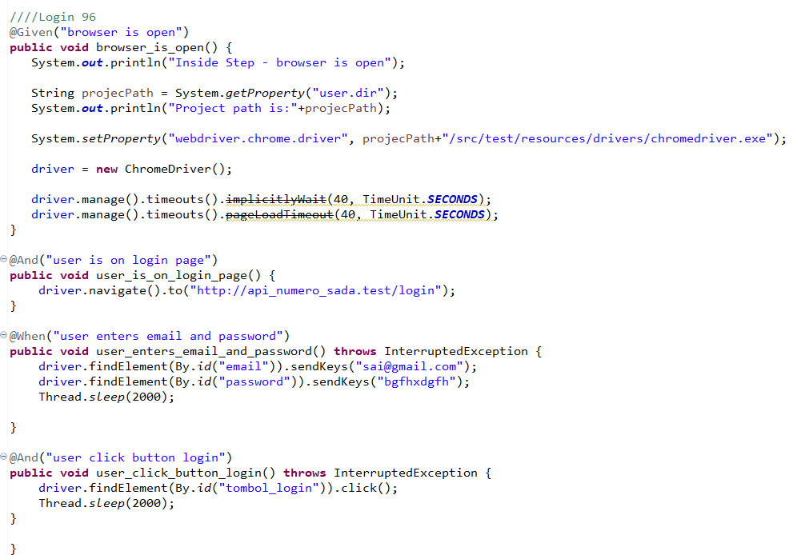

* The test runner



* The console after running



* The browser while testing



1. Fungsi Login 97

* The scenario



* The step definition

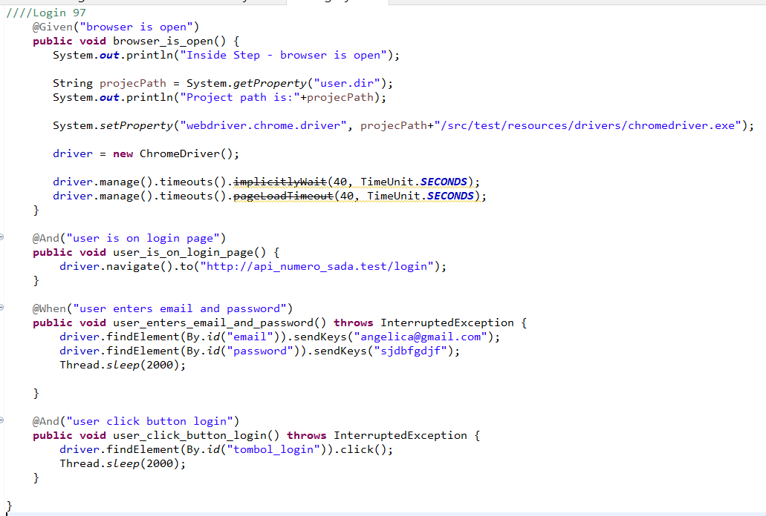

* The test runner



* The console after running



* The browser while testing



1. Fungsi Login 98

* The scenario



* The step definition

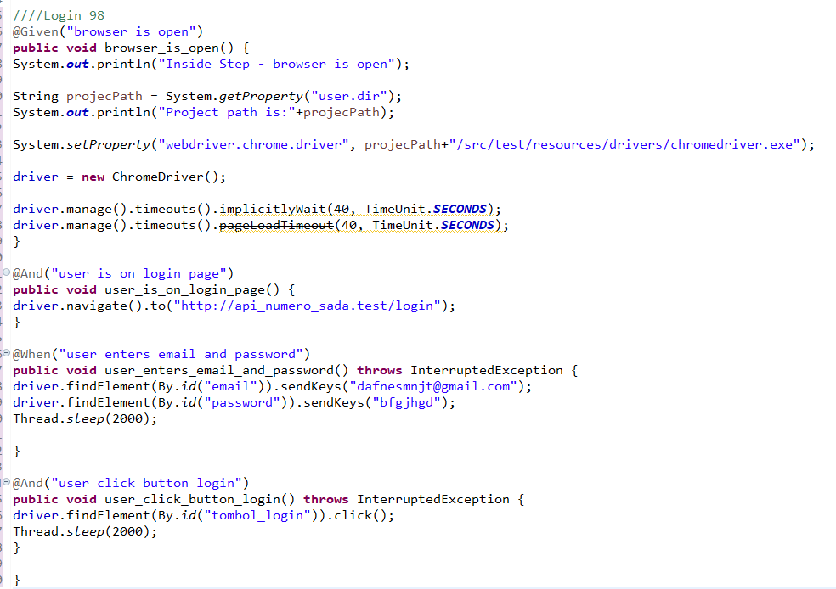

* The test runner



* The console after running



* The browser while testing



1. Fungsi Login 99

* The scenario



* The step definition

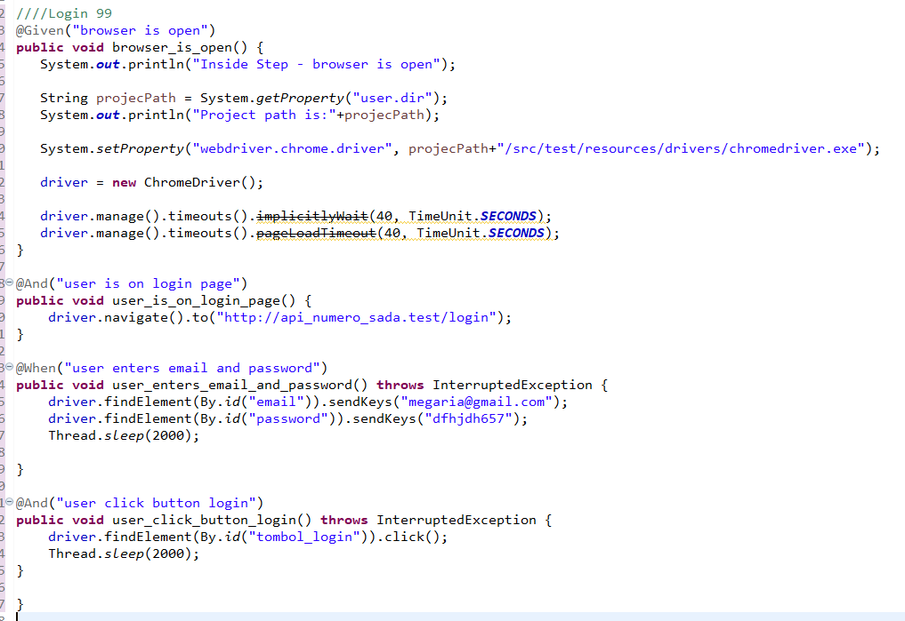

* The test runner



* The console after running



* The browser while testing



1. Fungsi Login 100

* The scenario



* The step definition

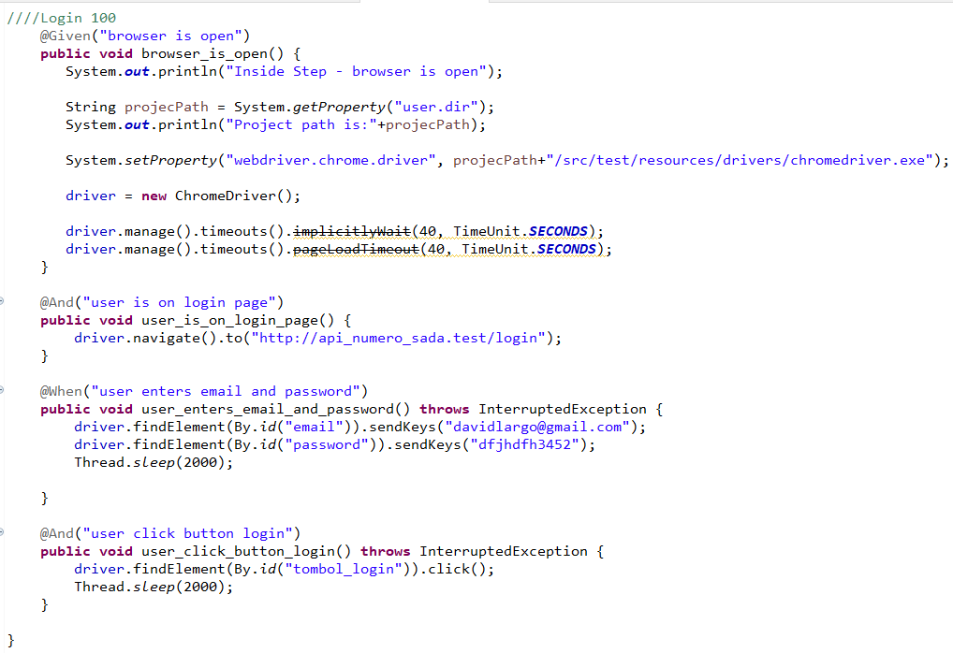

* The test runner



* The console after running



* The browser while testing



2.Fungsi Add Hidangan

Test Frame Fungsi Add Hidangan

|  |  |  |  |  |  |  |  |  |
| --- | --- | --- | --- | --- | --- | --- | --- | --- |
| Test Fungsi A | Input | | | | | | | Jumlah Testcase |
| Parameter  1  (Category) | Parameter 2 (Hidangan Picture) | Parameter 3  (Hidangan Name) | Parameter  4  (SKU) | Parameter  5  (Description) | Parameter  6  (Price) | Parameter  7  (Quantity) |
| Variasi 1 | Valid | Valid | Valid | Valid | Valid | Valid | Valid | 1 |
| Variasi 2 | Valid | Invalid | Valid | Valid | Valid | Valid | Valid | 1 |
| Variasi 3 | Valid | Valid | Invalid | Valid | Valid | Valid | Valid | 1 |
| Variasi 4 | Valid | Valid | Valid | Invalid | Valid | Valid | Valid | 1 |
| Variasi 5 | Valid | Valid | Valid | Valid | Invalid | Valid | Valid | 1 |
| Variasi 6 | Valid | Valid | Valid | Valid | Valid | Invalid | Valid | 1 |
| Variasi 7 | Valid | Valid | Valid | Valid | Valid | Valid | Invalid | 1 |
| Variasi 8 | Valid | Invalid | Invalid | Valid | Valid | Valid | Valid | 1 |
| Variasi 9 | Valid | Valid | Invalid | Invalid | Valid | Valid | Valid | 1 |
| Variasi 10 | Valid | Valid | Valid | Invalid | Invalid | Valid | Valid | 1 |
| Variasi 11 | Valid | Valid | Valid | Valid | Invalid | Invalid | Valid | 1 |
| Variasi 12 | Valid | Valid | Valid | Valid | Valid | Invalid | Invalid | 1 |
| Variasi 13 | Invalid | Invalid | Valid | Valid | Valid | Valid | Valid | 1 |
| Variasi 14 | Invalid | Invalid | Invalid | Valid | Valid | Valid | Valid | 1 |
| Variasi 15 | Valid | Invalid | Invalid | Invalid | Valid | Valid | Valid | 1 |
| Variasi 16 | Valid | Valid | Invalid | Invalid | Invalid | Valid | Valid | 1 |
| Variasi 16 | Valid | Valid | Valid | Invalid | Invalid | Invalid | Valid | 1 |
| Variasi 17 | Valid | Valid | Valid | Valid | Invalid | Invalid | Invalid | 1 |
| Variasi 18 | Invalid | Invalid | Invalid | Invalid | Valid | Valid | Valid | 1 |
| Variasi 19 | Valid | Invalid | Invalid | Invalid | Invalid | Valid | Valid | 1 |
| Variasi 20 | Valid | Valid | Invalid | Invalid | Invalid | Invalid | Valid | 1 |
| Variasi 21 | Valid | Valid | Valid | Invalid | Invalid | Invalid | Invalid | 1 |
| Variasi 22 | Invalid | Invalid | Invalid | Invalid | Invalid | Valid | Valid | 1 |
| Variasi 23 | Valid | Invalid | Invalid | Invalid | Invalid | Invalid | Valid | 1 |
| Variasi 24 | Valid | Valid | Invalid | Invalid | Invalid | Invalid | Invalid | 1 |
| Variasi 25 | Valid | Invalid | Invalid | Invalid | Invalid | Invalid | Invalid | 1 |
| Variasi 26 | Invalid | Invalid | Invalid | Invalid | Invalid | Invalid | Invalid | 1 |
| Variasi 27 | Valid | Invalid | Valid | Invalid | Valid | Valid | Valid | 1 |
| Variasi 28 | Valid | Valid | Invalid | Valid | Invalid | Valid | Valid | 1 |
| Variasi 30 | Valid | Valid | Valid | Invalid | Valid | Invalid | Valid | 1 |
| Variasi 31 | Valid | Valid | Valid | Valid | Invalid | Valid | Invalid | 1 |
| Variasi 32 | Valid | Invalid | Valid | Valid | Invalid | Valid | Valid | 1 |
| Variasi 33 | Valid | Valid | Invalid | Valid | Valid | Invalid | Valid | 1 |
| Variasi 34 | Valid | Valid | Valid | Invalid | Valid | Valid | Invalid | 1 |
| Variasi 35 | Valid | Invalid | Valid | Valid | Valid | Invalid | Valid | 1 |
| Variasi 36 | Valid | Valid | Invalid | Valid | Valid | Valid | Invalid | 1 |
| Variasi 37 | Valid | Invalid | Valid | Valid | Valid | Valid | Invalid | 1 |
| Variasi 38 | Valid | Invalid | Valid | Invalid | Valid | Invalid | Valid | 1 |
| Variasi 39 | Valid | Valid | Invalid | Valid | Invalid | Valid | Invalid | 1 |
| Variasi 40 | Invalid | Valid | Invalid | Valid | Invalid | Valid | Valid | 1 |
| Variasi 41 | Invalid | Valid | Invalid | Valid | Invalid | Valid | Invalid | 1 |
| Variasi 42 | Valid | Valid | Valid | Invalid | Invalid | Invalid | Invalid | 1 |
| Variasi 43 | Valid | Invalid | Invalid | Invalid | Invalid | Valid | Valid | 1 |
| Variasi 44 | Valid | Valid | Invalid | Invalid | Invalid | Invalid | Valid | 1 |
| Variasi 45 | Valid | Valid | Valid | Invalid | Invalid | Invalid | Invalid | 1 |
| Variasi 46 | Valid | Valid | Invalid | Invalid | Invalid | Invalid | Invalid | 1 |
| Variasi 47 | Valid | Invalid | Invalid | Invalid | Invalid | Invalid | Invalid | 1 |
| Variasi 48 | Invalid | Invalid | Invalid | Valid | Valid | Valid | Valid | 1 |
| Variasi 49 | Invalid | Invalid | Valid | Valid | Valid | Valid | Valid | 1 |
| Variasi 50 | Invalid | Invalid | Valid | Valid | Invalid | Invalid | Invalid | 1 |
| Variasi 51 | Invalid | Invalid | Invalid | Invalid | Valid | Valid | Invalid | 1 |
| Variasi 52 | Invalid | Invalid | Invalid | Invalid | Invalid | Valid | Valid | 1 |
| Variasi 53 | Invalid | Valid | Invalid | Valid | Invalid | Invalid | Invalid | 1 |
| Variasi 54 | Invalid | Invalid | Valid | Invalid | Valid | Invalid | Invalid | 1 |
| Variasi 55 | Invalid | Invalid | Invalid | Valid | Invalid | Valid | Invalid | 1 |
| Variasi 56 | Invalid | Invalid | Invalid | Invalid | Valid | Invalid | Valid | 1 |
| Variasi 57 | Valid | Invalid | Invalid | Invalid | Invalid | Valid | Invalid | 1 |
| Variasi 58 | Invalid | Valid | Invalid | Invalid | Valid | Invalid | Invalid | 1 |
| Variasi 59 | Invalid | Invalid | Valid | Invalid | Invalid | Valid | Invalid | 1 |
| Variasi 60 | Invalid | Invalid | Invalid | Valid | Invalid | Invalid | Valid | 1 |
| Variasi 61 | Valid | Invalid | Invalid | Invalid | Valid | Invalid | Invalid | 1 |
| Variasi 62 | Invalid | Valid | Invalid | Invalid | Invalid | Valid | Invalid | 1 |
| Variasi 63 | Invalid | Invalid | Valid | Invalid | Invalid | Invalid | Valid | 1 |
| Variasi 64 | Valid | Invalid | Invalid | Valid | Invalid | Invalid | Invalid | 1 |
| Variasi 65 | Invalid | Valid | Invalid | Invalid | Invalid | Valid | Invalid | 1 |
| Variasi 66 | Invalid | Valid | Invalid | Invalid | Invalid | Valid | Invalid | 1 |
| Variasi 67 | Invalid | Invalid | Valid | Invalid | Valid | Invalid | Invalid | 1 |
| Variasi 68 | Invalid | Invalid | Invalid | Invalid | Valid | Valid | Valid | 1 |
| Variasi 69 | Invalid | Invalid | Valid | Valid | Valid | Invalid | Invalid | 1 |
| Variasi 70 | Invalid | Invalid | Invalid | Valid | Valid | Valid | Valid | 1 |
| Variasi 71 | Invalid | Invalid | Valid | Valid | Valid | Valid | Valid | 1 |
| Variasi 72 | Invalid | Valid | Valid | Invalid | Valid | Valid | Invalid | 1 |
| Variasi 73 | Invalid | Invalid | Valid | Valid | Invalid | Valid | Valid | 1 |
| Variasi 74 | Invalid | Valid | Valid | Valid | Invalid | Valid | Valid | 1 |
| Variasi 75 | Valid | Invalid | Valid | Invalid | Valid | Valid | Invalid | 1 |
| Variasi 76 | Invalid | Valid | Invalid | Invalid | Invalid | Valid | Valid | 1 |
| Variasi 77 | Valid | Invalid | Valid | Valid | Invalid | Invalid | Invalid | 1 |
| Variasi 78 | Invalid | Valid | Valid | Valid | Invalid | Valid | Valid | 1 |
| Variasi 79 | Invalid | Valid | Valid | Valid | Invalid | Valid | Valid | 1 |
| Variasi 80 | Invalid | Valid | Valid | Valid | Invalid | Invalid | Valid | 1 |
| Variasi 81 | Invalid | Valid | Valid | Valid | Valid | Invalid | Valid | 1 |
| Variasi 82 | Invalid | Valid | Valid | Invalid | Valid | Valid | Valid | 1 |
| Variasi 83 | Invalid | Valid | Valid | Valid | Invalid | Valid | Invalid | 1 |
| Variasi 84 | Invalid | Valid | Valid | Invalid | Valid | Invalid | Valid | 1 |
| Variasi 85 | Valid | Invalid | Valid | Valid | Valid | Invalid | Valid | 1 |
| Variasi 86 | Invalid | Invalid | Invalid | Invalid | Invalid | Invalid | Invalid | 1 |
| Variasi 87 | Valid | Invalid | Valid | Valid | Invalid | Valid | Valid | 1 |
| Variasi 88 | Invalid | Valid | Invalid | Invalid | Valid | Valid | Invalid | 1 |
| Variasi 89 | Invalid | Valid | Valid | Invalid | Invalid | Invalid | Valid | 1 |
| Variasi 90 | Valid | Valid | Valid | Invalid | Invalid | Valid | Invalid | 1 |
| Variasi 91 | Invalid | Invalid | Invalid | Invalid | Invalid | Invalid | Invalid | 1 |
| Variasi 92 | Invalid | Valid | Valid | Invalid | Valid | Valid | Valid | 1 |
| Variasi 93 | Invalid | Invalid | Valid | Valid | Valid | Valid | Invalid | 1 |
| Variasi 94 | Invalid | Invalid | Invalid | Invalid | Invalid | Valid | Invalid | 1 |
| Variasi 95 | Invalid | Invalid | Invalid | Valid | Invalid | Valid | Valid | 1 |
| Variasi 96 | Invalid | Valid | Valid | Valid | Invalid | Valid | Invalid | 1 |
| Variasi 97 | Invalid | Invalid | Invalid | Invalid | Invalid | Invalid | Invalid | 1 |
| Variasi 98 | Invalid | Valid | Valid | Valid | Valid | Invalid | Valid | 1 |
| Variasi 99 | Valid | Invalid | Valid | Valid | Valid | Valid | Invalid | 1 |
| Variasi 100 | Valid | Valid | Invalid | Valid | Valid | Valid | Invalid | 1 |

1. Test Fungsi Add Hidangan Variasi 1: Add Hidangan dengan parameter yang valid

Fungsi Add Hidangan

1. The scenario

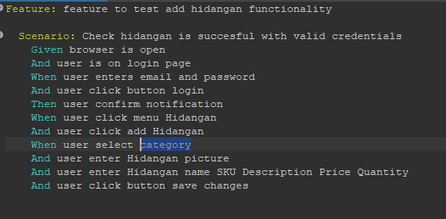

1. The step definition

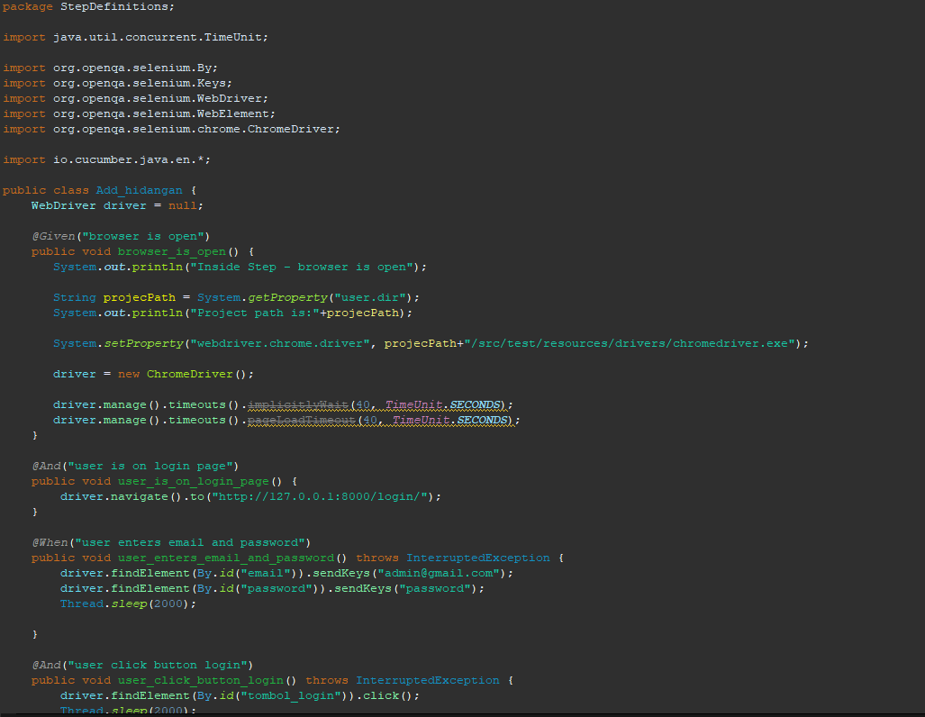

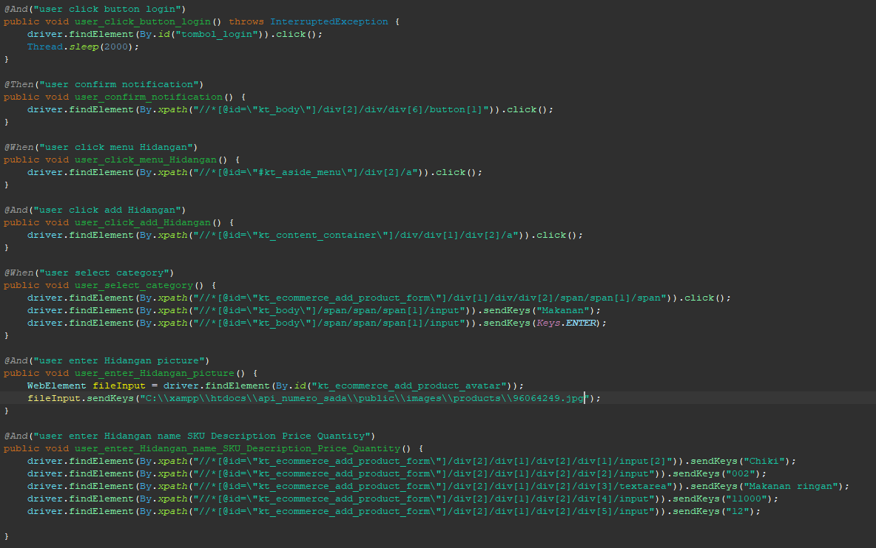

1. The test runner

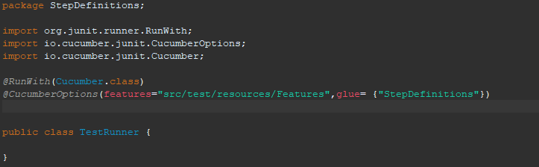

1. The console after running

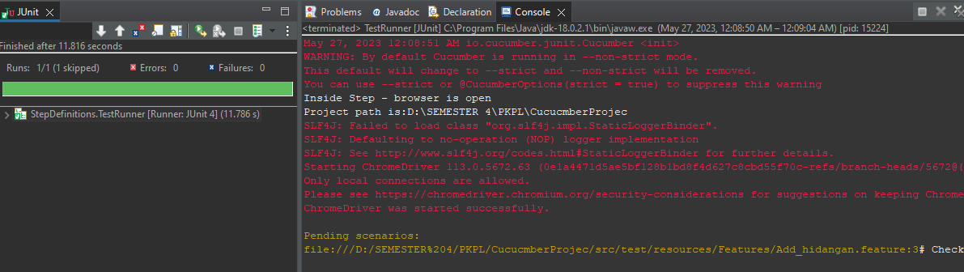

1. The browser while testing

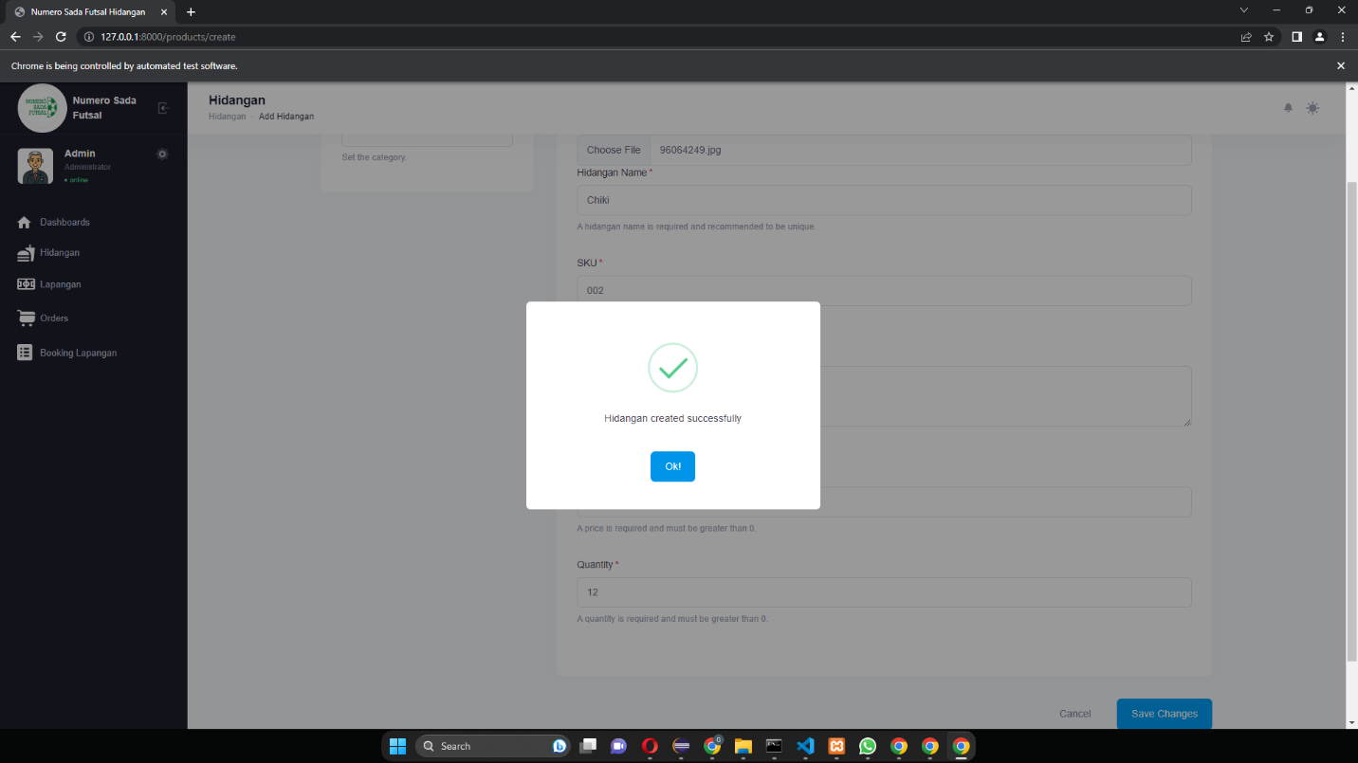

1. Test Fungsi Add Hidangan Variasi 2: Semua parameter valid kecuali parameter picture

Fungsi Add Hidangan

1. The scenario

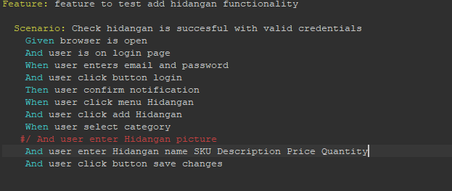

1. The Step definition

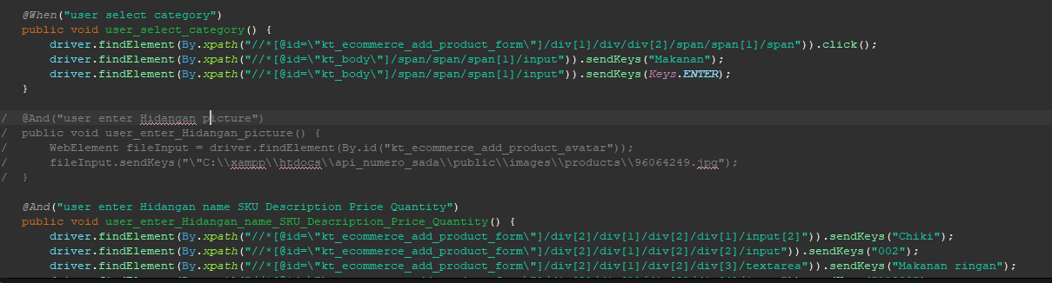

1. The test runner
2. The console after running



1. The browser while testing

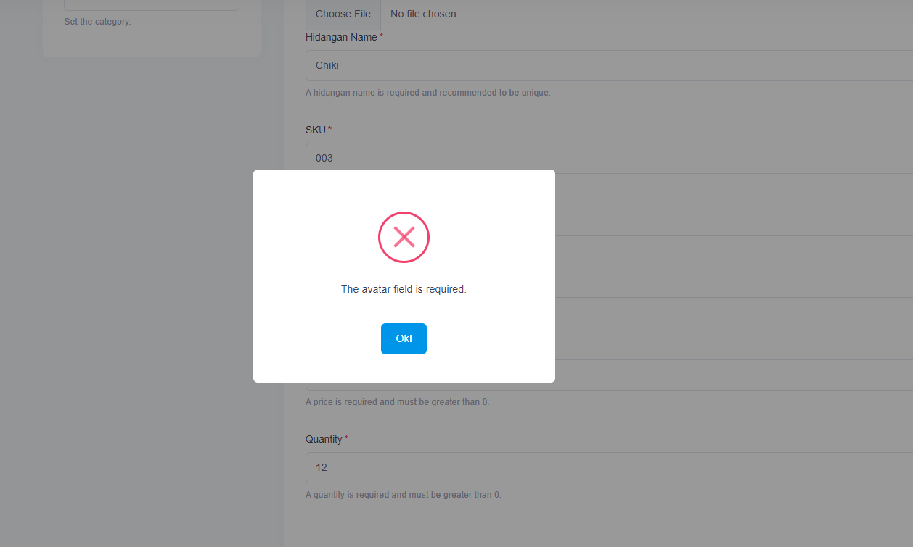

1. Test Fungsi Add Hidangan Variasi 3: Semua parameter valid kecuali parameter hidangan name

Fungsi Add Hidangan

1. The scenario

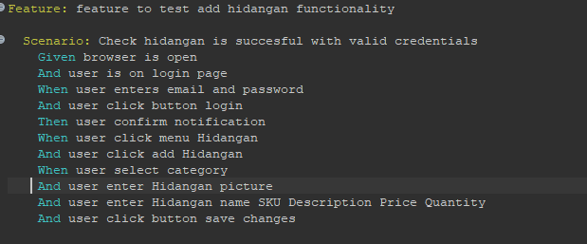

1. The Step definition



1. The test runner



1. The console after running



1. The browser while testing

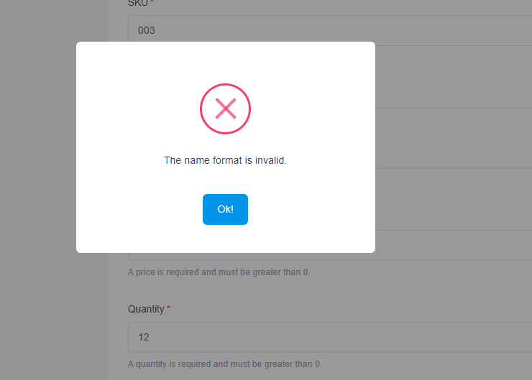

1. Test Fungsi Add Hidangan Variasi 4: Semua valid kecuali parameter SKU

Fungsi Add Hidangan

1. The scenario

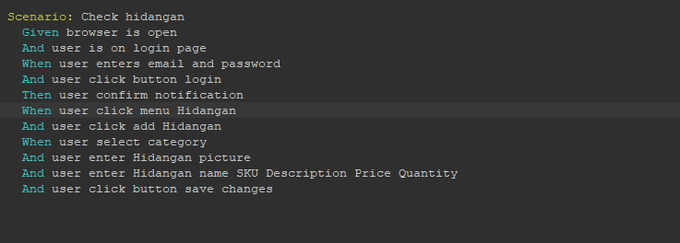

1. The Step definition

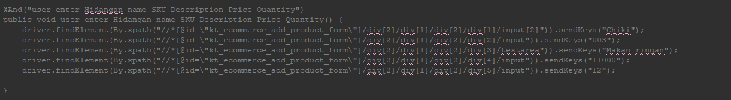

1. The test runner



1. The console after running



1. The browser while testing

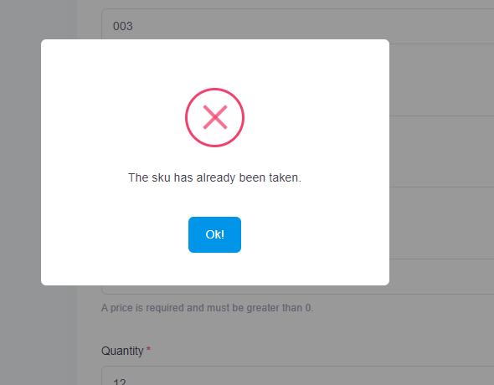

1. Test Fungsi Add Hidangan Variasi 5: Semua valid kecuali parameter description

Fungsi Add Hidangan

1. The scenario



1. The Step definition

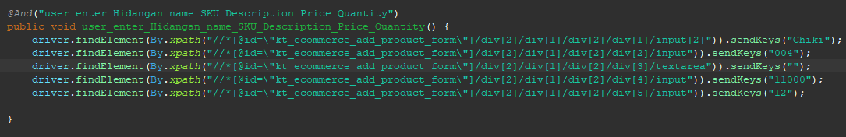

1. The test runner



1. The console after running



1. The browser while testing

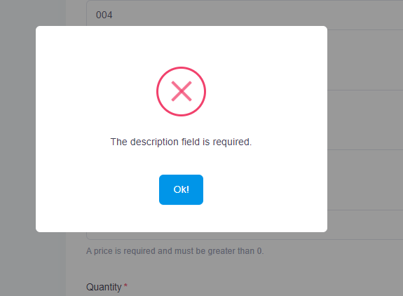

1. Test Fungsi Add Hidangan Variasi 6: Semua valid kecuali parameter price

Fungsi Add Hidangan

1. The scenario



1. The Step definition

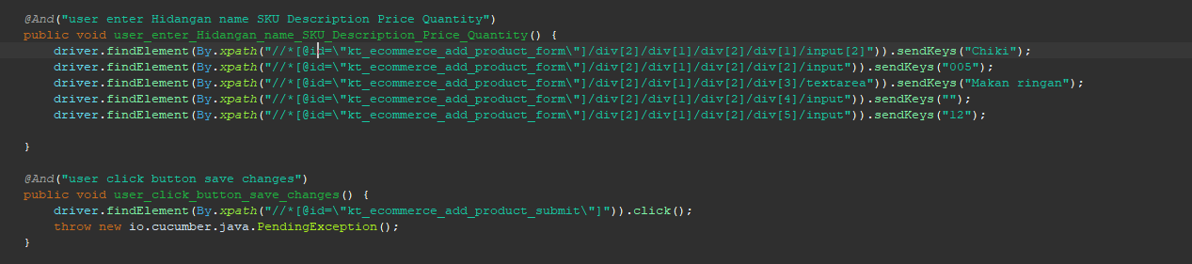

1. The test runner



1. The console after running



1. The browser while testing

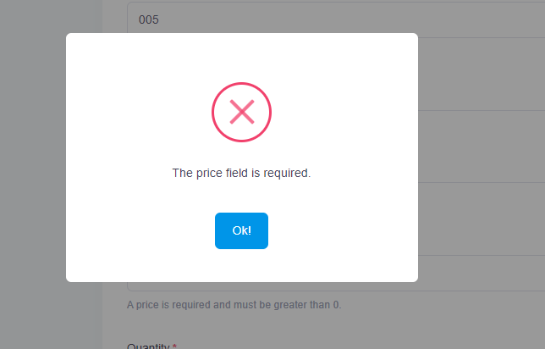

1. Test Fungsi Add Hidangan Variasi 7: Semua valid kecuali parameter quantity

Fungsi Add Hidangan

1. The scenario



1. The Step definition

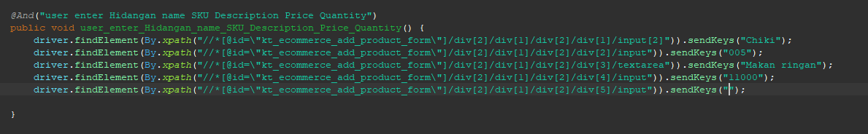

1. The test runner



1. The console after running



1. The browser while testing

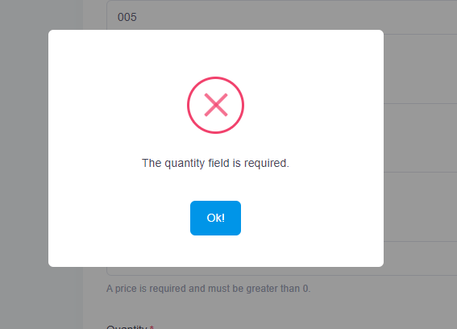

1. Test Fungsi Add Hidangan Variasi 8: Parameter 1,4,5,6,7 valid kecuali parameter 2 dan 3

Fungsi Add Hidangan

1. The scenario

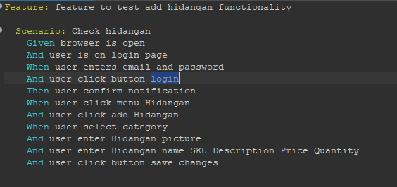

1. The Step definition

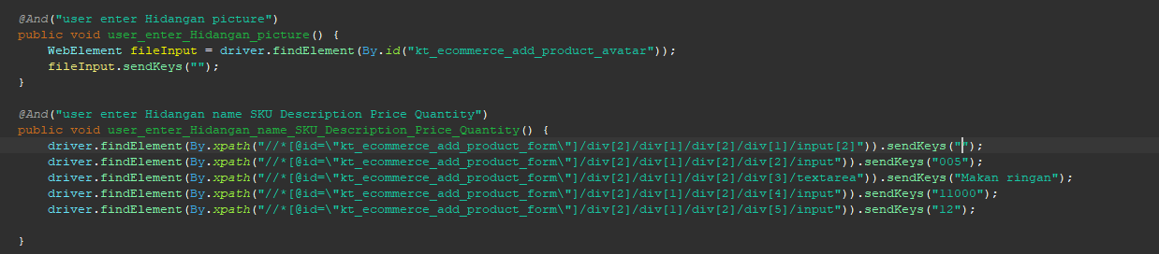

1. The test runner



1. The console after running



1. The browser while testing



1. Test Fungsi Add Hidangan Variasi 9: Parameter 1,2,5,6,7 valid kecuali parameter 3 dan 4

Fungsi Add Hidangan

1. The scenario



1. The Step definition

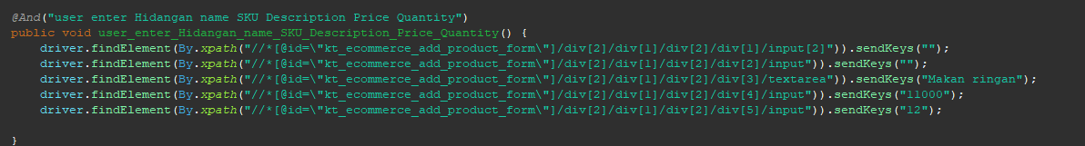

1. The test runner



1. The console after running



1. The browser while testing



1. Test Fungsi Add Hidangan Variasi 10: Parameter 1,2,3,6,7 valid kecuali parameter 4 dan 5

Fungsi Add Hidangan

1. The scenario



1. The Step definition

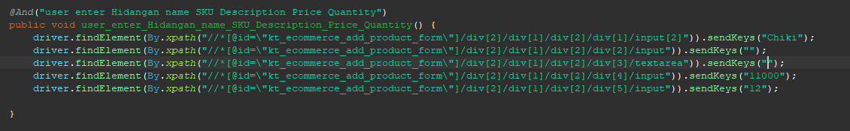

1. The test runner



1. The console after running



1. The browser while testing



1. Test Fungsi Add Hidangan Variasi 11: Parameter 1,2,3,4,7 valid kecuali parameter 5 dan 6

Fungsi Add Hidangan

* 1. The scenario



1. The Step definition



1. The test runner



1. The console after running



1. The browser while testing



1. Test Fungsi Add Hidangan Variasi 12: Parameter 1,2,3,4,5 valid kecuali parameter 6 dan 7

Fungsi Add Hidangan

1. The scenario



1. The Step definition

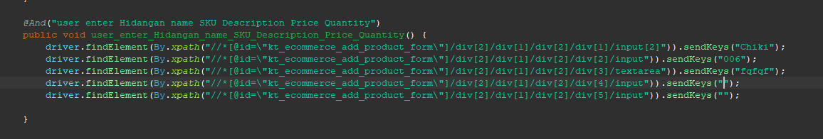

1. The test runner



1. The console after running



1. The browser while testing



1. Test Fungsi Add Hidangan Variasi 13: Parameter 3,4,5,6,7 valid kecuali parameter 1 dan 2

Fungsi Add Hidangan

* 1. The scenario



1. The Step definition



1. The test runner



1. The console after running



1. The browser while testing



1. Test Fungsi Add Hidangan Variasi 14: Parameter 4,5,6,7 valid kecuali parameter 1,2,3

Fungsi Add Hidangan

* 1. The scenario



* 1. The Step definition

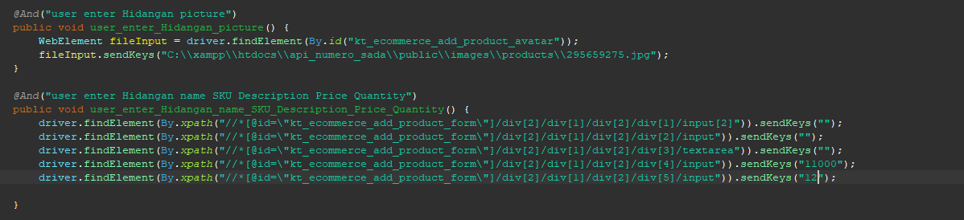

* 1. The test runner



* 1. The console after running



* 1. The browser while testing



1. Test Fungsi Add Hidangan Variasi 15: Parameter 1,5,6,7 valid kecuali parameter 2,3,4

Fungsi Add Hidangan

* 1. The scenario



1. The Step definition

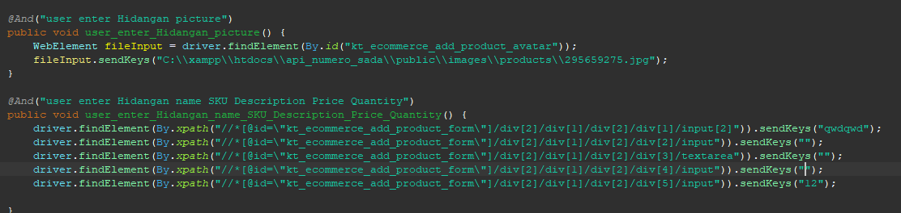

1. The test runner
2. The console after running



1. The browser while testing



1. Test Fungsi Add Hidangan Variasi 16: Parameter 1,2,6,7 valid kecuali parameter 3,4,5

Fungsi Add Hidangan

1. The scenario



1. The Step definition

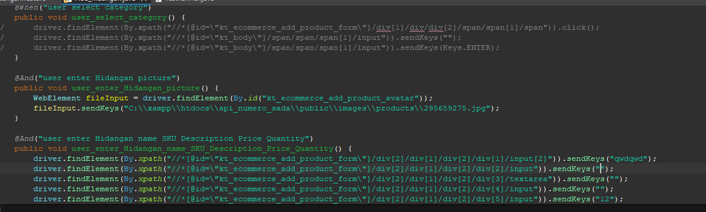

1. The test runner



1. The console after running



1. The browser while testing



1. Test Fungsi Add Hidangan Variasi 17: Parameter 1,2,3,4 valid kecuali parameter 5,6,7

Fungsi Add Hidangan

1. The scenario



1. The Step definition



1. The test runner



1. The console after running



1. The browser while testing



1. Test Fungsi Add Hidangan Variasi 18: Parameter 5,6,7 valid kecuali parameter 1,2,3,4

Fungsi Add Hidangan

1. The scenario



1. The Step definition

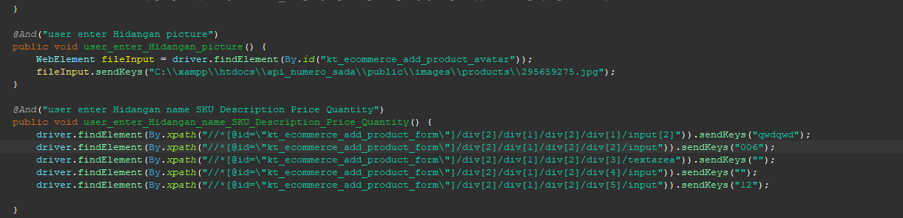

1. The test runner



1. The console after running



1. The browser while testing



1. Test Fungsi Add Hidangan Variasi 19: Parameter 1,6,7 valid kecuali parameter 2,3,4,5

Fungsi Add Hidangan

1. The scenario



1. The Step definition

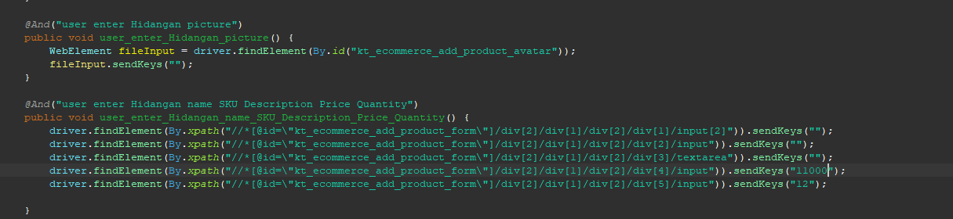

1. The test runner



1. The console after running



1. The browser while testing



1. Test Fungsi Add Hidangan Variasi 20: Parameter 1,2,7 valid kecuali parameter 3,4,5,6

Fungsi Add Hidangan

1. The scenario



1. The Step definition

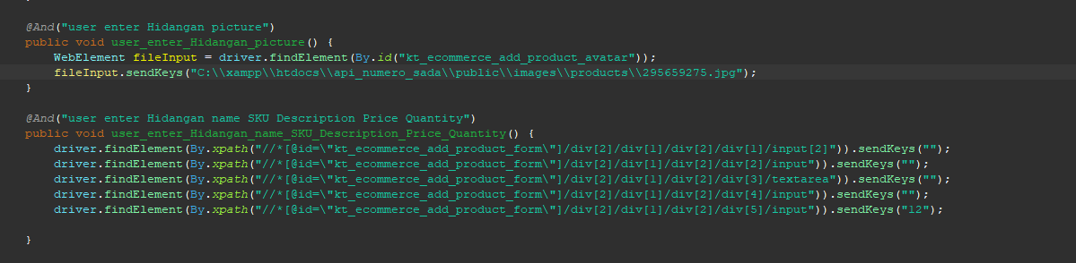

1. The test runner



1. The console after running



1. The browser while testing



1. Test Fungsi Add Hidangan Variasi 21: Parameter 1,2,3 valid kecuali parameter 4,5,6,7

Fungsi Add Hidangan

1. The scenario



1. The Step definition

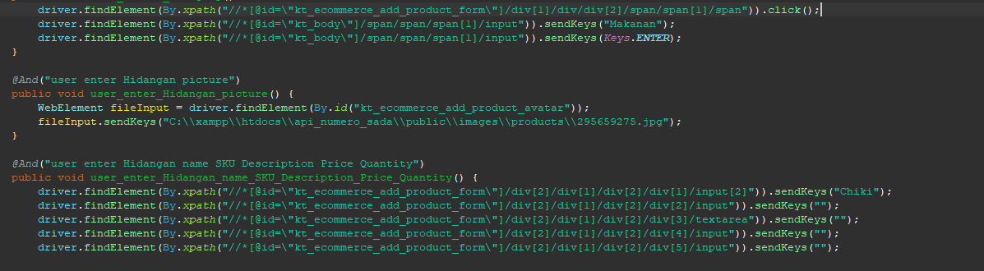

1. The test runner



1. The console after running



1. The browser while testing



1. Test Fungsi Add Hidangan Variasi 22: Parameter 6,7 valid kecuali parameter 1,2,3,4,5

Fungsi Add Hidangan

1. The scenario



1. The Step definition

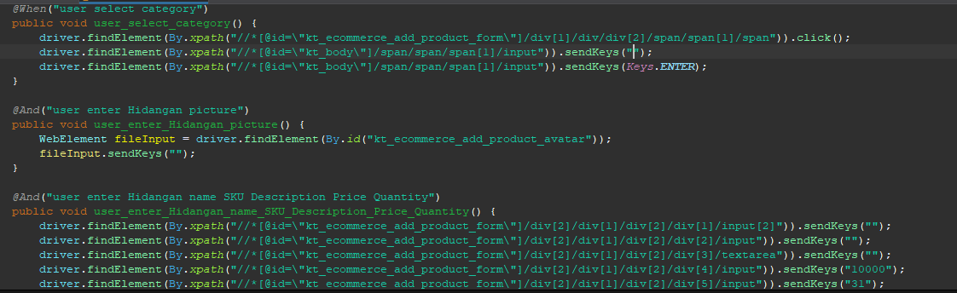

1. The test runner
2. The console after running



1. The browser while testing



1. Test Fungsi Add Hidangan Variasi 23: Parameter 1,7 valid kecuali parameter 2,3,4,5,6

Fungsi Add Hidangan

1. The scenario



1. The Step definition

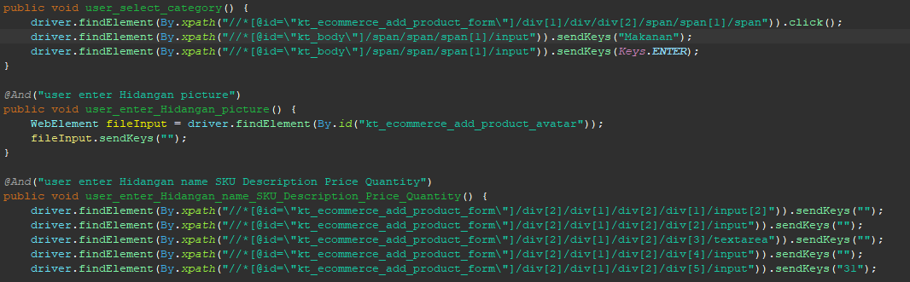

1. The test runner



1. The console after running



1. The browser while testing



1. Test Fungsi Add Hidangan Variasi 24: Parameter 1,2 valid kecuali parameter 3,4,5,6,7

Fungsi Add Hidangan

1. a.The scenario



1. The Step definition

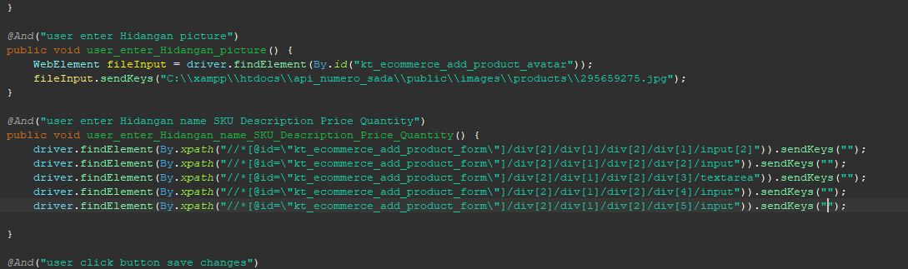

1. The test runner



1. The console after running



1. The browser while testing



1. Test Fungsi Add Hidangan Variasi 25: Parameter 1 valid kecuali parameter 2,3,4,5,6,7

Fungsi Add Hidangan

1. The scenario



1. The Step definition

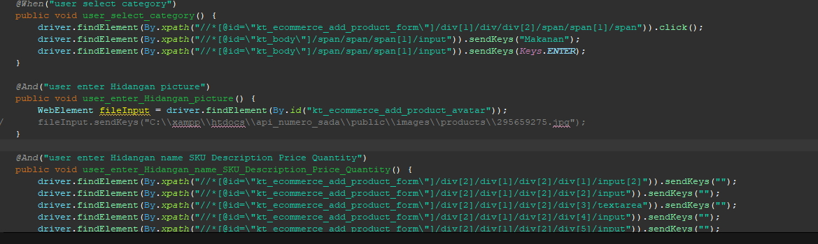

1. The test runner



1. The console after running



1. The browser while testing



1. Test Fungsi Add Hidangan Variasi 26: Tidak ada parameter yang valid

Fungsi Add Hidangan

1. The scenario



1. The Step definition

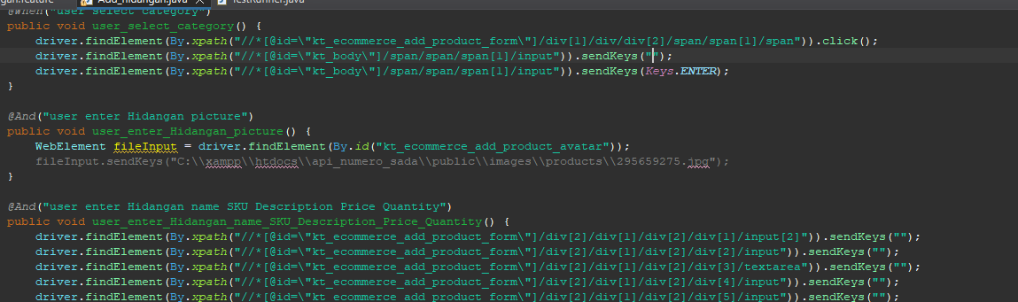

1. The test runner



1. The console after running



1. The browser while testing



1. Test Fungsi Add Hidangan Variasi 27: Parameter 1,3,5,6,7 valid kecuali parameter 2 dan 4

Fungsi Add Hidangan

1. The scenario



1. The Step definition

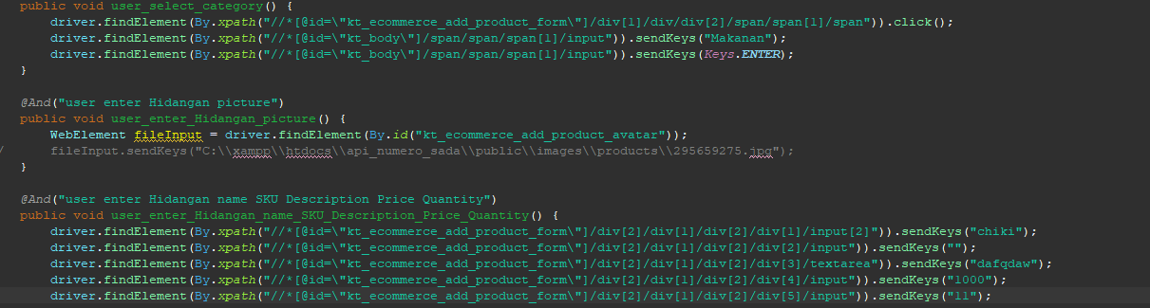

1. The test runner
2. The console after running



1. The browser while testing



1. Test Fungsi Add Hidangan Variasi 28: Parameter 1,2,4,6,7 valid kecuali parameter 3 dan 5

Fungsi Add Hidangan

1. The scenario



1. The Step definition

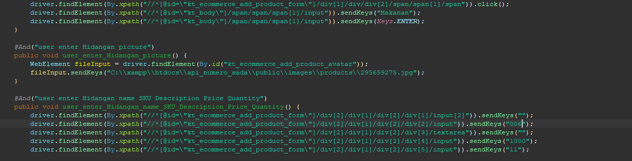

1. The test runner



1. The console after running



1. The browser while testing



1. Test Fungsi Add Hidangan Variasi 29: Parameter 1,2,3,7 valid kecuali parameter 4,5,6

Fungsi Add Hidangan

1. a.The scenario



1. The Step definition



1. The test runner



1. The console after running



1. The browser while testing



1. Test Fungsi Add Hidangan Variasi 30: Parameter 1,2,3,5,7 valid kecuali parameter 4 dan 6

Fungsi Add Hidangan

1. The scenario



1. The Step definition

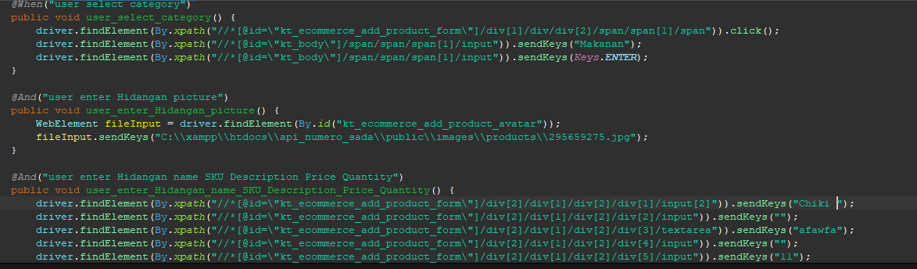

1. The test runner



1. The console after running



1. The browser while testing



1. Test Fungsi Add Hidangan Variasi 31: Parameter 1,2,3,4,6 valid kecuali parameter 5 dan 7

Fungsi Add Hidangan

1. a.The scenario



1. The Step definition

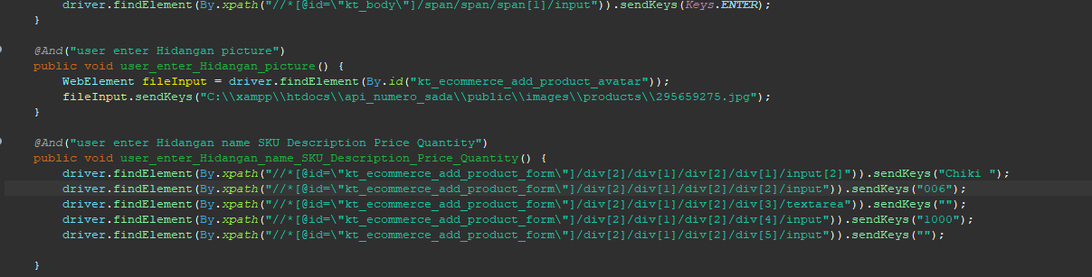

1. The test runner
2. The console after running



1. The browser while testing



1. Test Fungsi Add Hidangan Variasi 32: Parameter 1,3,4,6,7 valid kecuali parameter 2 dan 5

Fungsi Add Hidangan

1. The scenario



1. The Step definition

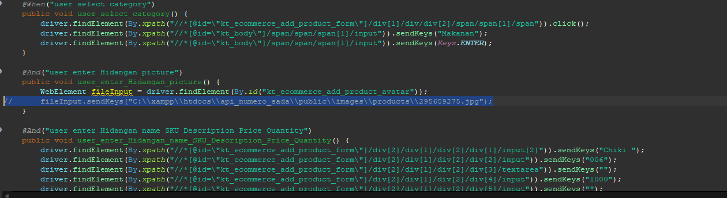

1. The test runner



1. The console after running



1. The browser while testing



1. Test Fungsi Add Hidangan Variasi 33: Parameter 1,2,4,5,7 valid kecuali parameter 3 dan 6

Fungsi Add Hidangan

1. The scenario



1. The Step definition



1. The test runner



1. The console after running



1. The browser while testing



1. Test Fungsi Add Hidangan Variasi 34: Parameter 1,2,3,5,6 valid kecuali parameter 4 dan 7

Fungsi Add Hidangan

1. The scenario



1. The Step definition



1. The test runner



1. The console after running



1. The browser while testing



1. Test Fungsi Add Hidangan Variasi 3: Parameter 1,3,4,5,7 valid kecuali parameter 2 dan 6

Fungsi Add Hidangan

1. The scenario



1. The Step definition



1. The test runner



1. The console after running



1. The browser while testing



1. Test Fungsi Add Hidangan Variasi 36: Parameter 1,2,4,5,6 valid kecuali parameter 3 dan 7

Fungsi Add Hidangan

1. The scenario



1. The Step definition



1. The test runner
2. The console after running



1. The browser while testing



1. Test Fungsi Add Hidangan Variasi 37: Parameter 1,3,4,5,6 valid kecuali parameter 2 dan 7

Fungsi Add Hidangan

1. The scenario



1. The Step definition



1. The test runner



1. The console after running



1. The browser while testing



1. Test Fungsi Add Hidangan Variasi 38: Parameter 1,3,5,7 valid kecuali parameter 2,4,6

Fungsi Add Hidangan

1. The scenario



1. The Step definition



1. The test runner



1. The console after running



1. The browser while testing



1. Test Fungsi Add Hidangan Variasi 39: Parameter 1,2,4,6 valid kecuali parameter 3,5,7

Fungsi Add Hidangan

1. The scenario



1. The Step definition



1. The test runner



1. The console after running



1. The browser while testing



1. Test Fungsi Add Hidangan Variasi 1: Parameter 2,4,6,7 valid kecuali parameter 1,3,5

Fungsi Add Hidangan

1. The scenario



1. The step definition





1. The test runner



1. The console after running



1. The browser while testing
2. Test Fungsi Add Hidangan Variasi 40: Parameter 2,4,6,7 valid kecuali parameter 1,3,5

Fungsi Add Hidangan

1. The scenario



1. The step definition





1. The test runner



1. The console after running



1. The browser while testing

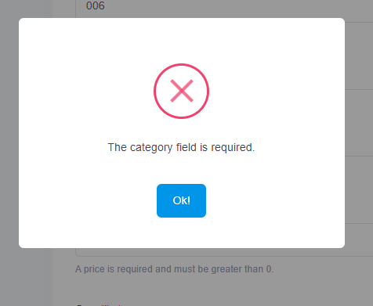

1. Test Fungsi Add Hidangan Variasi 41: Parameter 2,4,6 valid kecuali parameter 1,3,5,7

Fungsi Add Hidangan

1. The scenario



1. The Step definition



1. The test runner



1. The console after running



1. The browser while testing



1. Test Fungsi Add Hidangan Variasi 42: Parameter 1,2,3 valid kecuali parameter 4,5,6,7

Fungsi Add Hidangan

a.The scenario



1. The Step definition



1. The test runner



1. The console after running



1. The browser while testing



1. Test Fungsi Add Hidangan Variasi 43: Parameter 1,2,7 valid kecuali parameter 3,4,5,6

Fungsi Add Hidangan

1. The scenario



1. The Step definition



1. The test runner



1. The console after running



1. The browser while testing



1. Test Fungsi Add Hidangan Variasi 44: Parameter 1,2,7 valid kecuali parameter 3,4,5,6

Fungsi Add Hidangan

1. The scenario



1. The Step definition



1. The test runner



1. The console after running



1. The browser while testing



1. The scenario



1. The Step definition



1. The test runner



1. The console after running



1. The browser while testing



1. Test Fungsi Add Hidangan Variasi 45: Parameter 1,2,3 valid kecuali parameter 4,5,6,7

Fungsi Add Hidangan

1. The scenario



1. The Step definition



1. The test runner



1. The console after running



1. The browser while testing



1. Test Fungsi Add Hidangan Variasi 46: Parameter 1,2 valid kecuali parameter 3,4,5,6,7

Fungsi Add Hidangan

1. The scenario



1. The Step definition



1. The test runner



1. The console after running



1. The browser while testing



1. Test Fungsi Add Hidangan Variasi 47: Parameter 1 valid kecuali parameter 2,3,4,5,6,7

Fungsi Add Hidangan

1. The scenario



1. The Step definition



1. The test runner



1. The console after running



1. The browser while testing



1. Test Fungsi Add Hidangan Variasi 48: Parameter 4,5,6,7 valid kecuali parameter 1,2,3

Fungsi Add Hidangan

1. The scenario



1. The step definition





1. The test runner



1. The console after running



1. The browser while testing



1. Test Fungsi Add Hidangan Variasi 49: Parameter 3,4,5,6,7valid kecuali parameter 1 dan 2

Fungsi Add Hidangan

1. The scenario



1. The step definition





1. The test runner



1. The console after running



1. The browser while testing



1. Test Fungsi Add Hidangan Variasi 50: Add Hidangan dengan parameter valid 5 dan 6 kecuali 1,2,3,4, dan 7
2. a.The scenario



1. The Step definition



1. The test runner



1. The console after running



1. The browser while testing



1. Test Fungsi Add Hidangan Variasi 51: Add Hidangan dengan parameter valid 6 dan 7 kecuali 1,2,3,4, dan 5
2. The scenario



1. The step definition





1. The test runner



1. The console after running



1. The browser while testing



1. Test Fungsi Add Hidangan Variasi 52: Add Hidangan dengan parameter valid 2 dan 4 kecuali 1 dan 7
2. The step definition







1. The test runner



1. The console after running



1. The browser while testing



1. Test Fungsi Add Hidangan Variasi 53: Parameter 2,4 valid kecuali parameter 1,3,5,6,7
2. The scenario



1. The Step definition



1. The test runner
2. The console after running



1. The browser while testing



1. Test Fungsi Add Hidangan Variasi 54: Add Hidangan dengan parameter valid 3 dan 5 kecuali 1,2,4,6 dan 7

The scenario



1. The step definition





1. The test runner



1. The console after running



1. The browser while testing



1. Test Fungsi Add Hidangan Variasi 55: Parameter 4,6 valid kecuali parameter 1,2,3,5,7

Fungsi Add Hidangan

1. The scenario



1. The Step definition



1. The test runner



1. The console after running



1. The browser while testing



1. Test Fungsi Add Hidangan Variasi 56: Parameter 5,7 valid kecuali parameter 1,2,3,4,6

Fungsi Add Hidangan

1. The scenario



1. The Step definition



1. The test runner



1. The console after running



1. The browser while testing



1. Test Fungsi Add Hidangan Variasi 57: Parameter 1,6 valid kecuali parameter 2,3,4,5,7

Fungsi Add Hidangan

1. The scenario



1. The Step definition



1. The test runner



1. The console after running



1. The browser while testing



1. Test Fungsi Add Hidangan Variasi 58: Parameter 2,5 valid kecuali parameter 1,3,4,6,7

Fungsi Add Hidangan

1. The scenario



1. The step definition





1. The test runner



1. The console after running



1. The browser while testing



1. Test Fungsi Add Hidangan Variasi 59: Parameter 3,6 valid kecuali parameter 1,2,4,5,7

Fungsi Add Hidangan

1. The scenario



1. The Step definition



1. The test runner



1. The console after running



1. The browser while testing



1. Test Fungsi Add Hidangan Variasi 60: Parameter 4,7 valid kecuali parameter 1,2,3,5,6

Fungsi Add Hidangan

1. The scenario



1. The step definition





1. The test runner



1. The console after running



1. The browser while testing



1. Test Fungsi Add Hidangan Variasi 61: Parameter 1,6 valid kecuali parameter 2,3,4,5,7

Fungsi Add Hidangan

1. The scenario



1. The Step definition



1. The test runner
2. The console after running



1. The browser while testing



1. Test Fungsi Add Hidangan Variasi 62: Parameter 2,6 valid kecuali parameter 1,3,4,5,7

Fungsi Add Hidangan

1. The scenario



1. The step definition





1. The test runner



1. The console after running



1. The browser while testing



1. Test Fungsi Add Hidangan Variasi 63: Parameter valid 3 dan 7 kecuali 1,2,4, dan 6
2. The scenario



1. The Step definition



1. The test runner



1. The console after running



1. The browser while testing



1. Test Fungsi Add Hidangan Variasi 64: Parameter valid 1dan 3 kecuali 2,4,,5,6 dan 7
2. a.The scenario



1. The Step definition



1. The test runner



1. The console after running



1. The browser while testing



1. Test Fungsi Add Hidangan Variasi 66: Parameter valid 1,6 dan 7 kecuali 2,3,4, dan 5
2. The scenario



1. The step definition





1. The test runner



1. The console after running



1. The browser while testing



1. Test Fungsi Add Hidangan Variasi 67: Parameter valid 3 dan 5 kecuali 1,2,6,4, dan 7

The scenario



1. The step definition





1. The test runner



1. The console after running



1. The browser while testing



1. Test Fungsi Add Hidangan Variasi 68: Parameter valid 5,6 dan 7 kecuali 1,2,3,dan 4

The scenario



1. The Step definition



1. The test runner



1. The console after running



1. The browser while testing



1. Test Fungsi Add Hidangan Variasi 69:Parameter valid 1,2,6 dan 7 kecuali 3,4,dan 5
2. The scenario



1. The Step definition



1. The test runner



1. The console after running



1. The browser while testing



1. Test Fungsi Add Hidangan Variasi 70: Parameter valid 4,5,6 dan 7 kecuali 1,2 dan 3

The scenario



1. The step definition





1. The test runner



1. The console after running



1. The browser while testing



1. Test Fungsi Add Hidangan Variasi 71: Parameter valid 1 dan 2 kecuali 3,4,5,6 dan 7
2. The scenario



1. The Step definition



1. The test runner
2. The console after running



1. The browser while testing



1. Test Fungsi Add Hidangan Variasi 72: Parameter valid 1,4 dan 7 kecuali 2,3,5 dan 6
2. The scenario



1. The Step definition



1. The test runner



1. The console after running



1. The browser while testing



1. Test Fungsi Add Hidangan Variasi 73: Parameter valid 1,2 dan 5 kecuali 3,4,6 dan 7
2. The scenario



1. The Step definition



1. The test runner



1. The console after running



1. The browser while testing



1. Test Fungsi Add Hidangan Variasi 74: Parameter valid 1 dan 5 kecuali 2,3,4,6 dan7
2. The scenario



1. The Step definition



1. The test runner
2. The console after running



1. The browser while testing



1. Test Fungsi Add Hidangan Variasi 75: Parameter valid 2,4 dan 7 kecuali 1,3,5 dan 6
2. a.The scenario



1. The Step definition



1. The test runner



1. The console after running



1. The browser while testing



1. Test Fungsi Add Hidangan Variasi 76: Parameter valid 1,3,4 dan 5 kecuali 2,6 dan 7
2. The scenario



1. The Step definition



1. The test runner



1. The console after running



1. The browser while testing



1. Test Fungsi Add Hidangan Variasi 77:Parameter valid 2,5,6 dan 7 kecuali 1,3, dan 4
2. The scenario



1. The Step definition



1. The test runner
2. The console after running



1. The browser while testing



1. Test Fungsi Add Hidangan Variasi 78: Parameter valid 1 dan 5 kecuali 6,2,3,4, dan 7
2. The scenario



1. The step definition





1. The test runner



1. The console after running



1. The browser while testing



1. Test Fungsi Add Hidangan Variasi 79: Parameter valid 1 dan 5 kecuali 2,3,4, dan 7
   1. The scenario



1. The Step definition



1. The test runner



1. The console after running



1. The browser while testing



1. Test Fungsi Add Hidangan Variasi 80: Parameter valid 1, 5 dan 6 kecuali 2,3,4, dan 7
2. The scenario



1. The Step definition



1. The test runner



1. The console after running



1. The browser while testing



1. Test Fungsi Add Hidangan Variasi 81:Parameter valid 5 dan 6 kecuali 1,2,3,4, dan 7
2. The scenario



1. The step definition





1. The test runner



1. The console after running



1. The browser while testing



1. Test Fungsi Add Hidangan Variasi 82:Parameter valid 2,3,5,6 dan 7 kecuali 1 dan 4
2. The scenario



1. The Step definition



1. The test runner



1. The console after running



1. The browser while testing



1. Test Fungsi Add Hidangan Variasi 83: Add Hidangan dengan parameter yang valid

Fungsi Add Hidangan

1. The scenario



1. The Step definition



1. The test runner



1. The console after running



1. The browser while testing



1. Test Fungsi Add Hidangan Variasi 84:Parameter valid 2,3,4 dan 6 kecuali 1, 5 dan 7
2. The scenario



1. The Step definition



1. The test runner



1. The console after running



1. The browser while testing



1. Test Fungsi Add Hidangan Variasi 85:Parameter valid 1,3,4,5 dan 7 kecuali 2 dan 6
2. The scenario



1. The Step definition



1. The test runner
2. The console after running



1. The browser while testing



1. Test Fungsi Add Hidangan Variasi 86:Parameter valid tidak ada
2. The scenario



1. The Step definition



1. The test runner



1. The console after running



1. The browser while testing



1. Test Fungsi Add Hidangan Variasi 87:Parameter valid 2,4 dan 5 kecuali 1,3,dan 7
2. The scenario



1. The Step definition



1. The test runner
2. The console after running



1. The browser while testing



1. Test Fungsi Add Hidangan Variasi 88: Parameter valid 2,5 dan 6 kecuali 1,3,4, dan 7
2. The scenario



1. The Step definition



1. The test runner



1. The console after running



1. The browser while testing



1. Test Fungsi Add Hidangan Variasi 89: Parameter valid 1,4,5 dan 6 kecuali 2,3, dan 7
   1. The scenario



1. The Step definition



1. The test runner



1. The console after running



1. The browser while testing



1. Test Fungsi Add Hidangan Variasi 90: Parameter valid 1,2,3,6 dan 6 kecuali 4,5 dan 7
2. The scenario



1. The Step definition



1. The test runner



1. The console after running



1. The browser while testing



1. Test Fungsi Add Hidangan Variasi 91: Parameter valid tidak ada
2. The scenario



1. The Step definition

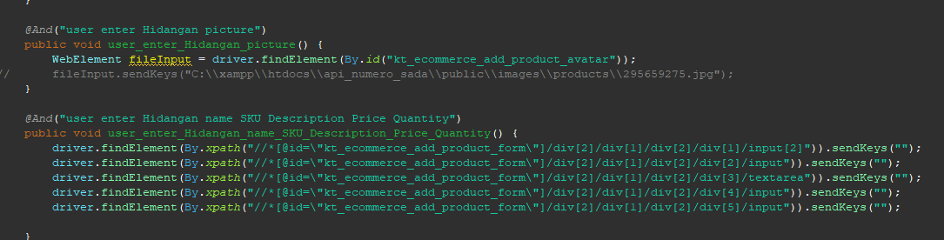

1. The test runner



1. The console after running



1. The browser while testing



1. Test Fungsi Add Hidangan Variasi 92: Parameter valid 1 dan 4 kecuali 2,3,5 dan 7
2. The scenario



1. The step definition





1. The test runner



1. The console after running



1. The browser while testing



1. Test Fungsi Add Hidangan Variasi 93: Parameter valid 3,4,5, dan 6 kecuali 1,2, dan 7

The scenario



1. The Step definition



1. The test runner



1. The console after running



1. The browser while testing



1. Test Fungsi Add Hidangan Variasi 94:Parameter valid 6 kecuali 1,2,3,4,6, dan 7
2. The scenario



1. The Step definition



1. The test runner



1. The console after running



1. The browser while testing



1. Test Fungsi Add Hidangan Variasi 95:Parameter valid 4,6 dan 7 kecuali 1,2,3, dan 5
2. The scenario



1. The Step definition



1. The test runner



1. The console after running



1. The browser while testing



1. Test Fungsi Add Hidangan Variasi 96: Parameter valid 2,3,4, dan 6 kecuali 1,5, dan 7
2. The scenario



1. The Step definition



1. The test runner



1. The console after running



1. The browser while testing



1. Test Fungsi Add Hidangan Variasi 97: Parameter tidak ada yang valid

The scenario



1. The Step definition



1. The test runner



1. The console after running



1. The browser while testing



1. Test Fungsi Add Hidangan Variasi 98: Parameter valid 2,3,4,5 dan 6 kecuali 1 dan 7

The scenario



1. The step definition





1. The test runner



1. The console after running



1. The browser while testing



1. Test Fungsi Add Hidangan Variasi 99: Parameter valid 1,3,4,5 dan 6 kecuali 2 dan 7

Fungsi Add Hidangan

1. The scenario



1. The Step definition



1. The test runner
2. The console after running



1. The browser while testing



1. Test Fungsi Add Hidangan Variasi 100: Parameter valid 1,2,4,5 dan 6 kecuali 3, dan 7

Fungsi Add Hidangan

1. The scenario



1. The Step definition



1. The test runner



1. The console after running



1. The browser while testing



1. Fungsi Add Hidangan

Test Frame Fungsi Add Hidangan

|  |  |  |  |  |  |  |  |  |
| --- | --- | --- | --- | --- | --- | --- | --- | --- |
| Test Fungsi A | Input | | | | | | | Jumlah Testcase |
| Parameter  1  (Category) | Parameter 2 (Hidangan Picture) | Parameter 3  (Hidangan Name) | Parameter  4  (SKU) | Parameter  5  (Description) | Parameter  6  (Price) | Parameter  7  (Quantity) |
| Variasi 1 | Valid | Valid | Valid | Valid | Valid | Valid | Valid | 1 |
| Variasi 2 | Valid | Invalid | Valid | Valid | Valid | Valid | Valid | 1 |
| Variasi 3 | Valid | Valid | Invalid | Valid | Valid | Valid | Valid | 1 |
| Variasi 4 | Valid | Valid | Valid | Invalid | Valid | Valid | Valid | 1 |
| Variasi 5 | Valid | Valid | Valid | Valid | Invalid | Valid | Valid | 1 |
| Variasi 6 | Valid | Valid | Valid | Valid | Valid | Invalid | Valid | 1 |
| Variasi 7 | Valid | Valid | Valid | Valid | Valid | Valid | Invalid | 1 |
| Variasi 8 | Valid | Invalid | Invalid | Valid | Valid | Valid | Valid | 1 |
| Variasi 9 | Valid | Valid | Invalid | Invalid | Valid | Valid | Valid | 1 |
| Variasi 10 | Valid | Valid | Valid | Invalid | Invalid | Valid | Valid | 1 |
| Variasi 11 | Valid | Valid | Valid | Valid | Invalid | Invalid | Valid | 1 |
| Variasi 12 | Valid | Valid | Valid | Valid | Valid | Invalid | Invalid | 1 |
| Variasi 13 | Invalid | Invalid | Valid | Valid | Valid | Valid | Valid | 1 |
| Variasi 14 | Invalid | Invalid | Invalid | Valid | Valid | Valid | Valid | 1 |
| Variasi 15 | Valid | Invalid | Invalid | Invalid | Valid | Valid | Valid | 1 |
| Variasi 16 | Valid | Valid | Invalid | Invalid | Invalid | Valid | Valid | 1 |
| Variasi 16 | Valid | Valid | Valid | Invalid | Invalid | Invalid | Valid | 1 |
| Variasi 17 | Valid | Valid | Valid | Valid | Invalid | Invalid | Invalid | 1 |
| Variasi 18 | Invalid | Invalid | Invalid | Invalid | Valid | Valid | Valid | 1 |
| Variasi 19 | Valid | Invalid | Invalid | Invalid | Invalid | Valid | Valid | 1 |
| Variasi 20 | Valid | Valid | Invalid | Invalid | Invalid | Invalid | Valid | 1 |
| Variasi 21 | Valid | Valid | Valid | Invalid | Invalid | Invalid | Invalid | 1 |
| Variasi 22 | Invalid | Invalid | Invalid | Invalid | Invalid | Valid | Valid | 1 |
| Variasi 23 | Valid | Invalid | Invalid | Invalid | Invalid | Invalid | Valid | 1 |
| Variasi 24 | Valid | Valid | Invalid | Invalid | Invalid | Invalid | Invalid | 1 |
| Variasi 25 | Valid | Invalid | Invalid | Invalid | Invalid | Invalid | Invalid | 1 |
| Variasi 26 | Invalid | Invalid | Invalid | Invalid | Invalid | Invalid | Invalid | 1 |
| Variasi 27 | Valid | Invalid | Valid | Invalid | Valid | Valid | Valid | 1 |
| Variasi 28 | Valid | Valid | Invalid | Valid | Invalid | Valid | Valid | 1 |
| Variasi 30 | Valid | Valid | Valid | Invalid | Valid | Invalid | Valid | 1 |
| Variasi 31 | Valid | Valid | Valid | Valid | Invalid | Valid | Invalid | 1 |
| Variasi 32 | Valid | Invalid | Valid | Valid | Invalid | Valid | Valid | 1 |
| Variasi 33 | Valid | Valid | Invalid | Valid | Valid | Invalid | Valid | 1 |
| Variasi 34 | Valid | Valid | Valid | Invalid | Valid | Valid | Invalid | 1 |
| Variasi 35 | Valid | Invalid | Valid | Valid | Valid | Invalid | Valid | 1 |
| Variasi 36 | Valid | Valid | Invalid | Valid | Valid | Valid | Invalid | 1 |
| Variasi 37 | Valid | Invalid | Valid | Valid | Valid | Valid | Invalid | 1 |
| Variasi 38 | Valid | Invalid | Valid | Invalid | Valid | Invalid | Valid | 1 |
| Variasi 39 | Valid | Valid | Invalid | Valid | Invalid | Valid | Invalid | 1 |
| Variasi 40 | Invalid | Valid | Invalid | Valid | Invalid | Valid | Valid | 1 |
| Variasi 41 | Invalid | Valid | Invalid | Valid | Invalid | Valid | Invalid | 1 |
| Variasi 42 | Valid | Valid | Valid | Invalid | Invalid | Invalid | Invalid | 1 |
| Variasi 43 | Valid | Invalid | Invalid | Invalid | Invalid | Valid | Valid | 1 |
| Variasi 44 | Valid | Valid | Invalid | Invalid | Invalid | Invalid | Valid | 1 |
| Variasi 45 | Valid | Valid | Valid | Invalid | Invalid | Invalid | Invalid | 1 |
| Variasi 46 | Valid | Valid | Invalid | Invalid | Invalid | Invalid | Invalid | 1 |
| Variasi 47 | Valid | Invalid | Invalid | Invalid | Invalid | Invalid | Invalid | 1 |
| Variasi 48 | Invalid | Invalid | Invalid | Valid | Valid | Valid | Valid | 1 |
| Variasi 49 | Invalid | Invalid | Valid | Valid | Valid | Valid | Valid | 1 |
| Variasi 50 | Invalid | Invalid | Valid | Valid | Invalid | Invalid | Invalid | 1 |
| Variasi 51 | Invalid | Invalid | Invalid | Invalid | Valid | Valid | Invalid | 1 |
| Variasi 52 | Invalid | Invalid | Invalid | Invalid | Invalid | Valid | Valid | 1 |
| Variasi 53 | Invalid | Valid | Invalid | Valid | Invalid | Invalid | Invalid | 1 |
| Variasi 54 | Invalid | Invalid | Valid | Invalid | Valid | Invalid | Invalid | 1 |
| Variasi 55 | Invalid | Invalid | Invalid | Valid | Invalid | Valid | Invalid | 1 |
| Variasi 56 | Invalid | Invalid | Invalid | Invalid | Valid | Invalid | Valid | 1 |
| Variasi 57 | Valid | Invalid | Invalid | Invalid | Invalid | Valid | Invalid | 1 |
| Variasi 58 | Invalid | Valid | Invalid | Invalid | Valid | Invalid | Invalid | 1 |
| Variasi 59 | Invalid | Invalid | Valid | Invalid | Invalid | Valid | Invalid | 1 |
| Variasi 60 | Invalid | Invalid | Invalid | Valid | Invalid | Invalid | Valid | 1 |
| Variasi 61 | Valid | Invalid | Invalid | Invalid | Valid | Invalid | Invalid | 1 |
| Variasi 62 | Invalid | Valid | Invalid | Invalid | Invalid | Valid | Invalid | 1 |
| Variasi 63 | Invalid | Invalid | Valid | Invalid | Invalid | Invalid | Valid | 1 |
| Variasi 64 | Valid | Invalid | Invalid | Valid | Invalid | Invalid | Invalid | 1 |
| Variasi 65 | Invalid | Valid | Invalid | Invalid | Invalid | Valid | Invalid | 1 |
| Variasi 66 | Invalid | Valid | Invalid | Invalid | Invalid | Valid | Invalid | 1 |
| Variasi 67 | Invalid | Invalid | Valid | Invalid | Valid | Invalid | Invalid | 1 |
| Variasi 68 | Invalid | Invalid | Invalid | Invalid | Valid | Valid | Valid | 1 |
| Variasi 69 | Invalid | Invalid | Valid | Valid | Valid | Invalid | Invalid | 1 |
| Variasi 70 | Invalid | Invalid | Invalid | Valid | Valid | Valid | Valid | 1 |
| Variasi 71 | Invalid | Invalid | Valid | Valid | Valid | Valid | Valid | 1 |
| Variasi 72 | Invalid | Valid | Valid | Invalid | Valid | Valid | Invalid | 1 |
| Variasi 73 | Invalid | Invalid | Valid | Valid | Invalid | Valid | Valid | 1 |
| Variasi 74 | Invalid | Valid | Valid | Valid | Invalid | Valid | Valid | 1 |
| Variasi 75 | Valid | Invalid | Valid | Invalid | Valid | Valid | Invalid | 1 |
| Variasi 76 | Invalid | Valid | Invalid | Invalid | Invalid | Valid | Valid | 1 |
| Variasi 77 | Valid | Invalid | Valid | Valid | Invalid | Invalid | Invalid | 1 |
| Variasi 78 | Invalid | Valid | Valid | Valid | Invalid | Valid | Valid | 1 |
| Variasi 79 | Invalid | Valid | Valid | Valid | Invalid | Valid | Valid | 1 |
| Variasi 80 | Invalid | Valid | Valid | Valid | Invalid | Invalid | Valid | 1 |
| Variasi 81 | Invalid | Valid | Valid | Valid | Valid | Invalid | Valid | 1 |
| Variasi 82 | Invalid | Valid | Valid | Invalid | Valid | Valid | Valid | 1 |
| Variasi 83 | Invalid | Valid | Valid | Valid | Invalid | Valid | Invalid | 1 |
| Variasi 84 | Invalid | Valid | Valid | Invalid | Valid | Invalid | Valid | 1 |
| Variasi 85 | Valid | Invalid | Valid | Valid | Valid | Invalid | Valid | 1 |
| Variasi 86 | Invalid | Invalid | Invalid | Invalid | Invalid | Invalid | Invalid | 1 |
| Variasi 87 | Valid | Invalid | Valid | Valid | Invalid | Valid | Valid | 1 |
| Variasi 88 | Invalid | Valid | Invalid | Invalid | Valid | Valid | Invalid | 1 |
| Variasi 89 | Invalid | Valid | Valid | Invalid | Invalid | Invalid | Valid | 1 |
| Variasi 90 | Valid | Valid | Valid | Invalid | Invalid | Valid | Invalid | 1 |
| Variasi 91 | Invalid | Invalid | Invalid | Invalid | Invalid | Invalid | Invalid | 1 |
| Variasi 92 | Invalid | Valid | Valid | Invalid | Valid | Valid | Valid | 1 |
| Variasi 93 | Invalid | Invalid | Valid | Valid | Valid | Valid | Invalid | 1 |
| Variasi 94 | Invalid | Invalid | Invalid | Invalid | Invalid | Valid | Invalid | 1 |
| Variasi 95 | Invalid | Invalid | Invalid | Valid | Invalid | Valid | Valid | 1 |
| Variasi 96 | Invalid | Valid | Valid | Valid | Invalid | Valid | Invalid | 1 |
| Variasi 97 | Invalid | Invalid | Invalid | Invalid | Invalid | Invalid | Invalid | 1 |
| Variasi 98 | Invalid | Valid | Valid | Valid | Valid | Invalid | Valid | 1 |
| Variasi 99 | Valid | Invalid | Valid | Valid | Valid | Valid | Invalid | 1 |
| Variasi 100 | Valid | Valid | Invalid | Valid | Valid | Valid | Invalid | 1 |

1. Test Fungsi Add Hidangan Variasi 1: Add Hidangan dengan parameter yang valid

Fungsi Add Hidangan

1. The scenario



1. The step definition





1. The test runner



1. The console after running



1. The browser while testing



1. Test Fungsi Add Hidangan Variasi 2: Semua parameter valid kecuali parameter picture

Fungsi Add Hidangan

1. The scenario



1. The Step definition



1. The test runner
2. The console after running



1. The browser while testing



1. Test Fungsi Add Hidangan Variasi 3: Semua parameter valid kecuali parameter hidangan name

Fungsi Add Hidangan

1. The scenario



1. The Step definition



1. The test runner



1. The console after running



1. The browser while testing



1. Test Fungsi Add Hidangan Variasi 4: Semua valid kecuali parameter SKU

Fungsi Add Hidangan

1. The scenario



1. The Step definition



1. The test runner



1. The console after running



1. The browser while testing



1. Test Fungsi Add Hidangan Variasi 5: Semua valid kecuali parameter description

Fungsi Add Hidangan

1. The scenario



1. The Step definition



1. The test runner



1. The console after running



1. The browser while testing



1. Test Fungsi Add Hidangan Variasi 6: Semua valid kecuali parameter price

Fungsi Add Hidangan

1. The scenario



1. The Step definition



1. The test runner



1. The console after running



1. The browser while testing



1. Test Fungsi Add Hidangan Variasi 7: Semua valid kecuali parameter quantity

Fungsi Add Hidangan

1. The scenario



1. The Step definition



1. The test runner



1. The console after running



1. The browser while testing



1. Test Fungsi Add Hidangan Variasi 8: Parameter 1,4,5,6,7 valid kecuali parameter 2 dan 3

Fungsi Add Hidangan

1. The scenario



1. The Step definition



1. The test runner



1. The console after running



1. The browser while testing



1. Test Fungsi Add Hidangan Variasi 9: Parameter 1,2,5,6,7 valid kecuali parameter 3 dan 4

Fungsi Add Hidangan

1. The scenario



1. The Step definition



1. The test runner



1. The console after running



1. The browser while testing



1. Test Fungsi Add Hidangan Variasi 10: Parameter 1,2,3,6,7 valid kecuali parameter 4 dan 5

Fungsi Add Hidangan

1. The scenario



1. The Step definition



1. The test runner



1. The console after running



1. The browser while testing



1. Test Fungsi Add Hidangan Variasi 11: Parameter 1,2,3,4,7 valid kecuali parameter 5 dan 6

Fungsi Add Hidangan

* 1. The scenario



1. The Step definition



1. The test runner



1. The console after running



1. The browser while testing



1. Test Fungsi Add Hidangan Variasi 12: Parameter 1,2,3,4,5 valid kecuali parameter 6 dan 7

Fungsi Add Hidangan

1. The scenario



1. The Step definition



1. The test runner



1. The console after running



1. The browser while testing



1. Test Fungsi Add Hidangan Variasi 13: Parameter 3,4,5,6,7 valid kecuali parameter 1 dan 2

Fungsi Add Hidangan

* 1. The scenario



1. The Step definition



1. The test runner



1. The console after running



1. The browser while testing



1. Test Fungsi Add Hidangan Variasi 14: Parameter 4,5,6,7 valid kecuali parameter 1,2,3

Fungsi Add Hidangan

* 1. The scenario



* 1. The Step definition



* 1. The test runner



* 1. The console after running



* 1. The browser while testing



1. Test Fungsi Add Hidangan Variasi 15: Parameter 1,5,6,7 valid kecuali parameter 2,3,4

Fungsi Add Hidangan

* 1. The scenario



1. The Step definition



1. The test runner
2. The console after running



1. The browser while testing



1. Test Fungsi Add Hidangan Variasi 16: Parameter 1,2,6,7 valid kecuali parameter 3,4,5

Fungsi Add Hidangan

1. The scenario



1. The Step definition



1. The test runner



1. The console after running



1. The browser while testing



1. Test Fungsi Add Hidangan Variasi 17: Parameter 1,2,3,4 valid kecuali parameter 5,6,7

Fungsi Add Hidangan

1. The scenario



1. The Step definition



1. The test runner



1. The console after running



1. The browser while testing



1. Test Fungsi Add Hidangan Variasi 18: Parameter 5,6,7 valid kecuali parameter 1,2,3,4

Fungsi Add Hidangan

1. The scenario



1. The Step definition



1. The test runner



1. The console after running



1. The browser while testing



1. Test Fungsi Add Hidangan Variasi 19: Parameter 1,6,7 valid kecuali parameter 2,3,4,5

Fungsi Add Hidangan

1. The scenario



1. The Step definition



1. The test runner



1. The console after running



1. The browser while testing



1. Test Fungsi Add Hidangan Variasi 20: Parameter 1,2,7 valid kecuali parameter 3,4,5,6

Fungsi Add Hidangan

1. The scenario



1. The Step definition



1. The test runner



1. The console after running



1. The browser while testing



1. Test Fungsi Add Hidangan Variasi 21: Parameter 1,2,3 valid kecuali parameter 4,5,6,7

Fungsi Add Hidangan

1. The scenario



1. The Step definition



1. The test runner



1. The console after running



1. The browser while testing



1. Test Fungsi Add Hidangan Variasi 22: Parameter 6,7 valid kecuali parameter 1,2,3,4,5

Fungsi Add Hidangan

1. The scenario



1. The Step definition



1. The test runner
2. The console after running



1. The browser while testing



1. Test Fungsi Add Hidangan Variasi 23: Parameter 1,7 valid kecuali parameter 2,3,4,5,6

Fungsi Add Hidangan

1. The scenario



1. The Step definition



1. The test runner



1. The console after running



1. The browser while testing



1. Test Fungsi Add Hidangan Variasi 24: Parameter 1,2 valid kecuali parameter 3,4,5,6,7

Fungsi Add Hidangan

1. a.The scenario



1. The Step definition



1. The test runner



1. The console after running



1. The browser while testing



1. Test Fungsi Add Hidangan Variasi 25: Parameter 1 valid kecuali parameter 2,3,4,5,6,7

Fungsi Add Hidangan

1. The scenario



1. The Step definition



1. The test runner



1. The console after running



1. The browser while testing



1. Test Fungsi Add Hidangan Variasi 26: Tidak ada parameter yang valid

Fungsi Add Hidangan

1. The scenario



1. The Step definition



1. The test runner



1. The console after running



1. The browser while testing



1. Test Fungsi Add Hidangan Variasi 27: Parameter 1,3,5,6,7 valid kecuali parameter 2 dan 4

Fungsi Add Hidangan

1. The scenario



1. The Step definition



1. The test runner
2. The console after running



1. The browser while testing



1. Test Fungsi Add Hidangan Variasi 28: Parameter 1,2,4,6,7 valid kecuali parameter 3 dan 5

Fungsi Add Hidangan

1. The scenario



1. The Step definition



1. The test runner



1. The console after running



1. The browser while testing



1. Test Fungsi Add Hidangan Variasi 29: Parameter 1,2,3,7 valid kecuali parameter 4,5,6

Fungsi Add Hidangan

1. a.The scenario



1. The Step definition



1. The test runner



1. The console after running



1. The browser while testing



1. Test Fungsi Add Hidangan Variasi 30: Parameter 1,2,3,5,7 valid kecuali parameter 4 dan 6

Fungsi Add Hidangan

1. The scenario



1. The Step definition



1. The test runner



1. The console after running



1. The browser while testing



1. Test Fungsi Add Hidangan Variasi 31: Parameter 1,2,3,4,6 valid kecuali parameter 5 dan 7

Fungsi Add Hidangan

1. a.The scenario



1. The Step definition



1. The test runner
2. The console after running



1. The browser while testing



1. Test Fungsi Add Hidangan Variasi 32: Parameter 1,3,4,6,7 valid kecuali parameter 2 dan 5

Fungsi Add Hidangan

1. The scenario



1. The Step definition



1. The test runner



1. The console after running



1. The browser while testing



1. Test Fungsi Add Hidangan Variasi 33: Parameter 1,2,4,5,7 valid kecuali parameter 3 dan 6

Fungsi Add Hidangan

1. The scenario



1. The Step definition



1. The test runner



1. The console after running



1. The browser while testing



1. Test Fungsi Add Hidangan Variasi 34: Parameter 1,2,3,5,6 valid kecuali parameter 4 dan 7

Fungsi Add Hidangan

1. The scenario



1. The Step definition



1. The test runner



1. The console after running



1. The browser while testing



1. Test Fungsi Add Hidangan Variasi 3: Parameter 1,3,4,5,7 valid kecuali parameter 2 dan 6

Fungsi Add Hidangan

1. The scenario



1. The Step definition



1. The test runner



1. The console after running



1. The browser while testing



1. Test Fungsi Add Hidangan Variasi 36: Parameter 1,2,4,5,6 valid kecuali parameter 3 dan 7

Fungsi Add Hidangan

1. The scenario



1. The Step definition



1. The test runner
2. The console after running



1. The browser while testing



1. Test Fungsi Add Hidangan Variasi 37: Parameter 1,3,4,5,6 valid kecuali parameter 2 dan 7

Fungsi Add Hidangan

1. The scenario



1. The Step definition



1. The test runner



1. The console after running



1. The browser while testing



1. Test Fungsi Add Hidangan Variasi 38: Parameter 1,3,5,7 valid kecuali parameter 2,4,6

Fungsi Add Hidangan

1. The scenario



1. The Step definition



1. The test runner



1. The console after running



1. The browser while testing



1. Test Fungsi Add Hidangan Variasi 39: Parameter 1,2,4,6 valid kecuali parameter 3,5,7

Fungsi Add Hidangan

1. The scenario



1. The Step definition



1. The test runner



1. The console after running



1. The browser while testing



1. Test Fungsi Add Hidangan Variasi 1: Parameter 2,4,6,7 valid kecuali parameter 1,3,5

Fungsi Add Hidangan

1. The scenario



1. The step definition





1. The test runner



1. The console after running



1. The browser while testing
2. Test Fungsi Add Hidangan Variasi 40: Parameter 2,4,6,7 valid kecuali parameter 1,3,5

Fungsi Add Hidangan

1. The scenario



1. The step definition





1. The test runner



1. The console after running



1. The browser while testing



1. Test Fungsi Add Hidangan Variasi 41: Parameter 2,4,6 valid kecuali parameter 1,3,5,7

Fungsi Add Hidangan

1. The scenario



1. The Step definition



1. The test runner



1. The console after running



1. The browser while testing



1. Test Fungsi Add Hidangan Variasi 42: Parameter 1,2,3 valid kecuali parameter 4,5,6,7

Fungsi Add Hidangan

a.The scenario



1. The Step definition



1. The test runner



1. The console after running



1. The browser while testing



1. Test Fungsi Add Hidangan Variasi 43: Parameter 1,2,7 valid kecuali parameter 3,4,5,6

Fungsi Add Hidangan

1. The scenario



1. The Step definition



1. The test runner



1. The console after running



1. The browser while testing



1. Test Fungsi Add Hidangan Variasi 44: Parameter 1,2,7 valid kecuali parameter 3,4,5,6

Fungsi Add Hidangan

1. The scenario



1. The Step definition



1. The test runner



1. The console after running



1. The browser while testing



1. The scenario



1. The Step definition



1. The test runner



1. The console after running



1. The browser while testing



1. Test Fungsi Add Hidangan Variasi 45: Parameter 1,2,3 valid kecuali parameter 4,5,6,7

Fungsi Add Hidangan

1. The scenario



1. The Step definition



1. The test runner



1. The console after running



1. The browser while testing



1. Test Fungsi Add Hidangan Variasi 46: Parameter 1,2 valid kecuali parameter 3,4,5,6,7

Fungsi Add Hidangan

1. The scenario



1. The Step definition



1. The test runner



1. The console after running



1. The browser while testing



1. Test Fungsi Add Hidangan Variasi 47: Parameter 1 valid kecuali parameter 2,3,4,5,6,7

Fungsi Add Hidangan

1. The scenario



1. The Step definition



1. The test runner



1. The console after running



1. The browser while testing



1. Test Fungsi Add Hidangan Variasi 48: Parameter 4,5,6,7 valid kecuali parameter 1,2,3

Fungsi Add Hidangan

1. The scenario



1. The step definition





1. The test runner



1. The console after running



1. The browser while testing



1. Test Fungsi Add Hidangan Variasi 49: Parameter 3,4,5,6,7valid kecuali parameter 1 dan 2

Fungsi Add Hidangan

1. The scenario



1. The step definition





1. The test runner



1. The console after running



1. The browser while testing



1. Test Fungsi Add Hidangan Variasi 50: Add Hidangan dengan parameter valid 5 dan 6 kecuali 1,2,3,4, dan 7
2. a.The scenario



1. The Step definition



1. The test runner



1. The console after running



1. The browser while testing



1. Test Fungsi Add Hidangan Variasi 51: Add Hidangan dengan parameter valid 6 dan 7 kecuali 1,2,3,4, dan 5
2. The scenario



1. The step definition





1. The test runner



1. The console after running



1. The browser while testing



1. Test Fungsi Add Hidangan Variasi 52: Add Hidangan dengan parameter valid 2 dan 4 kecuali 1 dan 7
2. The step definition







1. The test runner



1. The console after running



1. The browser while testing



1. Test Fungsi Add Hidangan Variasi 53: Parameter 2,4 valid kecuali parameter 1,3,5,6,7
2. The scenario



1. The Step definition



1. The test runner
2. The console after running



1. The browser while testing



1. Test Fungsi Add Hidangan Variasi 54: Add Hidangan dengan parameter valid 3 dan 5 kecuali 1,2,4,6 dan 7

The scenario



1. The step definition





1. The test runner



1. The console after running



1. The browser while testing



1. Test Fungsi Add Hidangan Variasi 55: Parameter 4,6 valid kecuali parameter 1,2,3,5,7

Fungsi Add Hidangan

1. The scenario



1. The Step definition



1. The test runner



1. The console after running



1. The browser while testing



1. Test Fungsi Add Hidangan Variasi 56: Parameter 5,7 valid kecuali parameter 1,2,3,4,6

Fungsi Add Hidangan

1. The scenario



1. The Step definition



1. The test runner



1. The console after running



1. The browser while testing



1. Test Fungsi Add Hidangan Variasi 57: Parameter 1,6 valid kecuali parameter 2,3,4,5,7

Fungsi Add Hidangan

1. The scenario



1. The Step definition



1. The test runner



1. The console after running



1. The browser while testing



1. Test Fungsi Add Hidangan Variasi 58: Parameter 2,5 valid kecuali parameter 1,3,4,6,7

Fungsi Add Hidangan

1. The scenario



1. The step definition





1. The test runner



1. The console after running



1. The browser while testing



1. Test Fungsi Add Hidangan Variasi 59: Parameter 3,6 valid kecuali parameter 1,2,4,5,7

Fungsi Add Hidangan

1. The scenario



1. The Step definition



1. The test runner



1. The console after running



1. The browser while testing



1. Test Fungsi Add Hidangan Variasi 60: Parameter 4,7 valid kecuali parameter 1,2,3,5,6

Fungsi Add Hidangan

1. The scenario



1. The step definition





1. The test runner



1. The console after running



1. The browser while testing



1. Test Fungsi Add Hidangan Variasi 61: Parameter 1,6 valid kecuali parameter 2,3,4,5,7

Fungsi Add Hidangan

1. The scenario



1. The Step definition



1. The test runner
2. The console after running



1. The browser while testing



1. Test Fungsi Add Hidangan Variasi 62: Parameter 2,6 valid kecuali parameter 1,3,4,5,7

Fungsi Add Hidangan

1. The scenario



1. The step definition





1. The test runner



1. The console after running



1. The browser while testing



1. Test Fungsi Add Hidangan Variasi 63: Parameter valid 3 dan 7 kecuali 1,2,4, dan 6
2. The scenario



1. The Step definition



1. The test runner



1. The console after running



1. The browser while testing



1. Test Fungsi Add Hidangan Variasi 64: Parameter valid 1dan 3 kecuali 2,4,,5,6 dan 7
2. a.The scenario



1. The Step definition



1. The test runner



1. The console after running



1. The browser while testing



1. Test Fungsi Add Hidangan Variasi 66: Parameter valid 1,6 dan 7 kecuali 2,3,4, dan 5
2. The scenario



1. The step definition





1. The test runner



1. The console after running



1. The browser while testing



1. Test Fungsi Add Hidangan Variasi 67: Parameter valid 3 dan 5 kecuali 1,2,6,4, dan 7

The scenario



1. The step definition





1. The test runner



1. The console after running



1. The browser while testing



1. Test Fungsi Add Hidangan Variasi 68: Parameter valid 5,6 dan 7 kecuali 1,2,3,dan 4

The scenario



1. The Step definition



1. The test runner



1. The console after running



1. The browser while testing



1. Test Fungsi Add Hidangan Variasi 69:Parameter valid 1,2,6 dan 7 kecuali 3,4,dan 5
2. The scenario



1. The Step definition



1. The test runner



1. The console after running



1. The browser while testing



1. Test Fungsi Add Hidangan Variasi 70: Parameter valid 4,5,6 dan 7 kecuali 1,2 dan 3

The scenario



1. The step definition





1. The test runner



1. The console after running



1. The browser while testing



1. Test Fungsi Add Hidangan Variasi 71: Parameter valid 1 dan 2 kecuali 3,4,5,6 dan 7
2. The scenario



1. The Step definition



1. The test runner
2. The console after running



1. The browser while testing



1. Test Fungsi Add Hidangan Variasi 72: Parameter valid 1,4 dan 7 kecuali 2,3,5 dan 6
2. The scenario



1. The Step definition



1. The test runner



1. The console after running



1. The browser while testing



1. Test Fungsi Add Hidangan Variasi 73: Parameter valid 1,2 dan 5 kecuali 3,4,6 dan 7
2. The scenario



1. The Step definition



1. The test runner



1. The console after running



1. The browser while testing



1. Test Fungsi Add Hidangan Variasi 74: Parameter valid 1 dan 5 kecuali 2,3,4,6 dan7
2. The scenario



1. The Step definition



1. The test runner
2. The console after running



1. The browser while testing



1. Test Fungsi Add Hidangan Variasi 75: Parameter valid 2,4 dan 7 kecuali 1,3,5 dan 6
2. a.The scenario



1. The Step definition



1. The test runner



1. The console after running



1. The browser while testing



1. Test Fungsi Add Hidangan Variasi 76: Parameter valid 1,3,4 dan 5 kecuali 2,6 dan 7
2. The scenario



1. The Step definition



1. The test runner



1. The console after running



1. The browser while testing



1. Test Fungsi Add Hidangan Variasi 77:Parameter valid 2,5,6 dan 7 kecuali 1,3, dan 4
2. The scenario



1. The Step definition



1. The test runner
2. The console after running



1. The browser while testing



1. Test Fungsi Add Hidangan Variasi 78: Parameter valid 1 dan 5 kecuali 6,2,3,4, dan 7
2. The scenario



1. The step definition





1. The test runner



1. The console after running



1. The browser while testing



1. Test Fungsi Add Hidangan Variasi 79: Parameter valid 1 dan 5 kecuali 2,3,4, dan 7
   1. The scenario



1. The Step definition



1. The test runner



1. The console after running



1. The browser while testing



1. Test Fungsi Add Hidangan Variasi 80: Parameter valid 1, 5 dan 6 kecuali 2,3,4, dan 7
2. The scenario



1. The Step definition



1. The test runner



1. The console after running



1. The browser while testing



1. Test Fungsi Add Hidangan Variasi 81:Parameter valid 5 dan 6 kecuali 1,2,3,4, dan 7
2. The scenario



1. The step definition





1. The test runner



1. The console after running



1. The browser while testing



1. Test Fungsi Add Hidangan Variasi 82:Parameter valid 2,3,5,6 dan 7 kecuali 1 dan 4
2. The scenario



1. The Step definition



1. The test runner



1. The console after running



1. The browser while testing



1. Test Fungsi Add Hidangan Variasi 83: Add Hidangan dengan parameter yang valid

Fungsi Add Hidangan

1. The scenario



1. The Step definition



1. The test runner



1. The console after running



1. The browser while testing



1. Test Fungsi Add Hidangan Variasi 84:Parameter valid 2,3,4 dan 6 kecuali 1, 5 dan 7
2. The scenario



1. The Step definition



1. The test runner



1. The console after running



1. The browser while testing



1. Test Fungsi Add Hidangan Variasi 85:Parameter valid 1,3,4,5 dan 7 kecuali 2 dan 6
2. The scenario



1. The Step definition



1. The test runner
2. The console after running



1. The browser while testing



1. Test Fungsi Add Hidangan Variasi 86:Parameter valid tidak ada
2. The scenario



1. The Step definition



1. The test runner



1. The console after running



1. The browser while testing



1. Test Fungsi Add Hidangan Variasi 87:Parameter valid 2,4 dan 5 kecuali 1,3,dan 7
2. The scenario



1. The Step definition



1. The test runner
2. The console after running



1. The browser while testing



1. Test Fungsi Add Hidangan Variasi 88: Parameter valid 2,5 dan 6 kecuali 1,3,4, dan 7
2. The scenario



1. The Step definition



1. The test runner



1. The console after running



1. The browser while testing



1. Test Fungsi Add Hidangan Variasi 89: Parameter valid 1,4,5 dan 6 kecuali 2,3, dan 7
   1. The scenario



1. The Step definition



1. The test runner



1. The console after running



1. The browser while testing



1. Test Fungsi Add Hidangan Variasi 90: Parameter valid 1,2,3,6 dan 6 kecuali 4,5 dan 7
2. The scenario



1. The Step definition



1. The test runner



1. The console after running



1. The browser while testing



1. Test Fungsi Add Hidangan Variasi 91: Parameter valid tidak ada
2. The scenario



1. The Step definition



1. The test runner



1. The console after running



1. The browser while testing



1. Test Fungsi Add Hidangan Variasi 92: Parameter valid 1 dan 4 kecuali 2,3,5 dan 7
2. The scenario



1. The step definition





1. The test runner



1. The console after running



1. The browser while testing



1. Test Fungsi Add Hidangan Variasi 93: Parameter valid 3,4,5, dan 6 kecuali 1,2, dan 7

The scenario



1. The Step definition



1. The test runner



1. The console after running



1. The browser while testing



1. Test Fungsi Add Hidangan Variasi 94:Parameter valid 6 kecuali 1,2,3,4,6, dan 7
2. The scenario



1. The Step definition



1. The test runner



1. The console after running



1. The browser while testing



1. Test Fungsi Add Hidangan Variasi 95:Parameter valid 4,6 dan 7 kecuali 1,2,3, dan 5
2. The scenario



1. The Step definition



1. The test runner



1. The console after running



1. The browser while testing



1. Test Fungsi Add Hidangan Variasi 96: Parameter valid 2,3,4, dan 6 kecuali 1,5, dan 7
2. The scenario



1. The Step definition



1. The test runner



1. The console after running



1. The browser while testing



1. Test Fungsi Add Hidangan Variasi 97: Parameter tidak ada yang valid

The scenario



1. The Step definition



1. The test runner



1. The console after running



1. The browser while testing



1. Test Fungsi Add Hidangan Variasi 98: Parameter valid 2,3,4,5 dan 6 kecuali 1 dan 7

The scenario



1. The step definition





1. The test runner



1. The console after running



1. The browser while testing



1. Test Fungsi Add Hidangan Variasi 99: Parameter valid 1,3,4,5 dan 6 kecuali 2 dan 7

Fungsi Add Hidangan

1. The scenario



1. The Step definition



1. The test runner
2. The console after running



1. The browser while testing



1. Test Fungsi Add Hidangan Variasi 100: Parameter valid 1,2,4,5 dan 6 kecuali 3, dan 7

Fungsi Add Hidangan

1. The scenario



1. The Step definition



1. The test runner



1. The console after running



1. The browser while testing



1. Fungsi Edit Lapangan

Test Frame Fungsi Edit Lapangan

|  |  |  |  |  |  |
| --- | --- | --- | --- | --- | --- |
| Test Fungsi A | Input | | | | Jumlah Testcase |
| Parameter  1  (Status) | Parameter 2 (Lapangan Picture) | Parameter 3  (Lapangan Name) | Parameter  4  (Description) |
| Variasi 1 | Valid | Valid | Valid | Valid | 10 testcase |
| Variasi 2 | Valid | Valid | Valid | Invalid | 6 testcase |
| Variasi 3 | Valid | Valid | Invalid | Valid | 6 testcase |
| Variasi 4 | Valid | Valid | Invalid | Invalid | 6 testcase |
| Variasi 5 | Valid | Invalid | Valid | Valid | 6 testcase |
| Variasi 6 | Valid | Invalid | Valid | Invalid | 6 testcase |
| Variasi 7 | Valid | Invalid | Invalid | Valid | 6 testcase |
| Variasi 8 | Valid | Invalid | Invalid | Invalid | 6 testcase |
| Variasi 9 | Invalid | Valid | Valid | Valid | 6 testcase |
| Variasi 10 | Invalid | Valid | Valid | Invalid | 6 testcase |
| Variasi 11 | Invalid | Valid | Invalid | Valid | 6 testcase |
| Variasi 12 | Invalid | Valid | Invalid | Invalid | 6 testcase |
| Variasi 13 | Invalid | Invalid | Valid | Valid | 6 testcase |
| Variasi 14 | Invalid | Invalid | Valid | Invalid | 6 testcase |
| Variasi 15 | Invalid | Invalid | Invalid | Valid | 6 testcase |
| Variasi 16 | Invalid | Invalid | Invalid | Invalid | 6 testcase |

1. Test Fungsi Edit Lapangan Variasi 1: edit Lapangan dengan parameter yang valid

Fungsi Edit Lapangan 1

1. The scenario

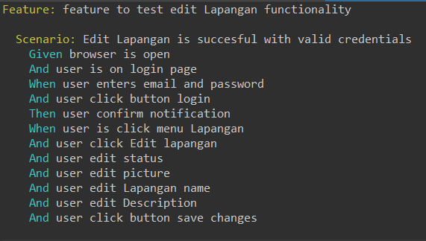

1. The step definition

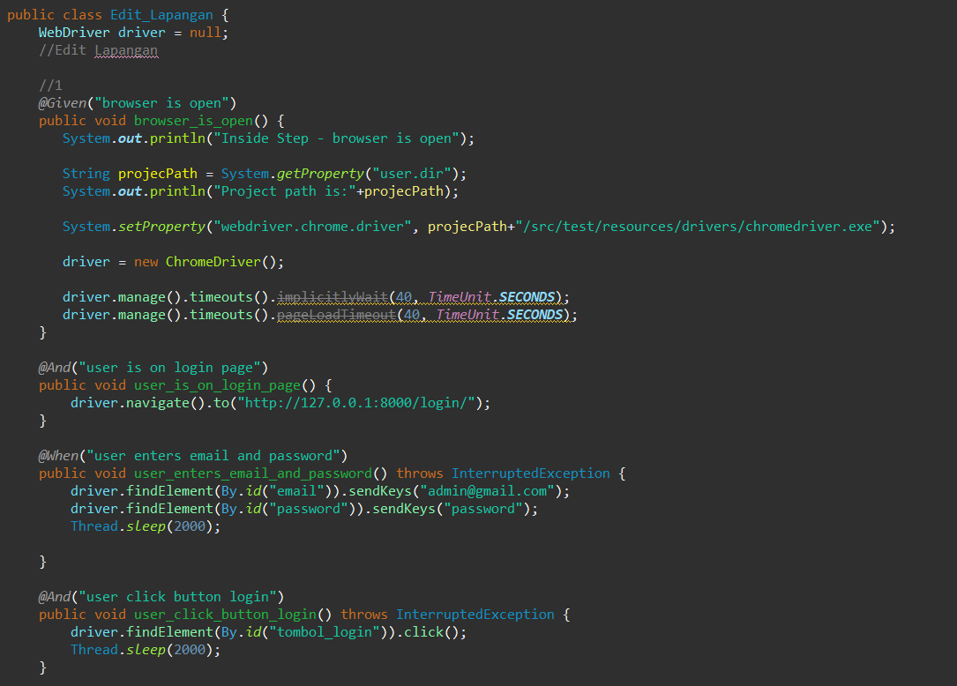

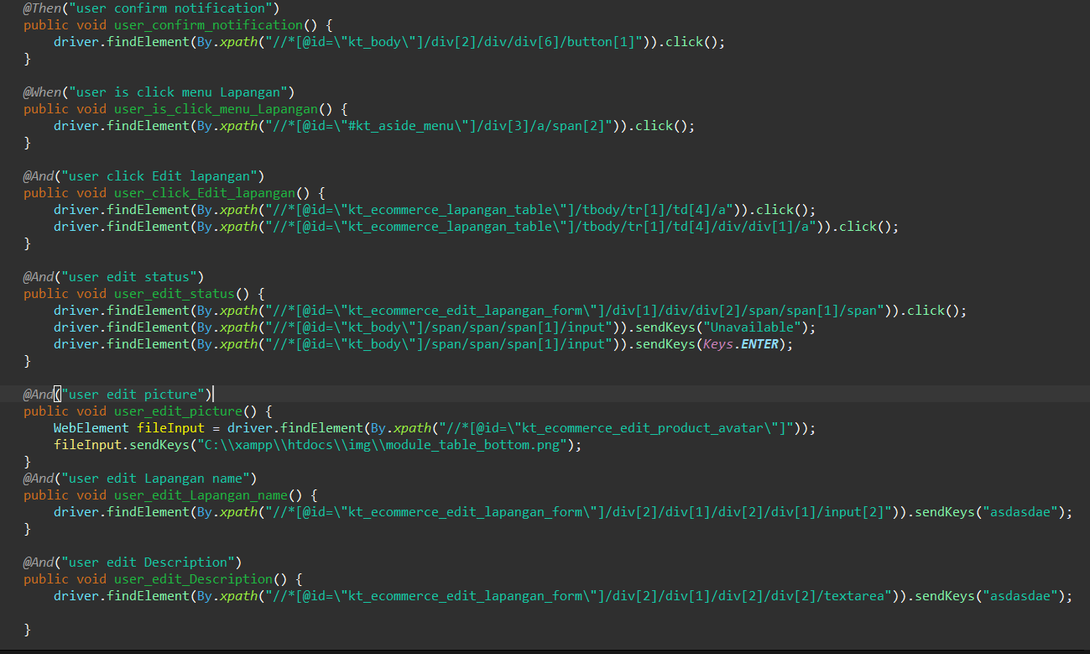

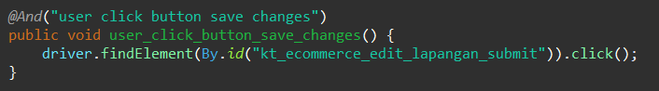

1. The test runner

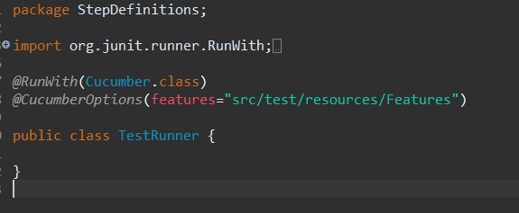

1. The console after running

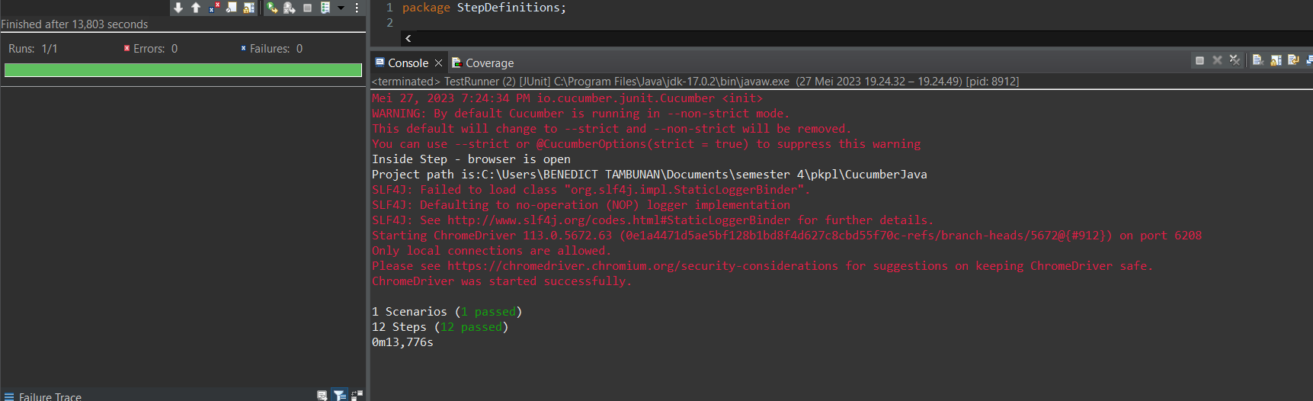

1. The browser while testing

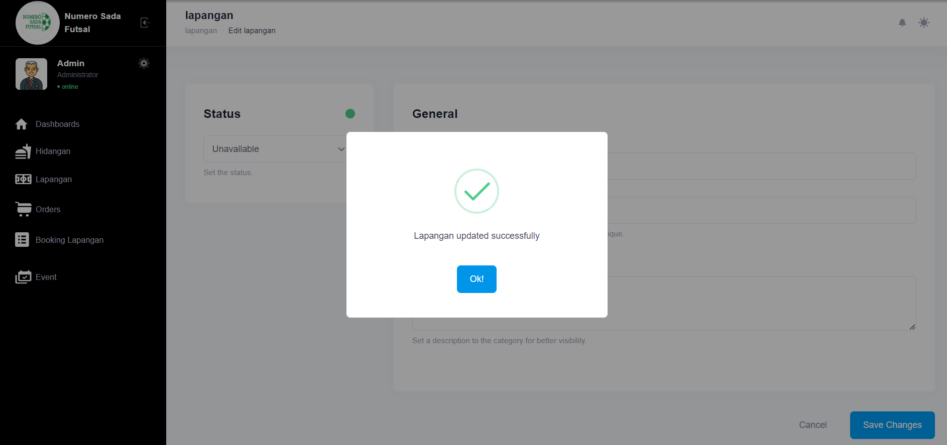

Fungsi edit edit Lapangan 2

1. The scenario



1. The Step definition

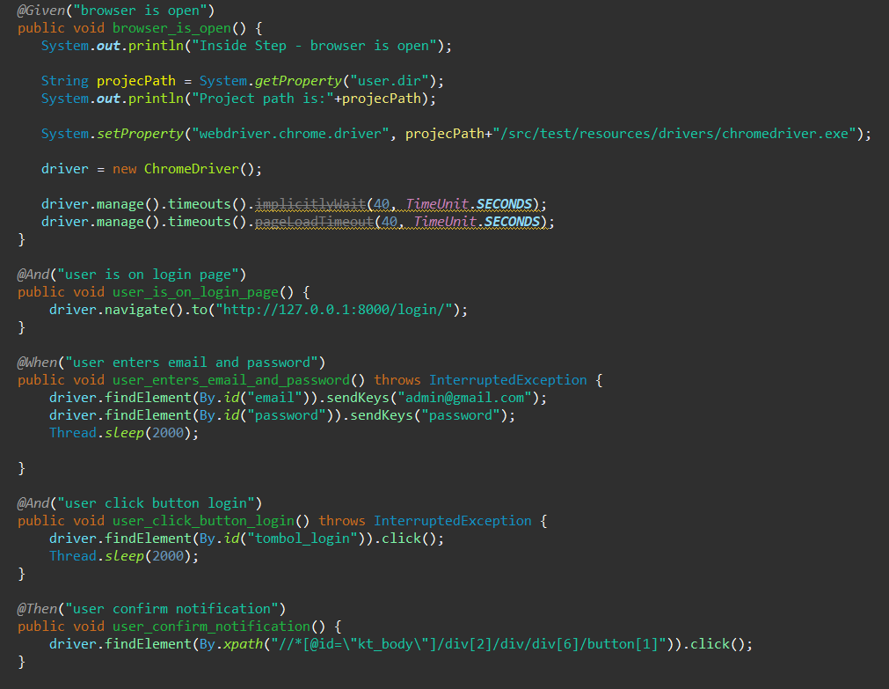

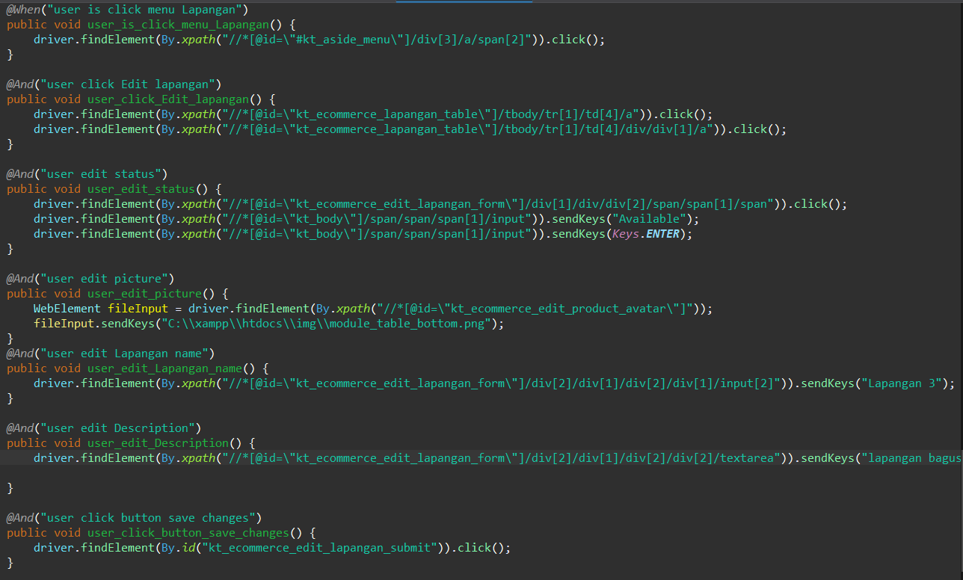

1. The test runner



1. The console after running



1. The browser while testing

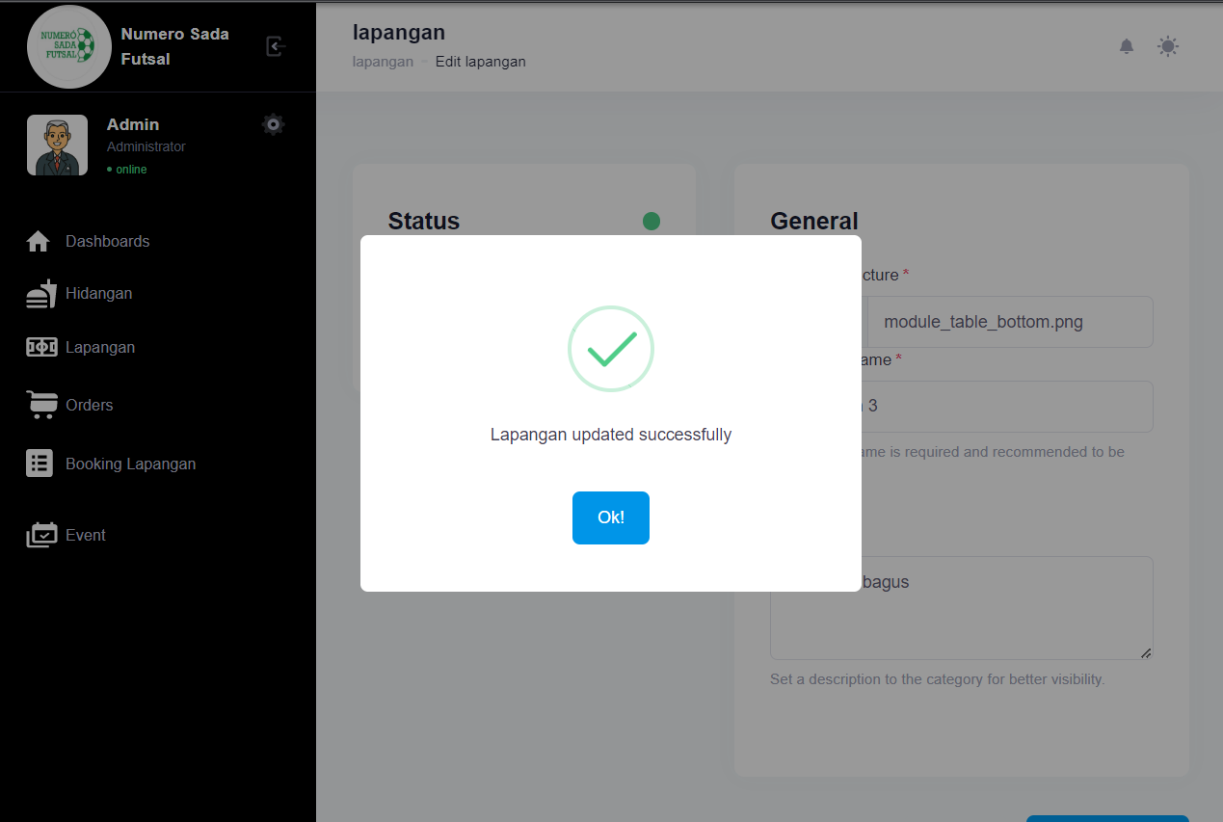

Fungsi edit Lapangan 3

1. The scenario



1. The Step definition



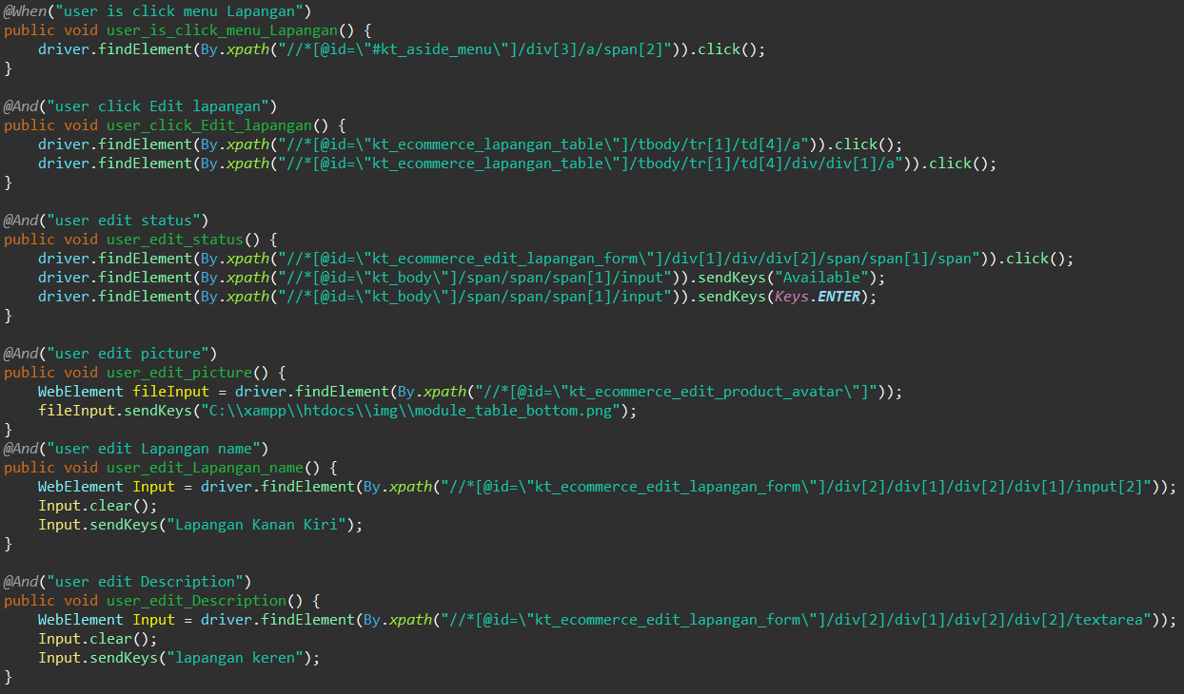

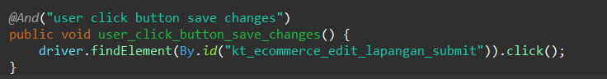

1. The test runner



1. The console after running

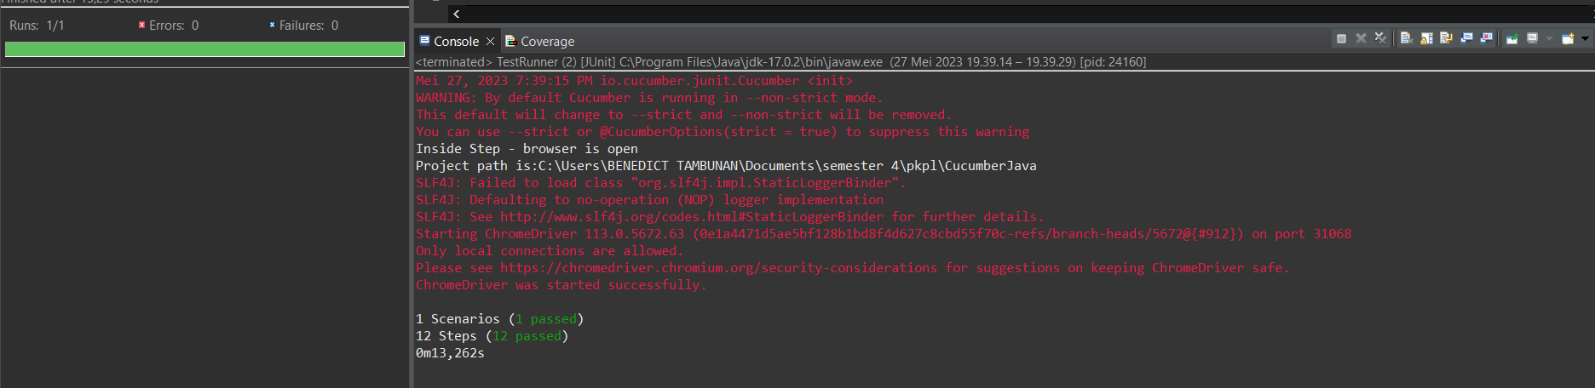

1. The browser while testing

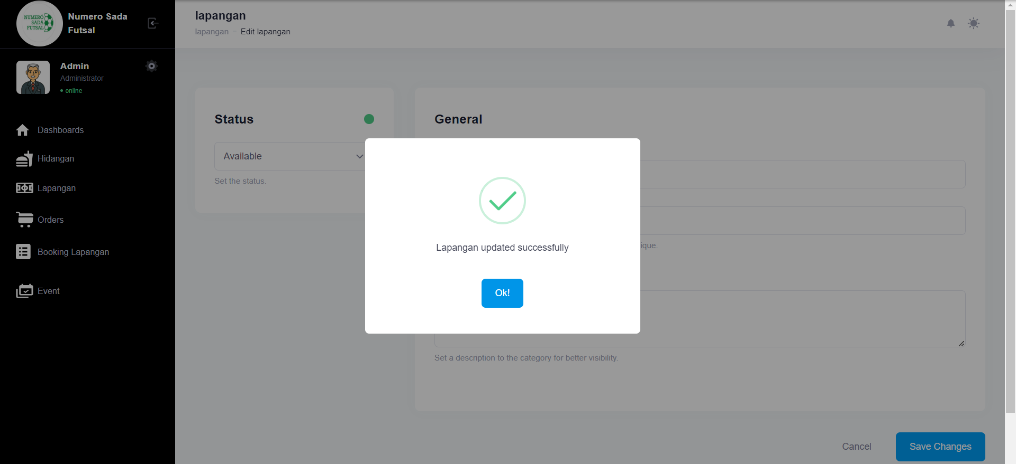

Fungsi edit Lapangan 4

1. The scenario



1. The Step definition



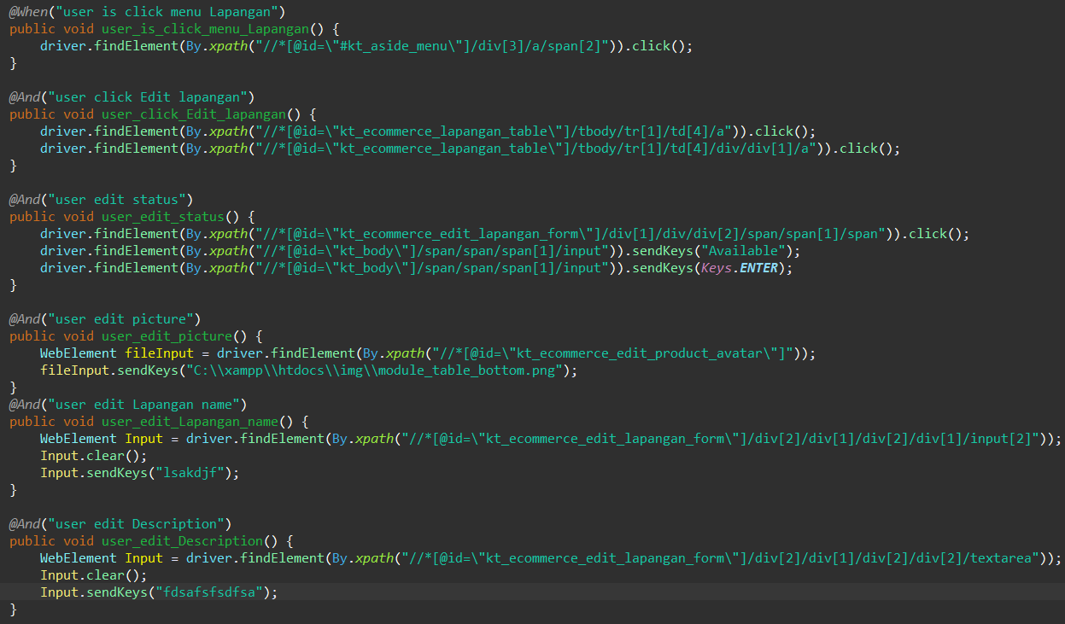

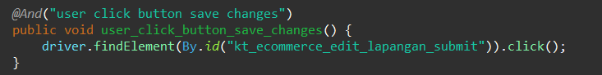

1. The test runner



1. The console after running

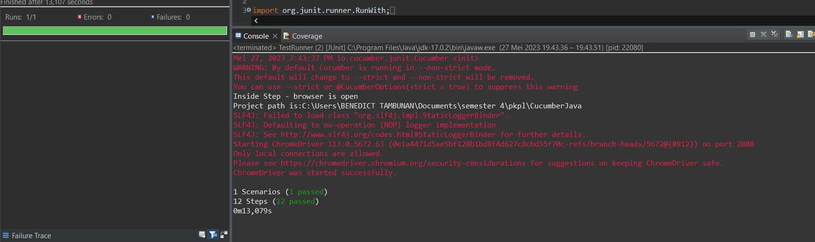

1. The browser while testing

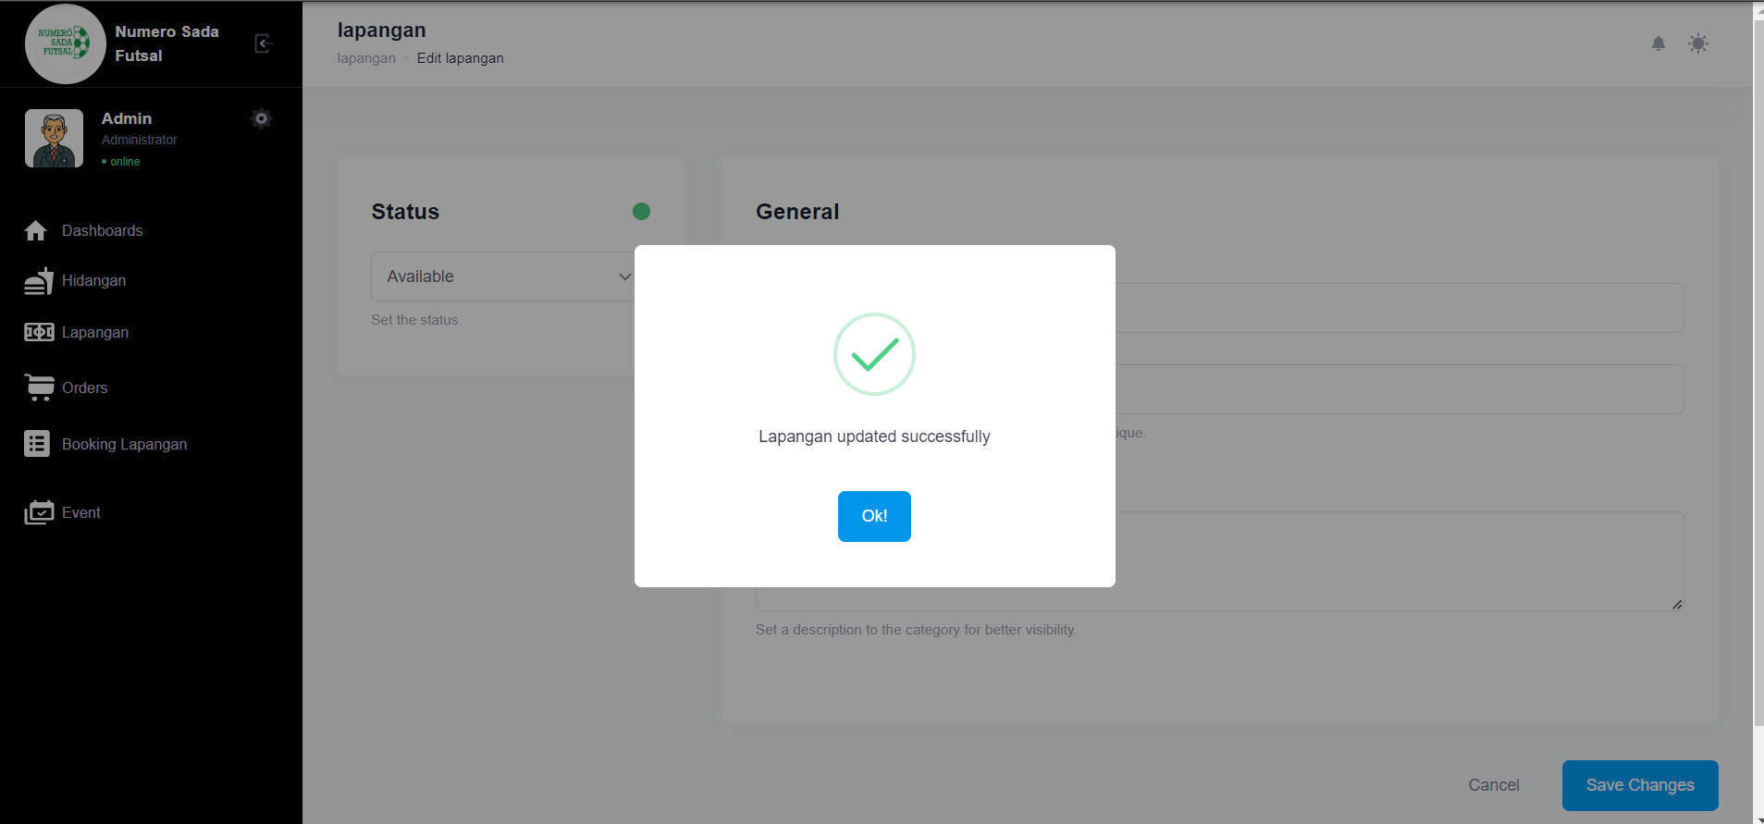

Fungsi edit Lapangan 5

1. The scenario



1. The Step definition



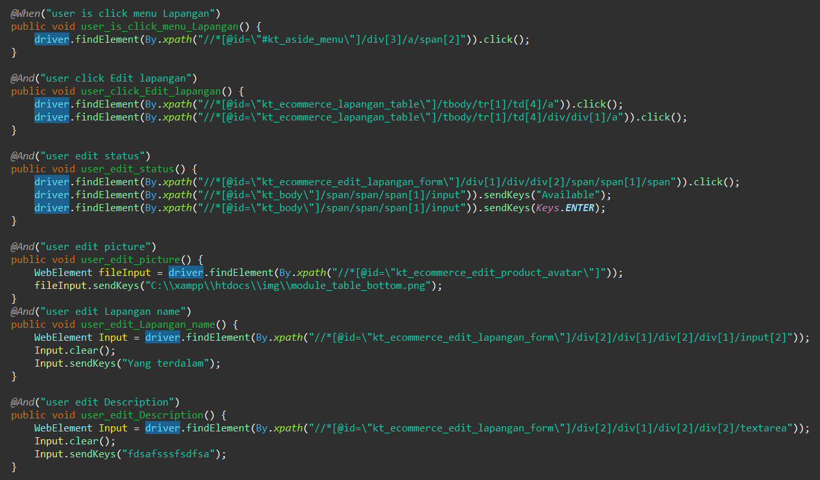



1. The test runner



1. The console after running

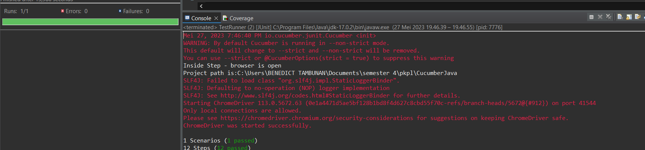

1. The browser while testing

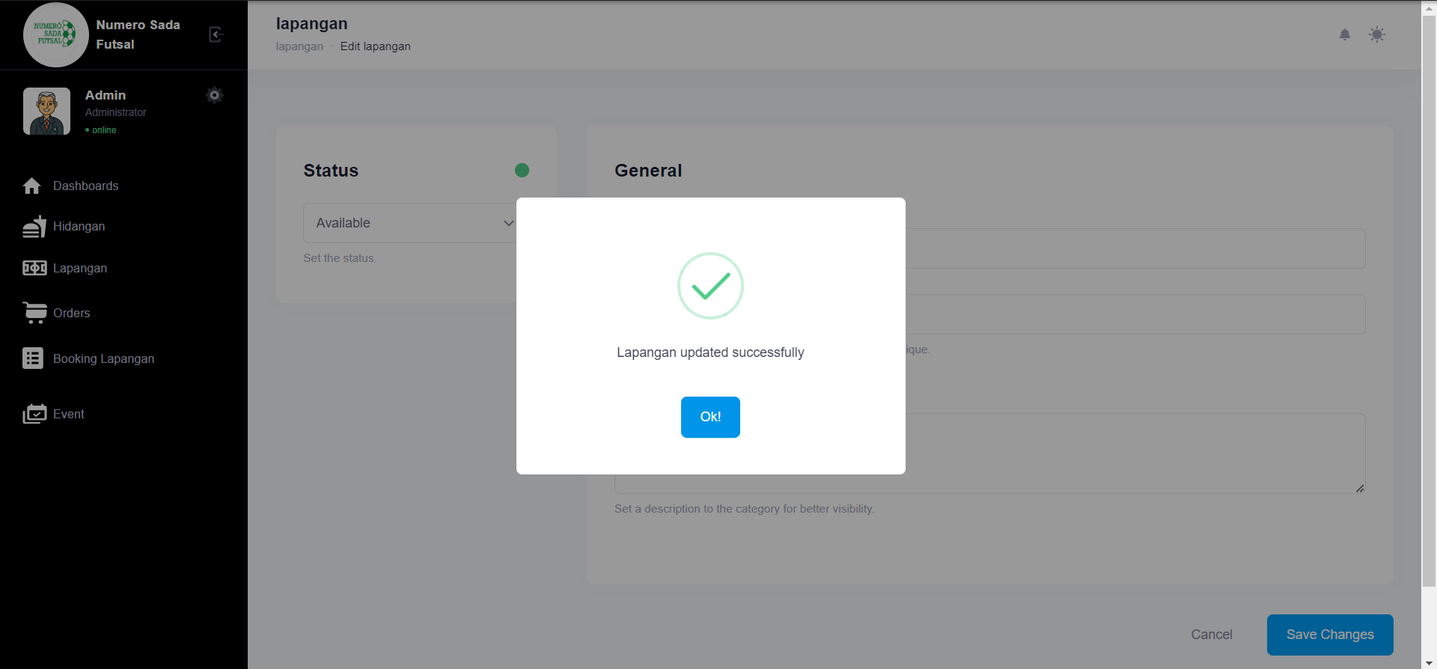

Fungsi edit Lapangan 6

1. The scenario



1. The Step definition



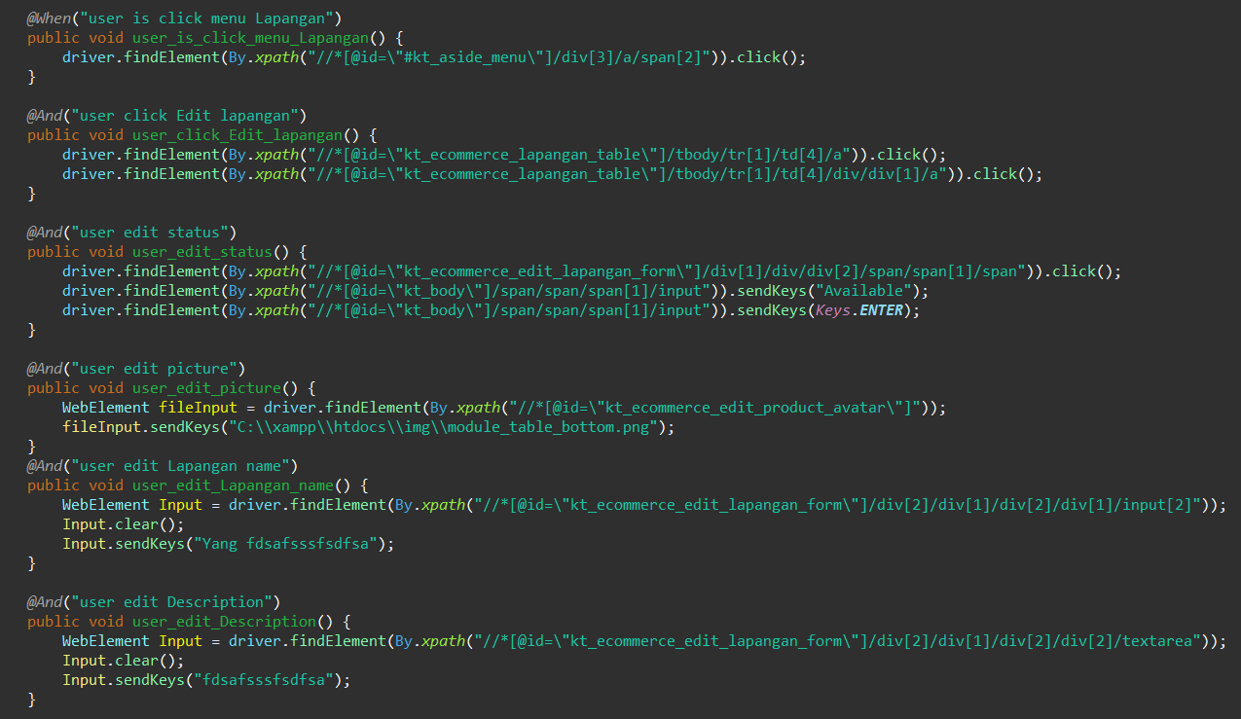

1. The test runner



1. The console after running

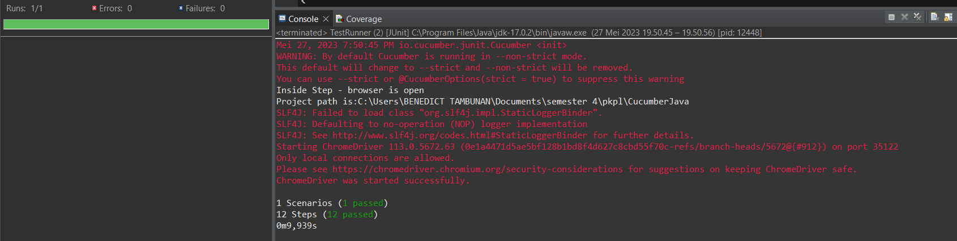

1. The browser while testing

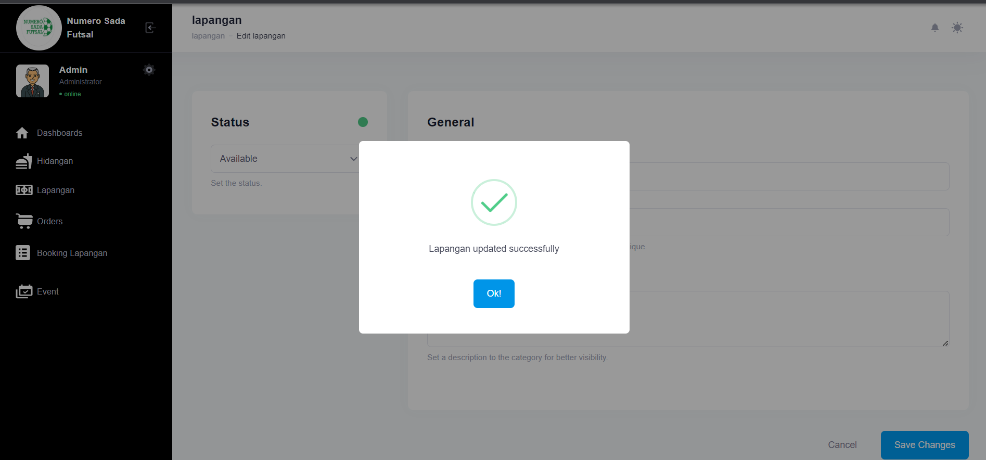

Fungsi edit Lapangan 7

1. The scenario



1. The Step definition



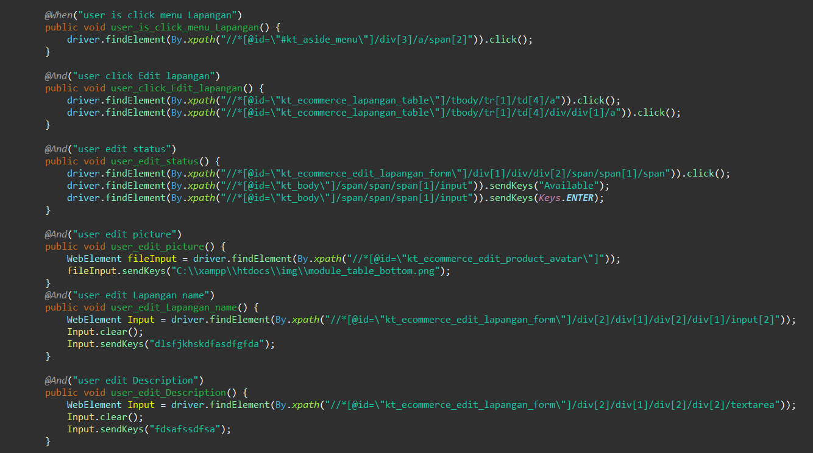

1. The test runner



1. The console after running

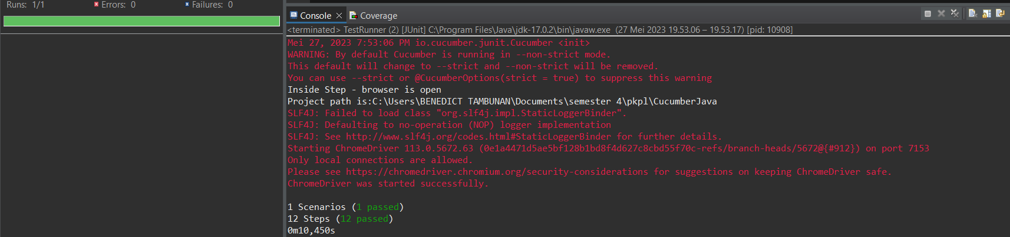

1. The browser while testing

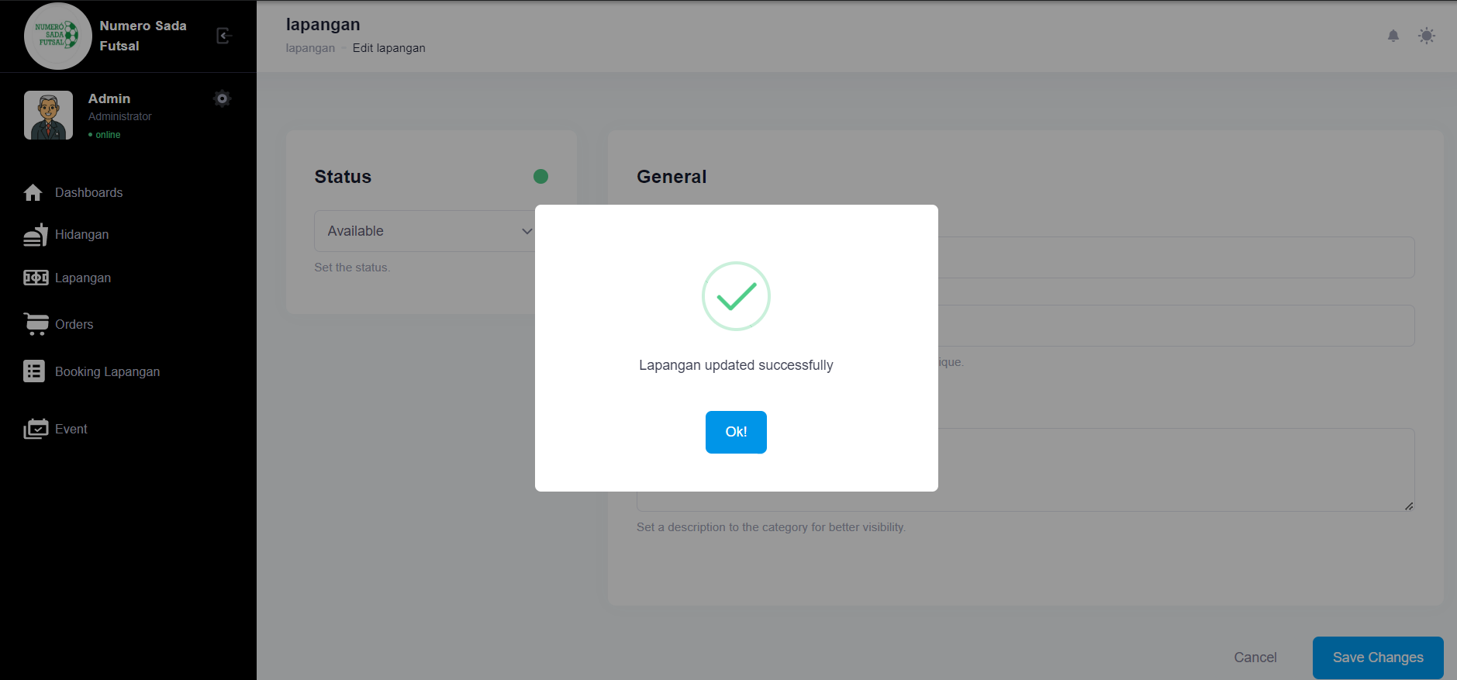

Fungsi edit Lapangan 8

1. The scenario



1. The Step definition



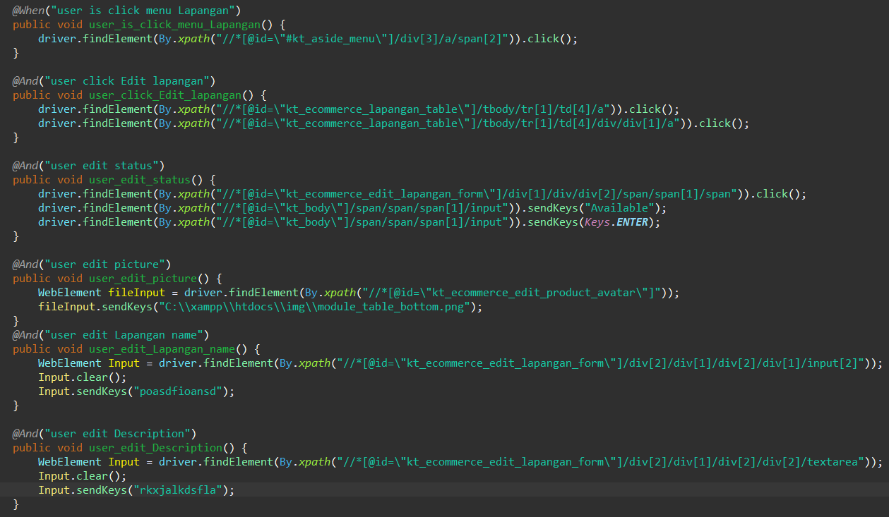

1. The test runner



1. The console after running

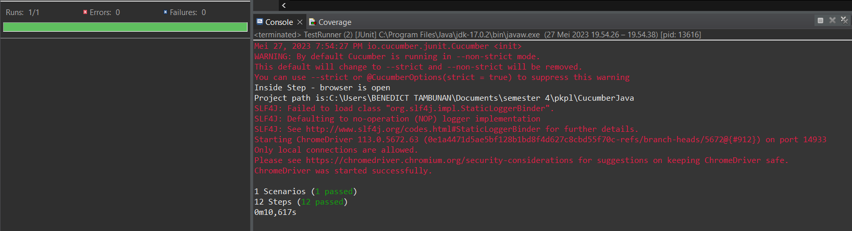

1. The browser while testing

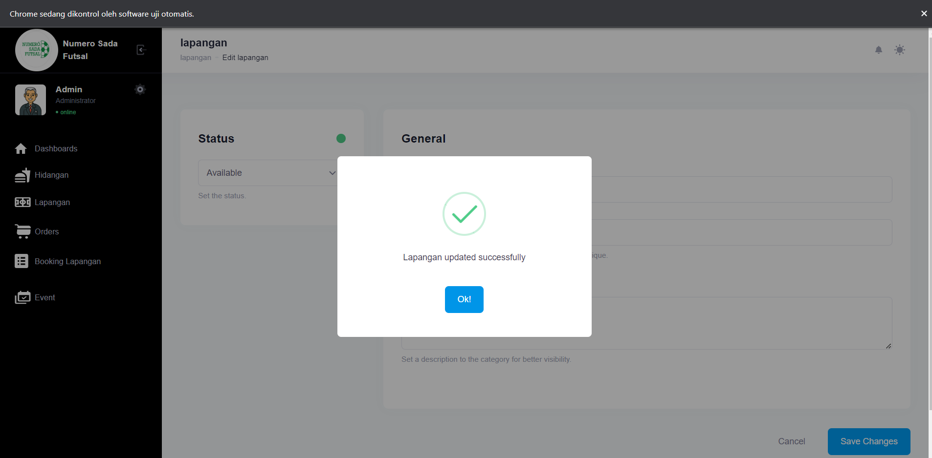

Fungsi edit Lapangan 9

1. The scenario



1. The Step definition



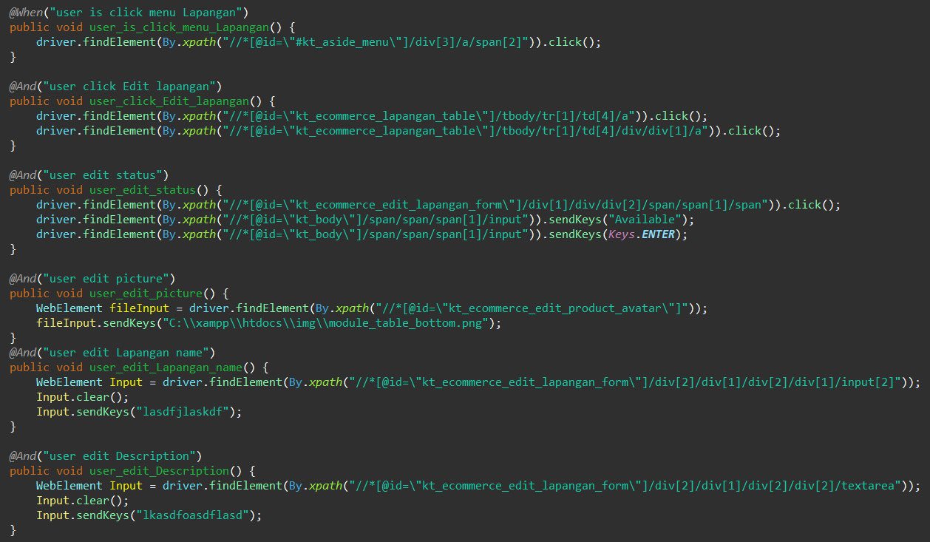

1. The test runner



1. The console after running

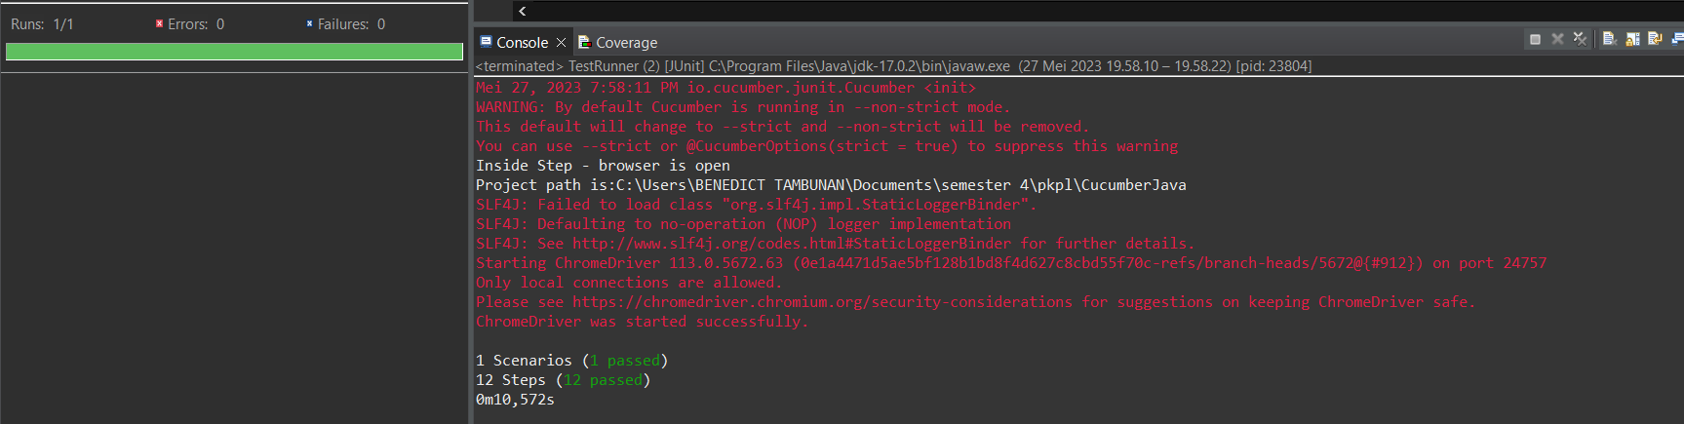

1. The browser while testing

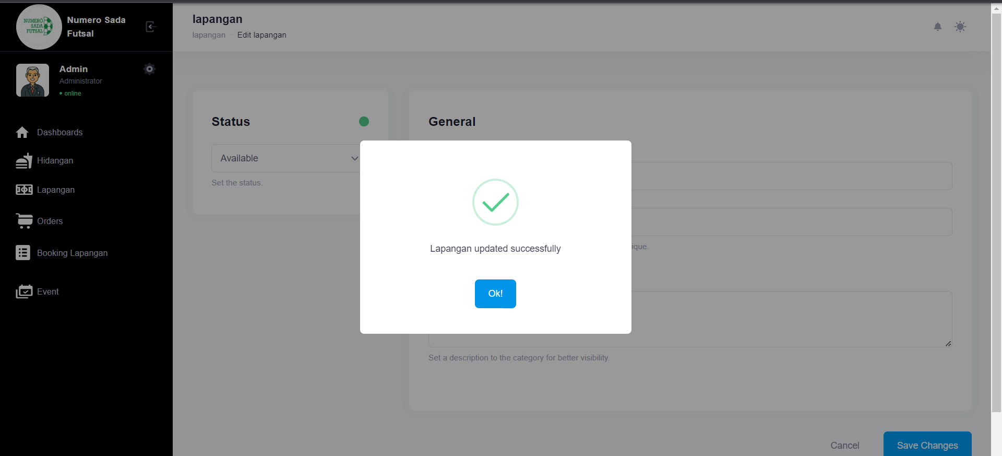

Fungsi edit Lapangan 10

1. The scenario



1. The Step definition



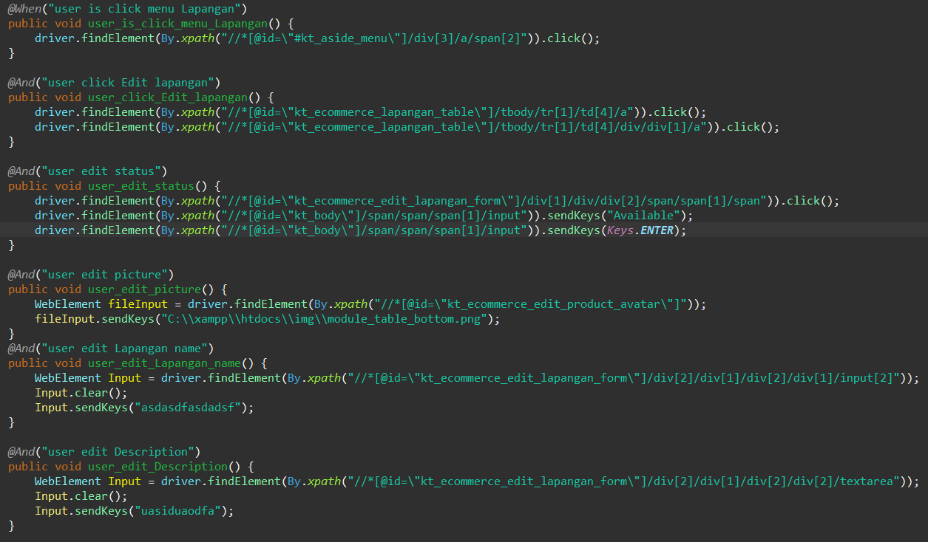

1. The test runner



1. The console after running

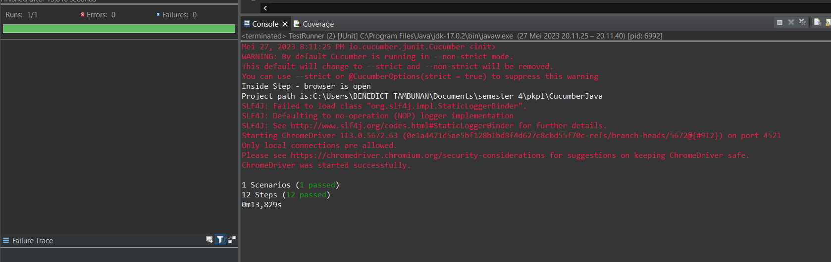

1. The browser while testing

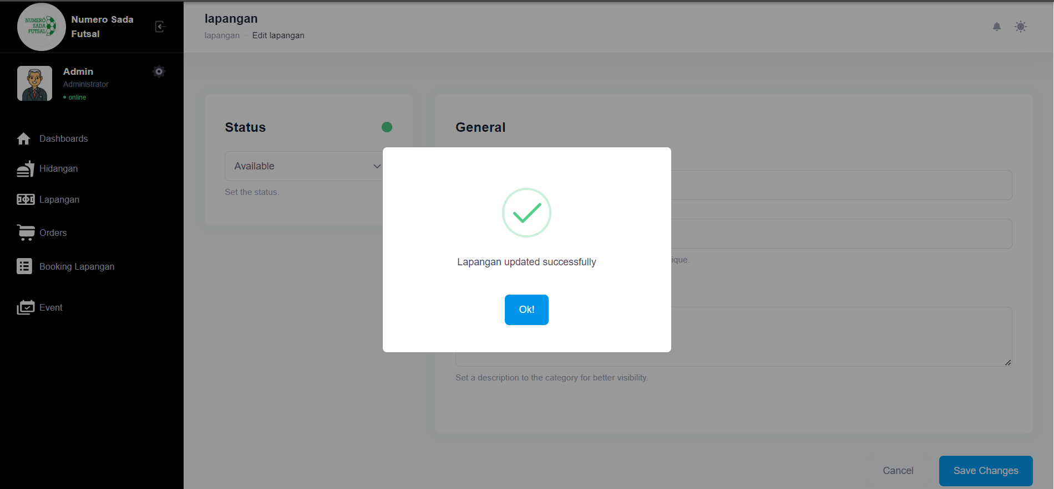

1. Test Fungsi edit Lapangan Variasi 2: edit Lapangan dengan parameter 1,2,3 valid namun ke 4 tidak valid

Fungsi edit Lapangan 1

1. The scenario



1. The Step definition



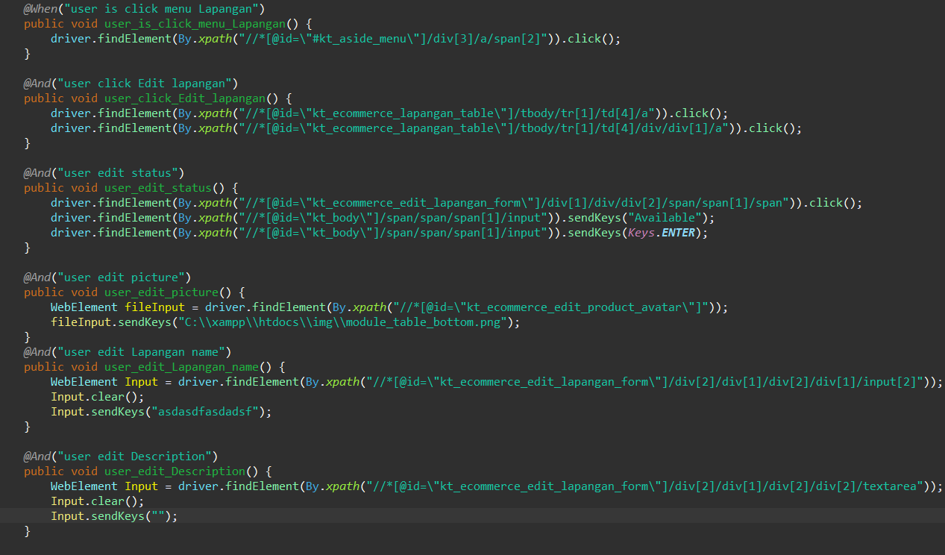

1. The test runner



1. The console after running

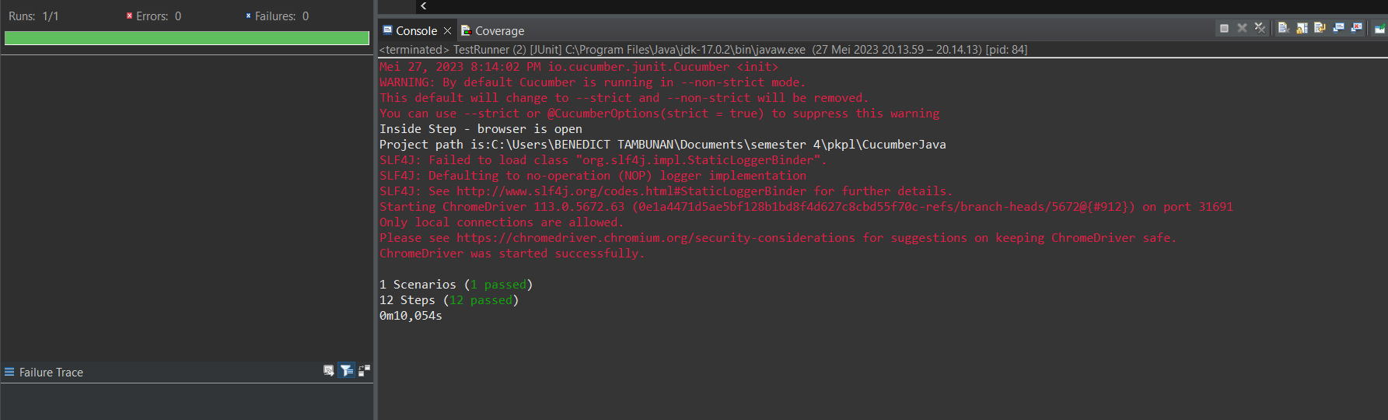

1. The browser while testing
2. 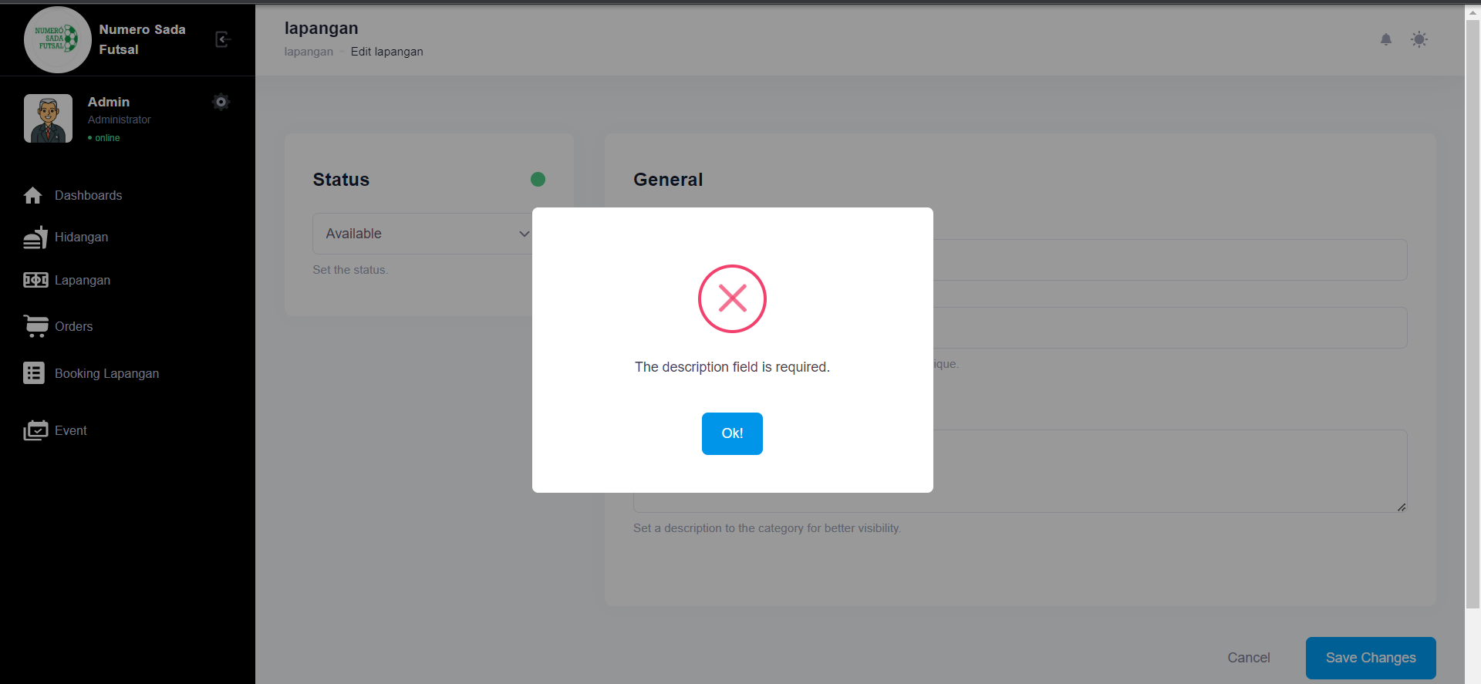

Fungsi edit Lapangan 2

1. The scenario



1. The Step definition



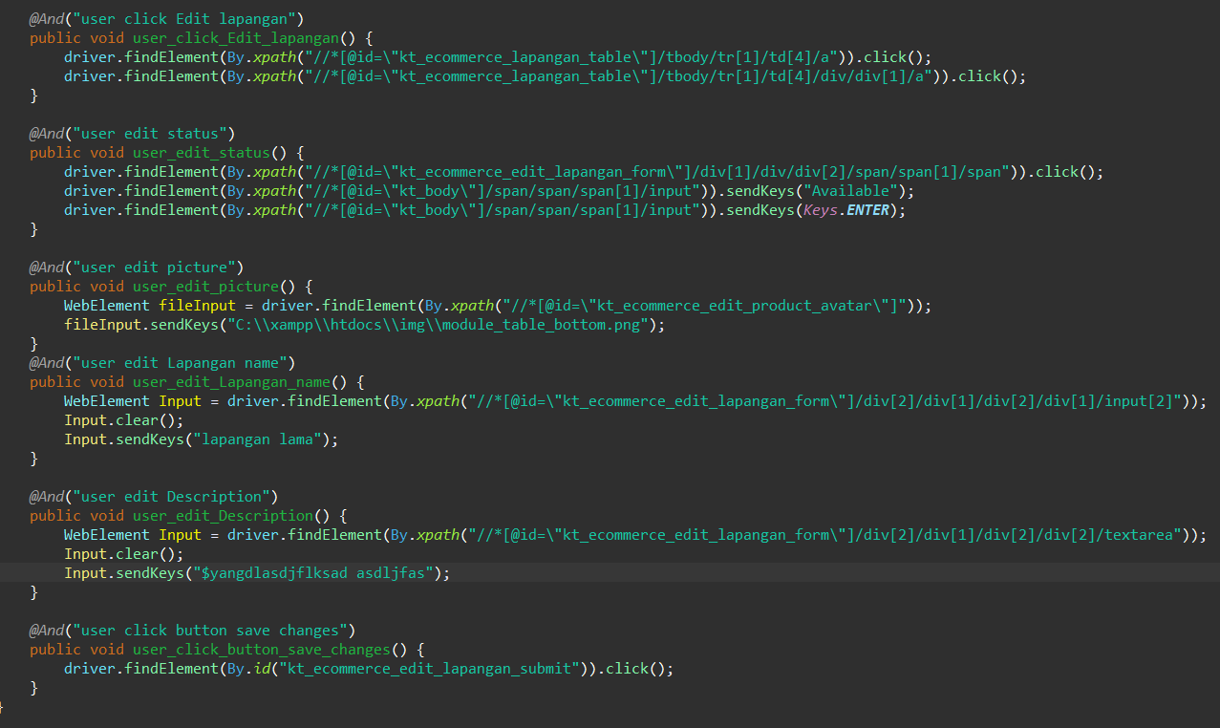

1. The test runner



1. The console after running

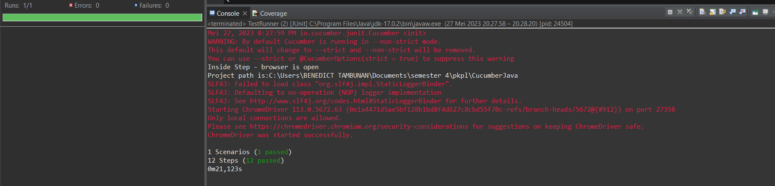

1. The browser while testing

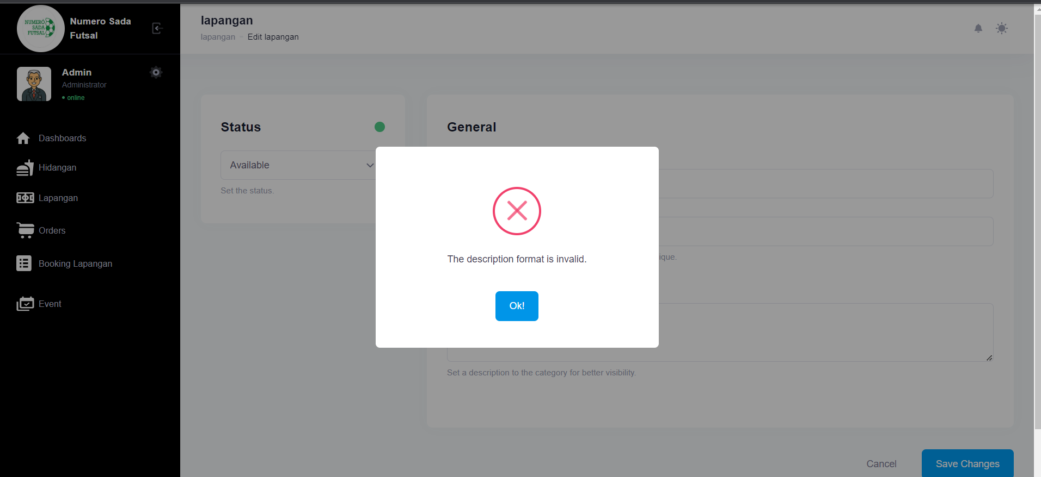

Fungsi edit Lapangan 3

1. The scenario



1. The Step definition



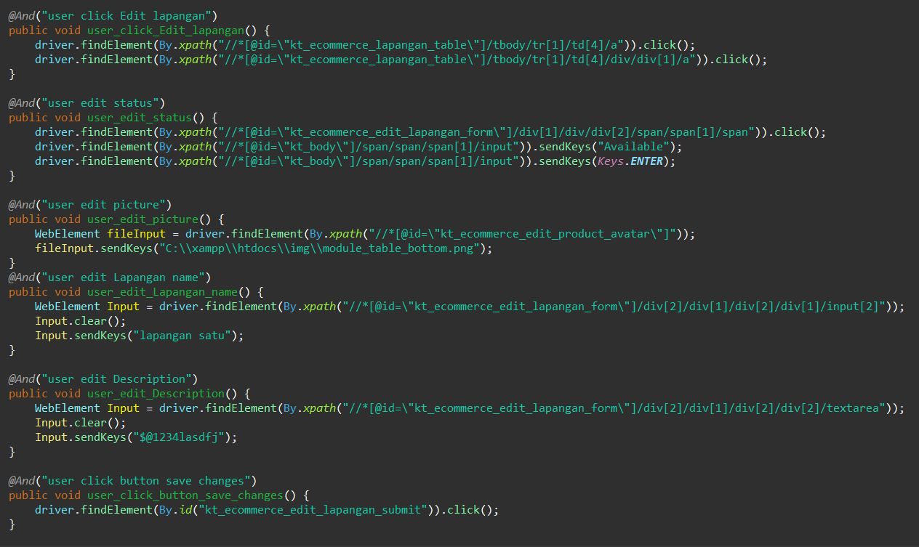

1. The test runner



1. The console after running

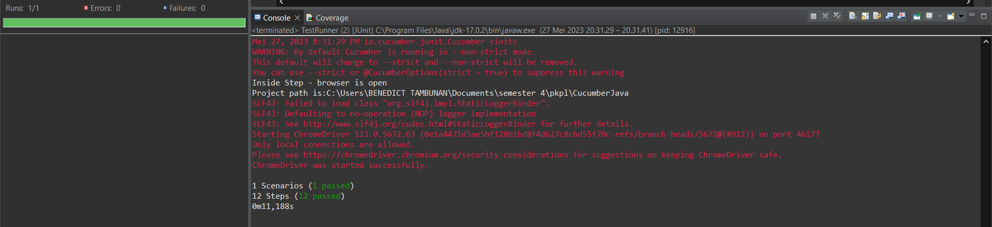

1. The browser while testing

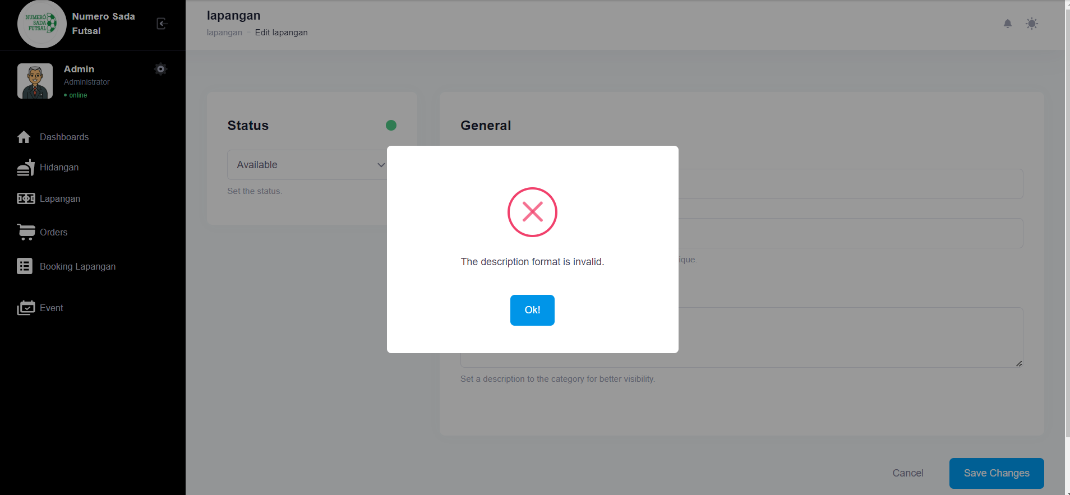

Fungsi edit Lapangan 4

1. The scenario



1. The Step definition



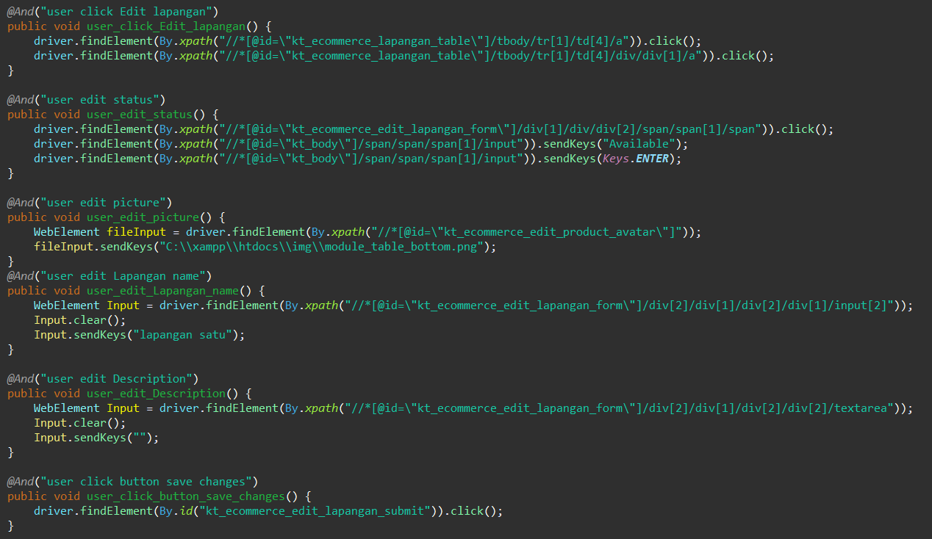

1. The test runner



1. The console after running

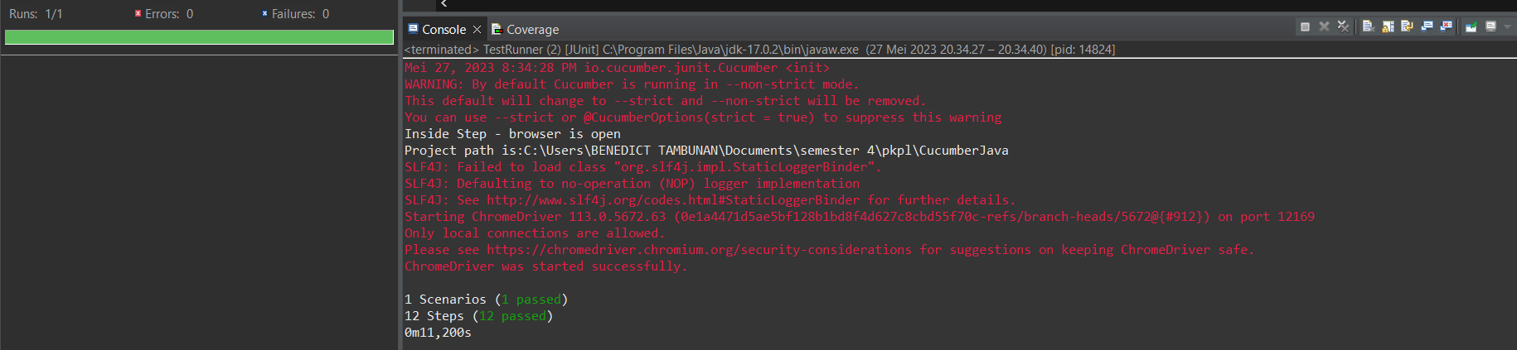

1. The browser while testing

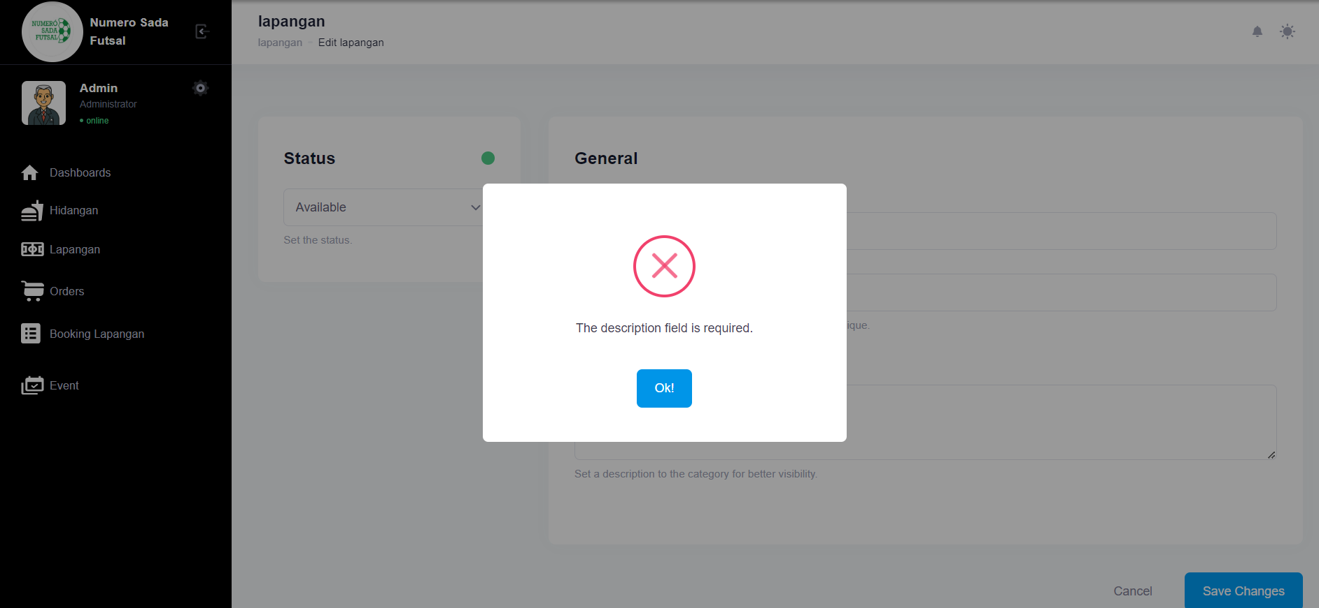

Fungsi edit Lapangan 5

1. The scenario



1. The Step definition



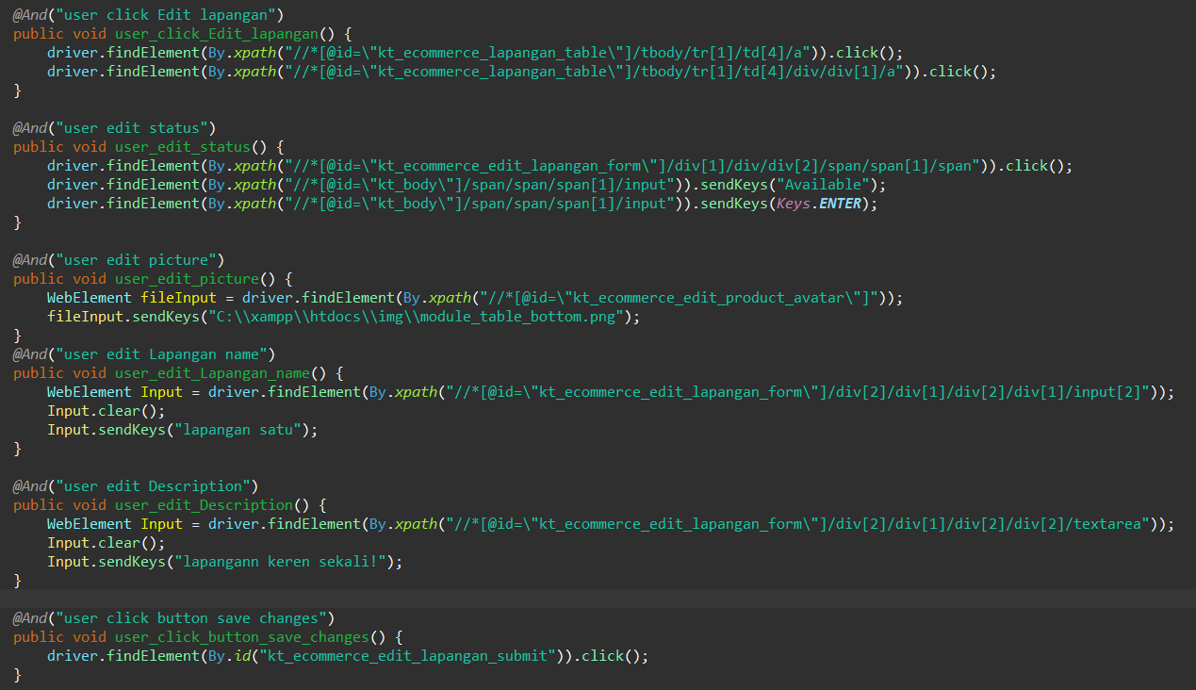

1. The test runner



1. The console after running

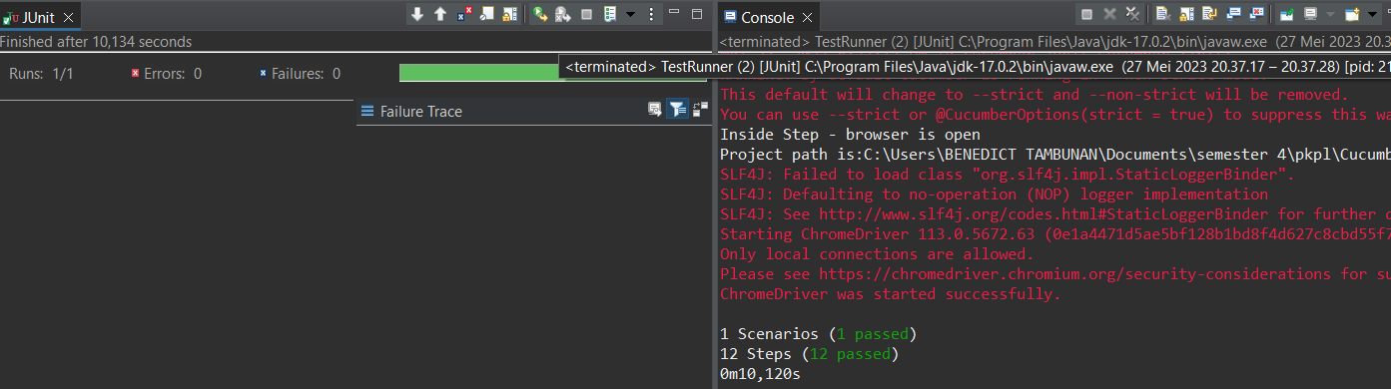

1. The browser while testing

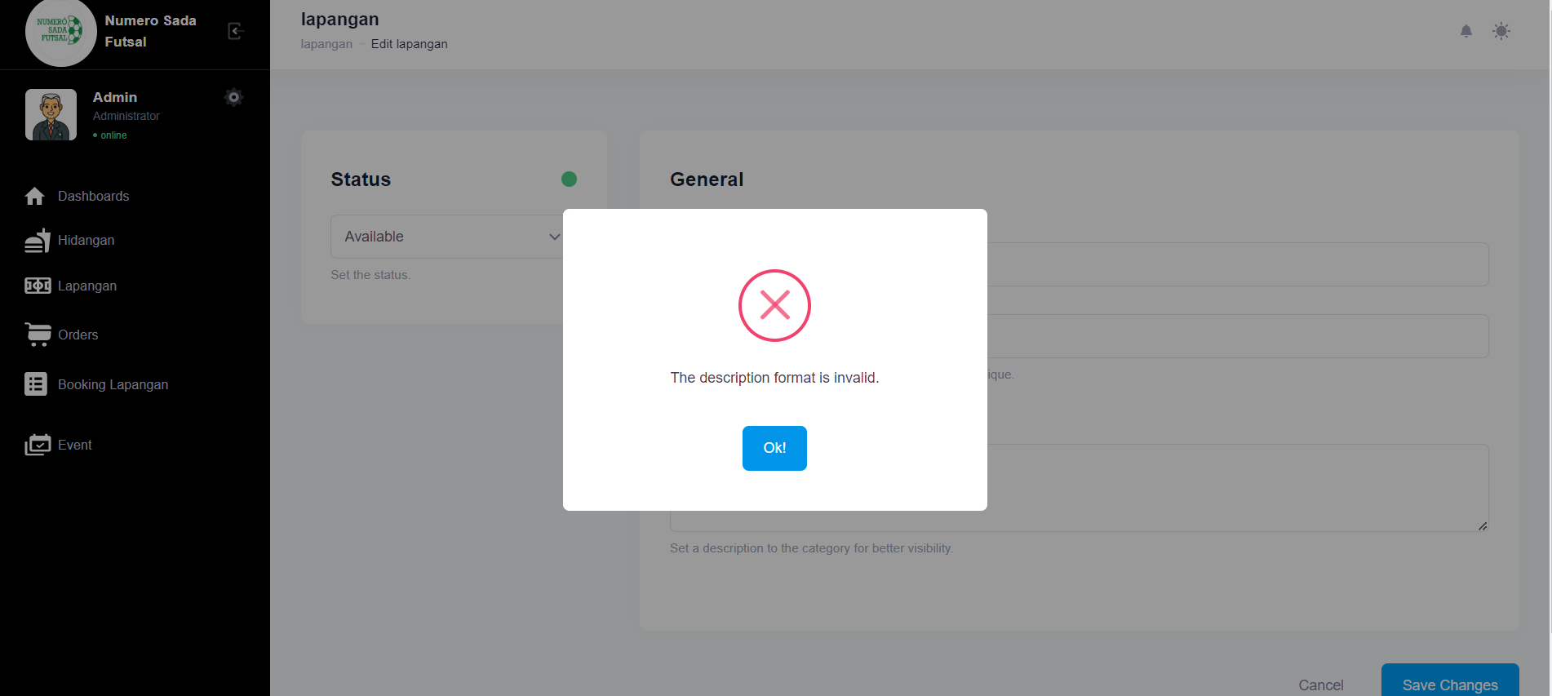

Fungsi edit Lapangan 6

1. The scenario



1. The Step definition



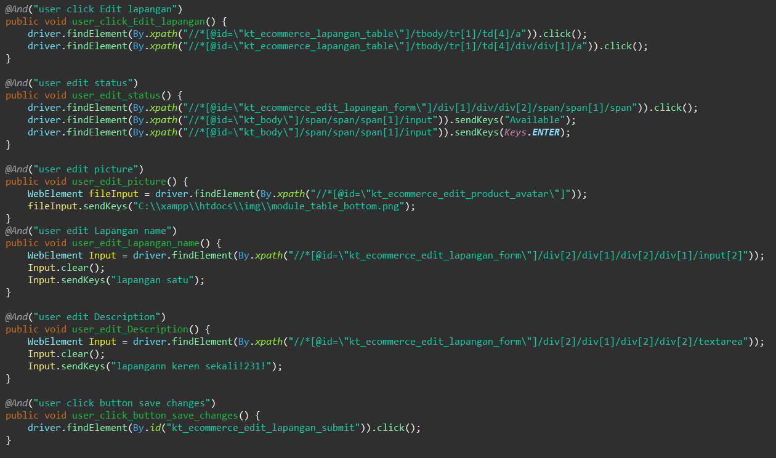

1. The test runner



1. The console after running

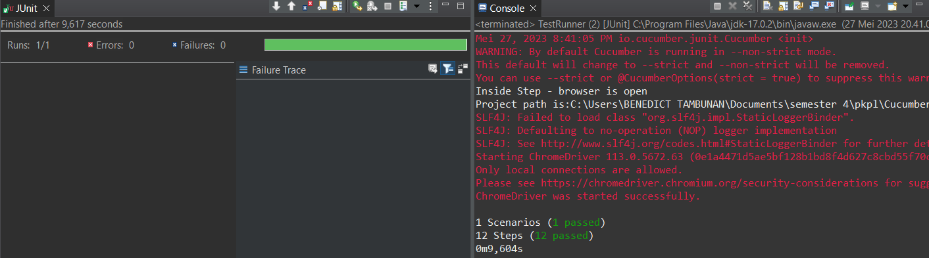

1. The browser while testing

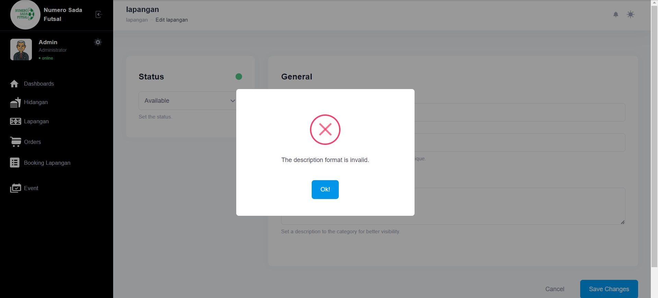

1. Test Fungsi edit Lapangan Variasi 3: edit Lapangan dengan parameter 1,2,4 valid namun ke 3 tidak valid

Fungsi edit Lapangan 1

1. The scenario



1. The Step definition



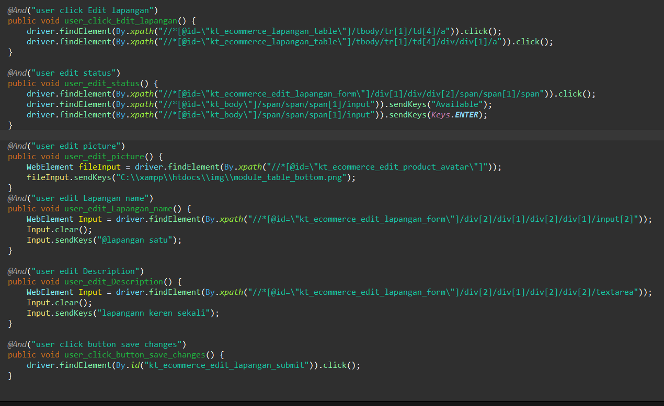

1. The test runner



1. The console after running

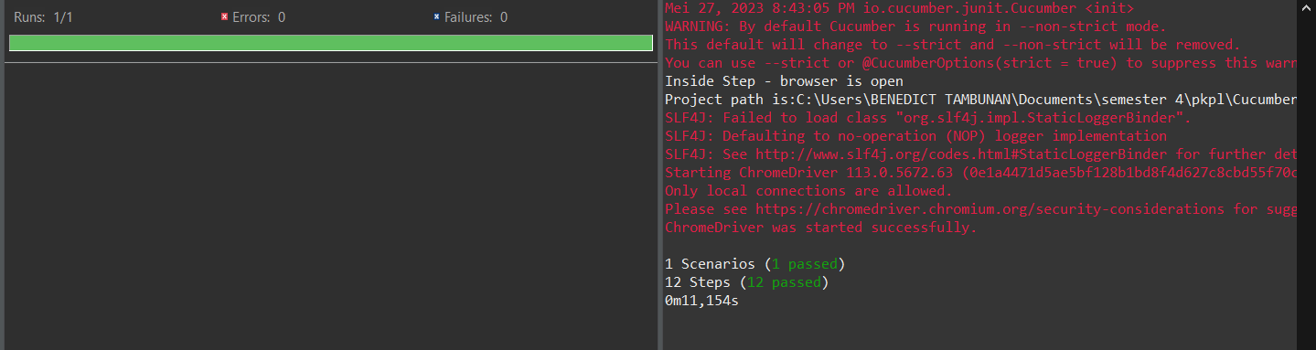

1. The browser while testing

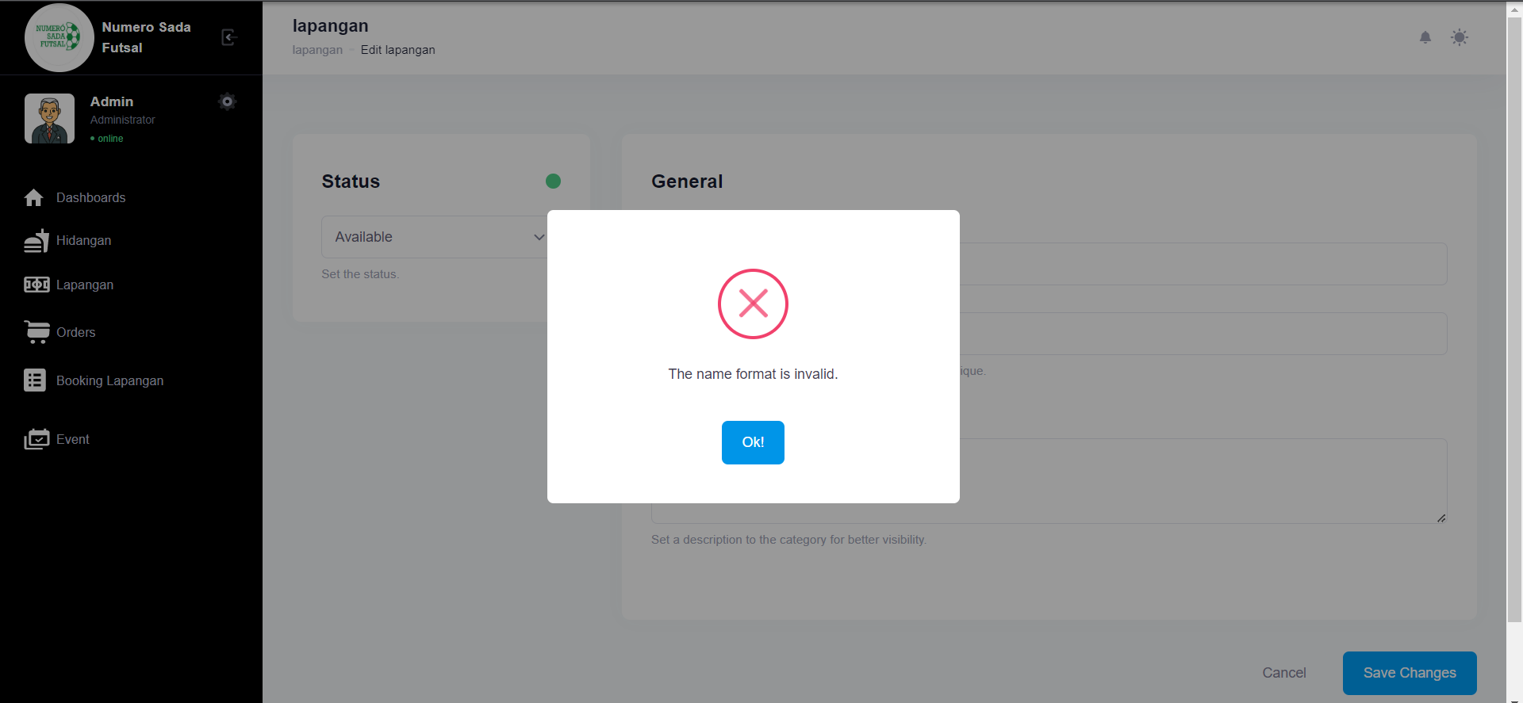

Fungsi edit Lapangan 2

1. The scenario



1. The Step definition



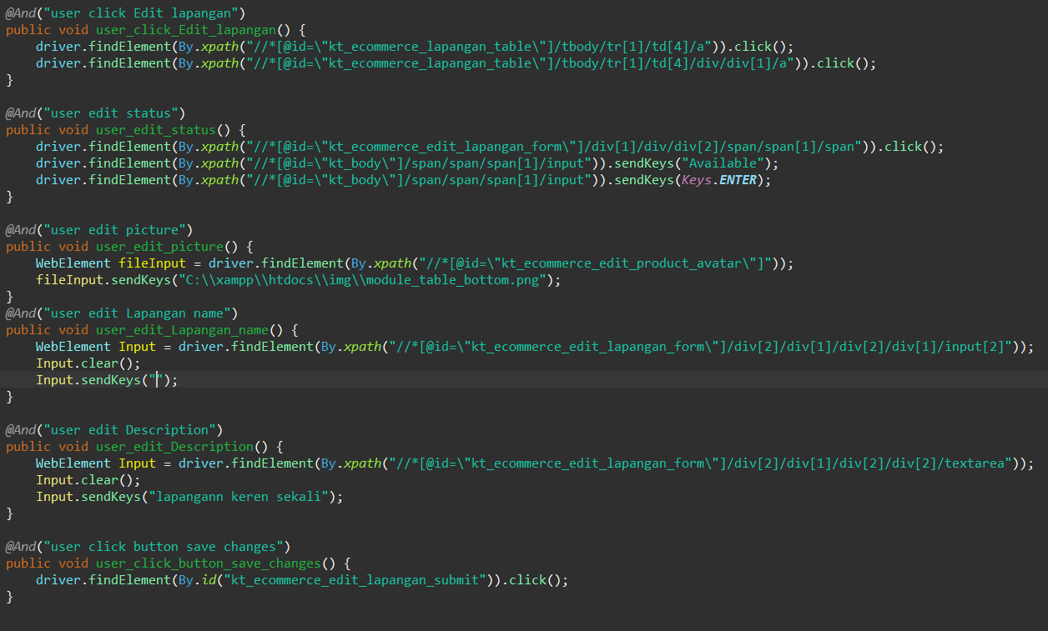

1. The test runner



1. The console after running

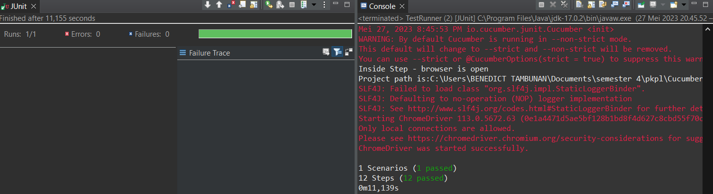

1. The browser while testing

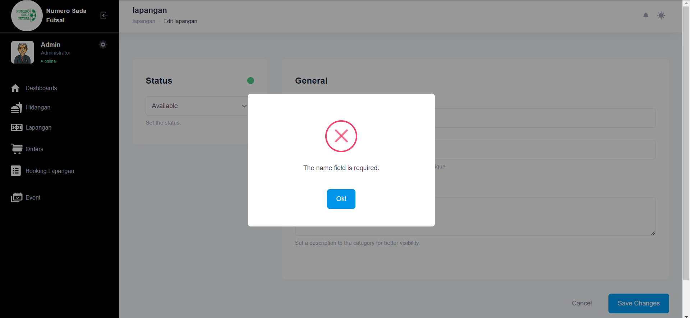

Fungsi edit Lapangan 3

1. The scenario



1. The Step definition



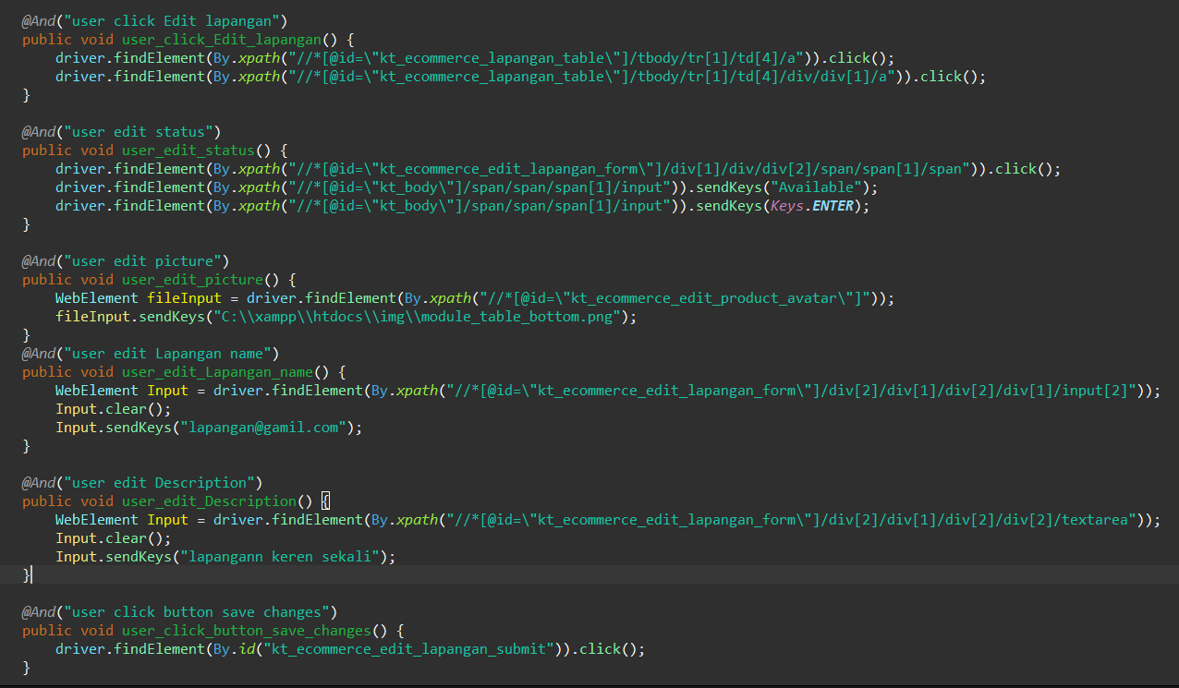

1. The test runner



1. The console after running

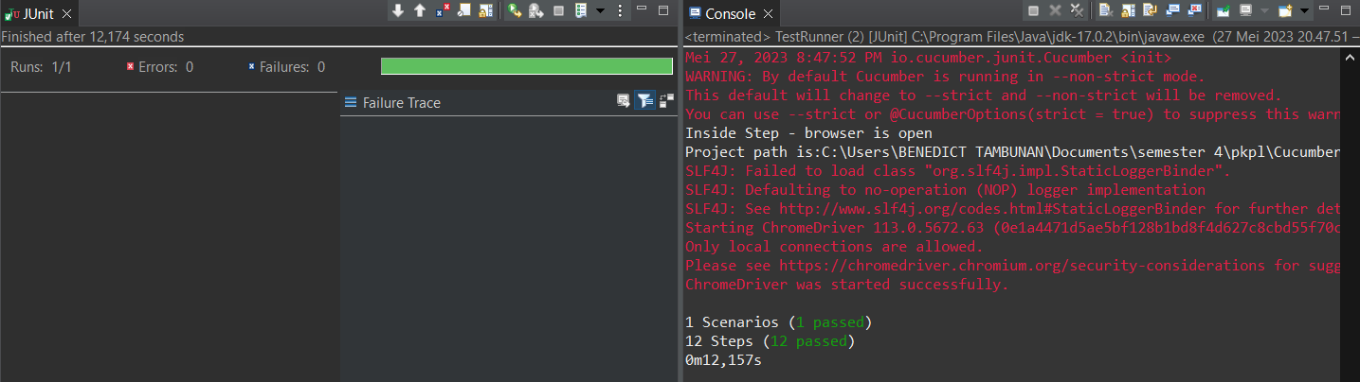

1. The browser while testing

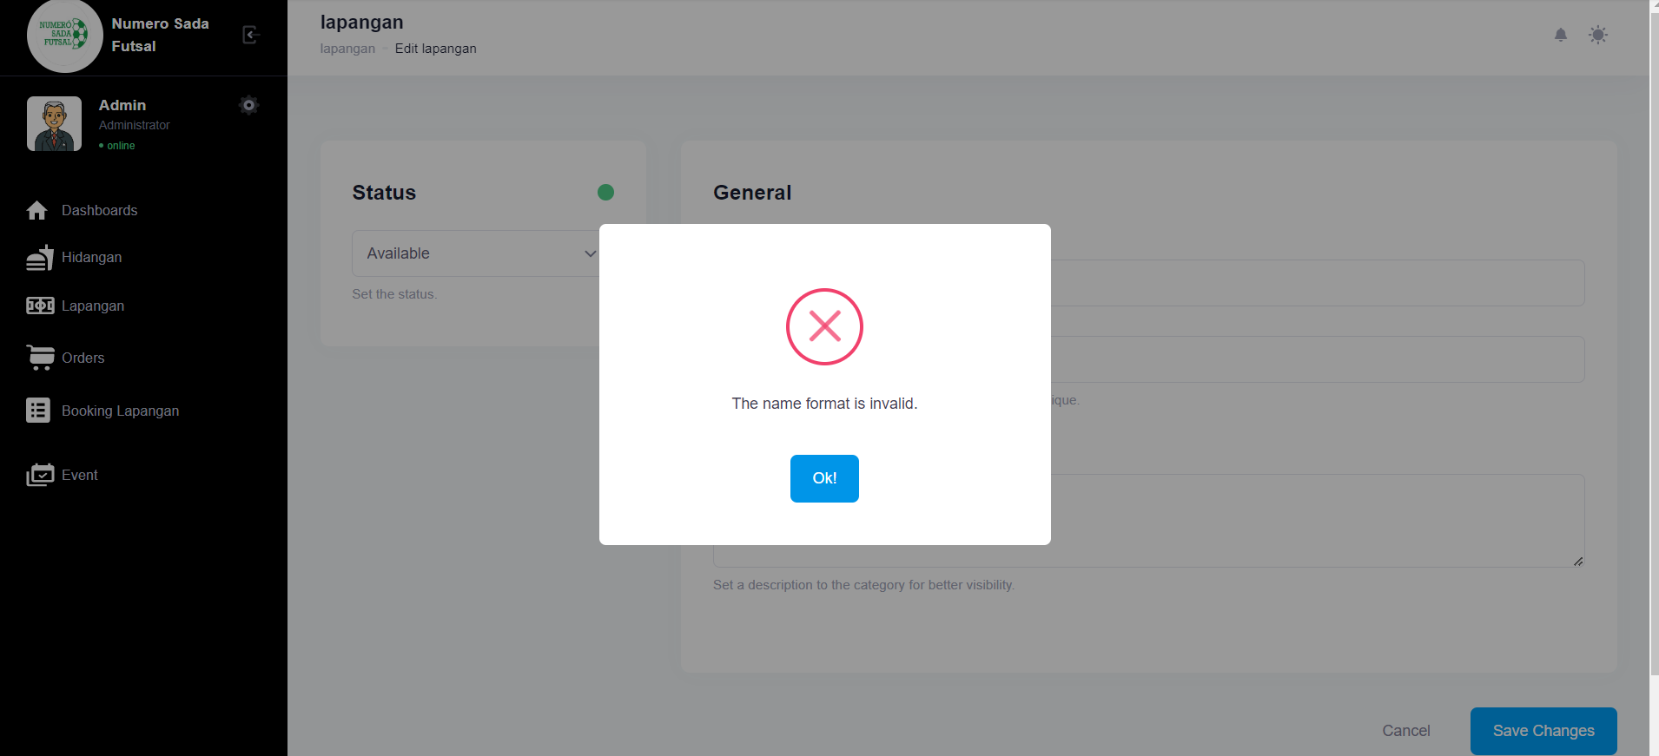

Fungsi edit Lapangan 4

1. The scenario



1. The Step definition



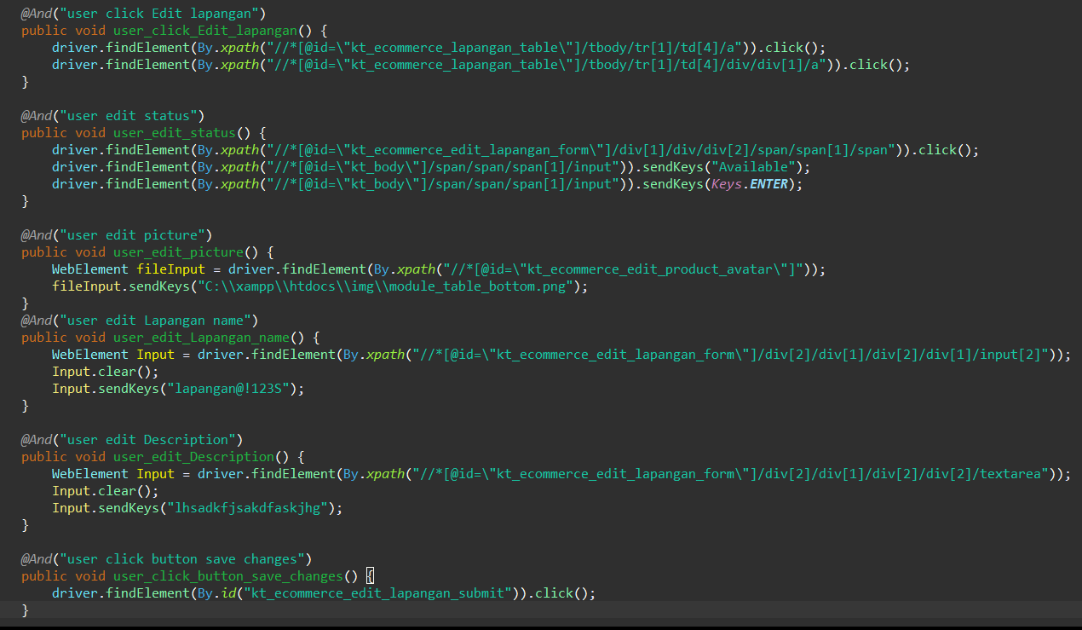

1. The test runner



1. The console after running

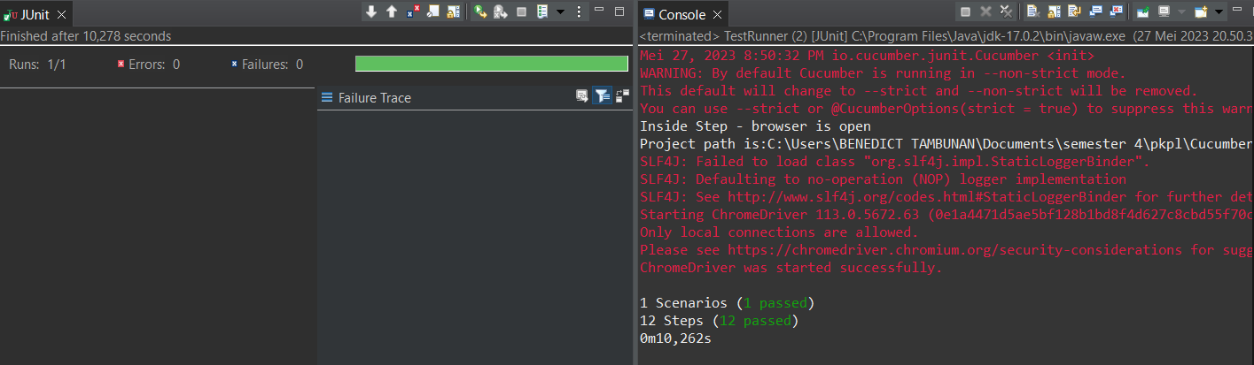

1. The browser while testing

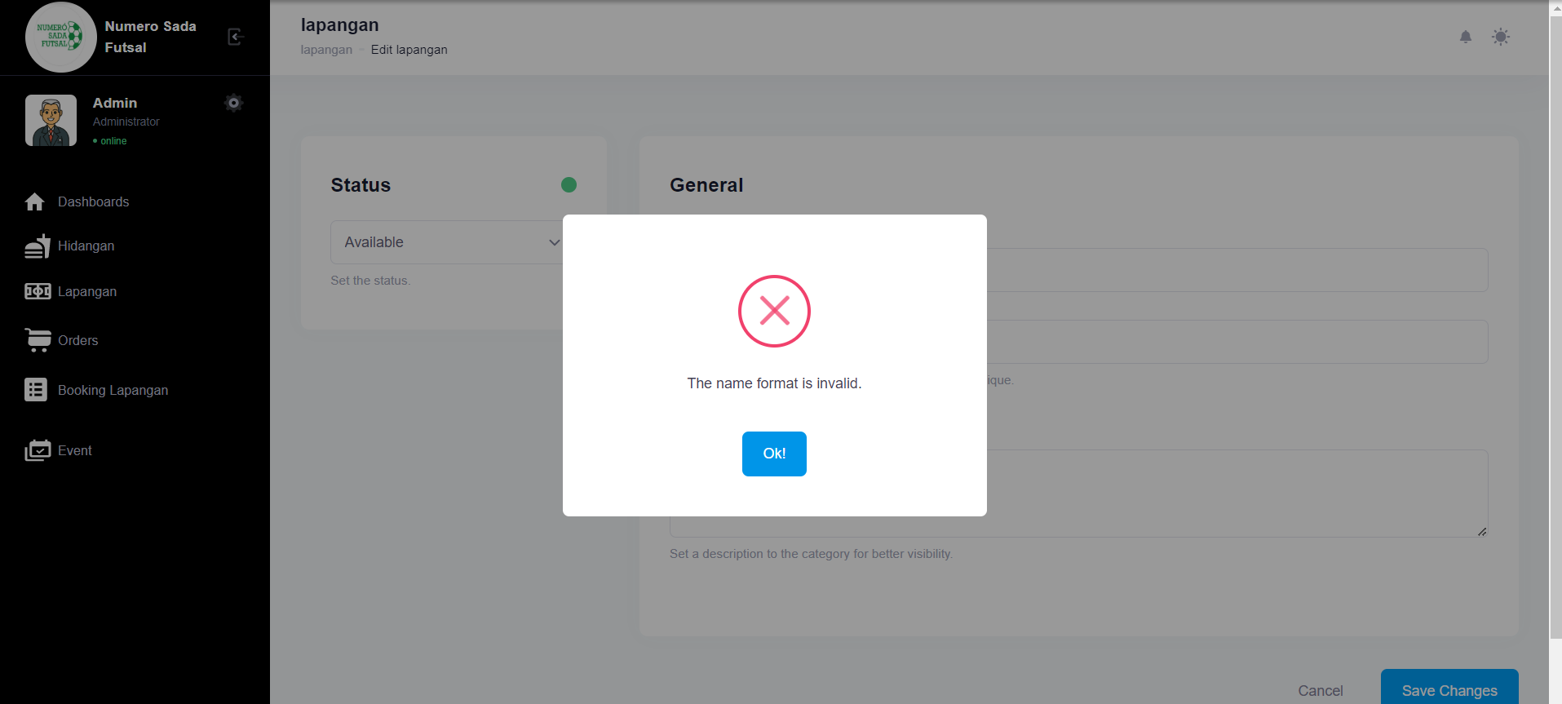

Fungsi edit Lapangan 5

1. The scenario



1. The Step definition



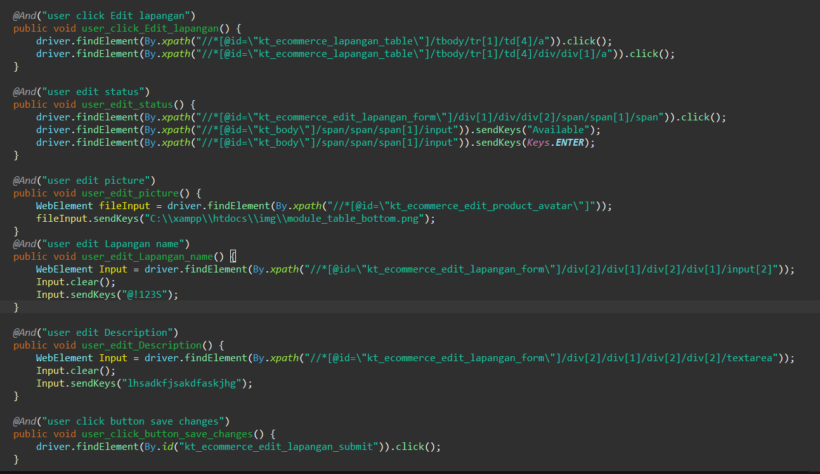

1. The test runner



1. The console after running

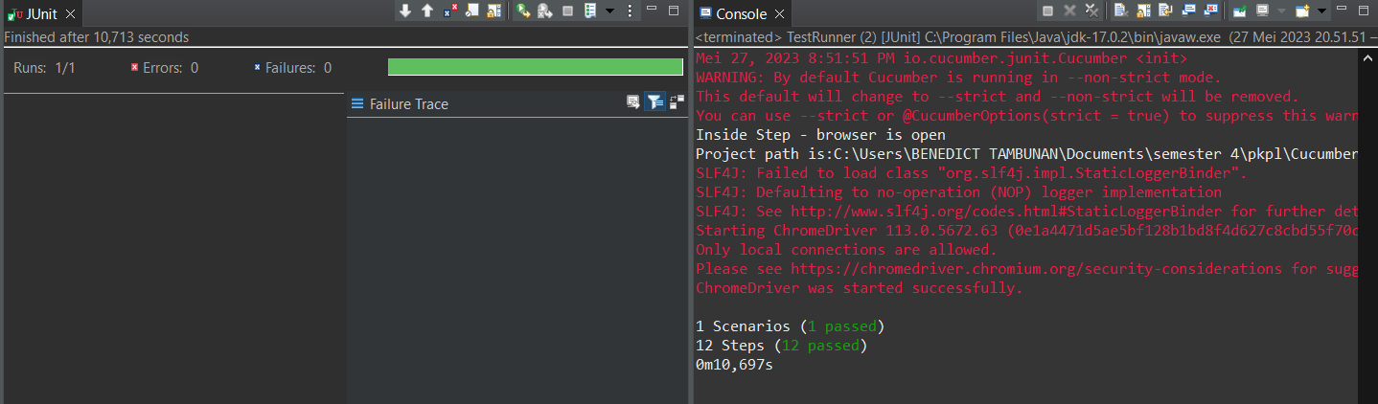

1. The browser while testing

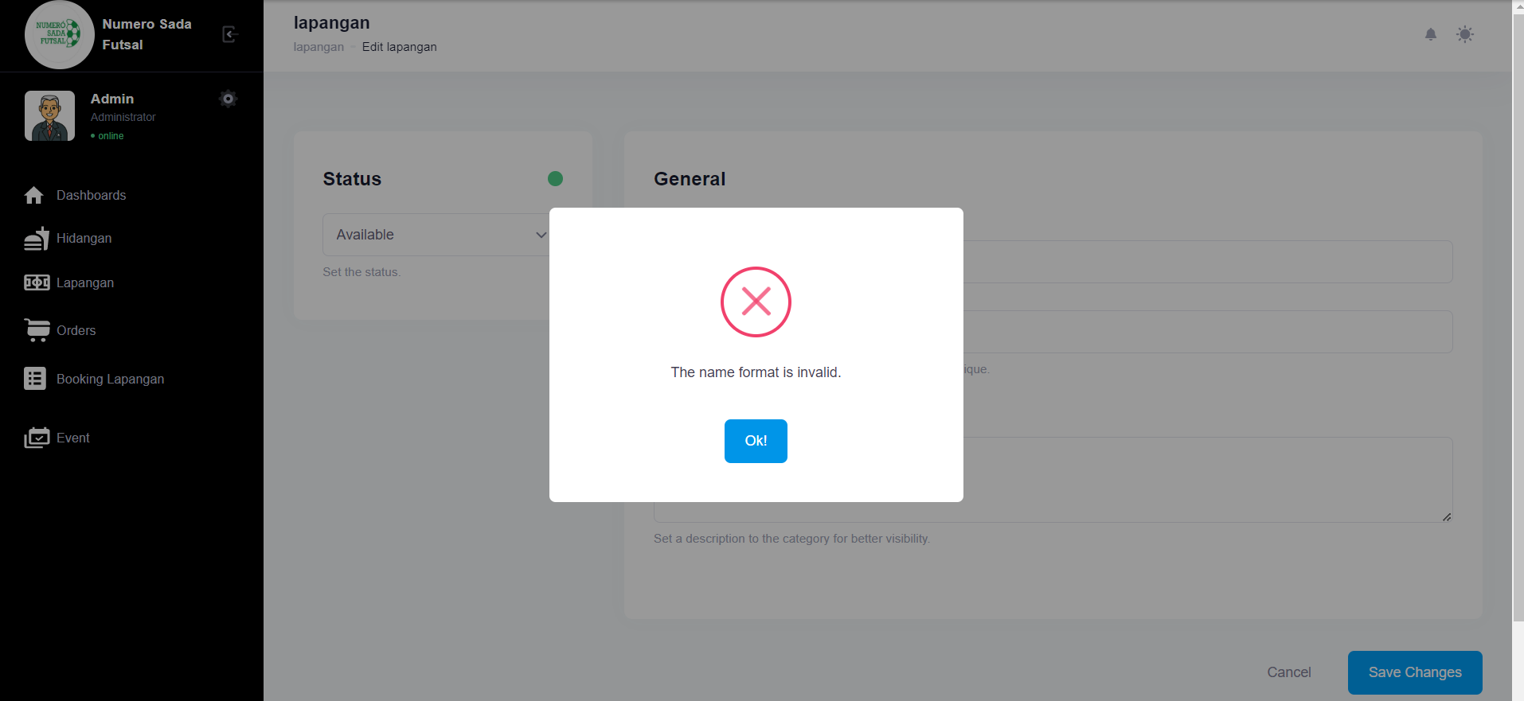

Fungsi edit Lapangan 6

1. The scenario



1. The Step definition



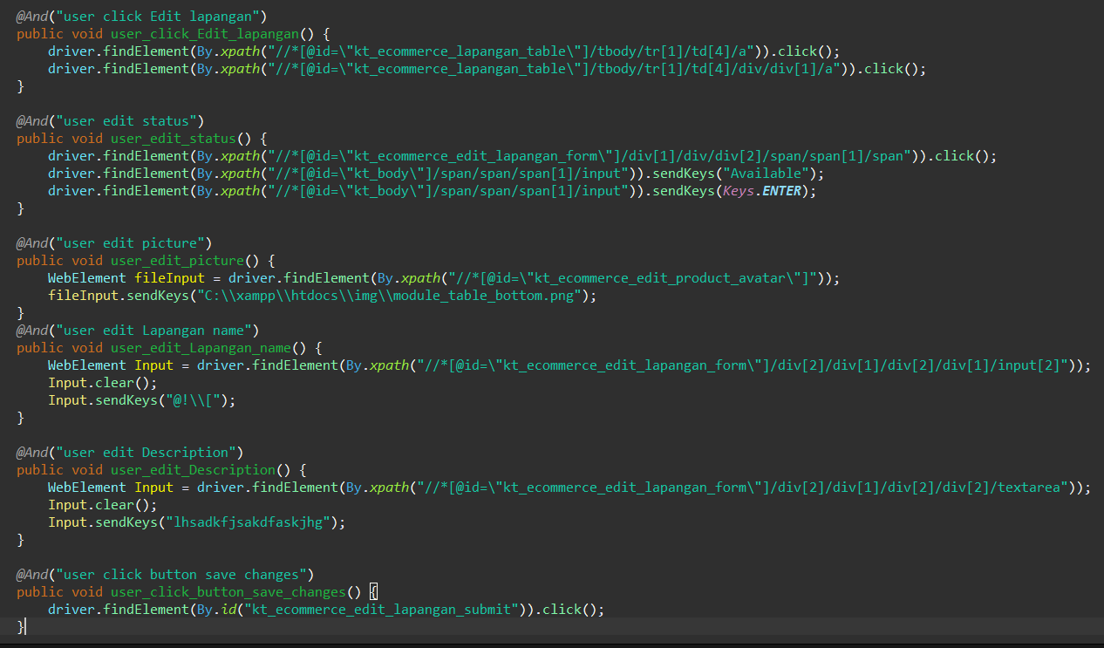

1. The test runner



1. The console after running

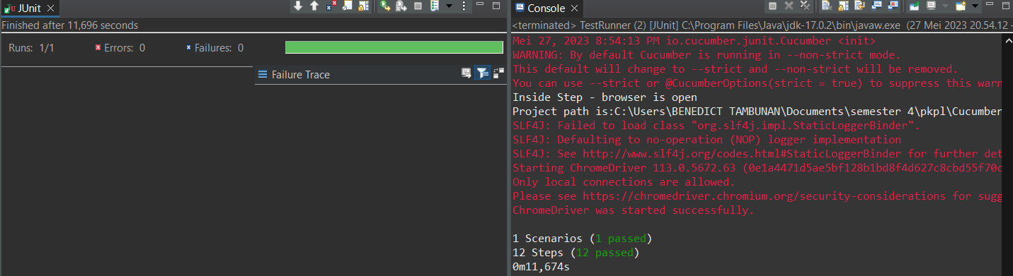

1. The browser while testing

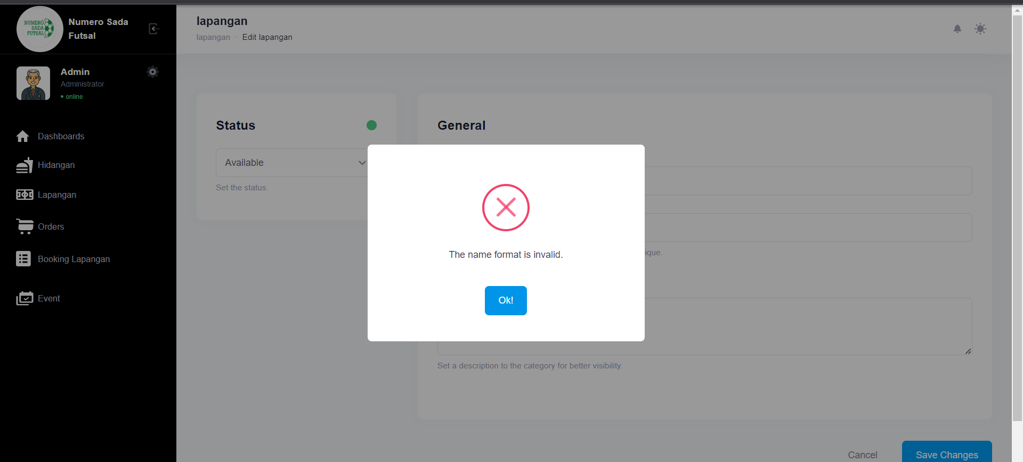

1. Test Fungsi edit Lapangan Variasi 4: edit Lapangan dengan parameter 1,2 valid namun ke 3,4 tidak valid

Fungsi edit Lapangan 1

1. The scenario



1. The Step definition



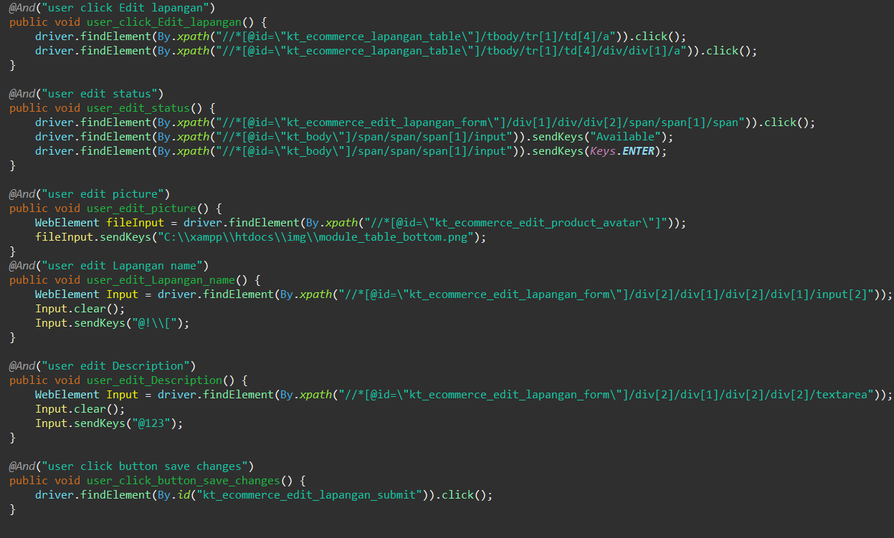

1. The test runner



1. The console after running

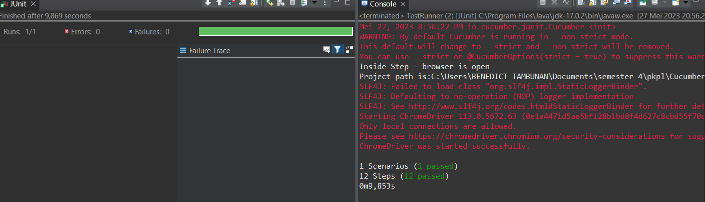

1. The browser while testing

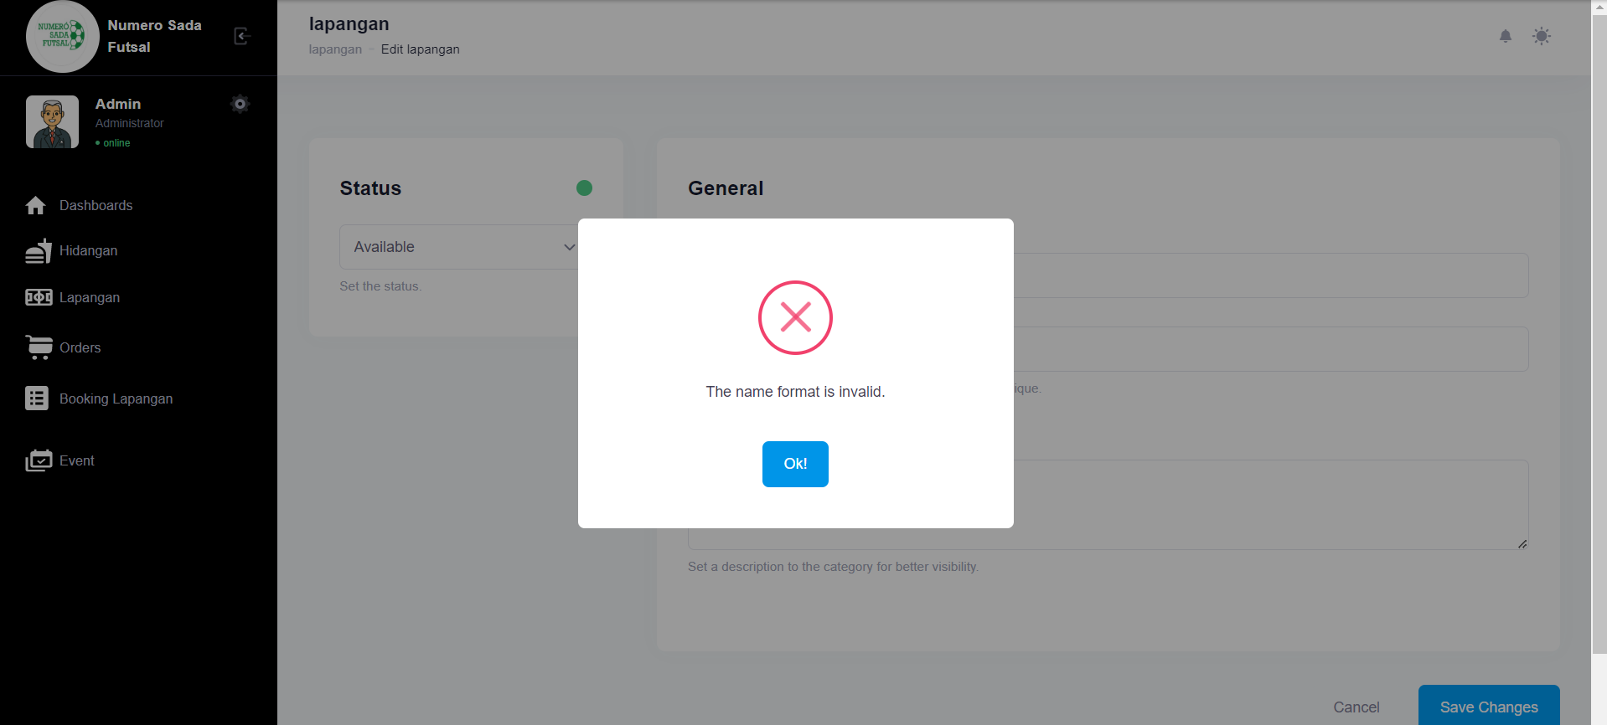

Fungsi edit Lapangan 2

1. The scenario



1. The Step definition



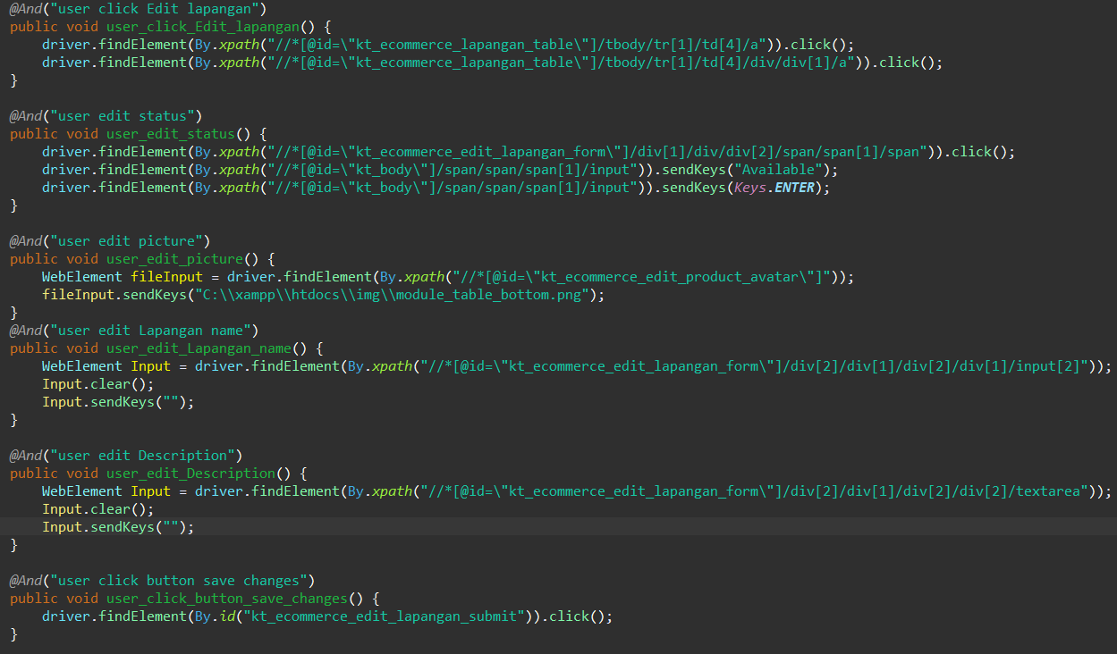

1. The test runner



1. The console after running

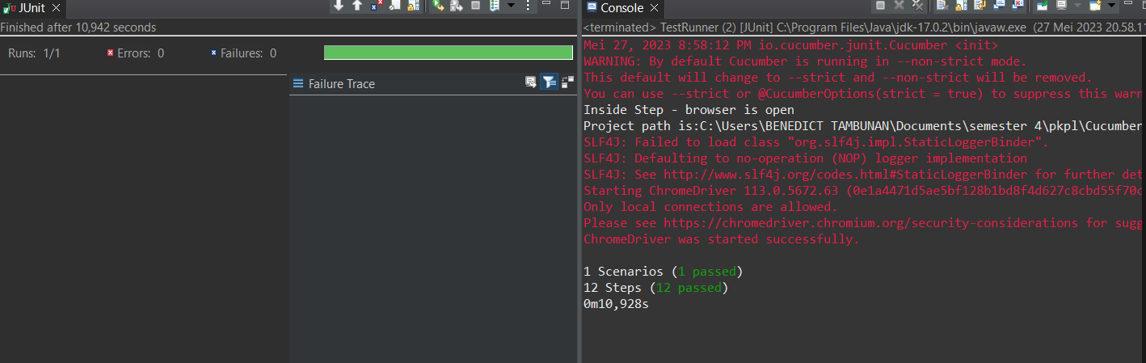

1. The browser while testing

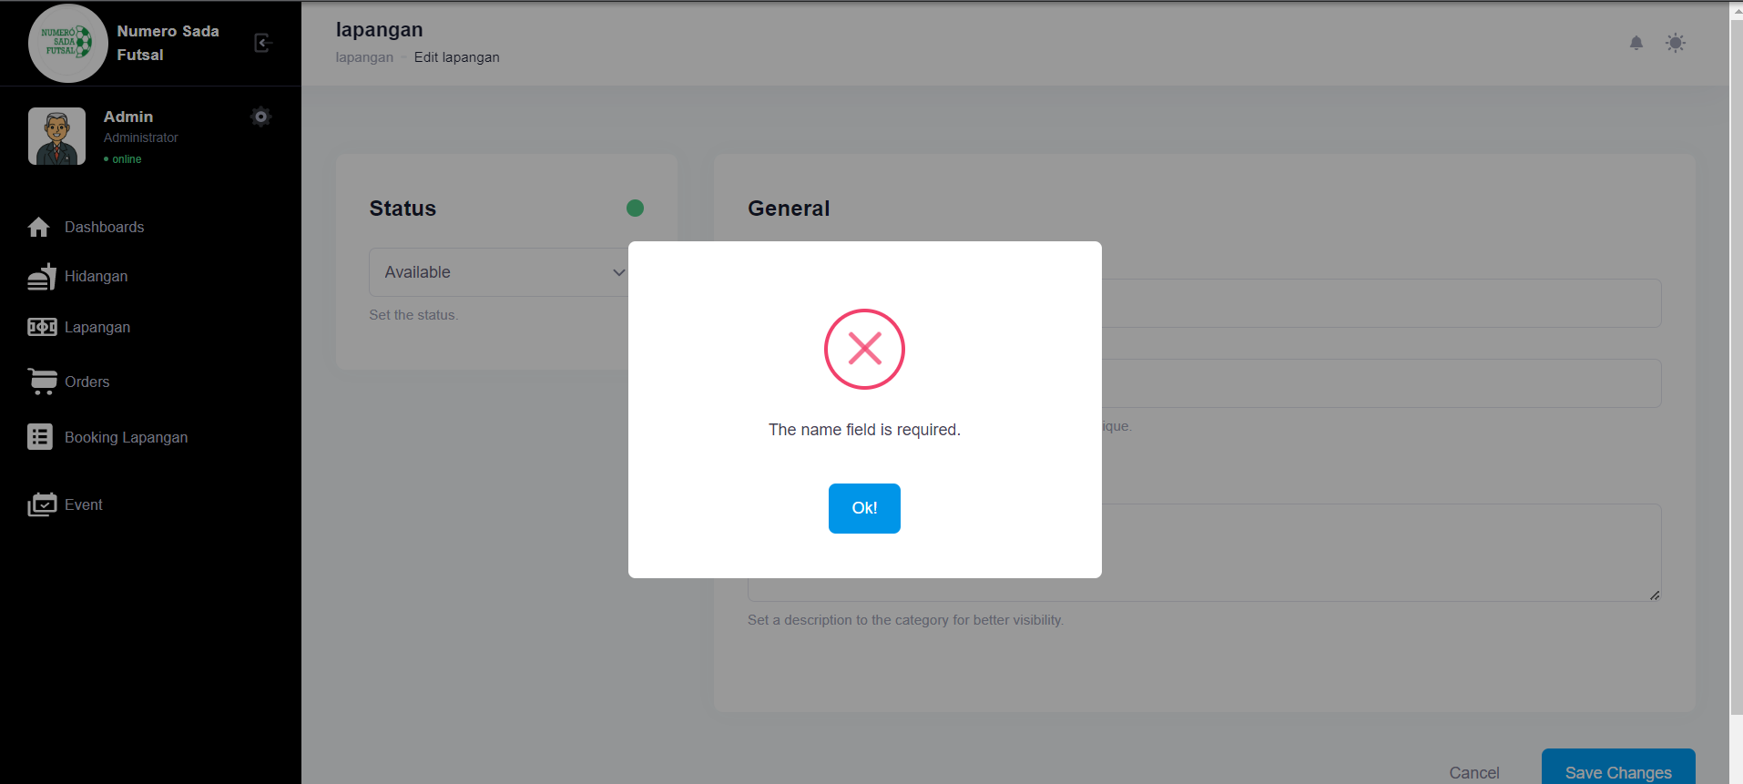

Fungsi edit Lapangan 3

1. The scenario



1. The Step definition



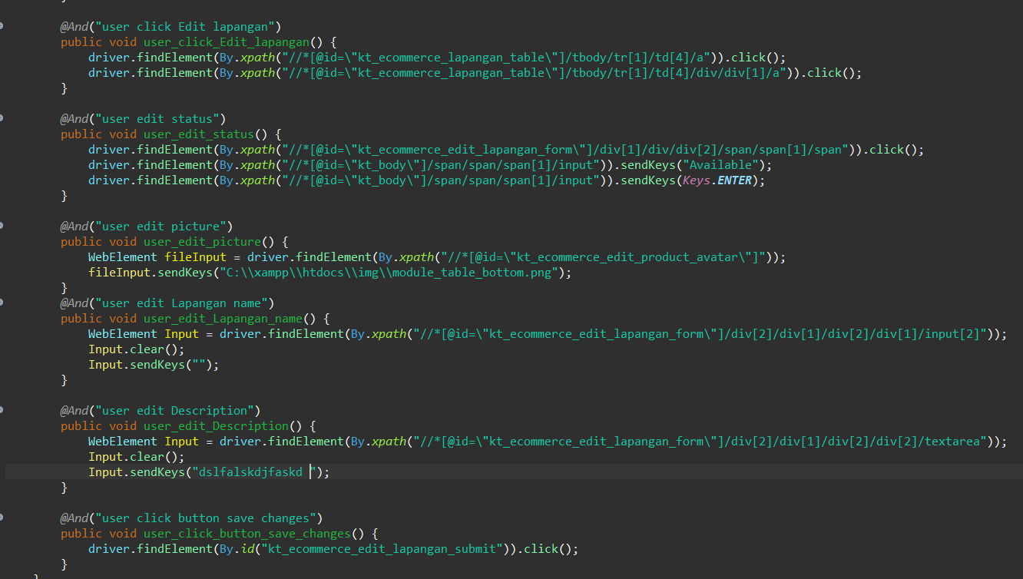

1. The test runner



1. The console after running

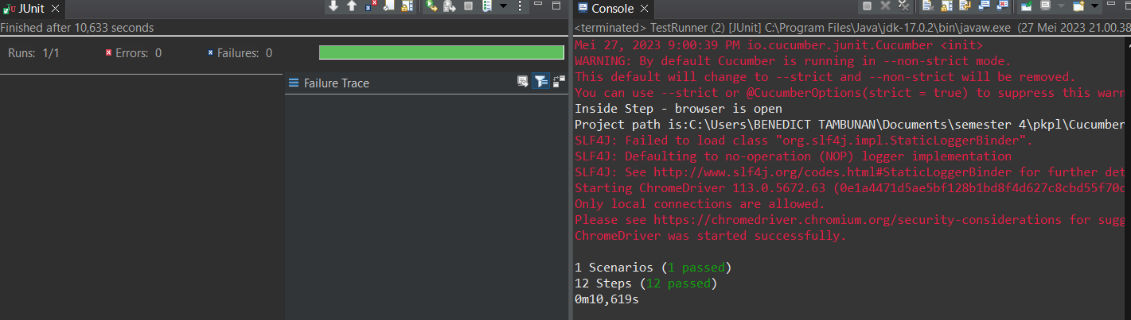

1. The browser while testing

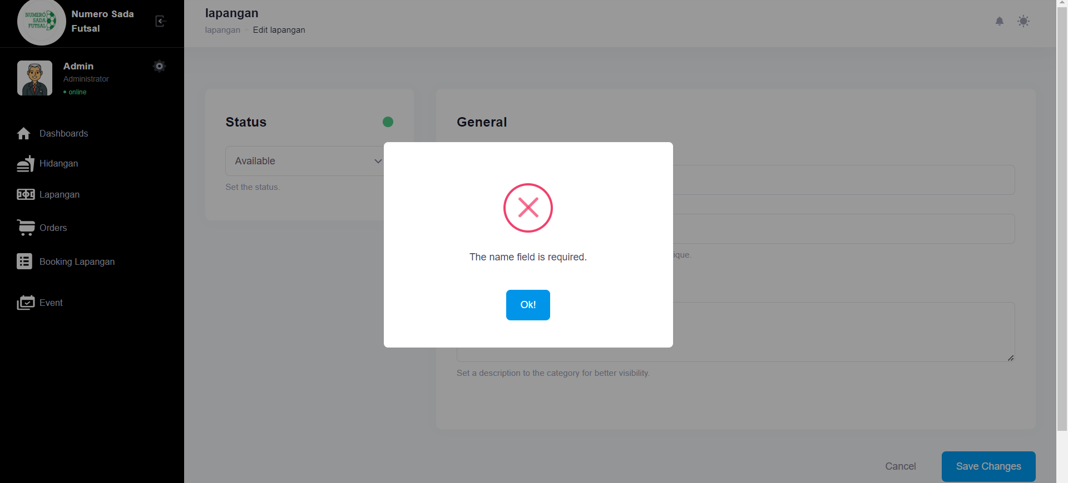

Fungsi edit Lapangan 4

1. The scenario



1. The Step definition



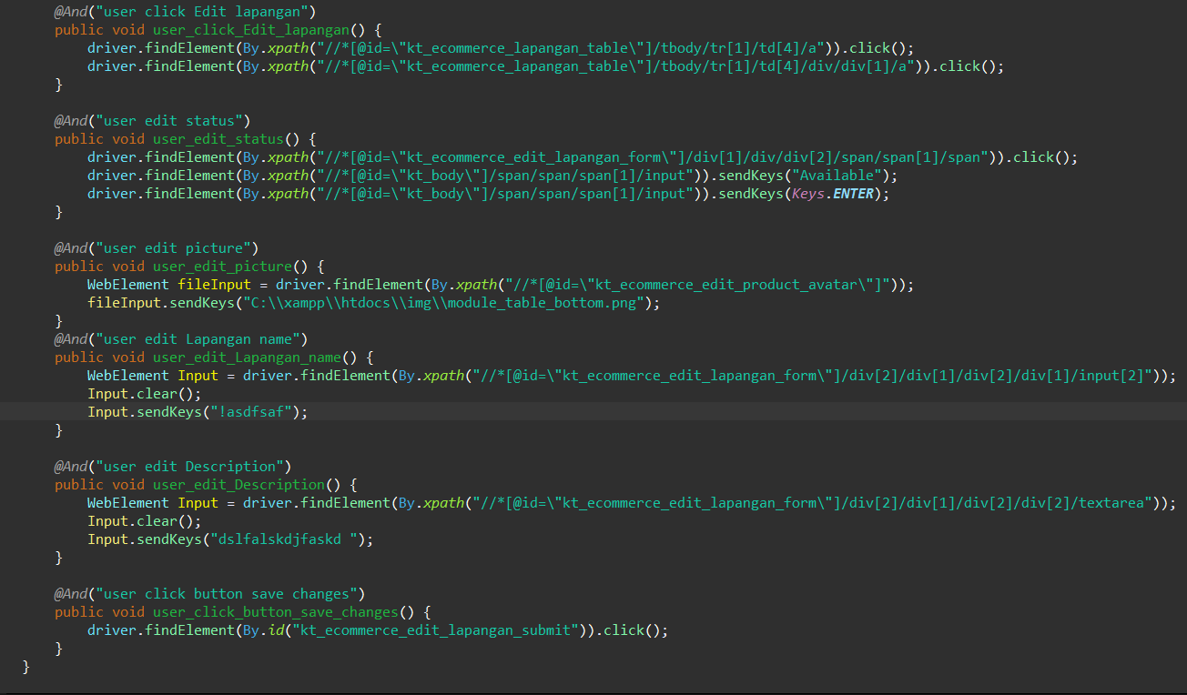

1. The test runner



1. The console after running

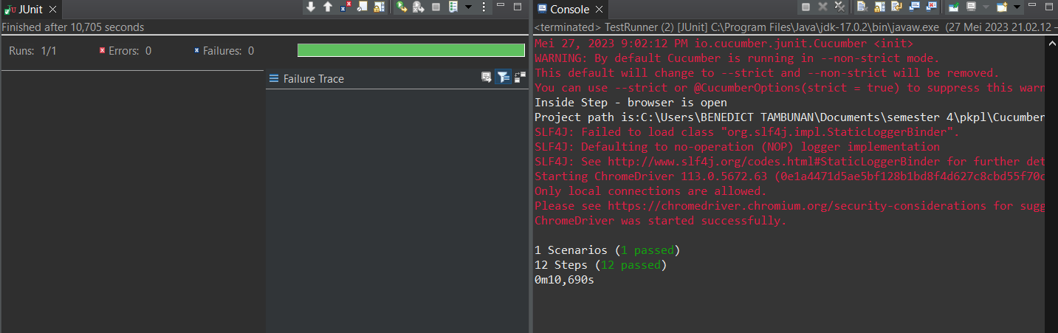

1. The browser while testing

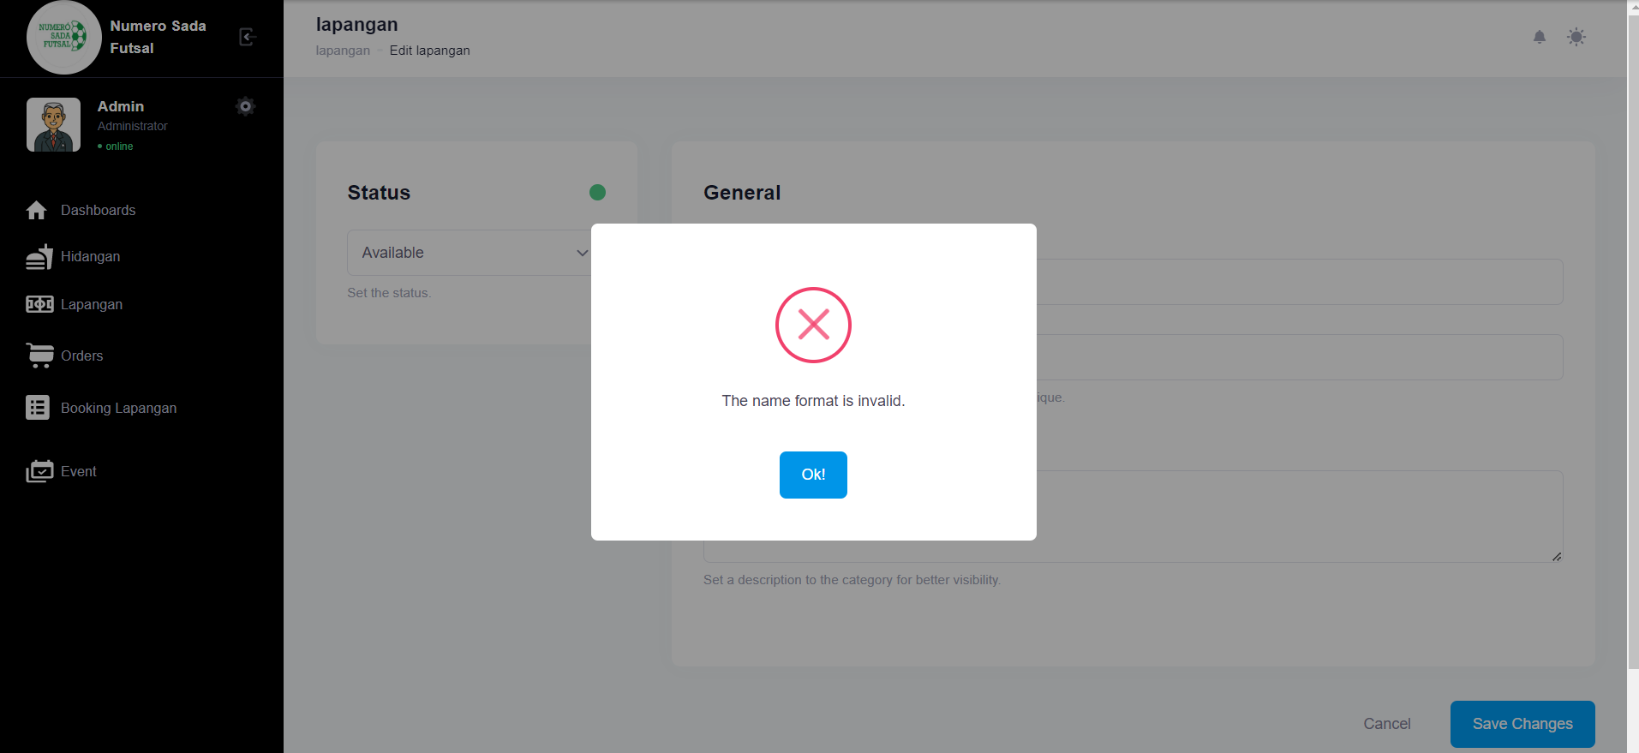

Fungsi edit Lapangan 5

1. The scenario



1. The Step definition



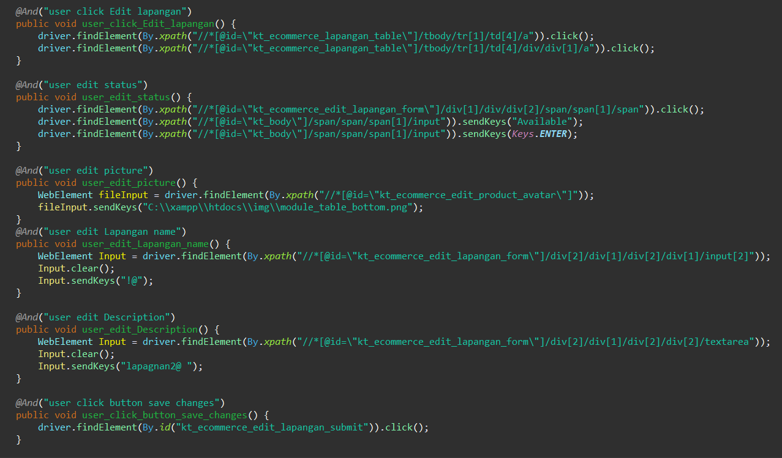

1. The test runner



1. The console after running

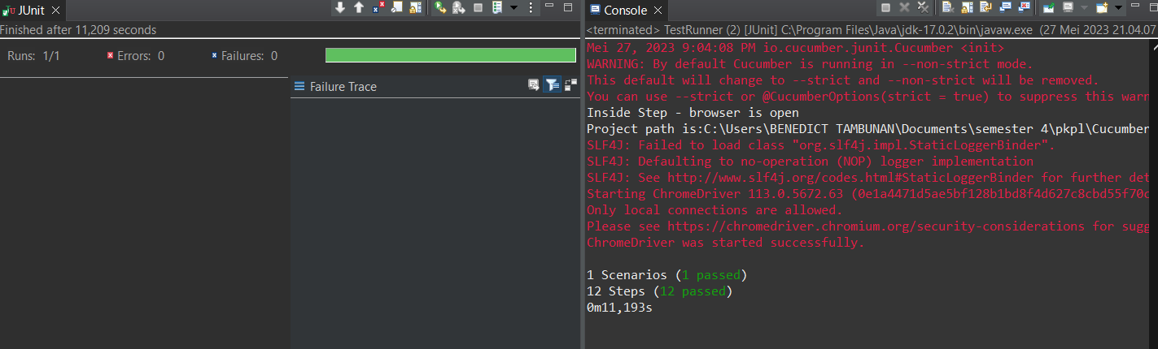

1. The browser while testing

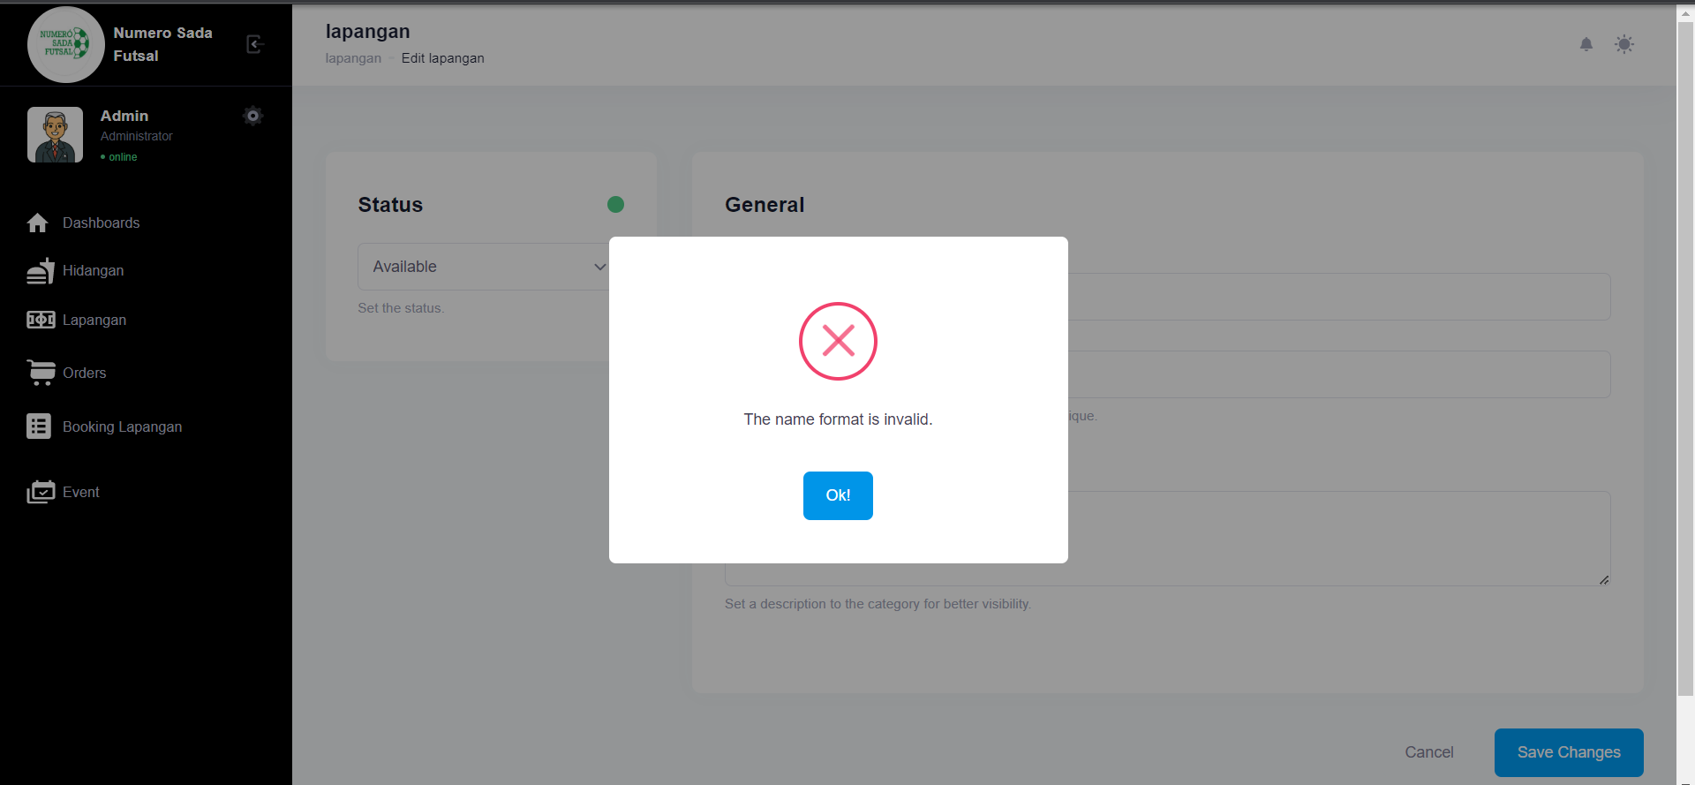

Fungsi edit Lapangan 6

1. The scenario



1. The Step definition



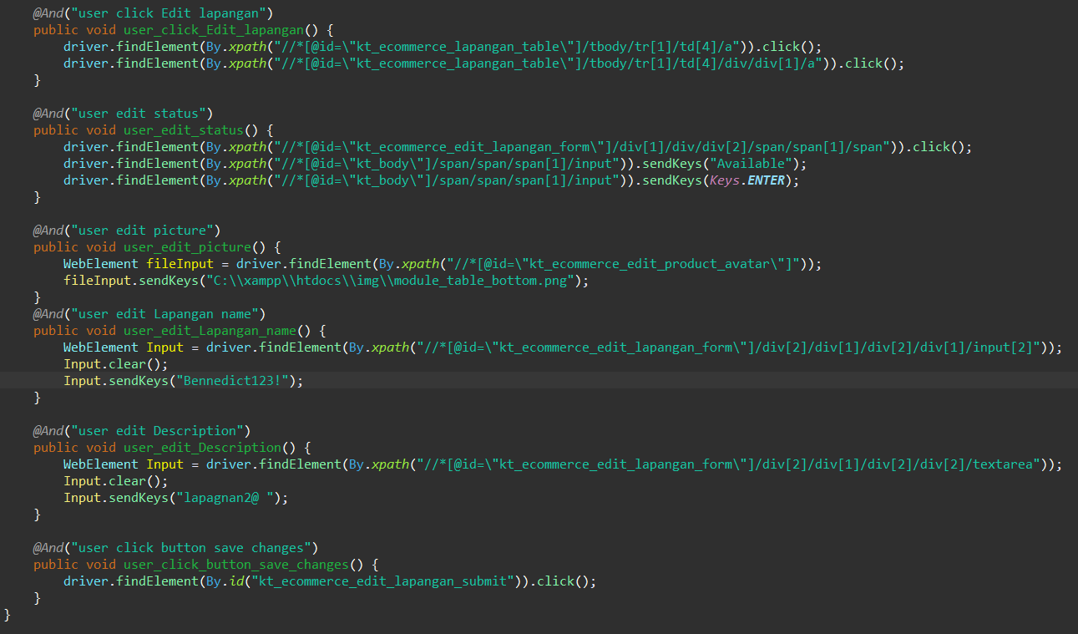

1. The test runner



1. The console after running

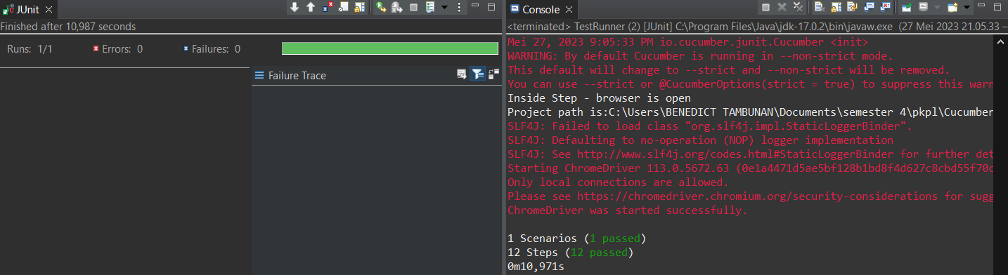

1. The browser while testing

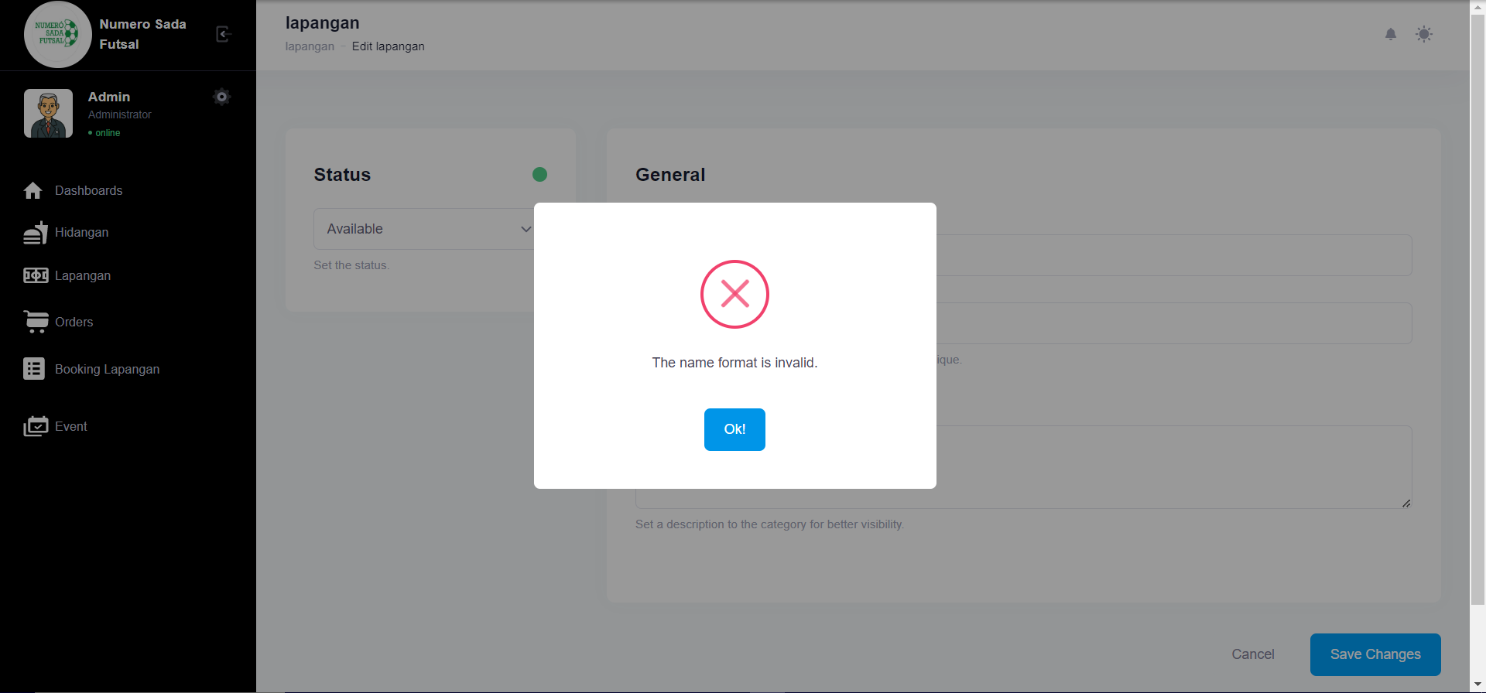

1. Test Fungsi edit Lapangan Variasi 5: edit Lapangan dengan parameter 1,3,4 valid namun ke 2 tidak valid

Fungsi edit Lapangan 1

1. The scenario



1. The Step definition



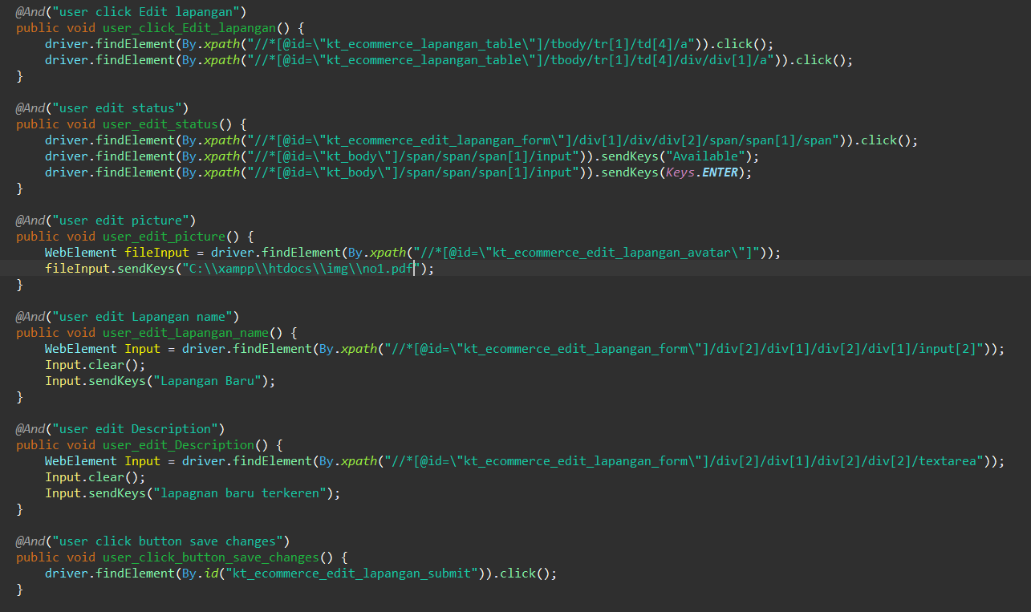

1. The test runner



1. The console after running

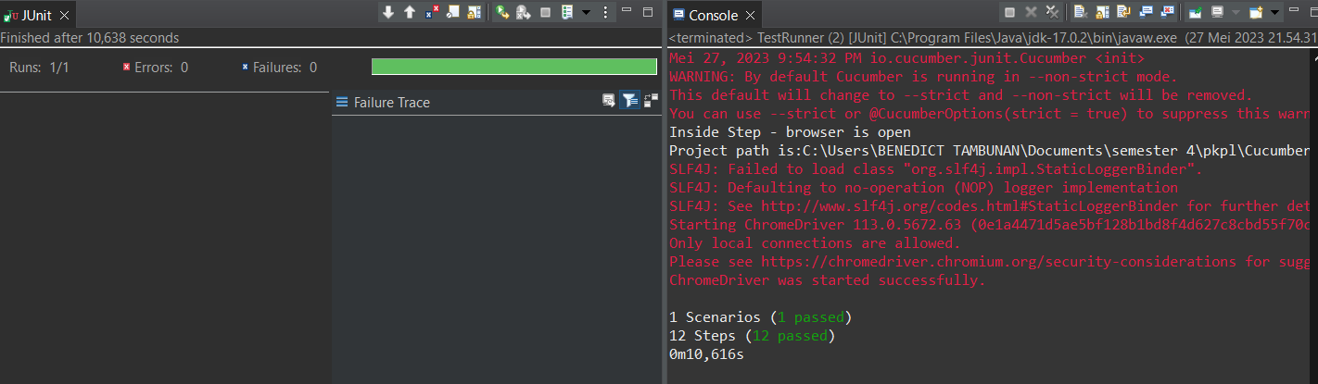

1. The browser while testing

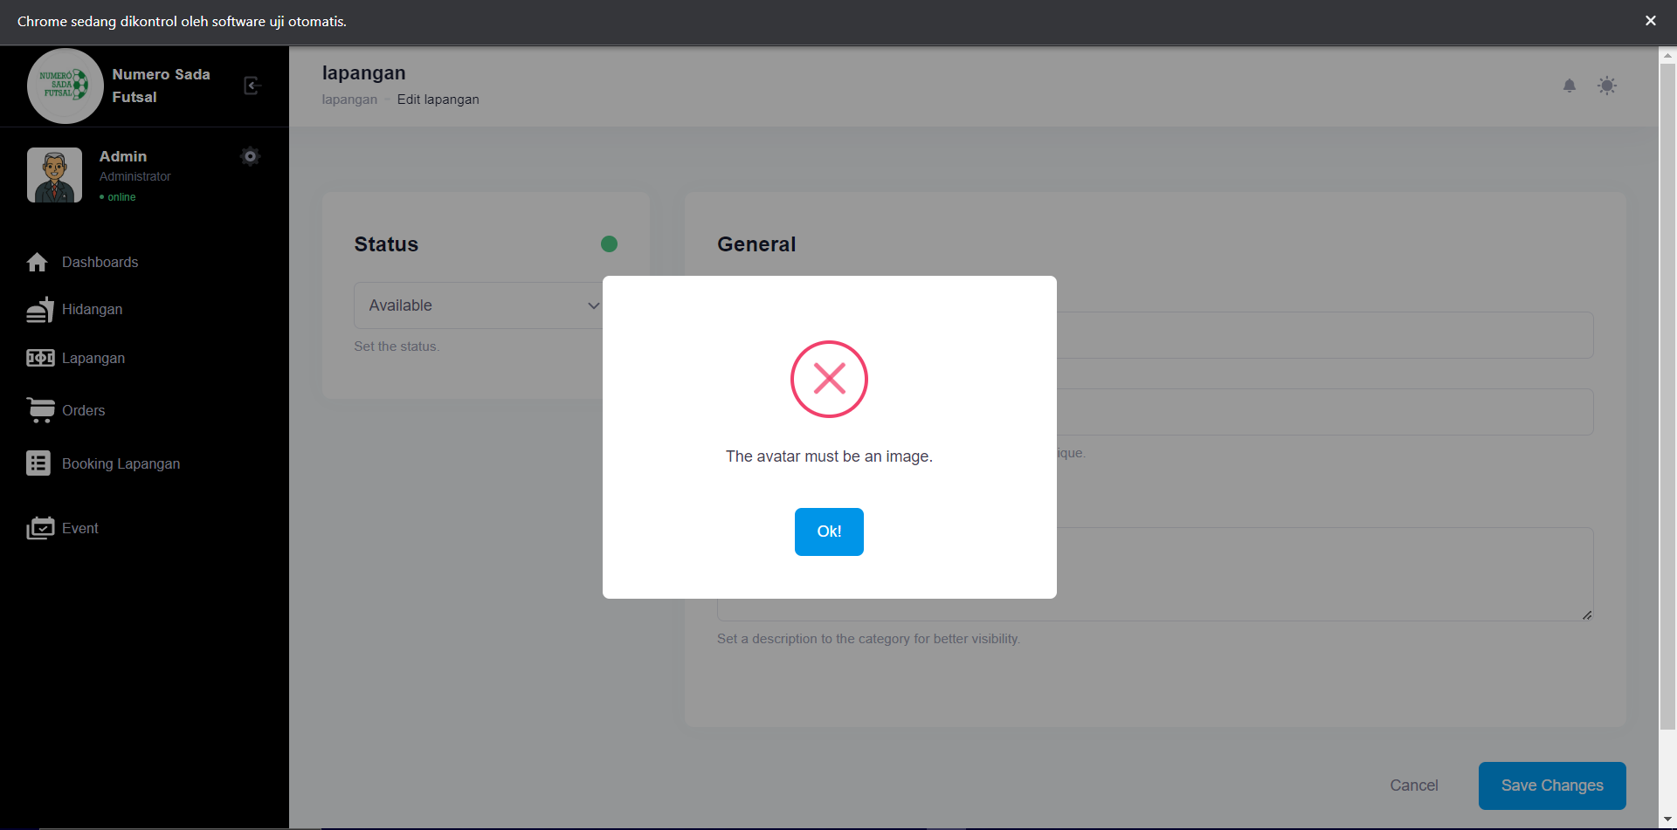

Fungsi edit Lapangan 2

1. The scenario



1. The Step definition



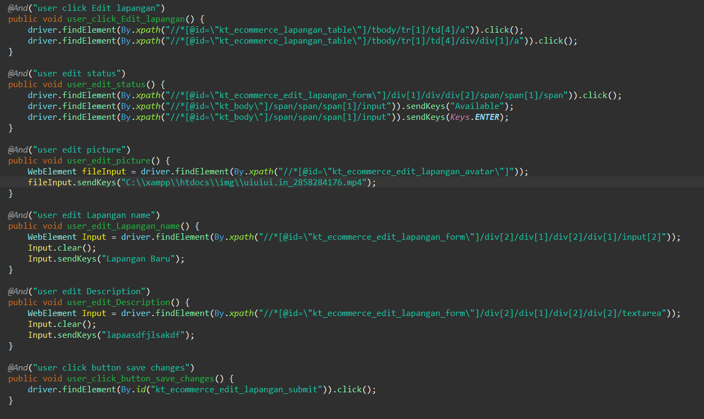

1. The test runner



1. The console after running

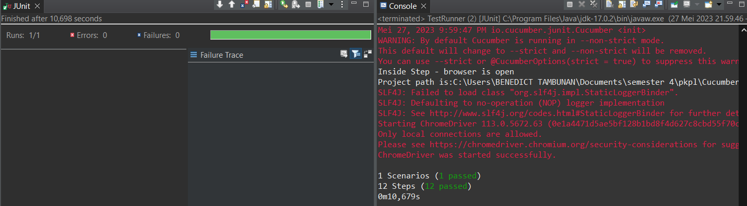

1. The browser while testing

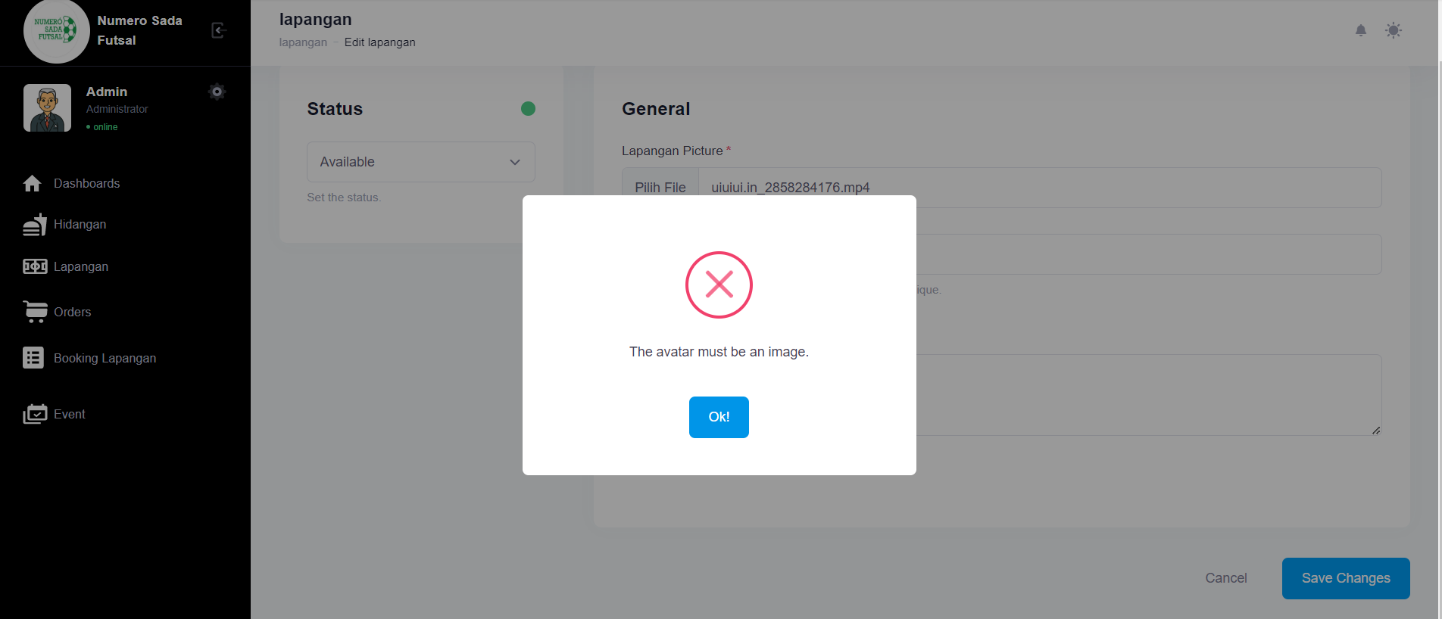

Fungsi edit Lapangan 3

1. The scenario



1. The Step definition



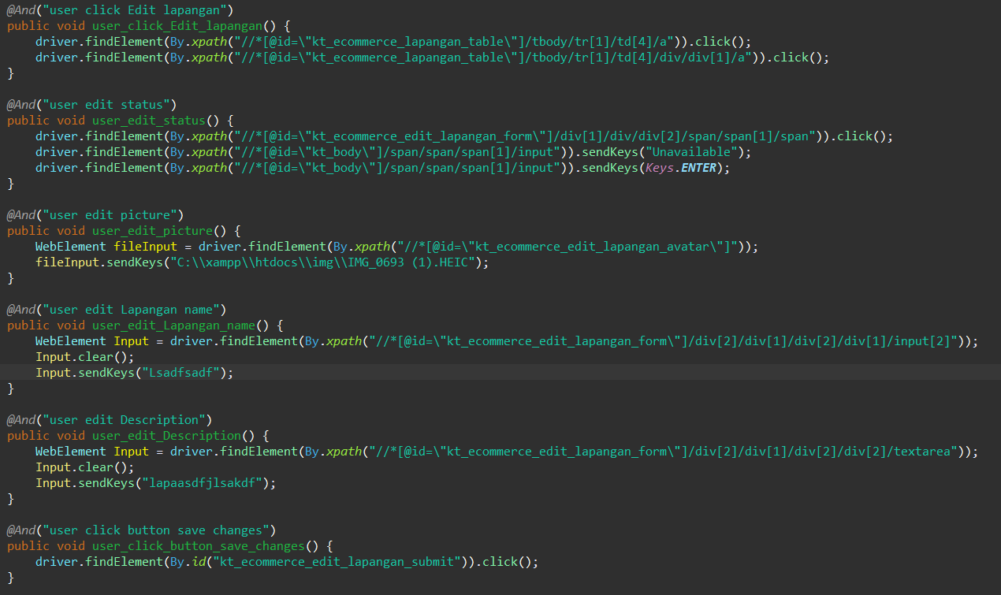

1. The test runner



1. The console after running

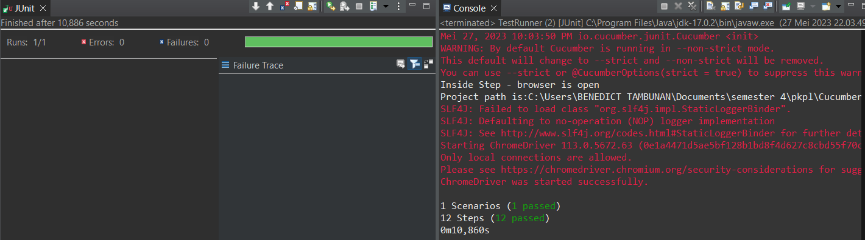

1. The browser while testing

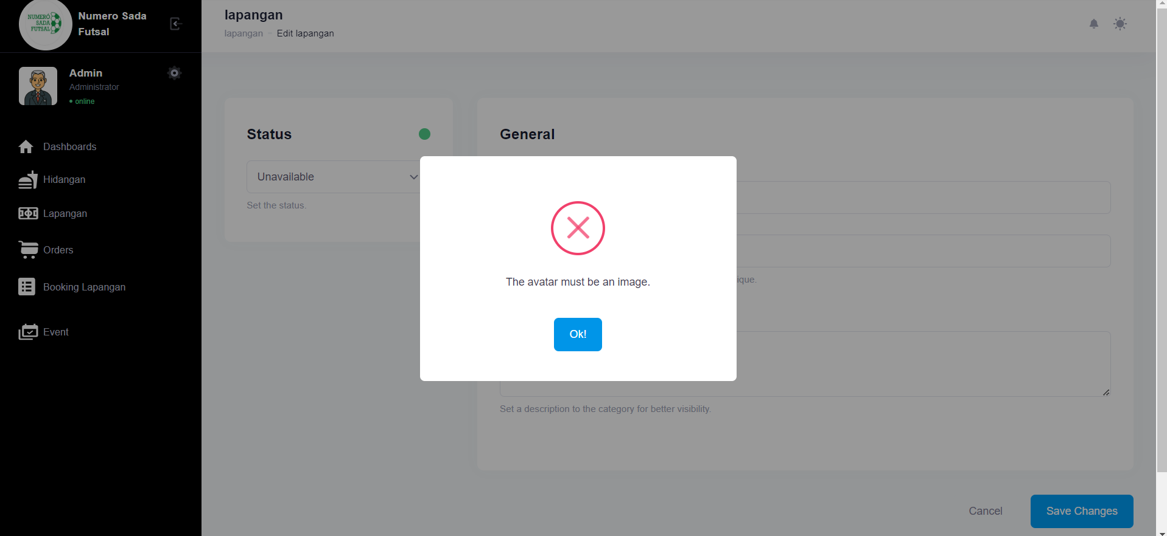

Fungsi edit Lapangan 4

1. The scenario



1. The Step definition



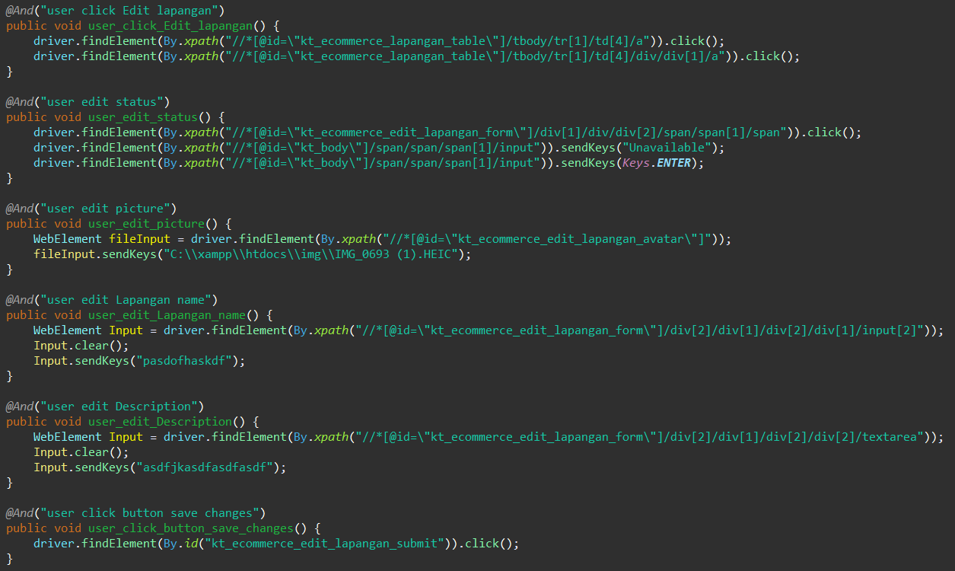

1. The test runner



1. The console after running

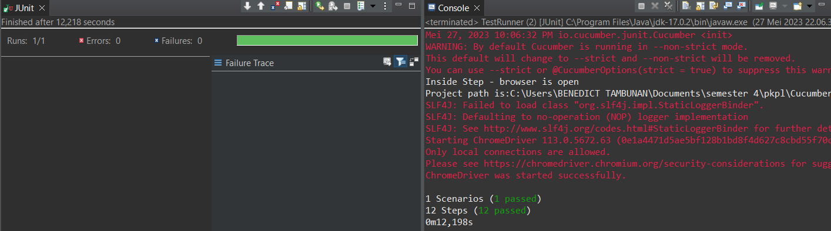

1. The browser while testing

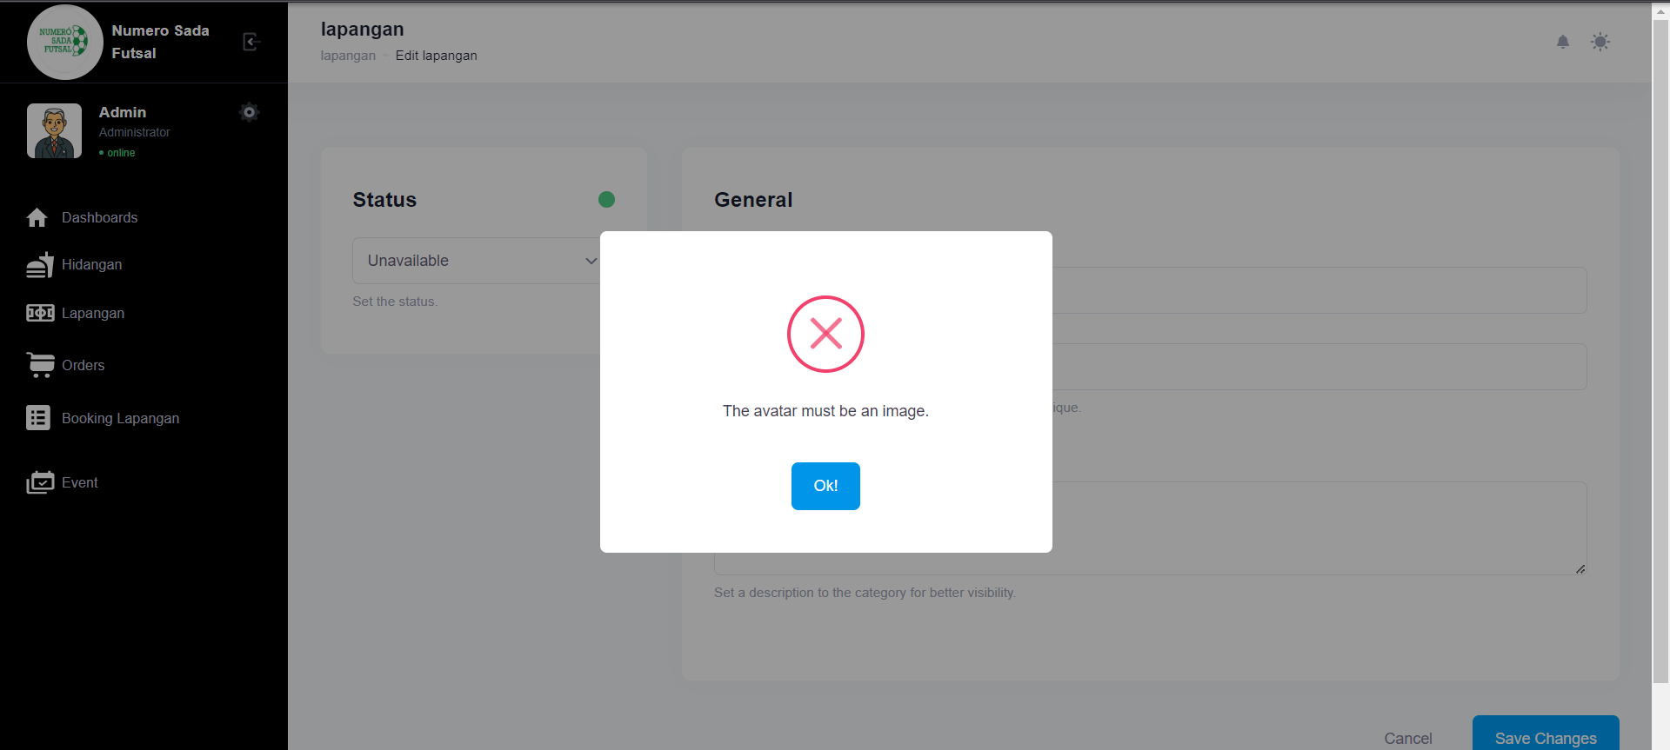

Fungsi edit Lapangan 5

1. The scenario



1. The Step definition



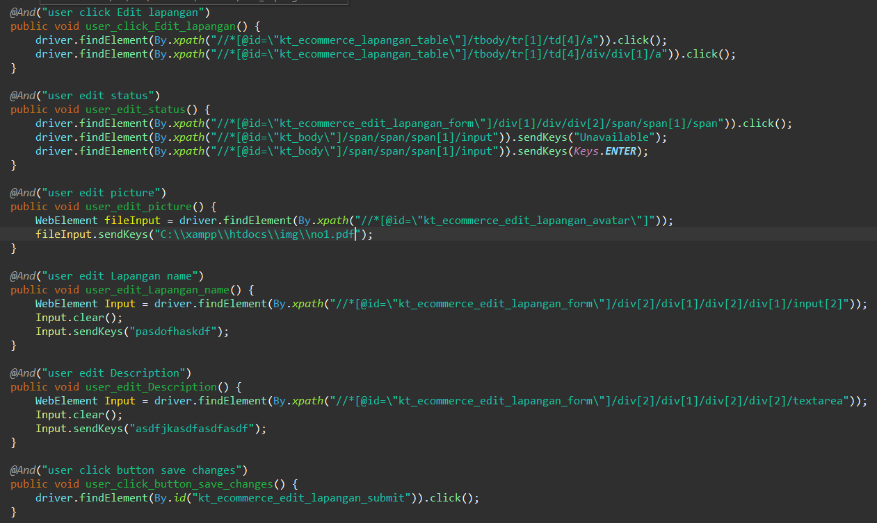

1. The test runner



1. The console after running

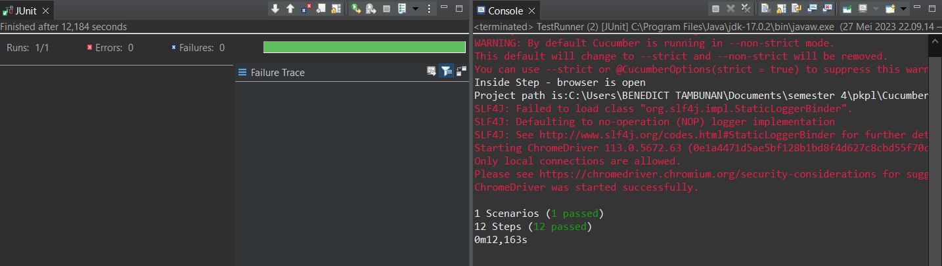

1. The browser while testing

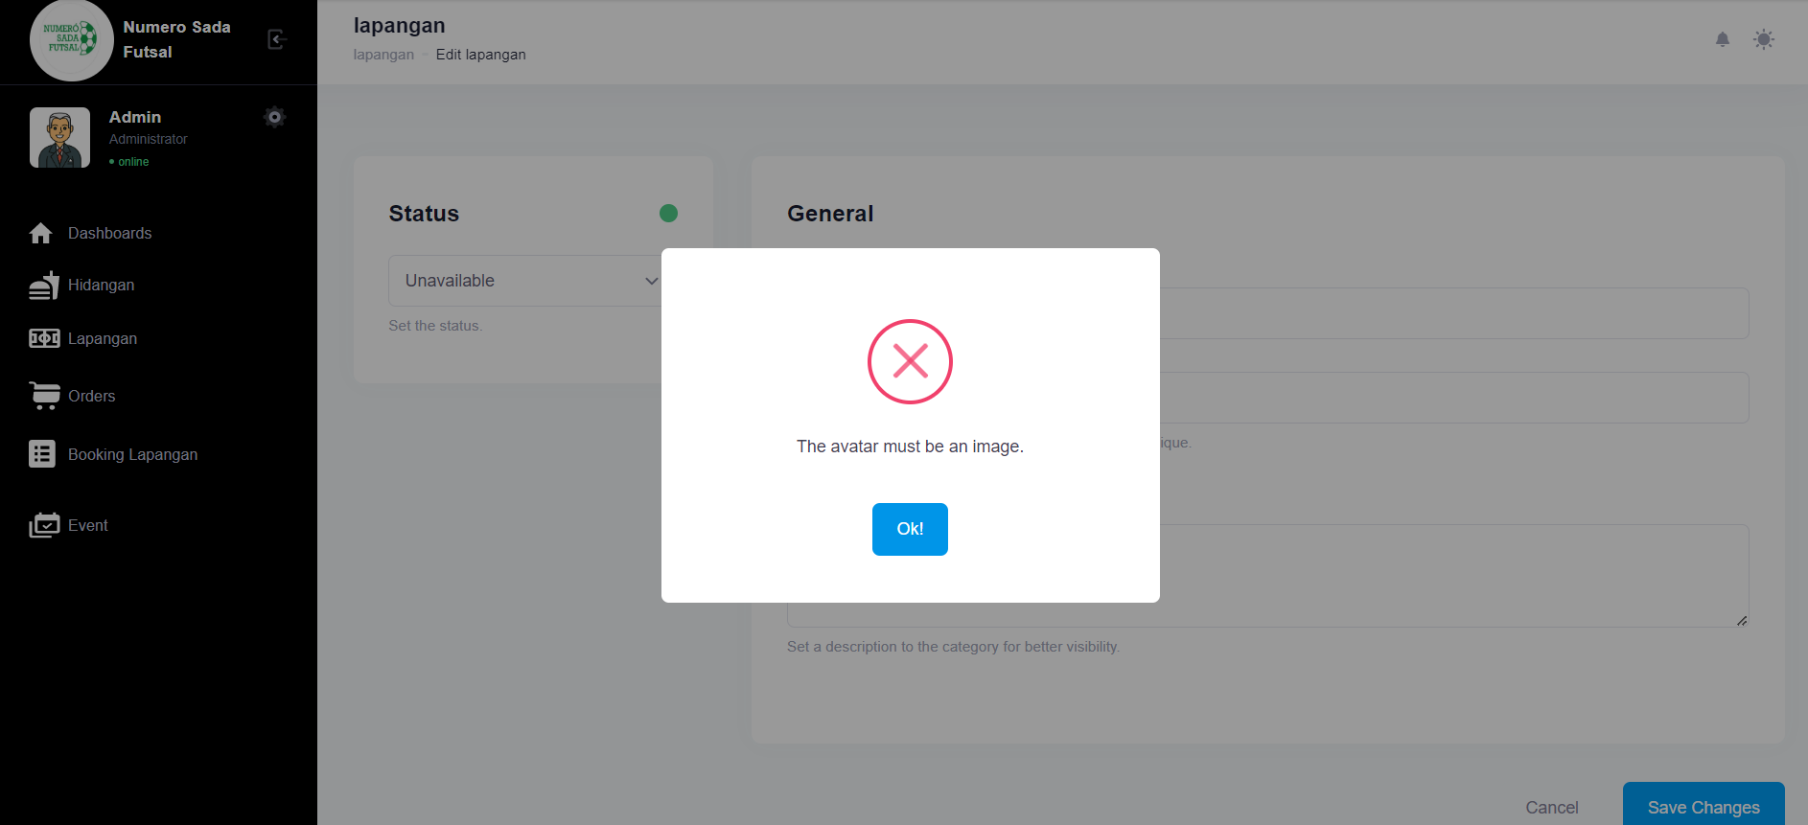

Fungsi edit Lapangan 6

1. The scenario
2. The Step definition



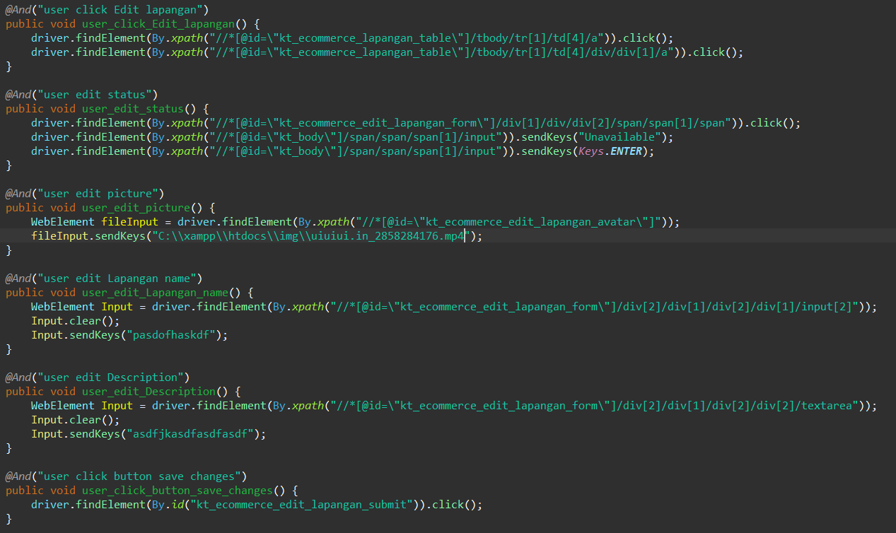

1. The test runne
2. The console after running

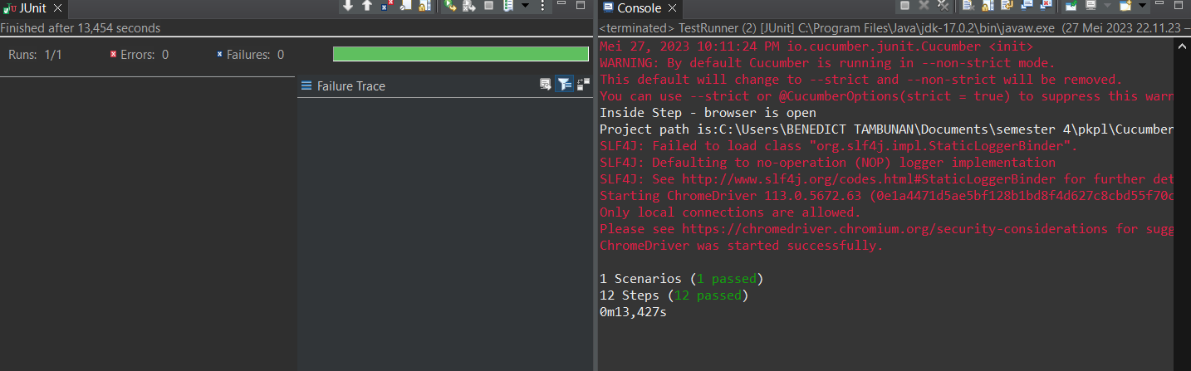

1. The browser while testing

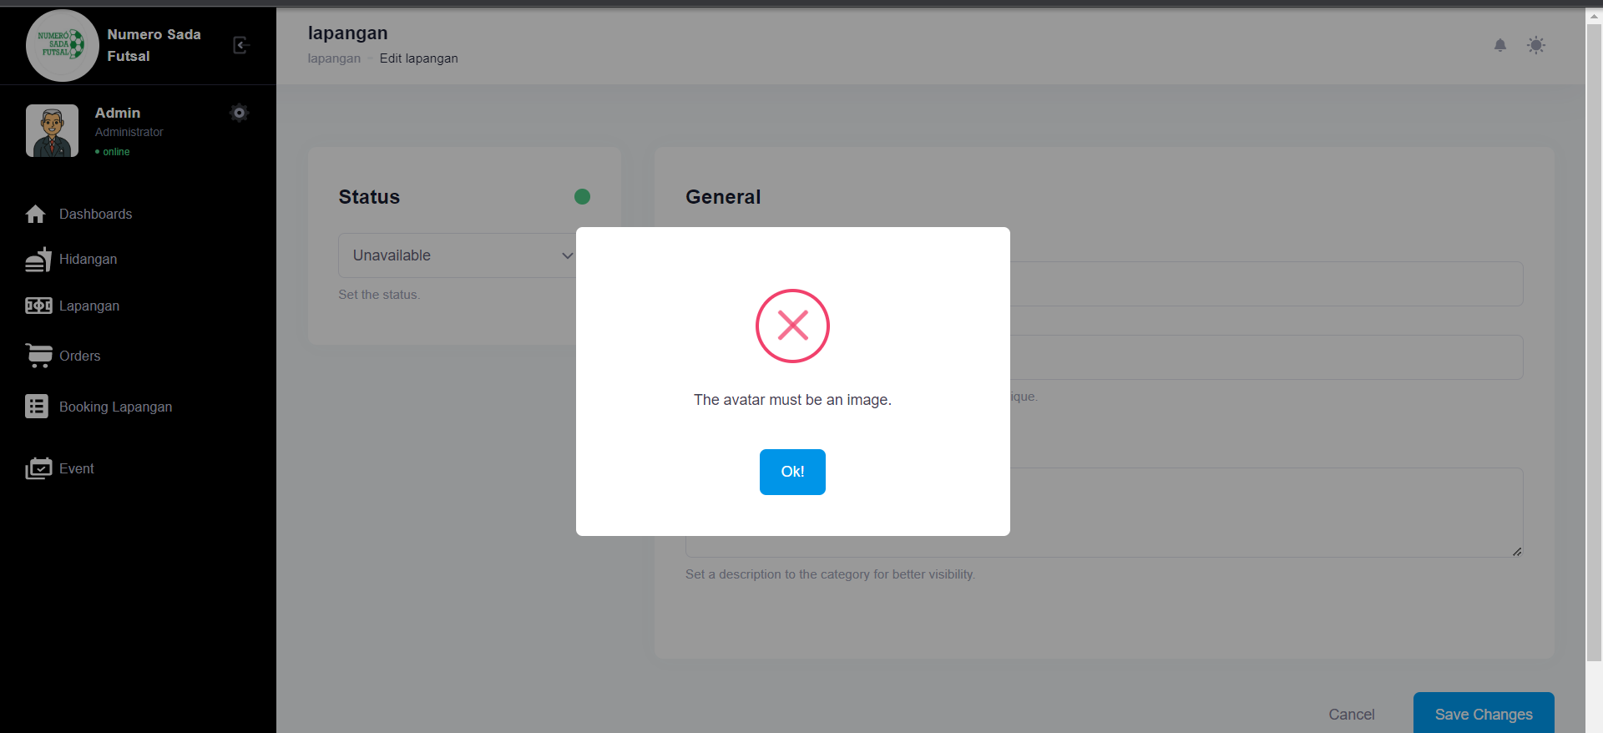

1. Test Fungsi edit Lapangan Variasi 6: edit Lapangan dengan parameter 1,3 valid namun ke 2,4 tidak valid

Fungsi edit Lapangan 1

1. The scenario



1. The Step definition



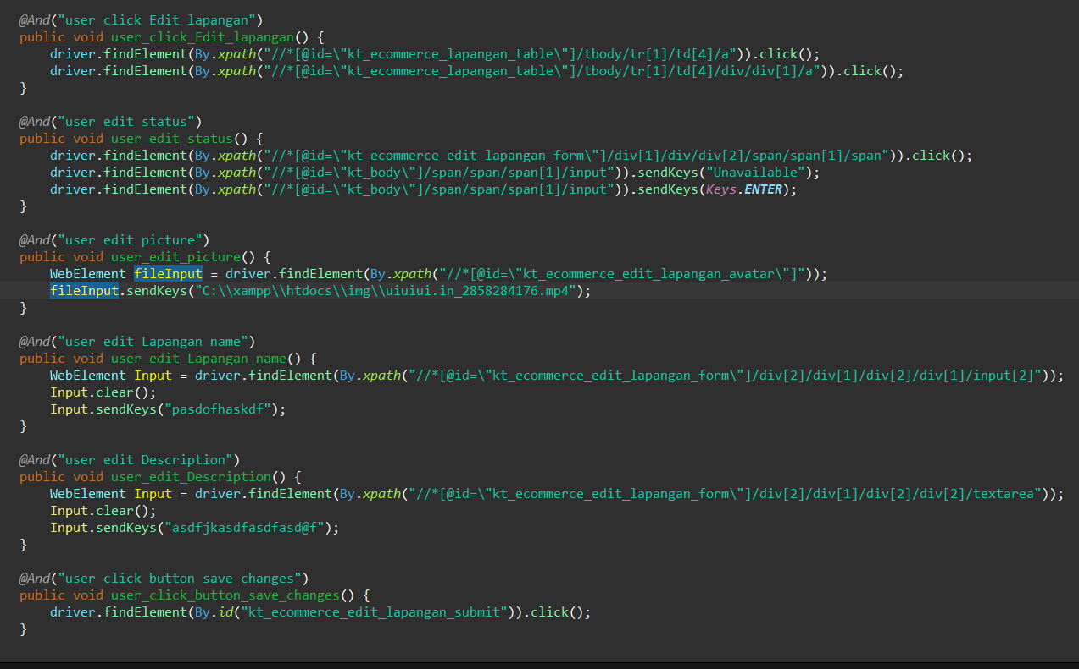

1. The test runner



1. The console after running

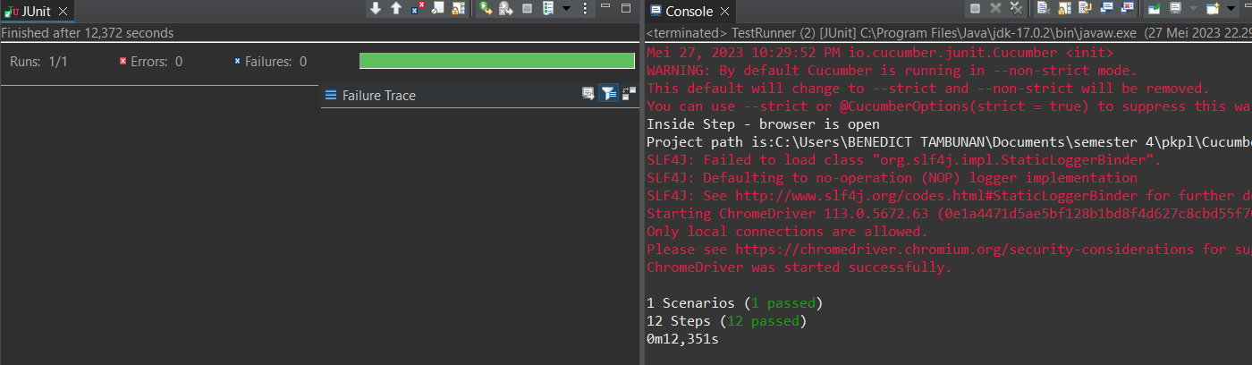

1. The browser while testing

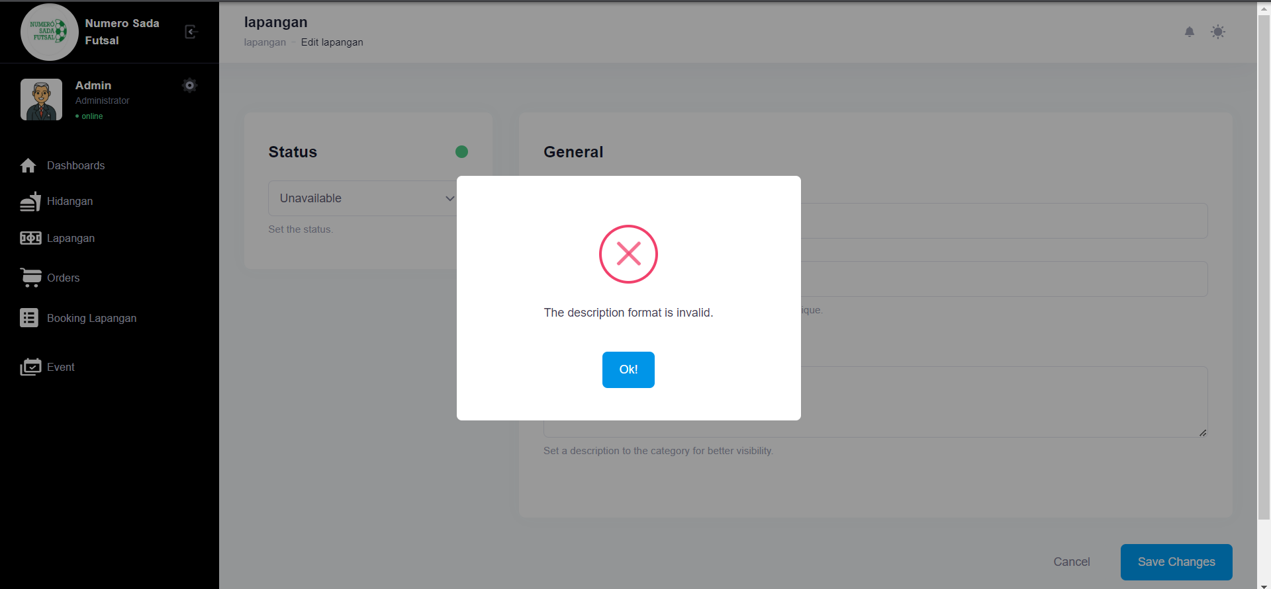

Fungsi edit Lapangan 2

1. The scenario



1. The Step definition



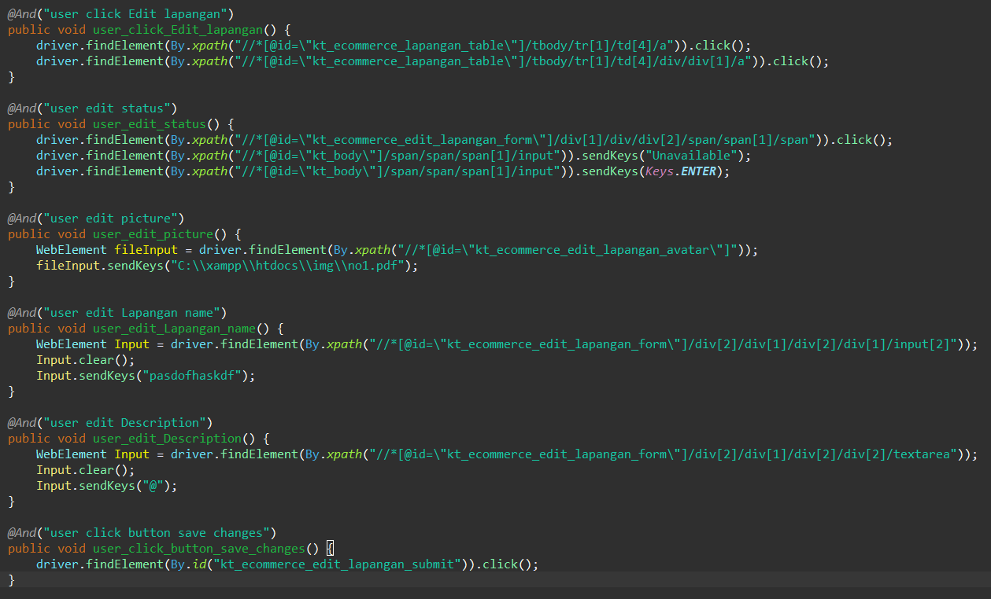

1. The test runner



1. The console after running

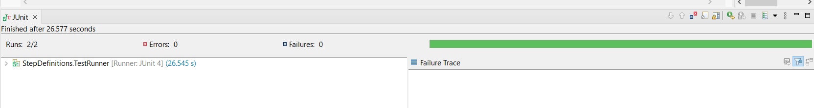

1. The browser while testing

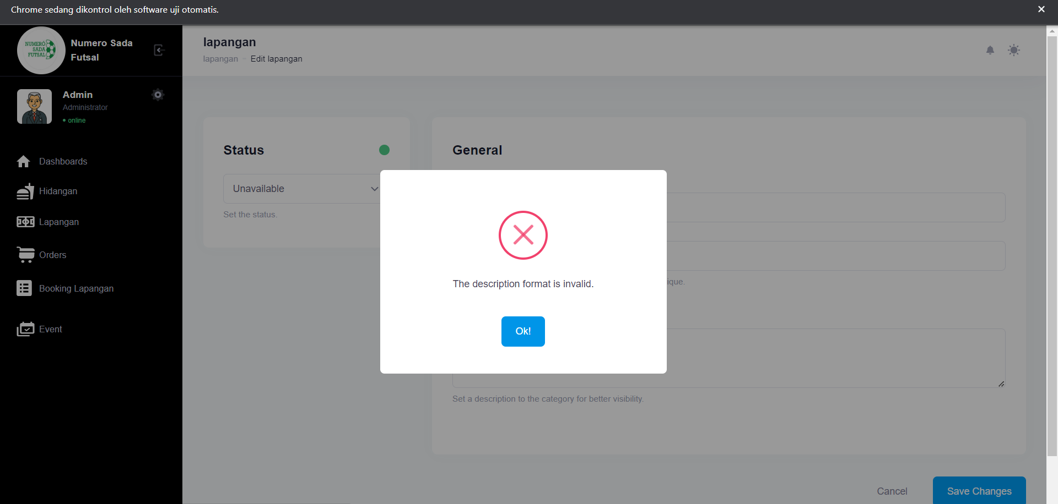

Fungsi edit Lapangan 3

1. The scenario



1. The Step definition



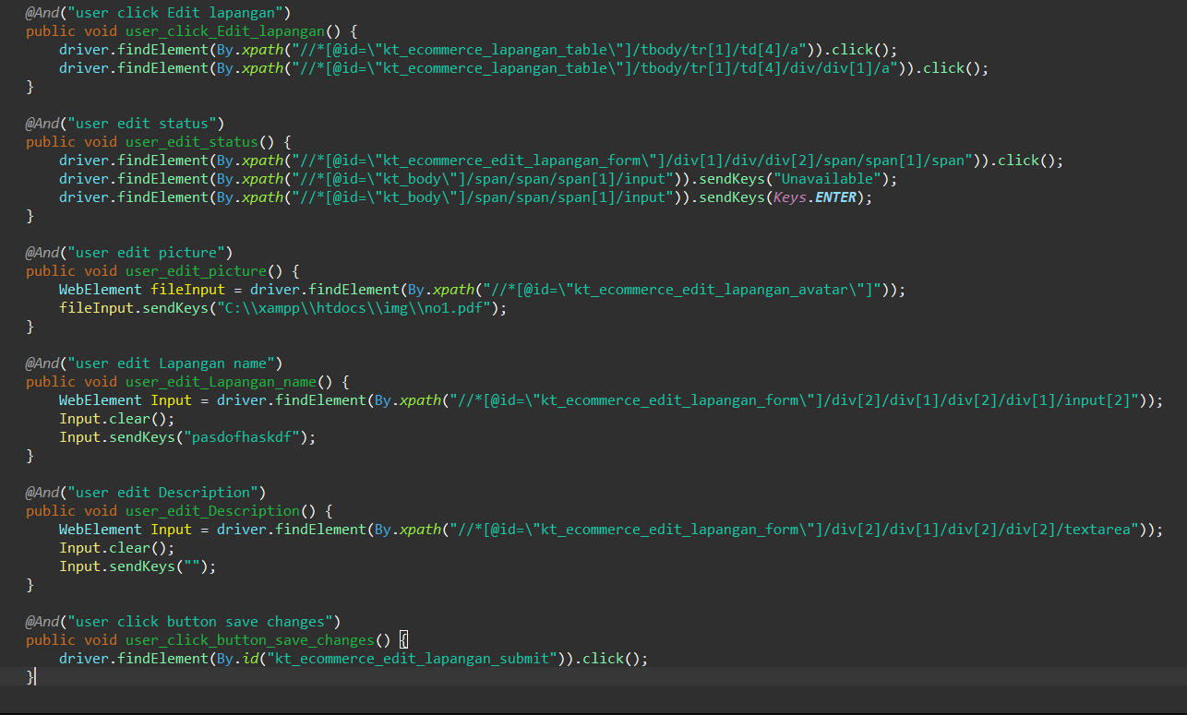

1. The test runner



1. The console after running

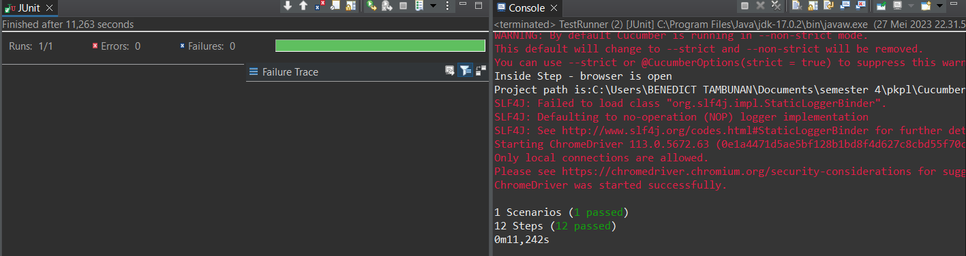

1. The browser while testing

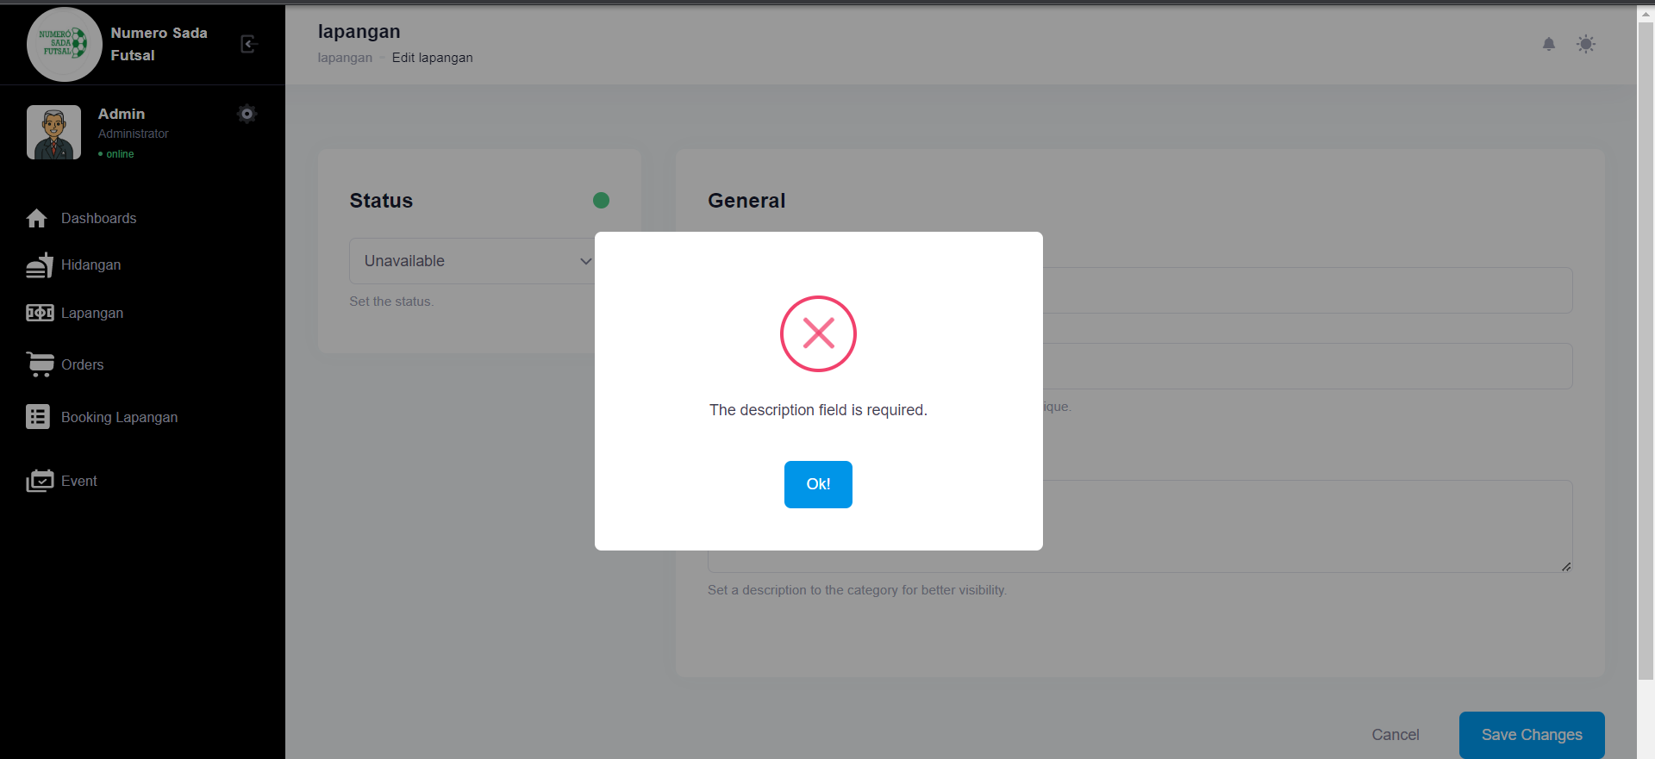

Fungsi edit Lapangan 4

1. The scenario



1. The Step definition



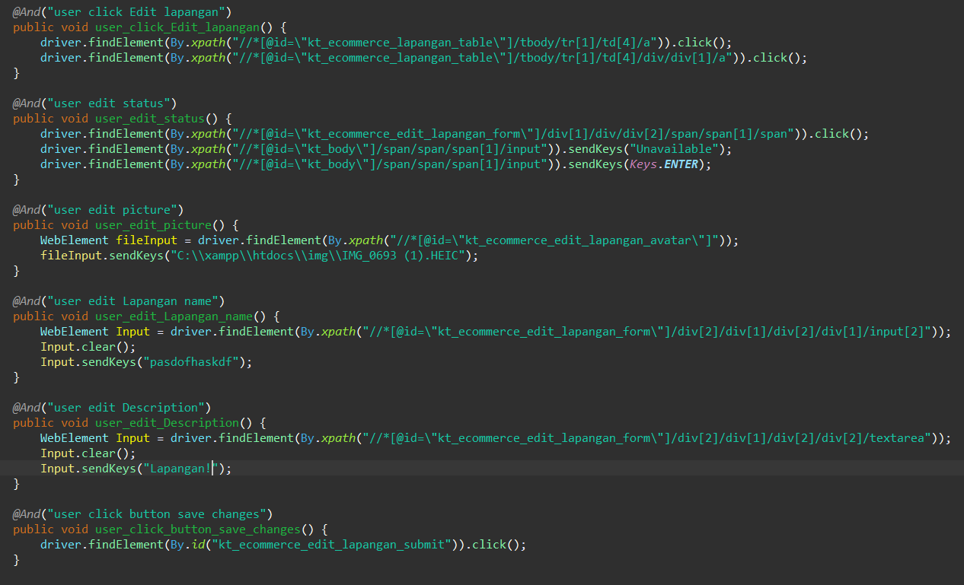

1. The test runner



1. The console after running

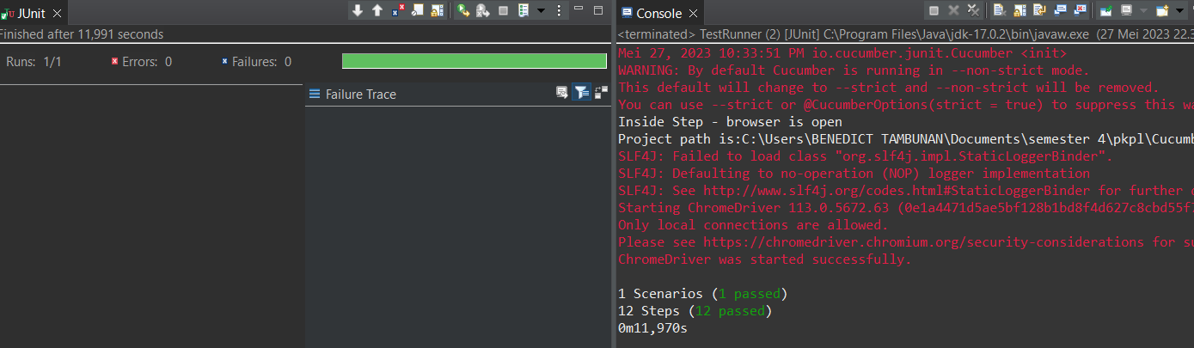

1. The browser while testing

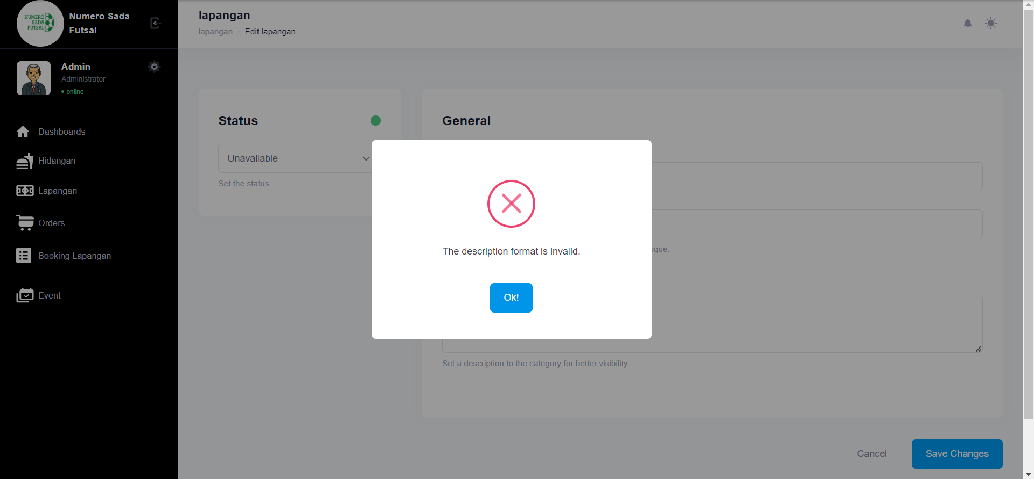

Fungsi edit Lapangan 5

1. The scenario



1. The Step definition



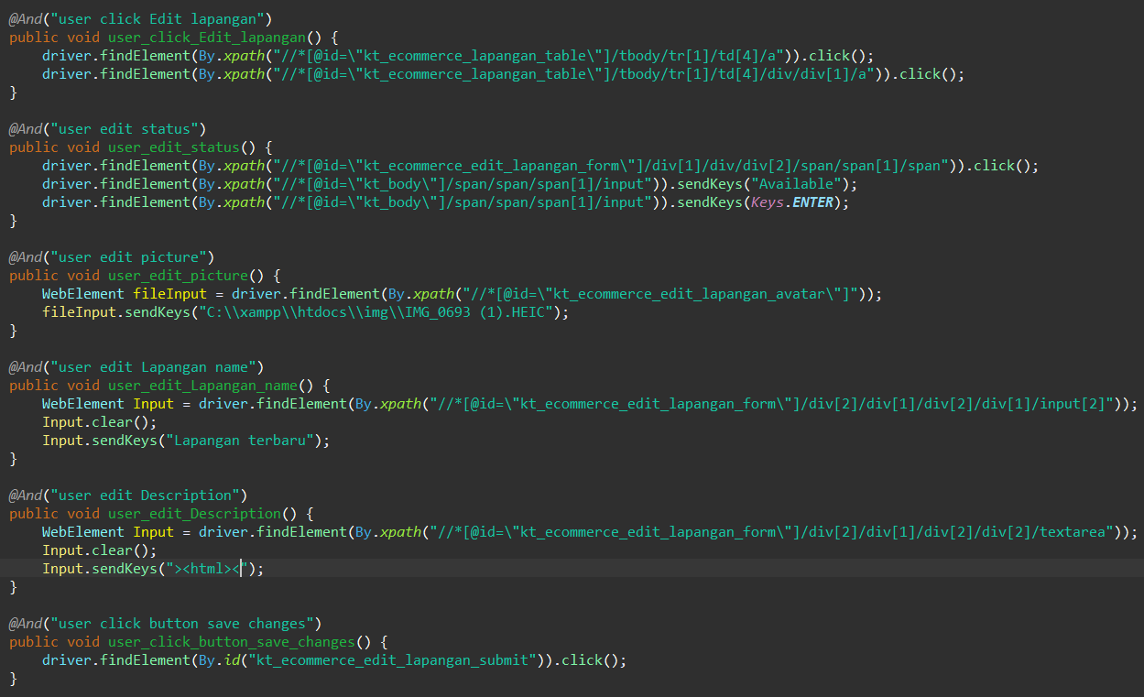

1. The test runner



1. The console after running

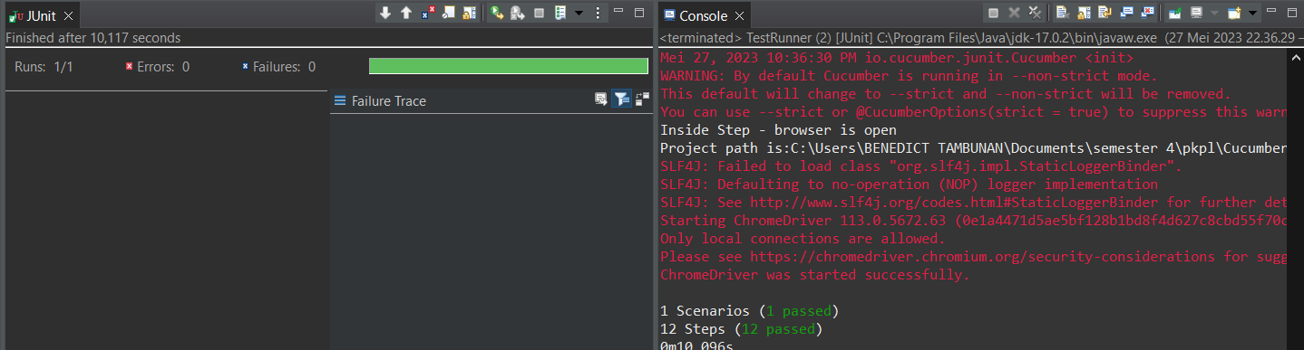

1. The browser while testing

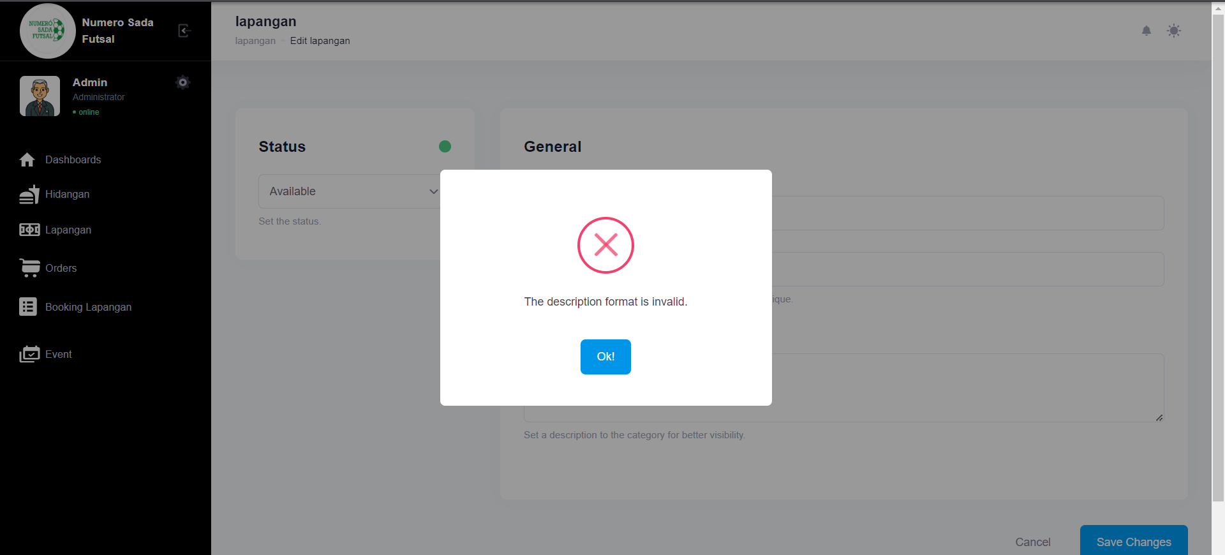Fungsi edit Lapangan 6

1. The scenario



1. The Step definition



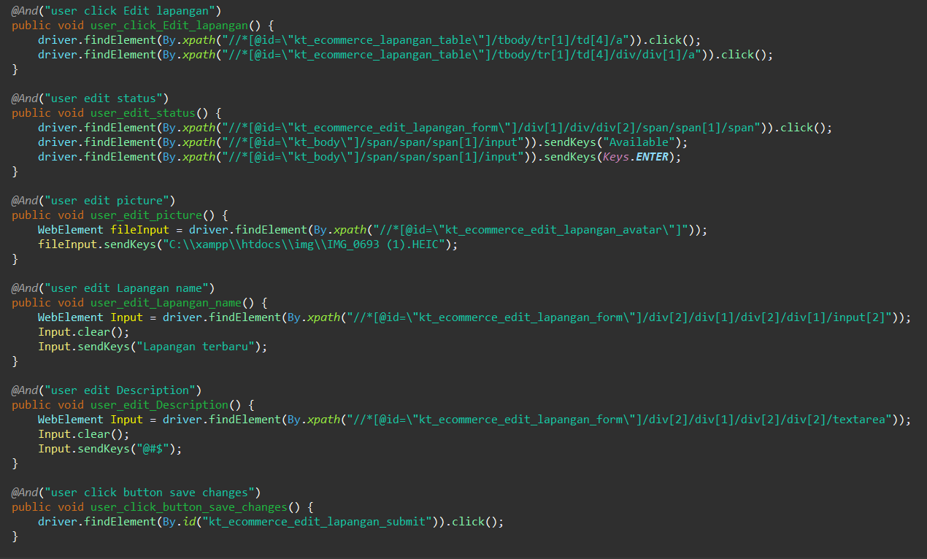

1. The test runner



1. The console after running

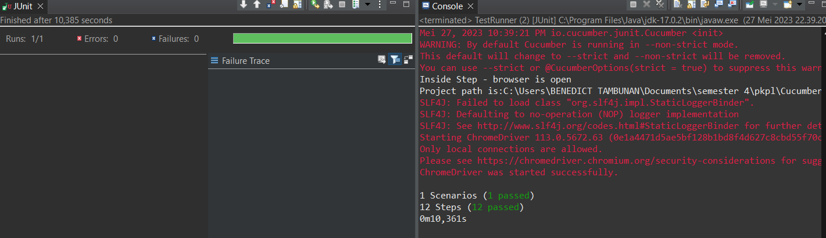

1. The browser while testing

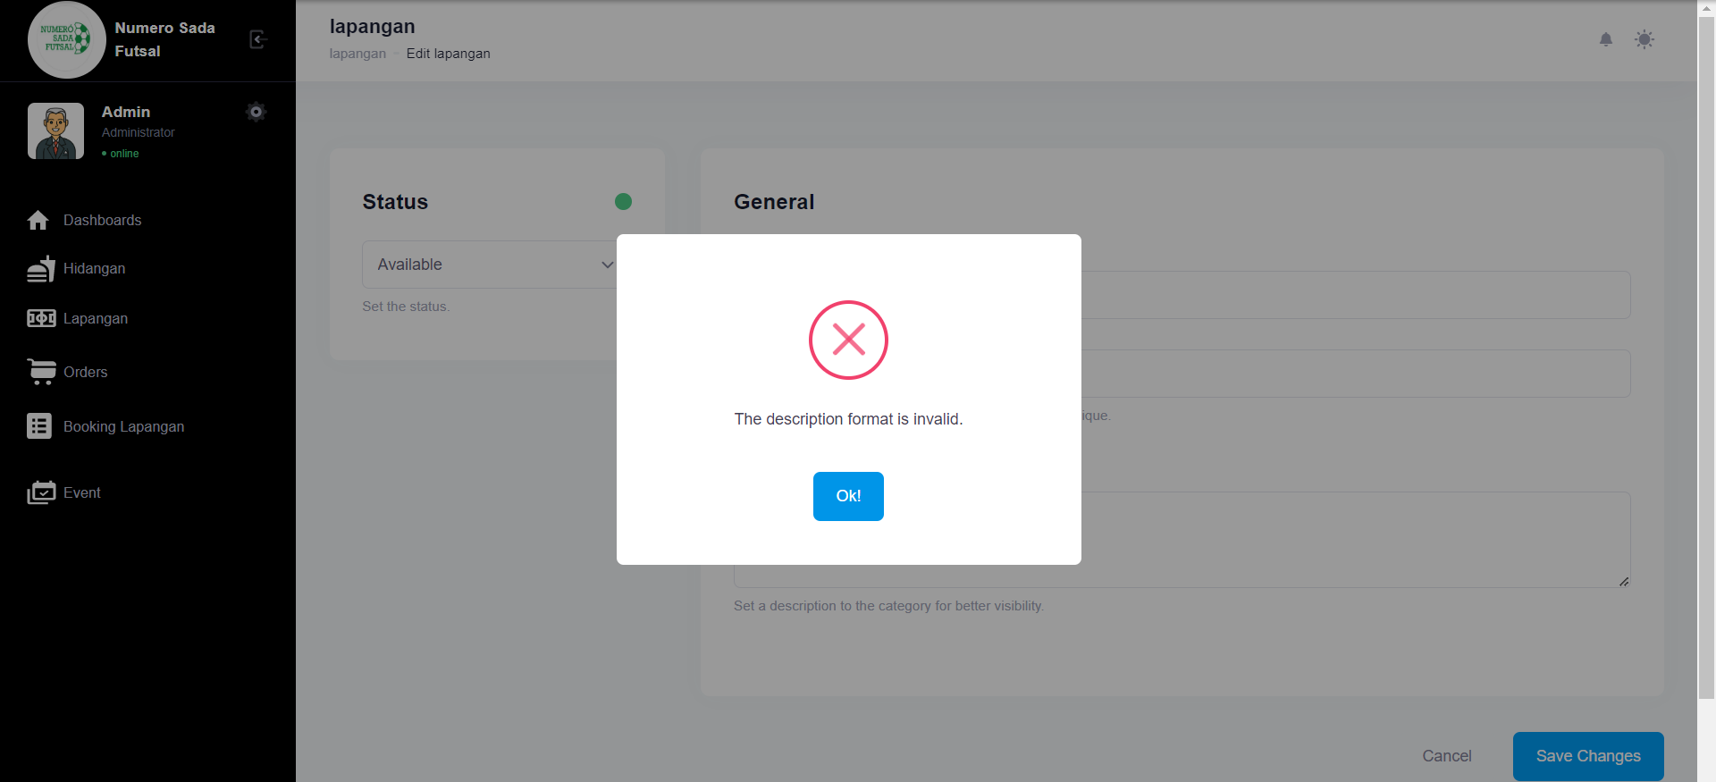

1. Test Fungsi edit Lapangan Variasi 7: edit Lapangan dengan parameter 1,4 valid namun ke 2,3 tidak valid

Fungsi edit Lapangan 1

1. The scenario



1. The Step definition



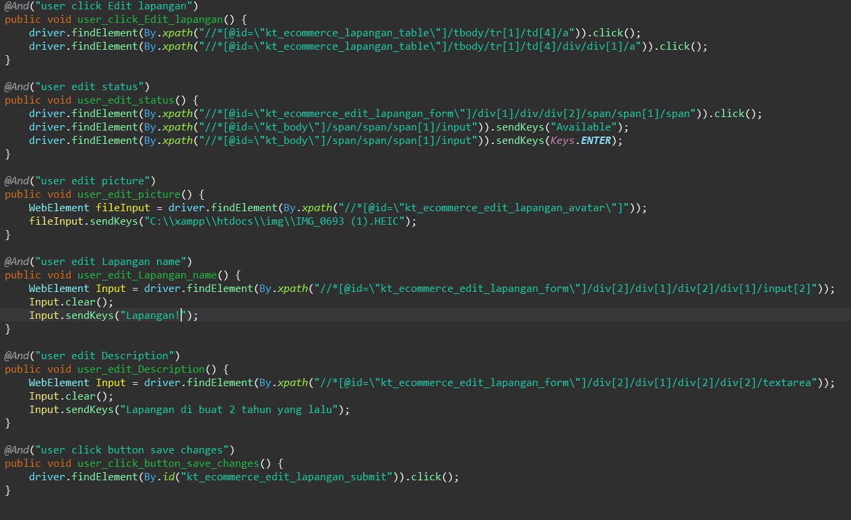

1. The test runner



1. The console after running

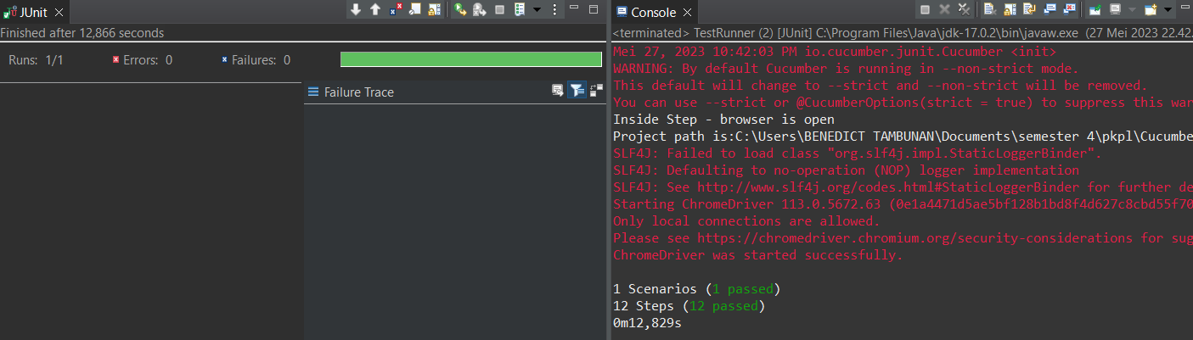

1. The browser while testing

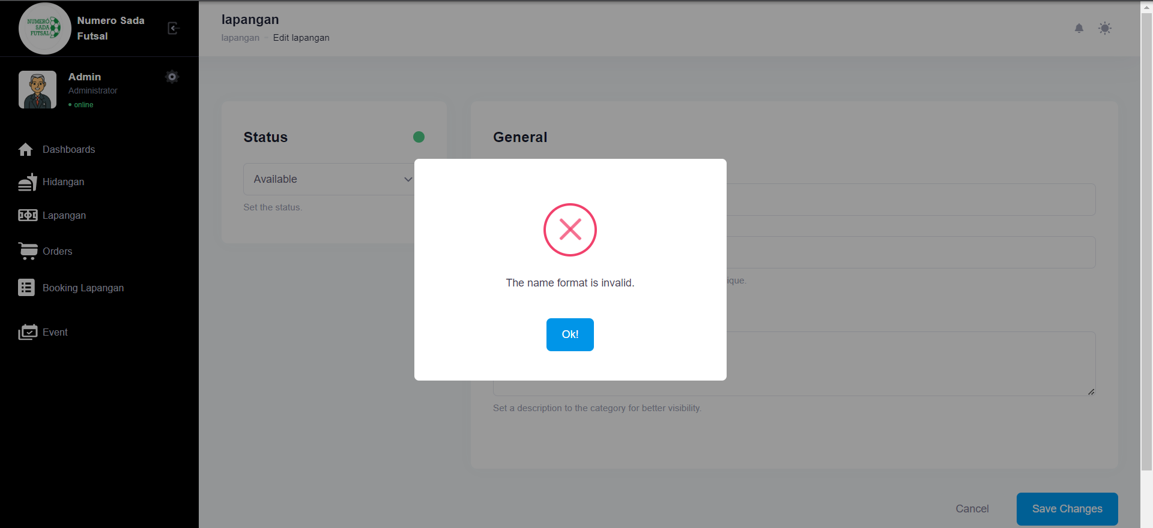

Fungsi edit Lapangan 2

1. The scenario



1. The Step definition



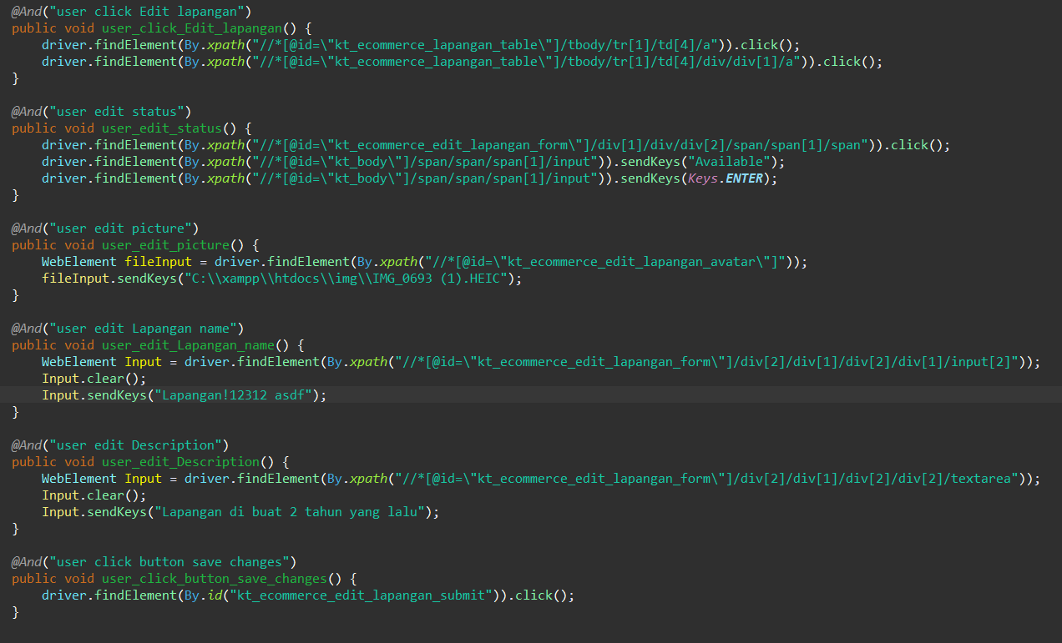

1. The test runner



1. The console after running

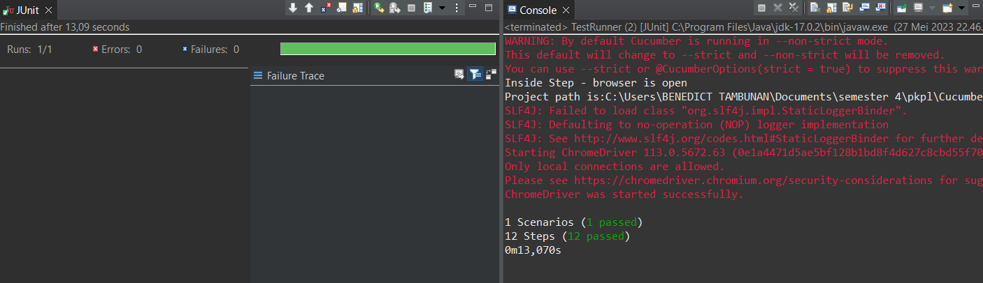

1. The browser while testing

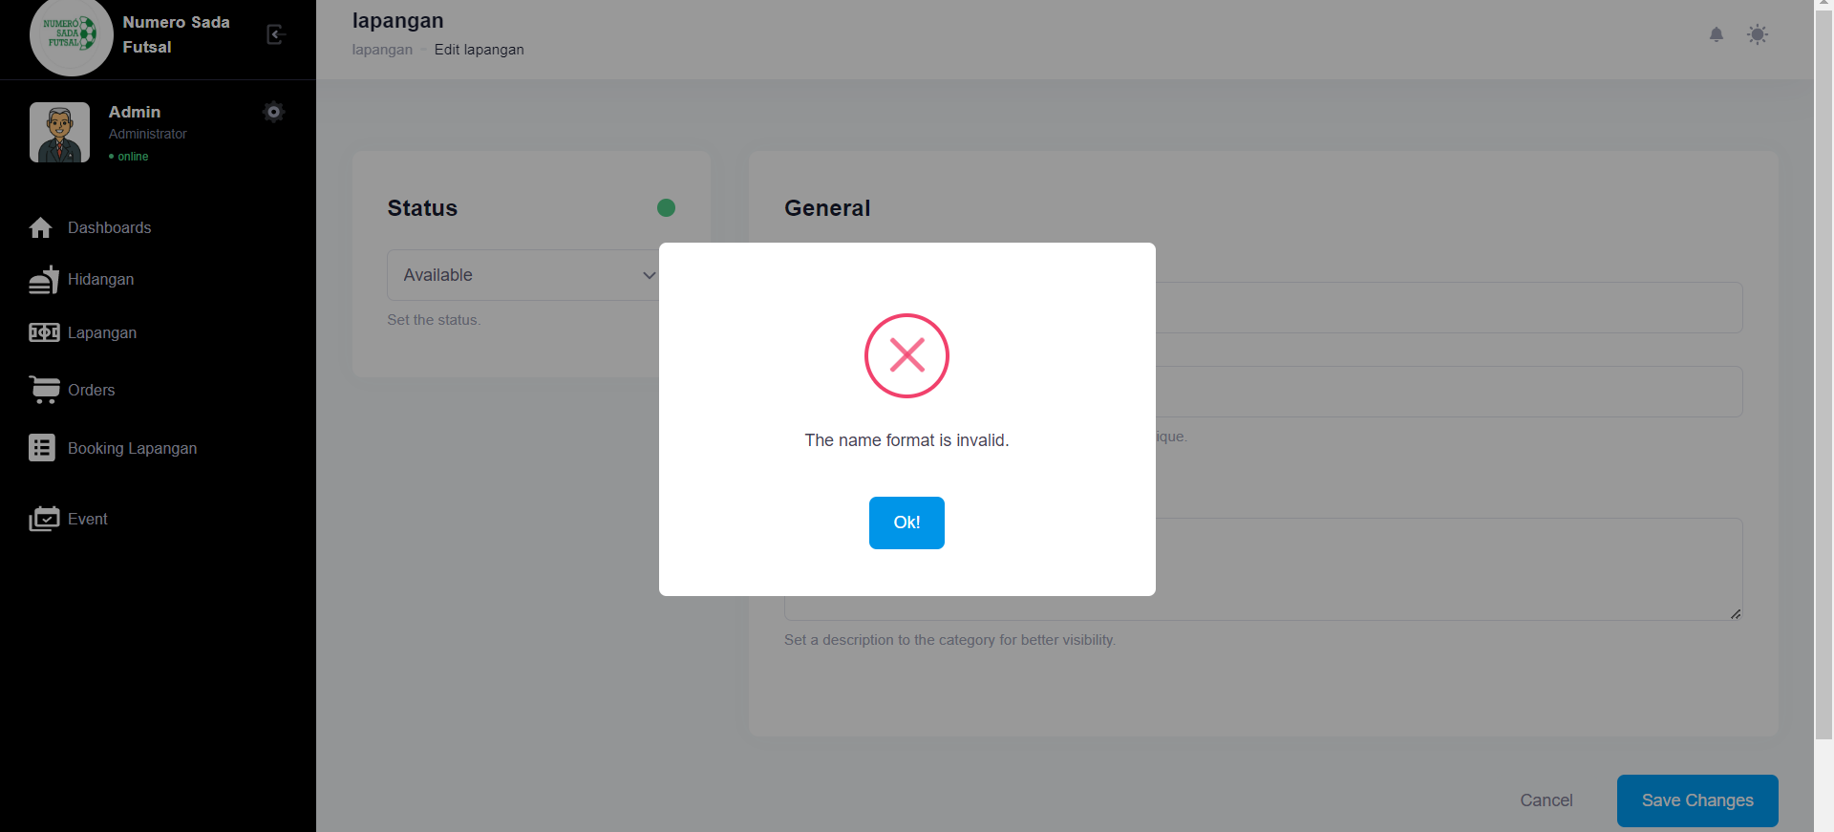

Fungsi edit Lapangan 3

1. The scenario



1. The Step definition



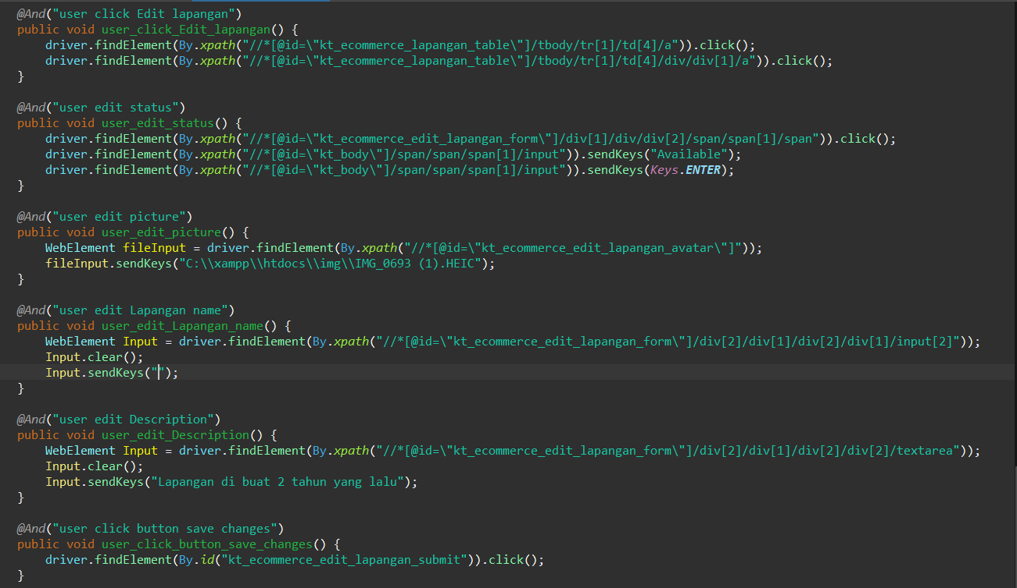

1. The test runner



1. The console after running

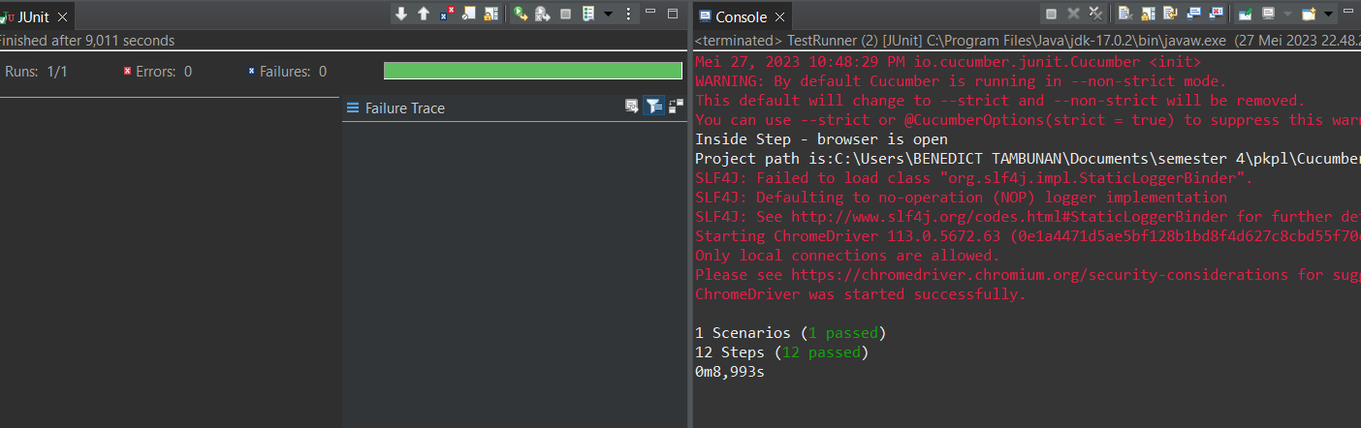

1. The browser while testing

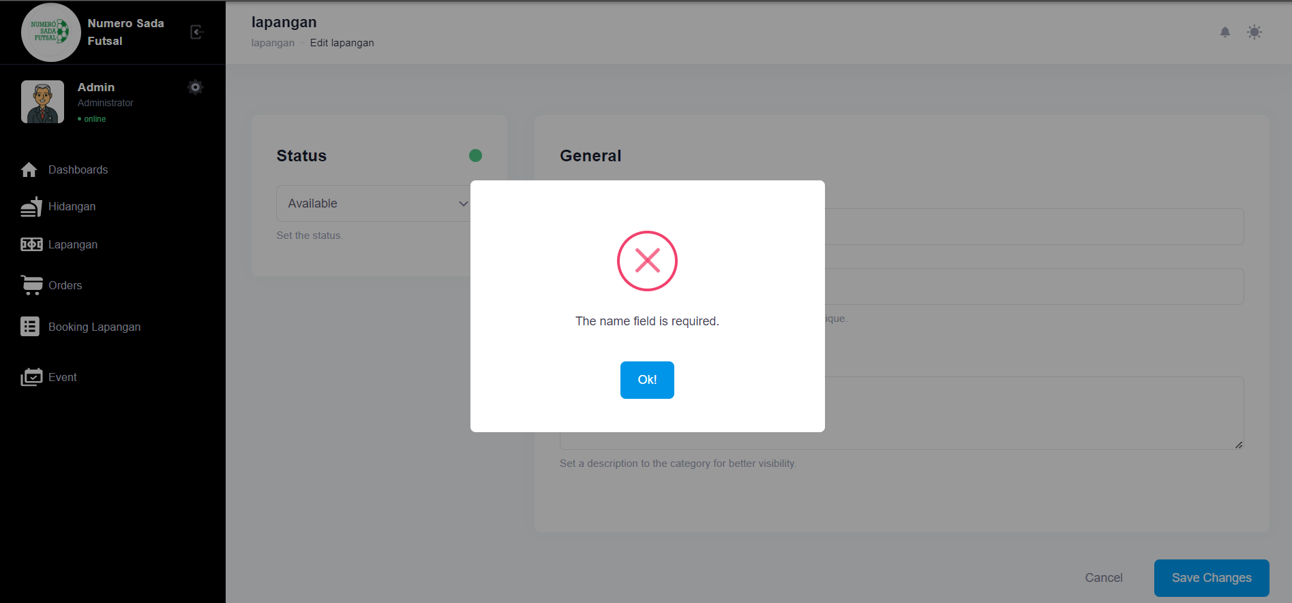

Fungsi edit Lapangan 4

1. The scenario



1. The Step definition



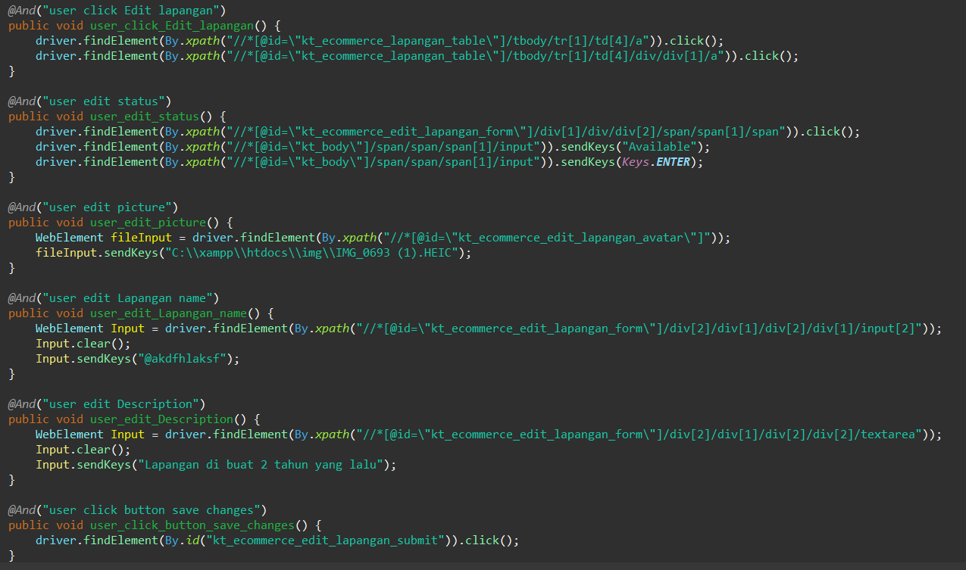

1. The test runner



1. The console after running

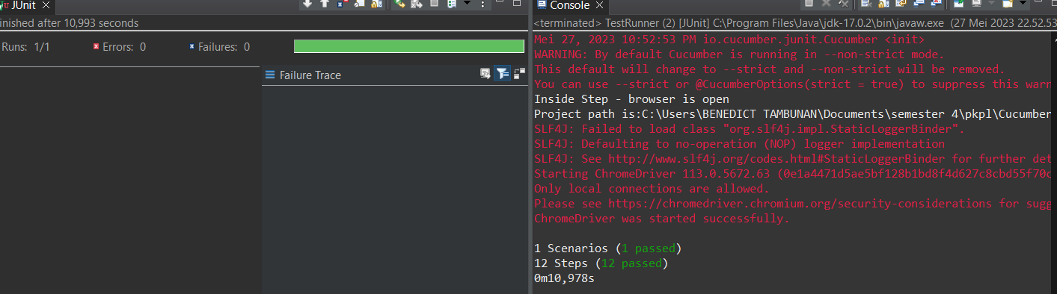

1. The browser while testing

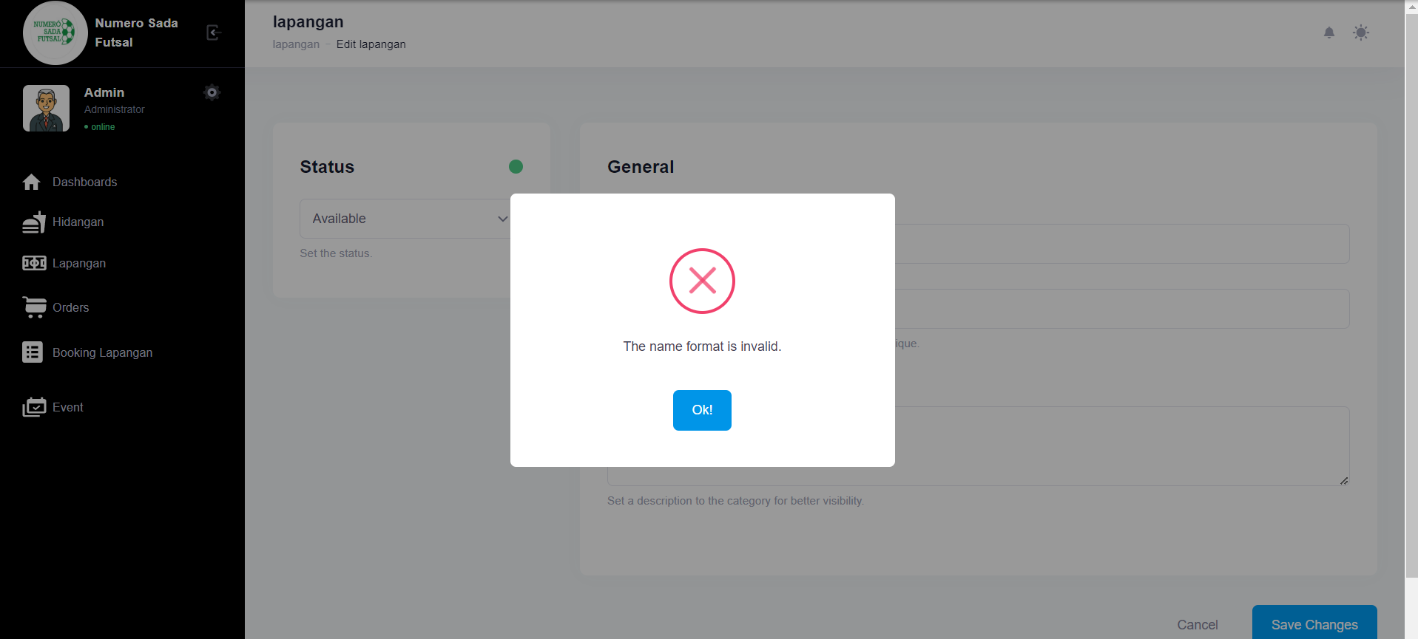

Fungsi edit Lapangan 5

1. The scenario



1. The Step definition



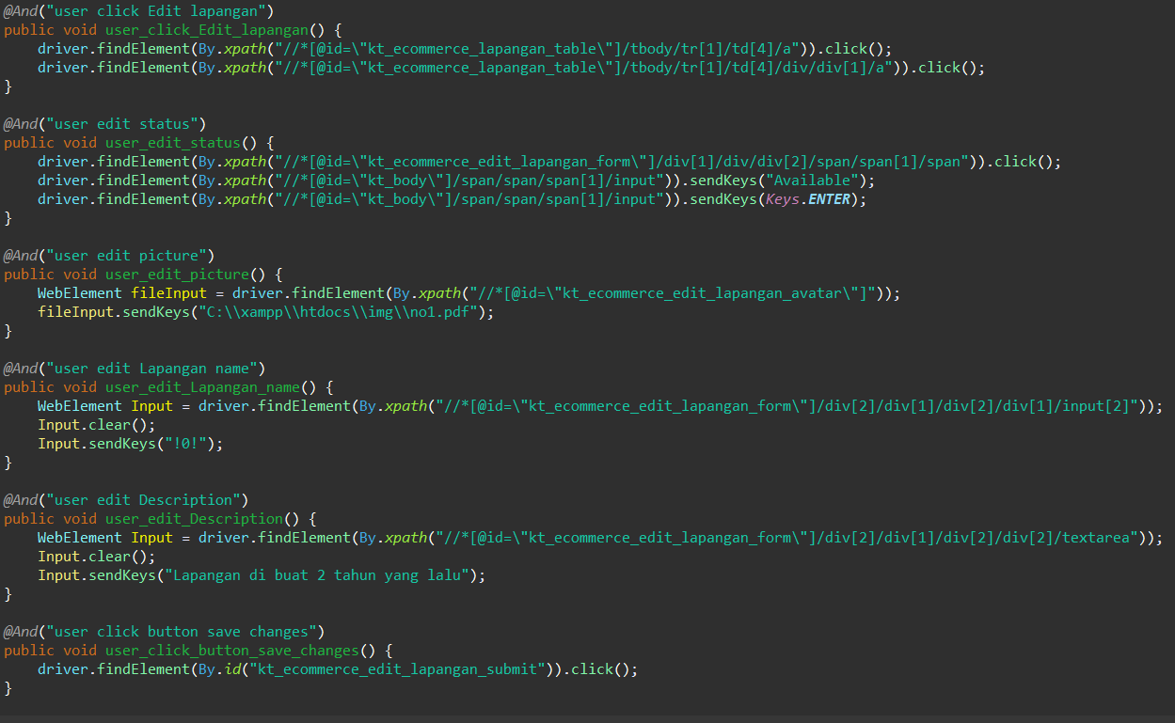

1. The test runner



1. The console after running

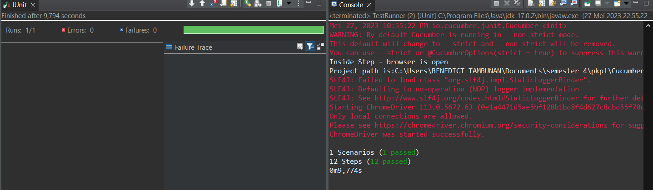

1. The browser while testing



Fungsi edit Lapangan 6

1. The scenario



1. The Step definition



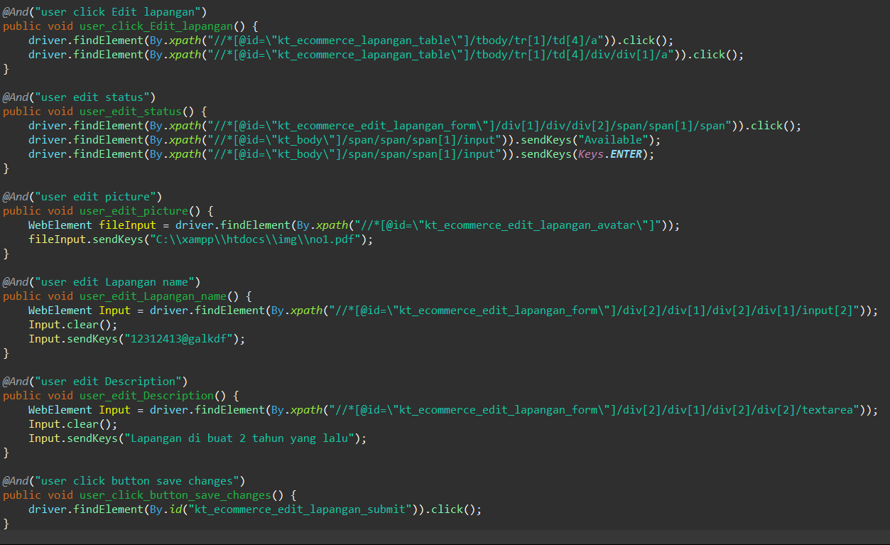

1. The test runner



1. The console after running

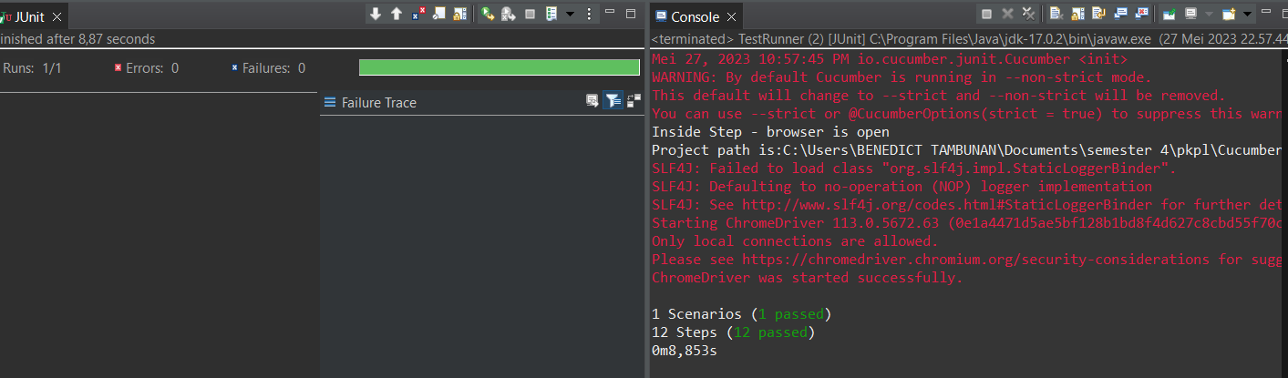

1. The browser while testing



1. Test Fungsi edit Lapangan Variasi 8: edit Lapangan dengan parameter 2,3,4 tidak valid namun ke 1 valid

Fungsi edit Lapangan 1

1. The scenario



1. The Step definition





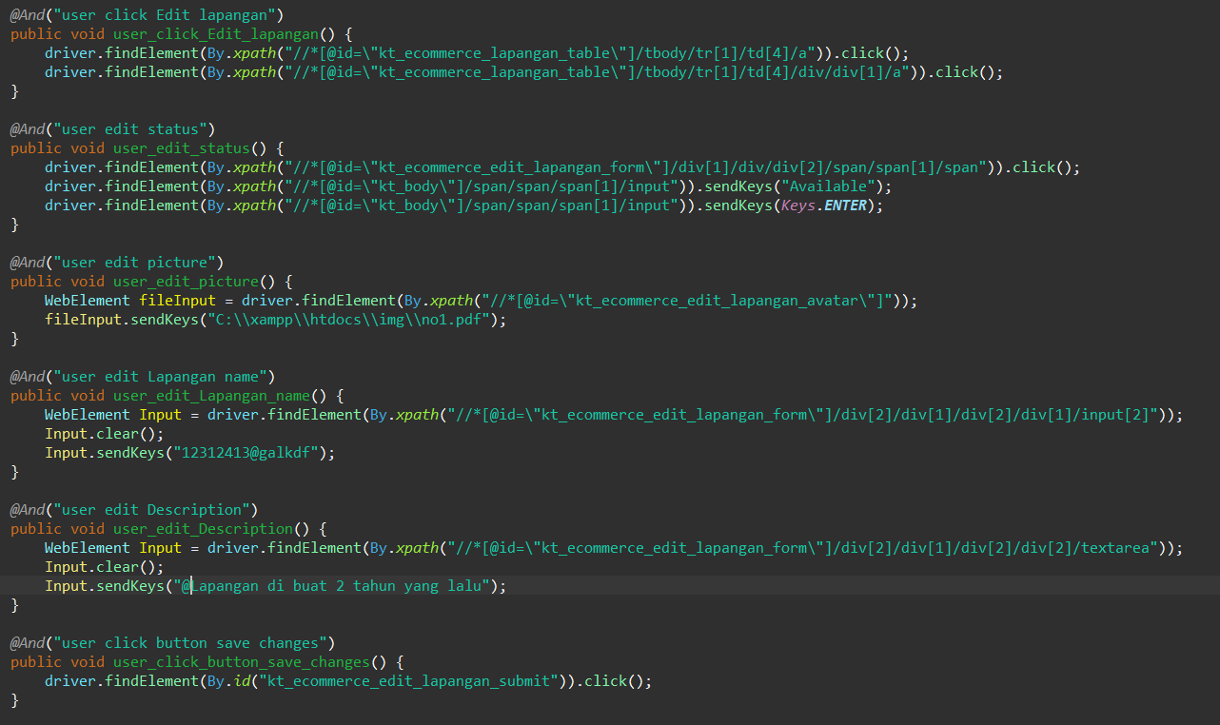

1. The test runner



1. The console after running

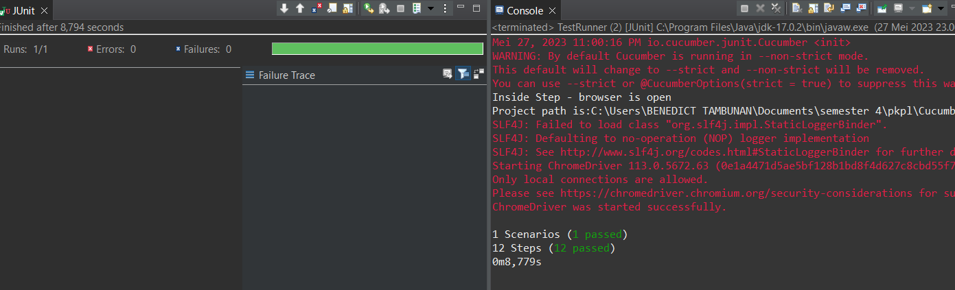

1. The browser while testing

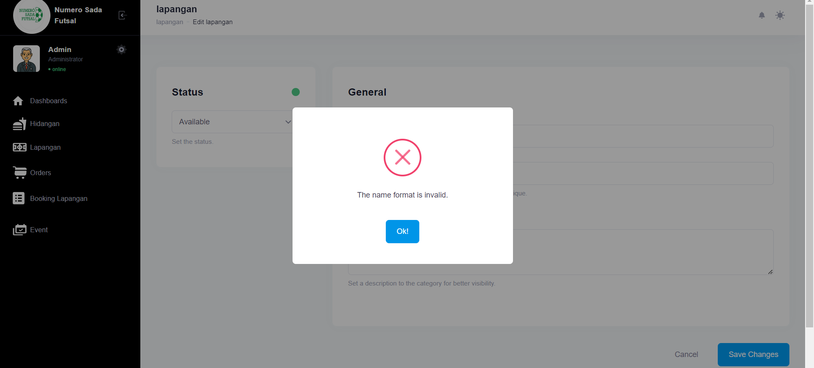

Fungsi edit Lapangan 2

1. The scenario



1. The Step definition



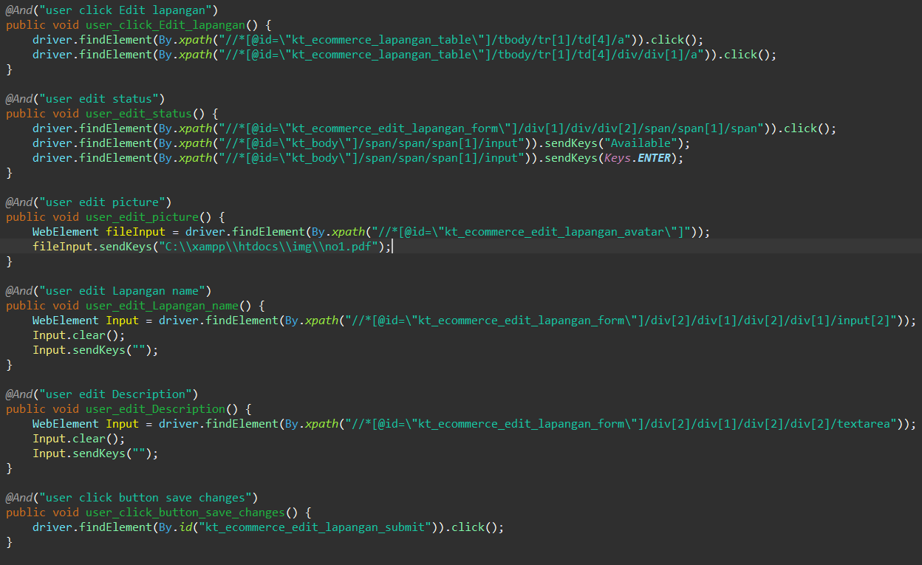

1. The test runner



1. The console after running

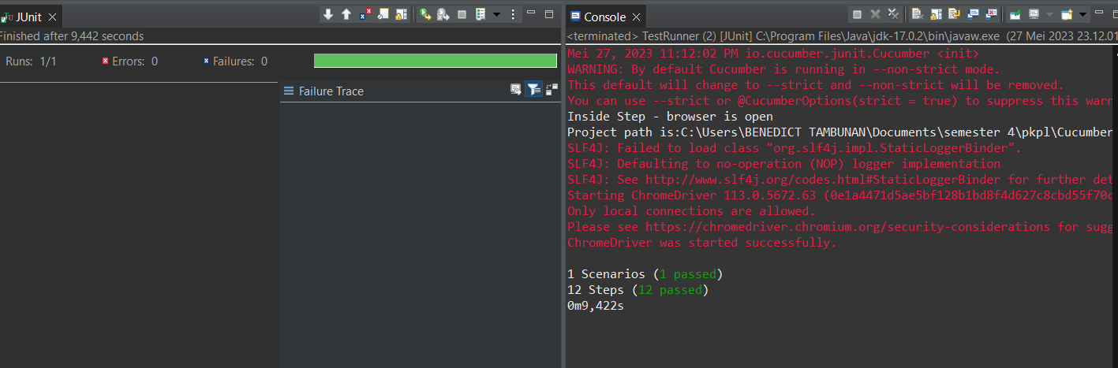

1. The browser while testing

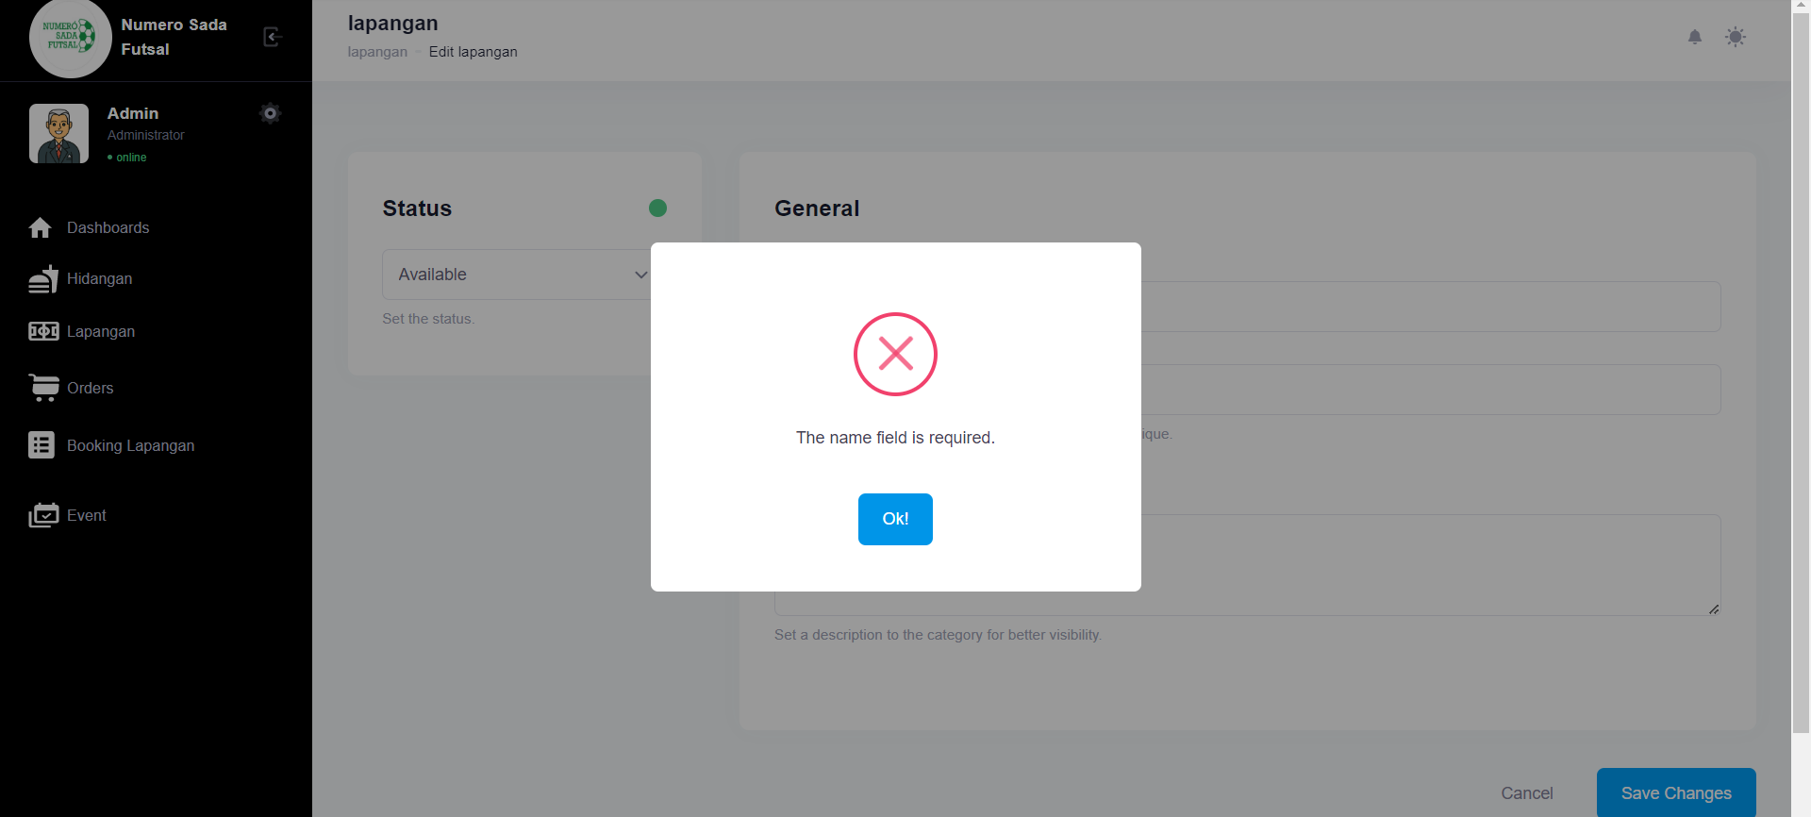

Fungsi edit Lapangan 3

1. The scenario



1. The Step definition



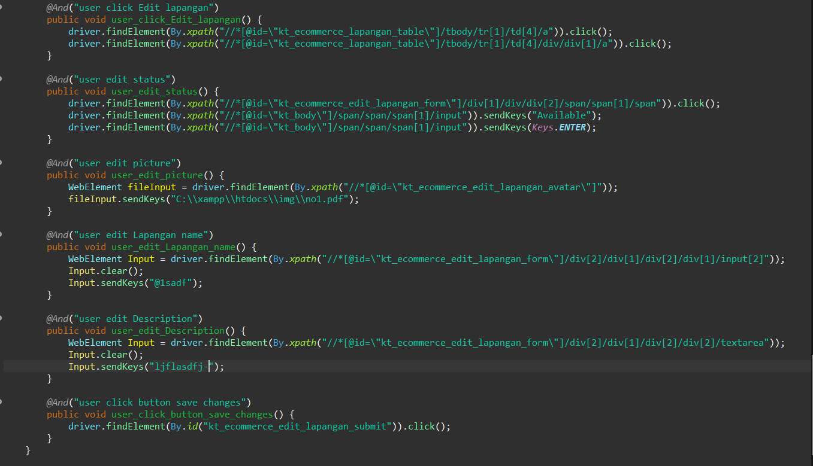

1. The test runner



1. The console after running

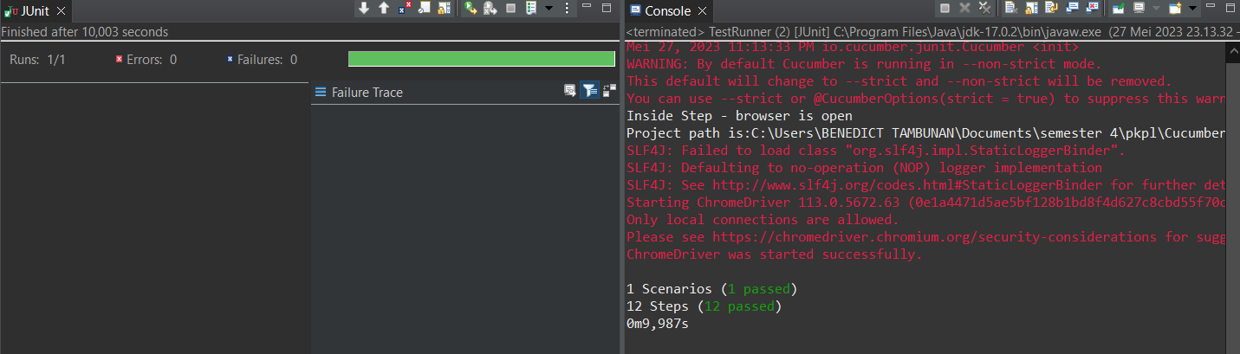

1. The browser while testing

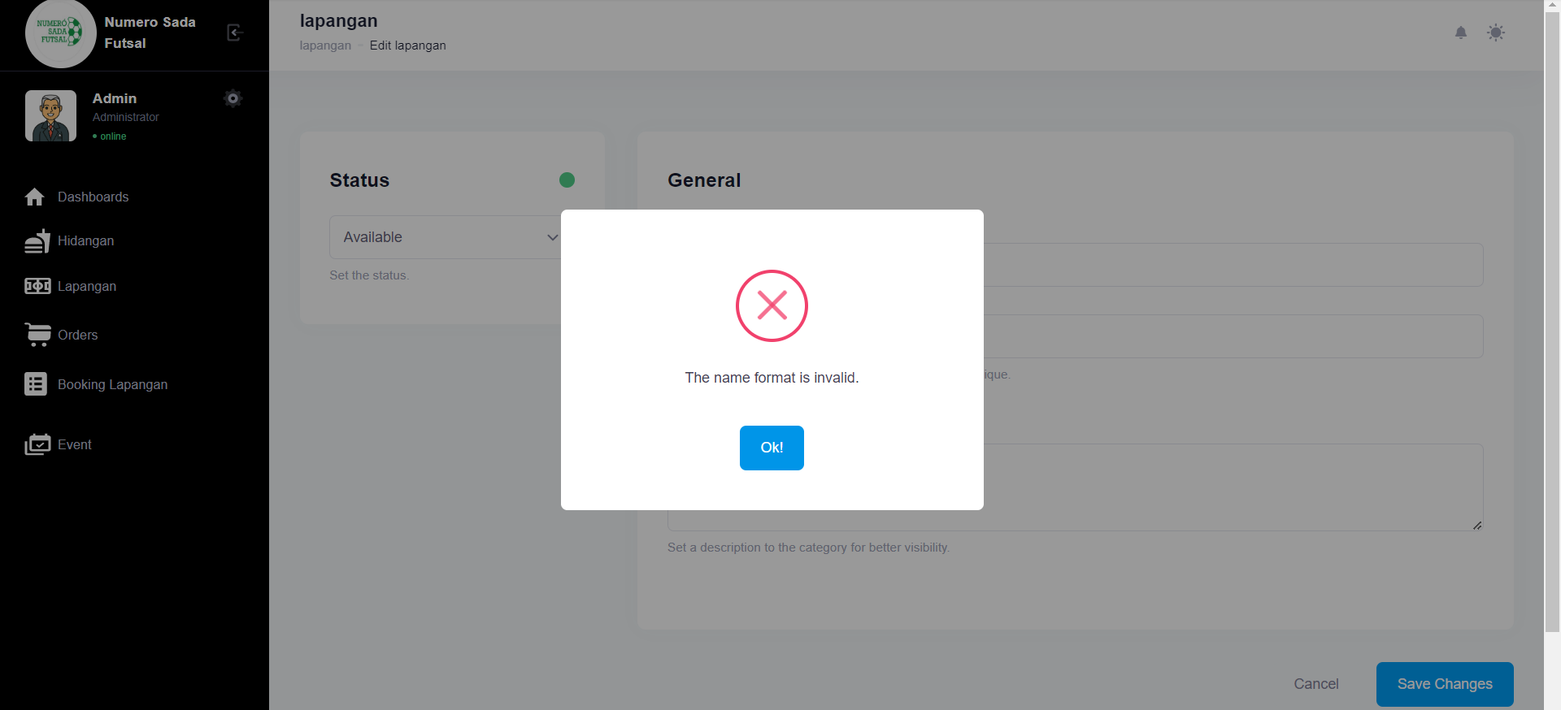

Fungsi edit Lapangan 4

1. The scenario



1. The Step definition



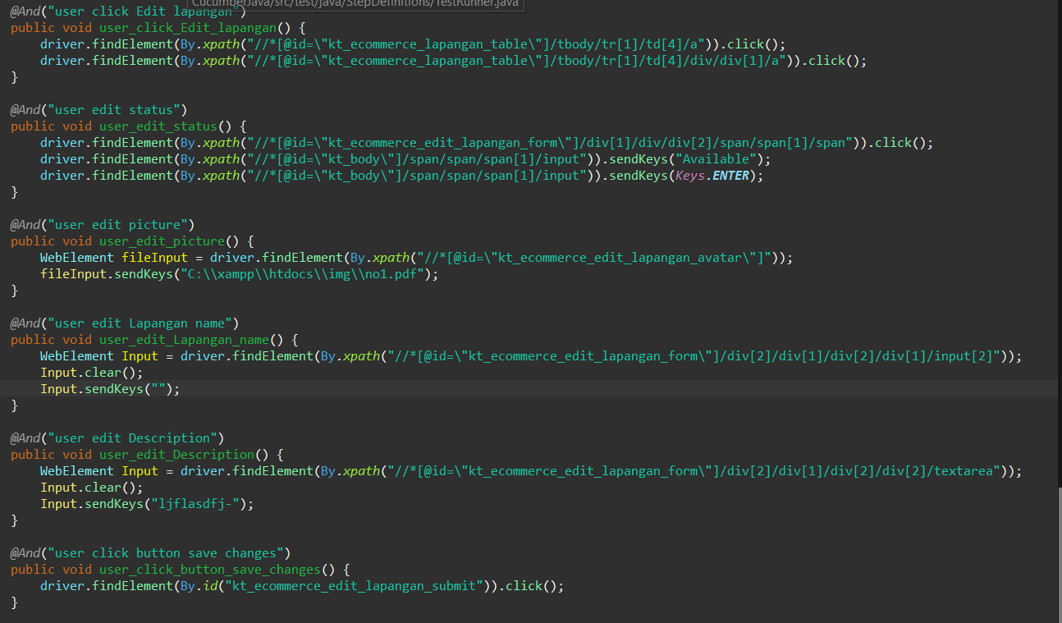

1. The test runner



1. The console after running

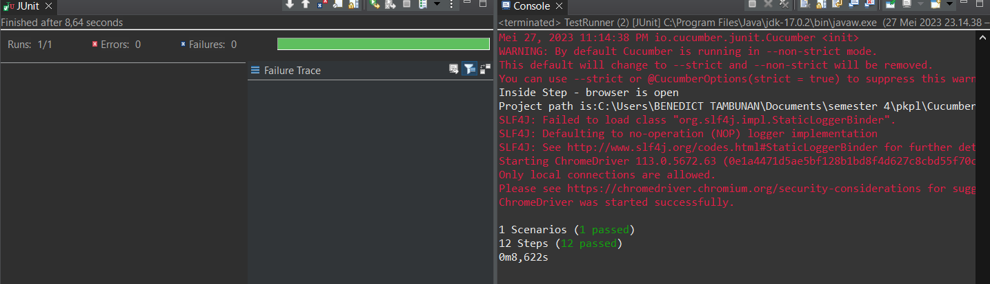

1. The browser while testing

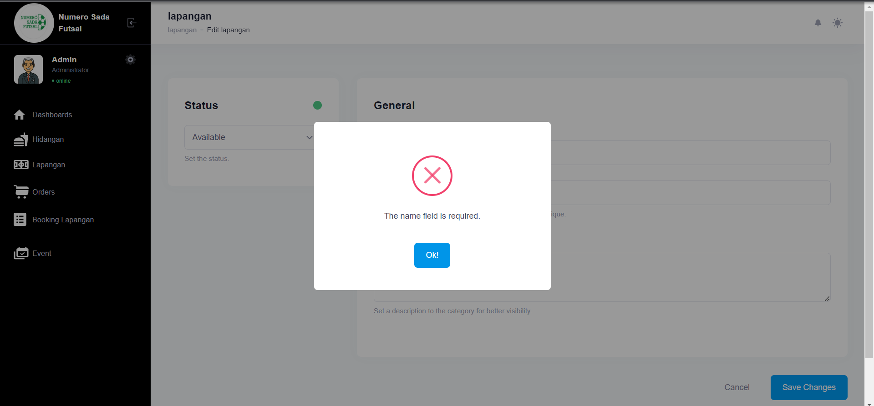

Fungsi edit Lapangan 5

1. The scenario



1. The Step definition



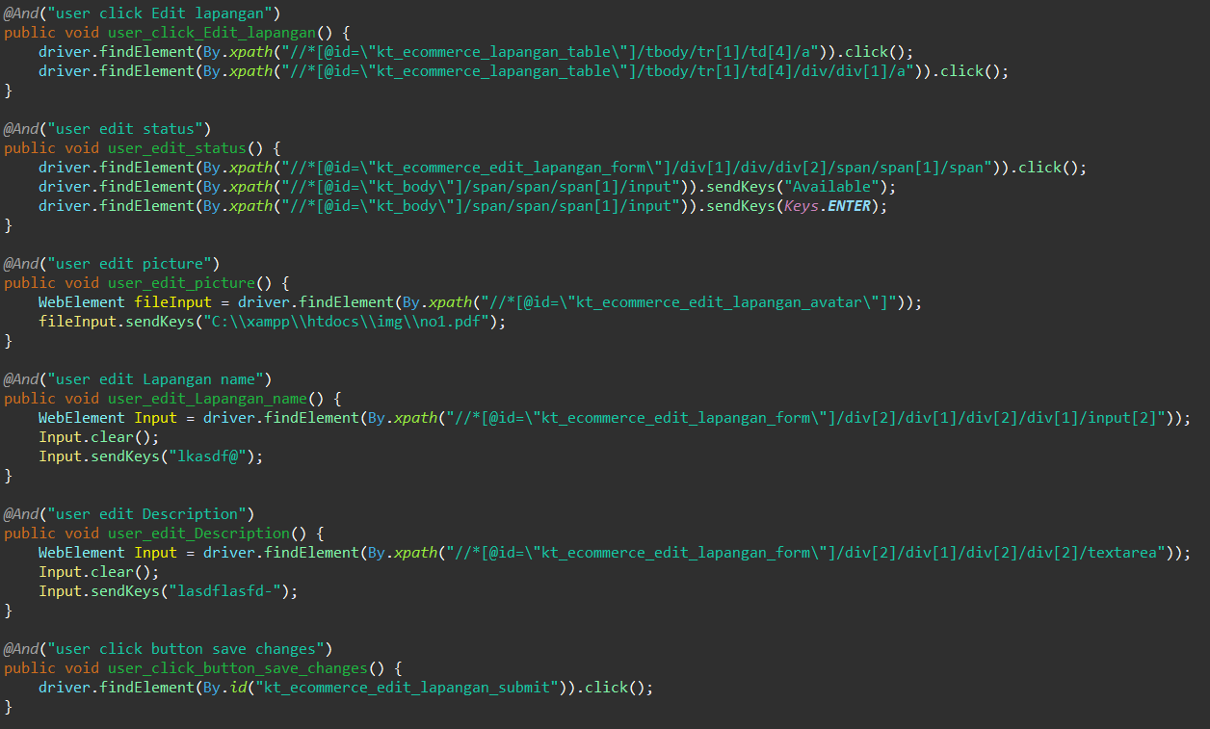

1. The test runner



1. The console after running

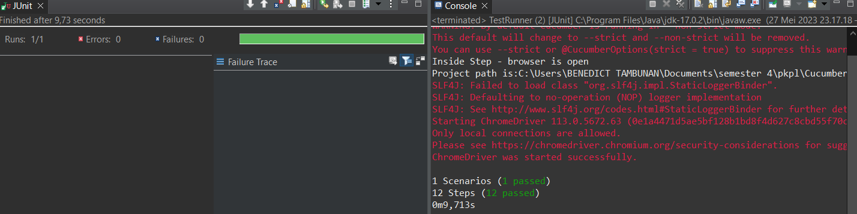

1. The browser while testing

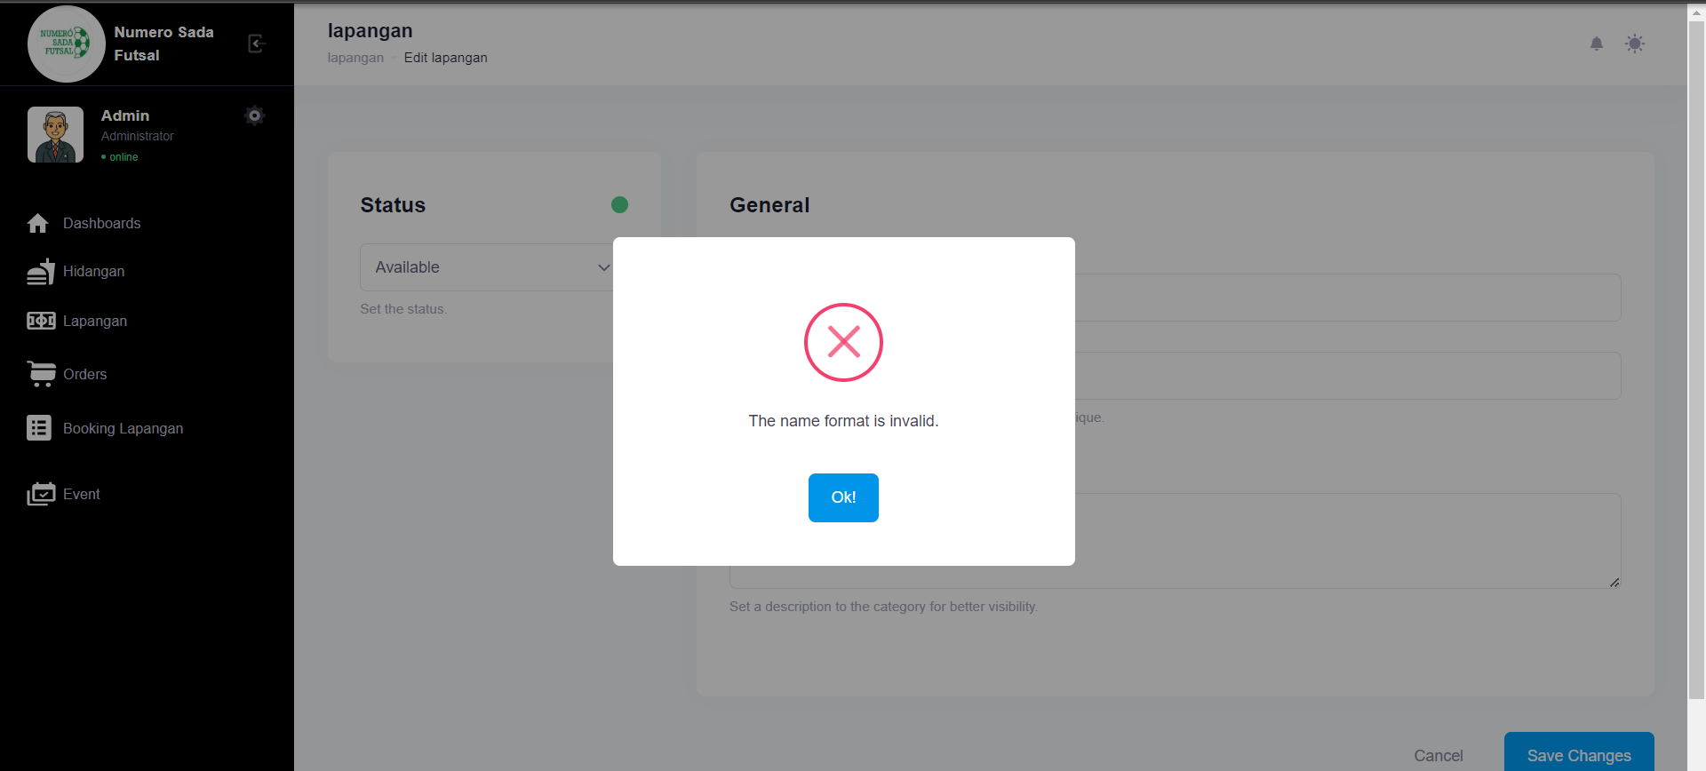

Fungsi edit Lapangan 6

1. The scenario



1. The Step definition





1. The test runner



1. The console after running



1. The browser while testing



1. Test Fungsi edit Lapangan Variasi 9: edit Lapangan dengan parameter 2,3,4 valid namun ke 1 tidak valid

Fungsi edit Lapangan 1

1. The scenario



1. The Step definition



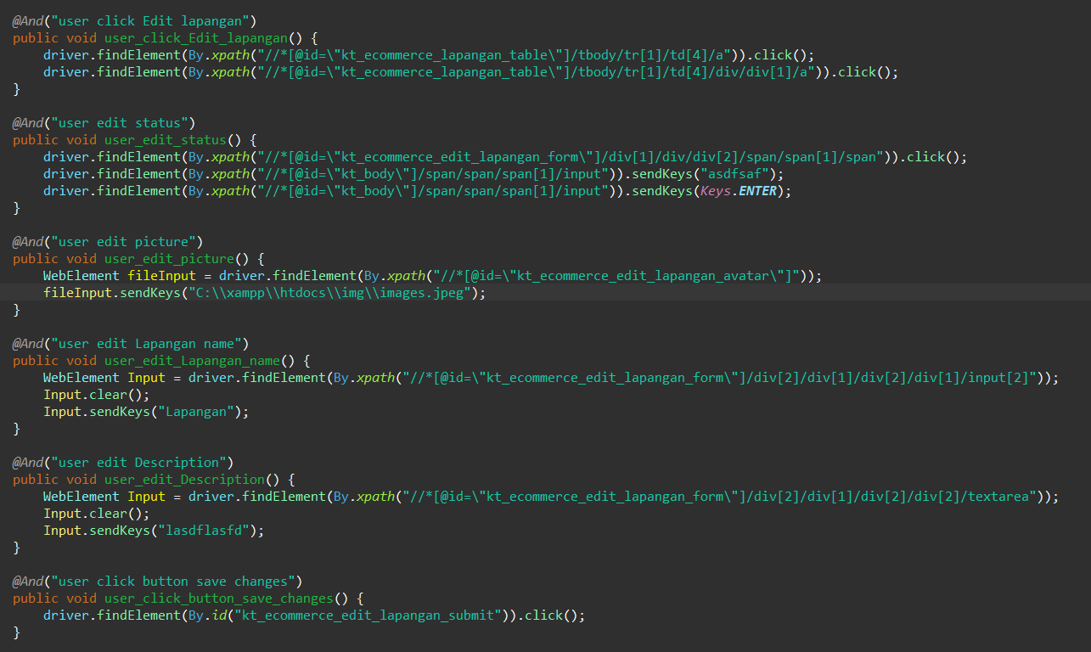

1. The test runner



1. The console after running

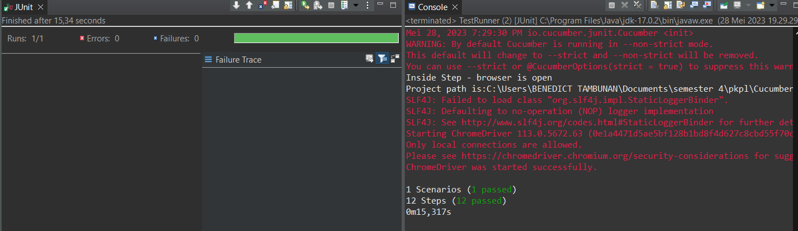

1. The browser while testing

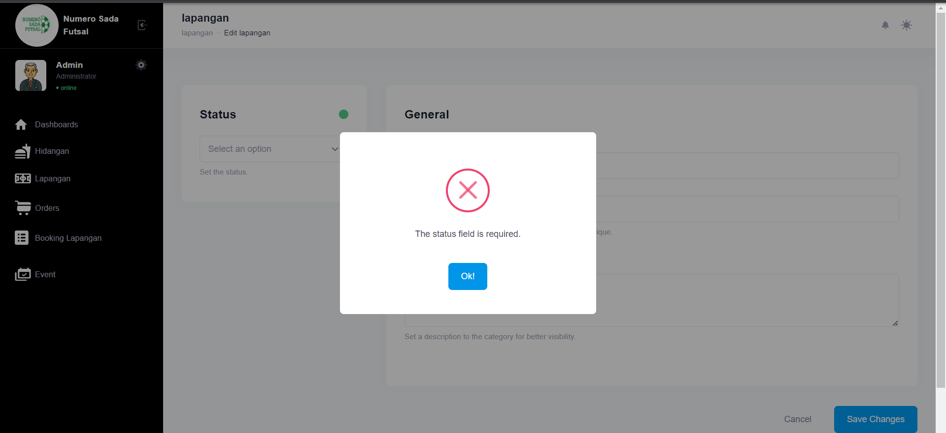

Fungsi edit Lapangan 2

1. The scenario

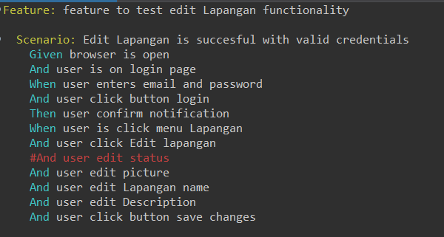

1. The Step definition



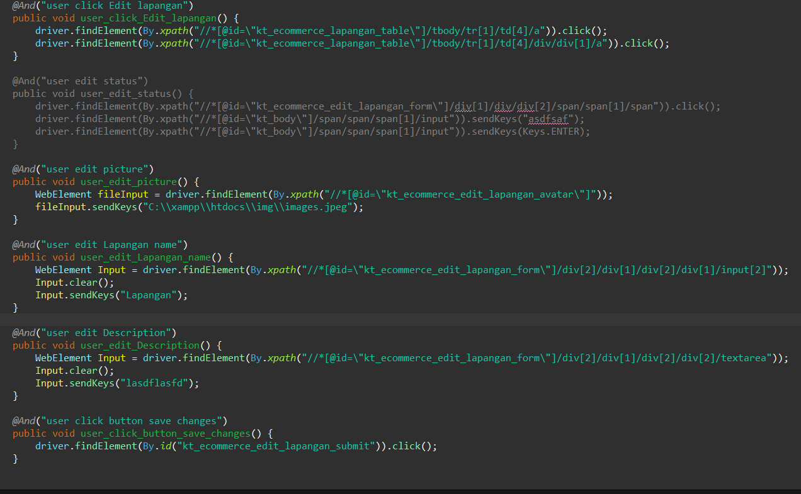

1. The test runner



1. The console after running

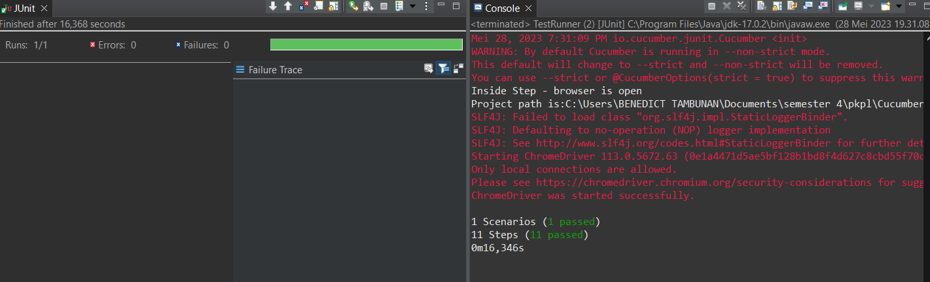

1. The browser while testing



Fungsi edit Lapangan 3

1. The scenario



1. The Step definition



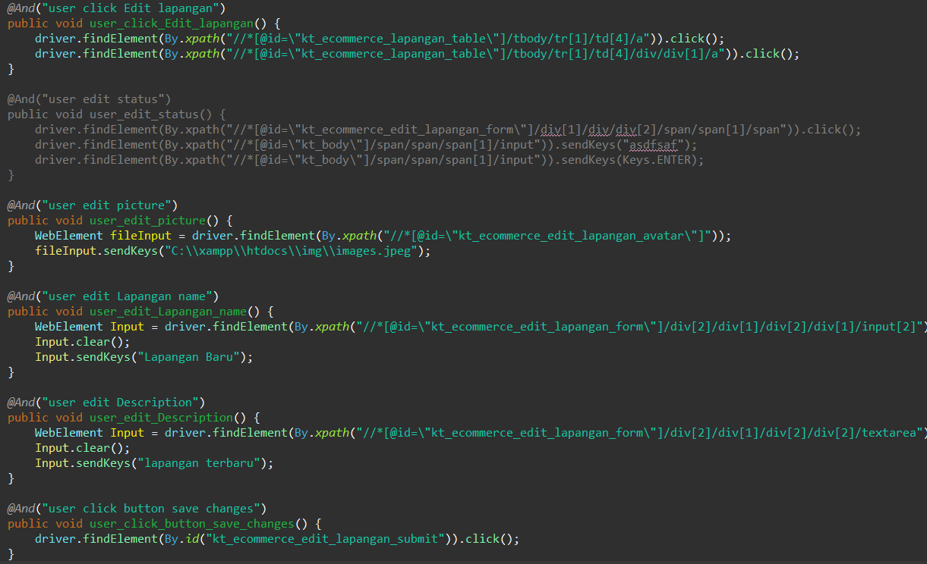

1. The test runner



1. The console after running

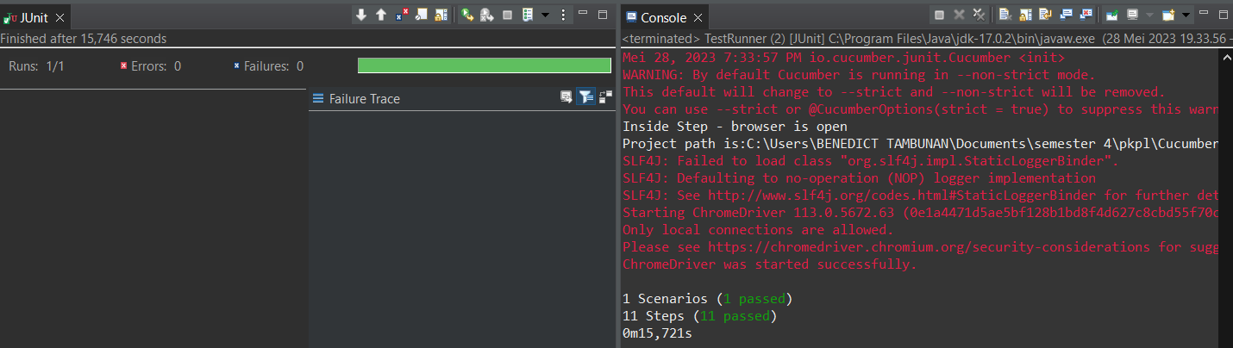

1. The browser while testing



Fungsi edit Lapangan 4

1. The scenario



1. The Step definition



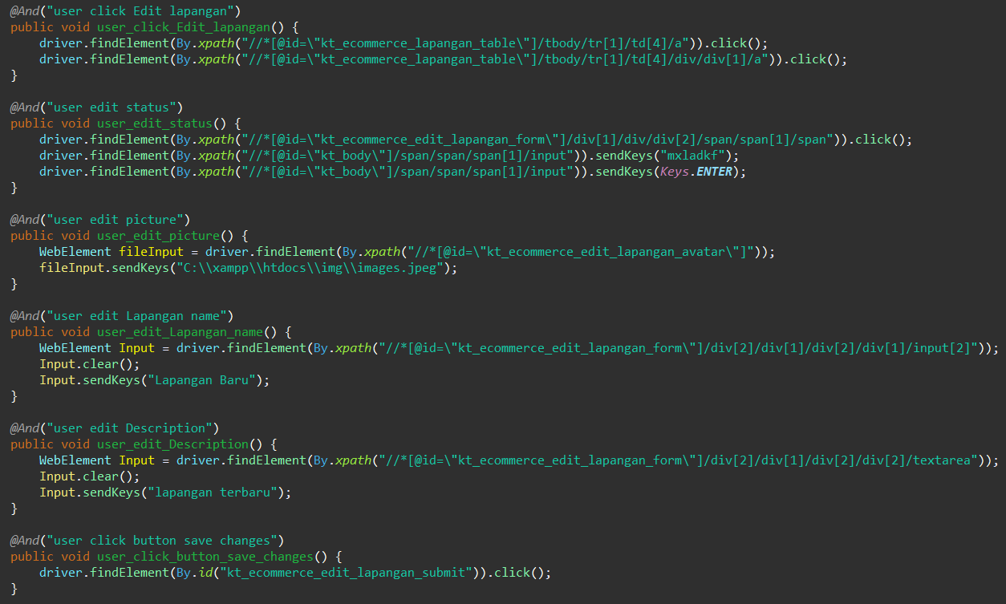

1. The test runner



1. The console after running

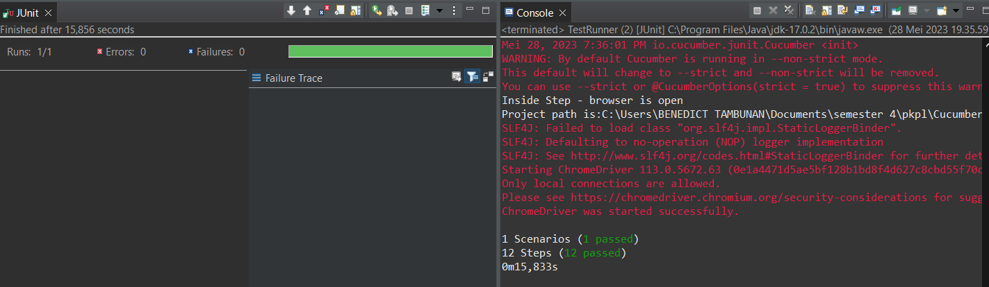

1. The browser while testing



Fungsi edit Lapangan 5

1. The scenario



1. The Step definition



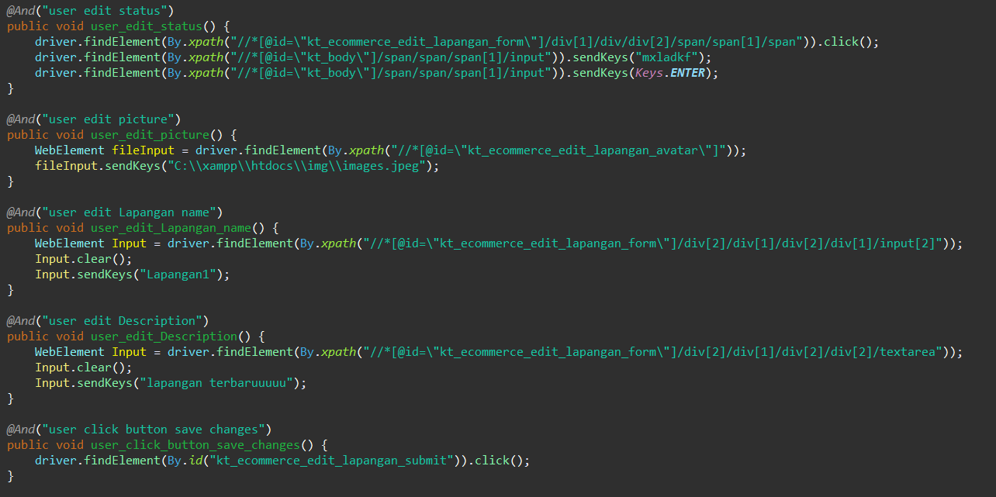

1. The test runner



1. The console after running

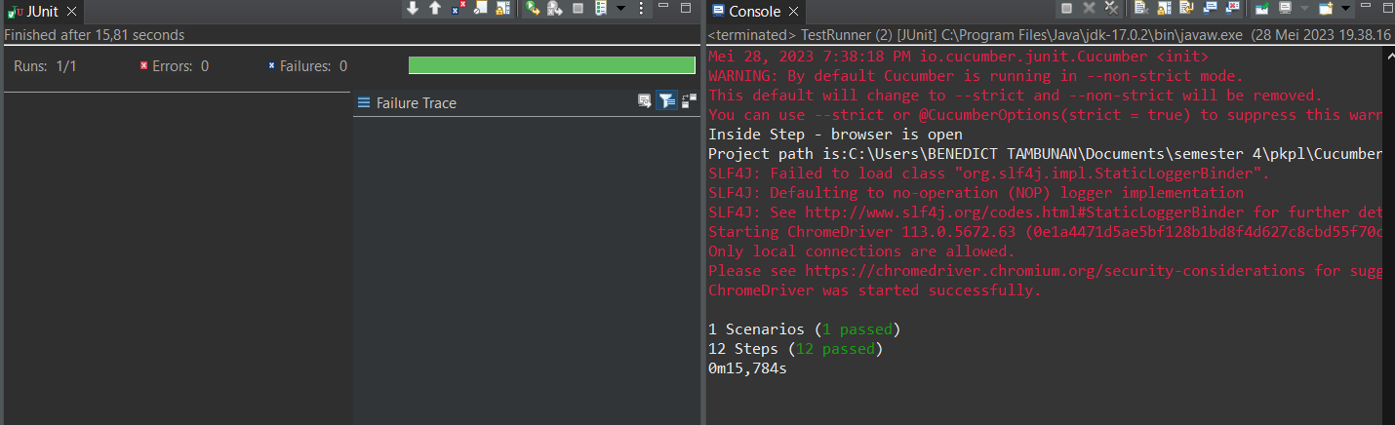

1. The browser while testing



Fungsi edit Lapangan 6

1. The scenario



1. The Step definition



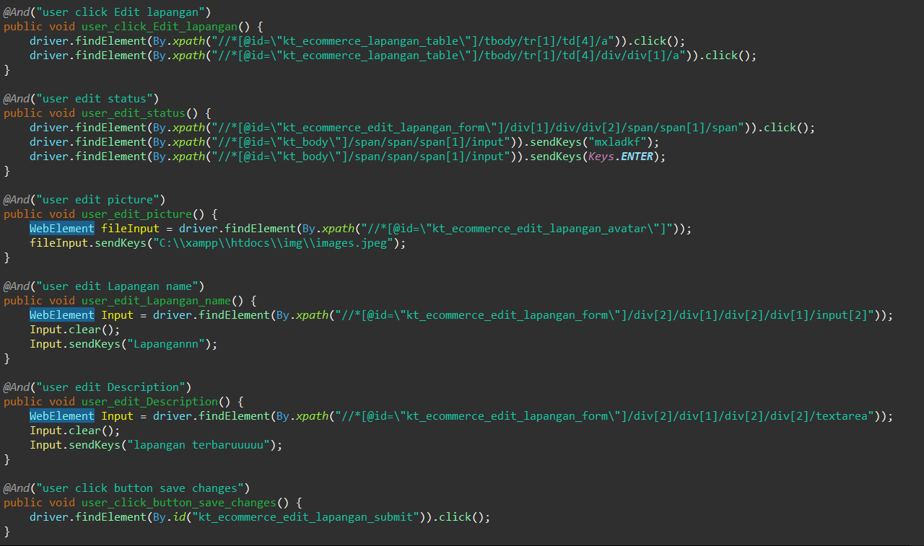

1. The test runner



1. The console after running

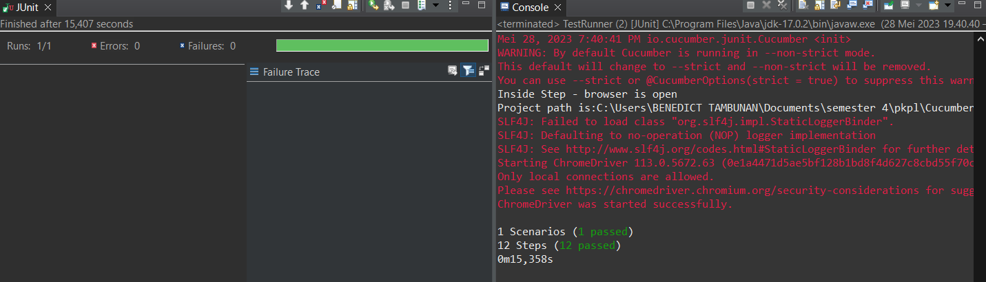

1. The browser while testing



1. Test Fungsi edit Lapangan Variasi 10: edit Lapangan dengan parameter 1,4 tidak valid namun ke 2,3 valid

Fungsi edit Lapangan 1

1. The scenario



1. The Step definition



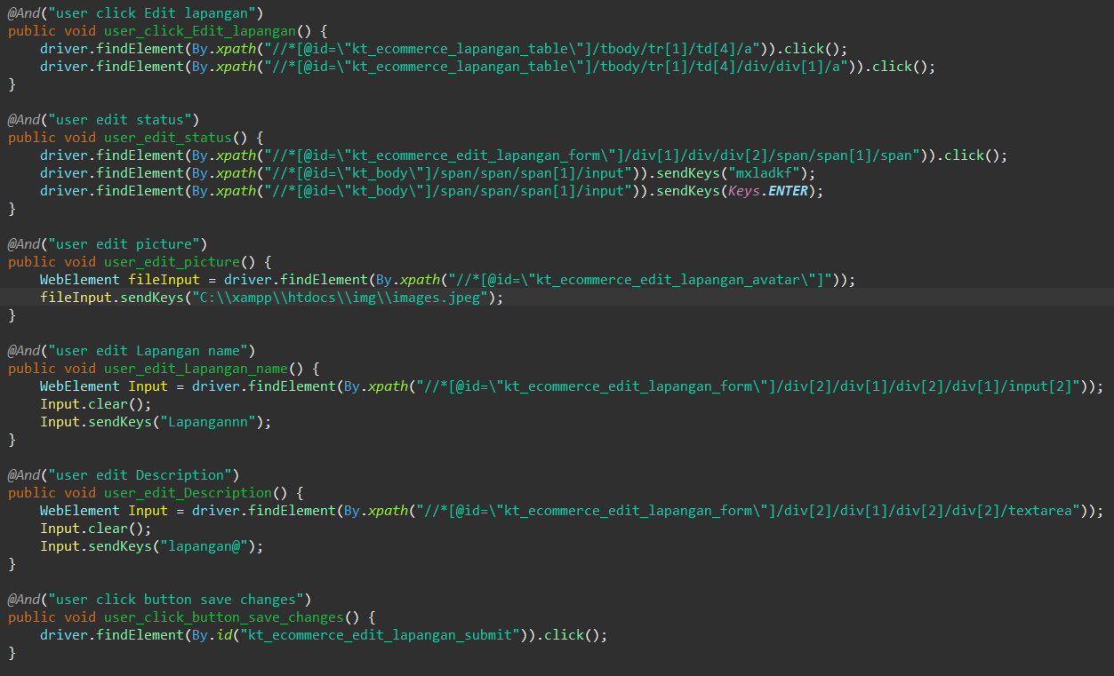

1. The test runner



1. The console after running

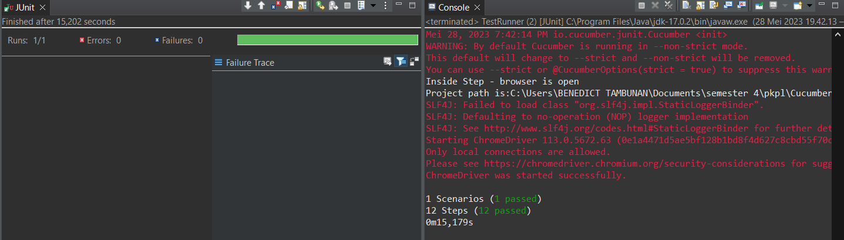

1. The browser while testing

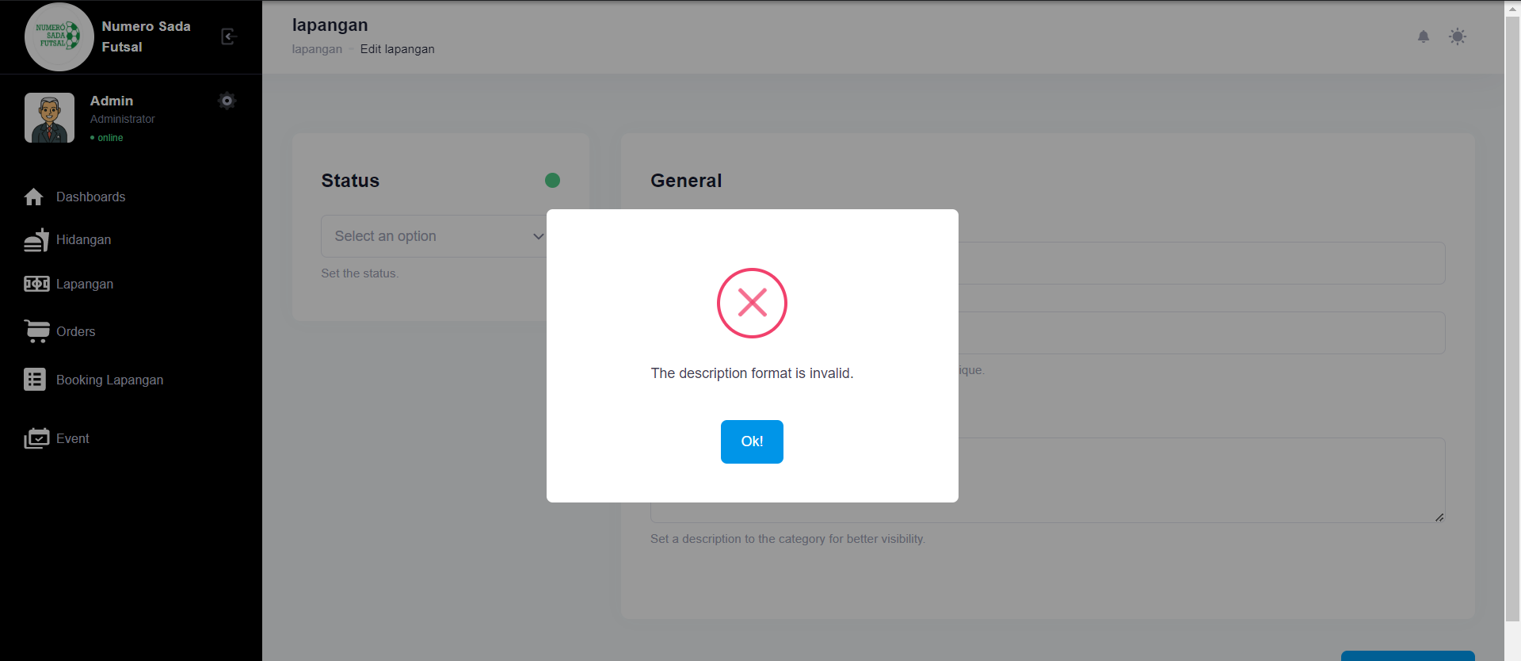

Fungsi edit Lapangan 2

1. The scenario



1. The Step definition



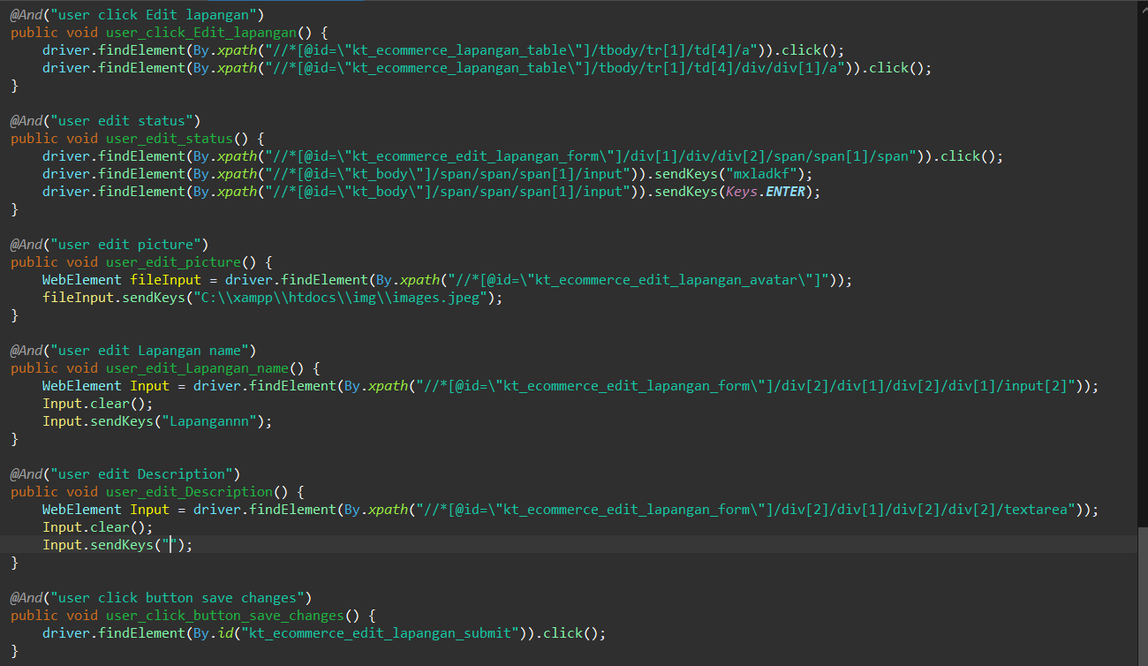

1. The test runner



1. The console after running

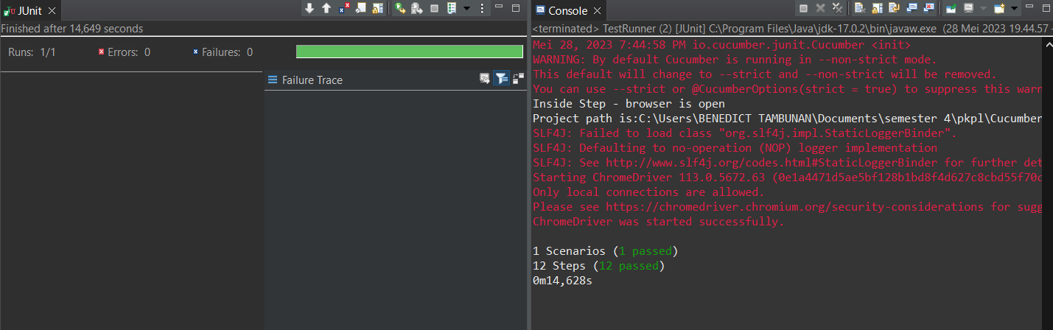

1. The browser while testing

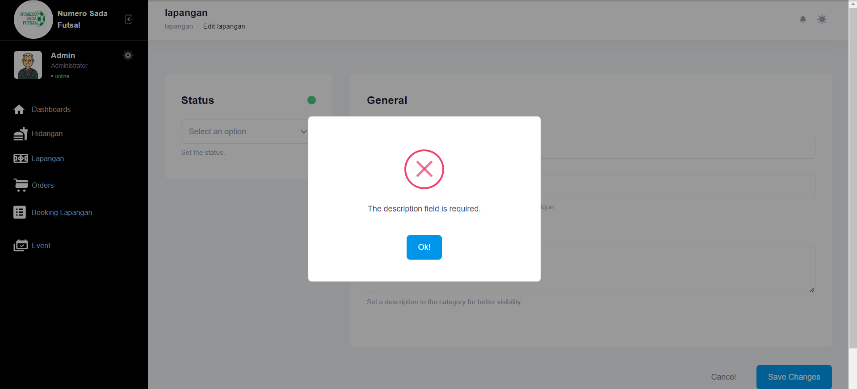

Fungsi edit Lapangan 3

1. The scenario

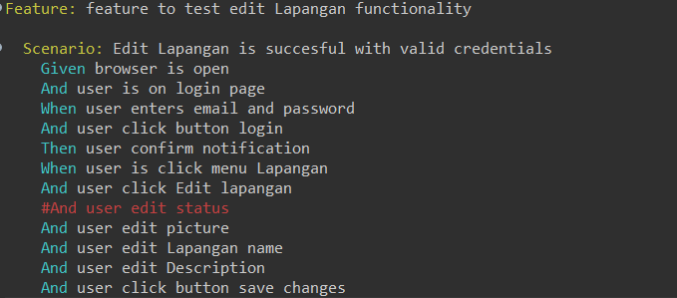

1. The Step definition



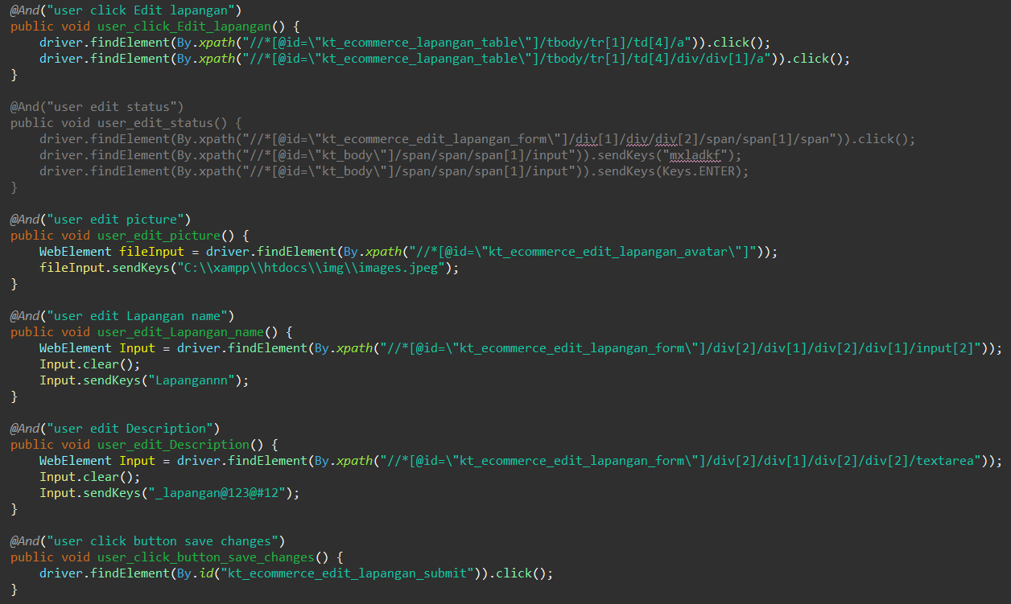

1. The test runner



1. The console after running

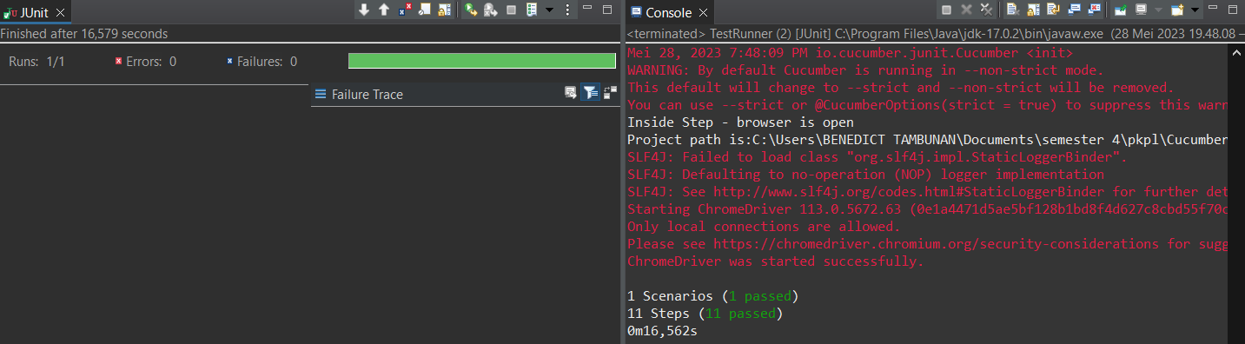

1. The browser while testing

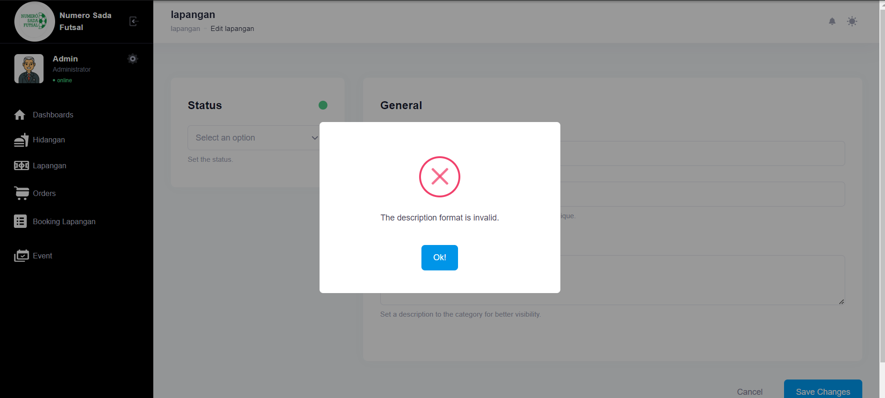

Fungsi edit Lapangan 4

1. The scenario



1. The Step definition



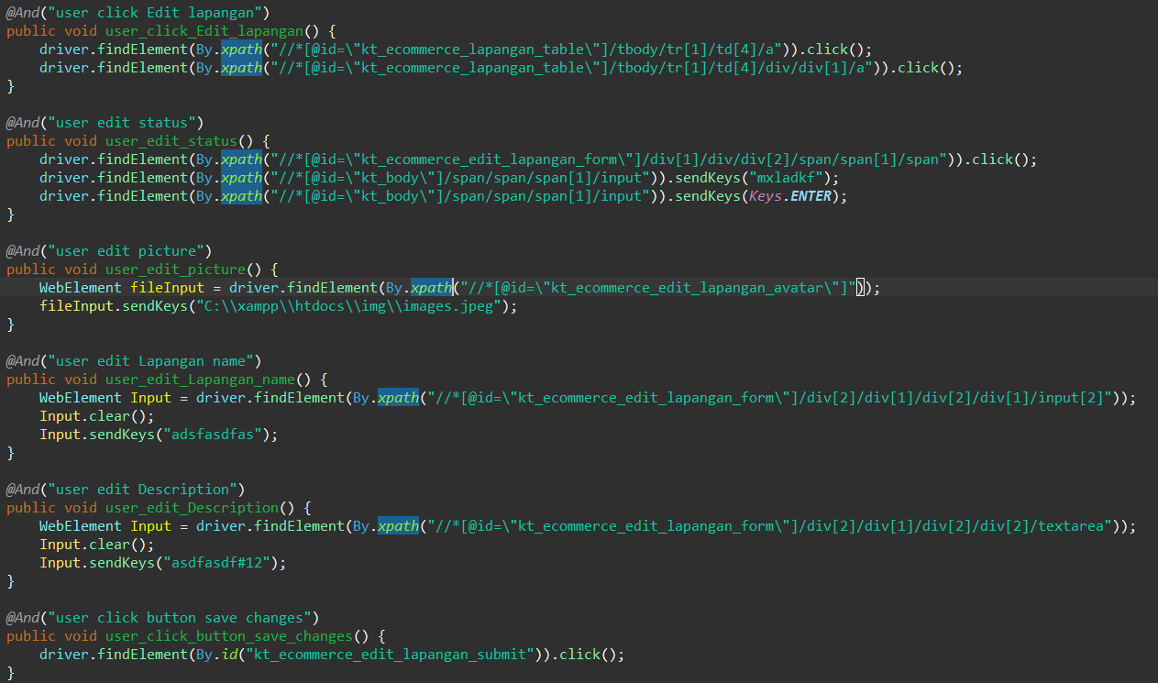

1. The test runner



1. The console after running

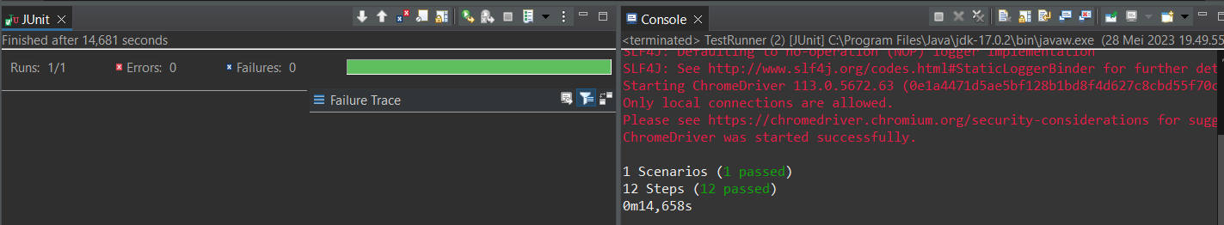

1. The browser while testing



Fungsi edit Lapangan 5

1. The scenario



1. The Step definition



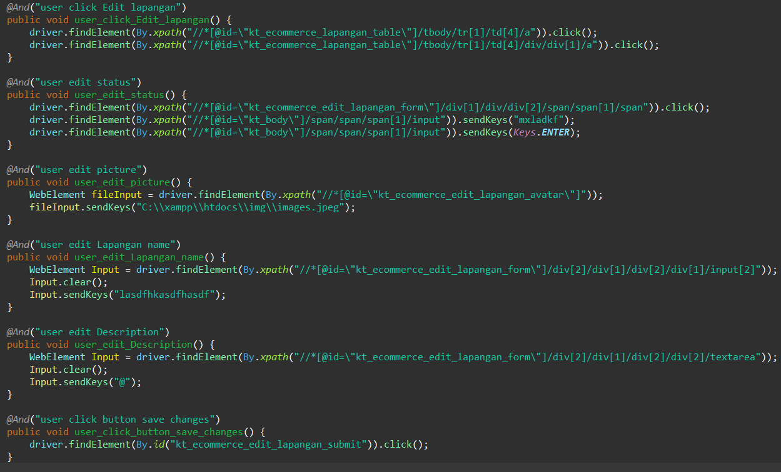

1. The test runner



1. The console after running



1. The browser while testing



Fungsi edit Lapangan 6

1. The scenario



1. The Step definition



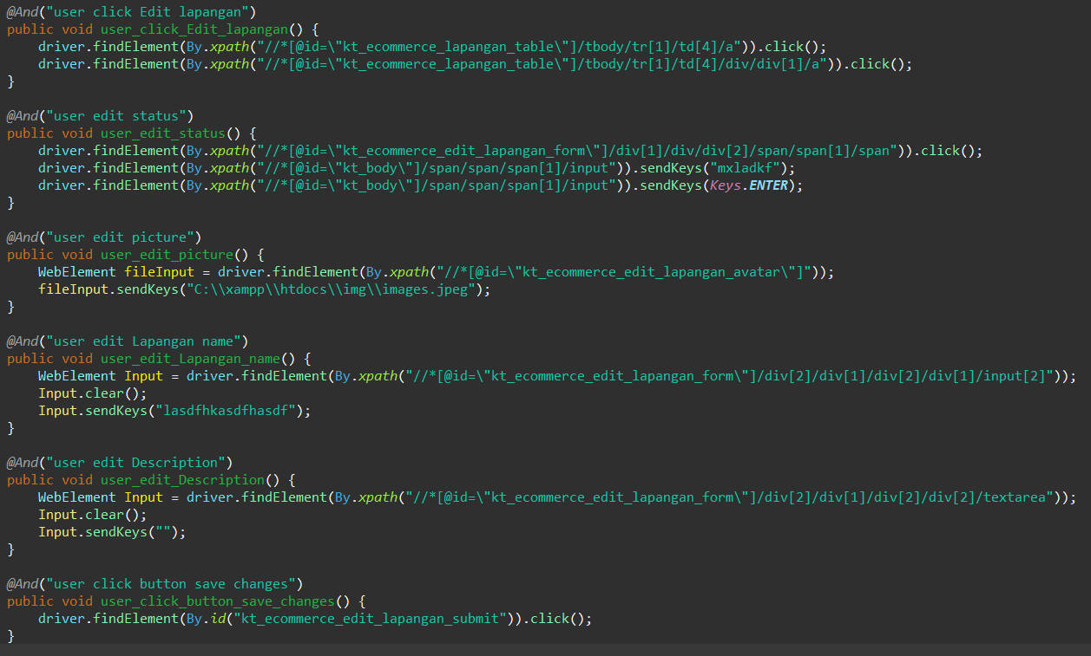

1. The test runner



1. The console after running

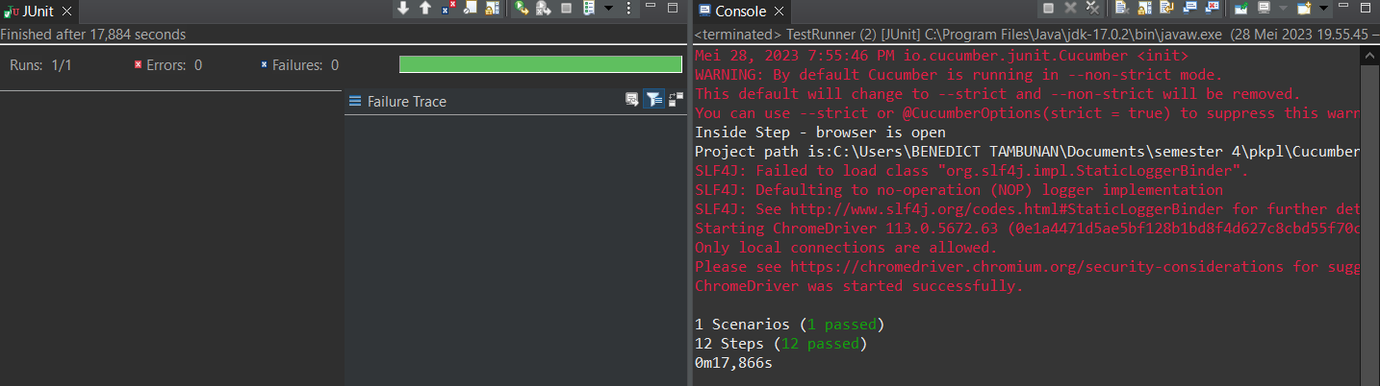

1. The browser while testing

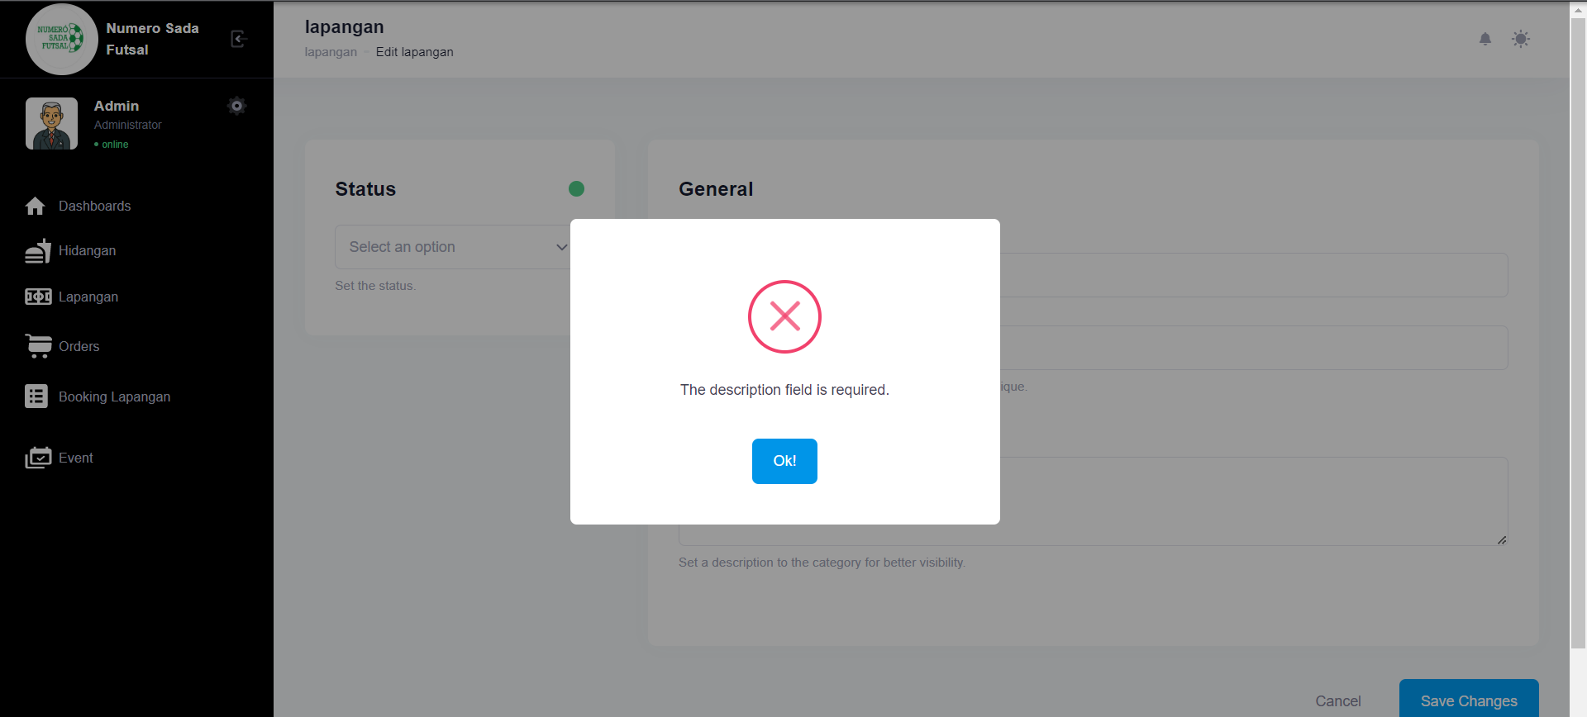

1. Test Fungsi edit Lapangan Variasi 11: edit Lapangan dengan parameter 1,3 tidak valid namun ke 2,4 valid

Fungsi edit Lapangan 1

1. The scenario



1. The Step definition



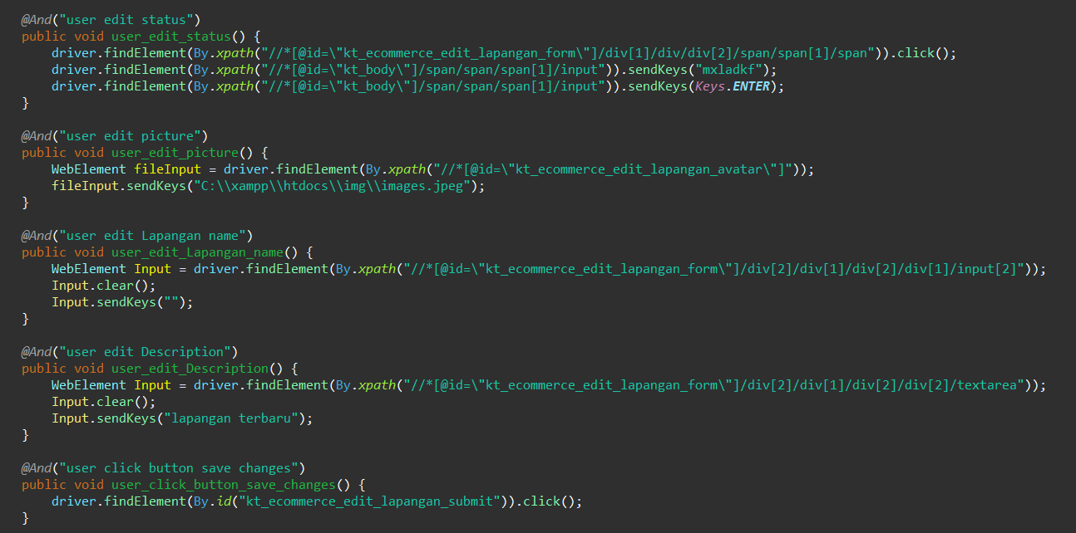

1. The test runner



1. The console after running

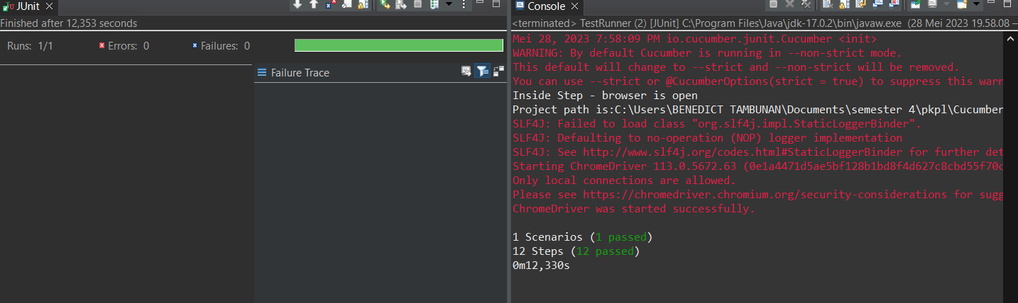

1. The browser while testing

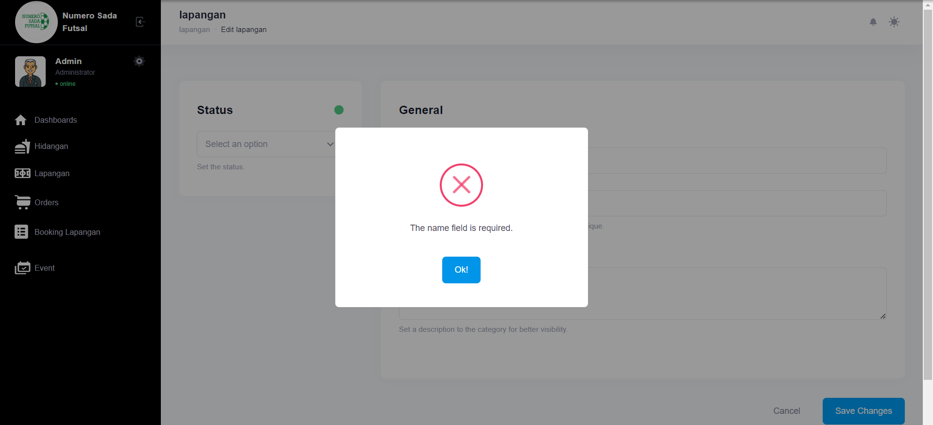

Fungsi edit Lapangan 2

1. The scenario



1. The Step definition



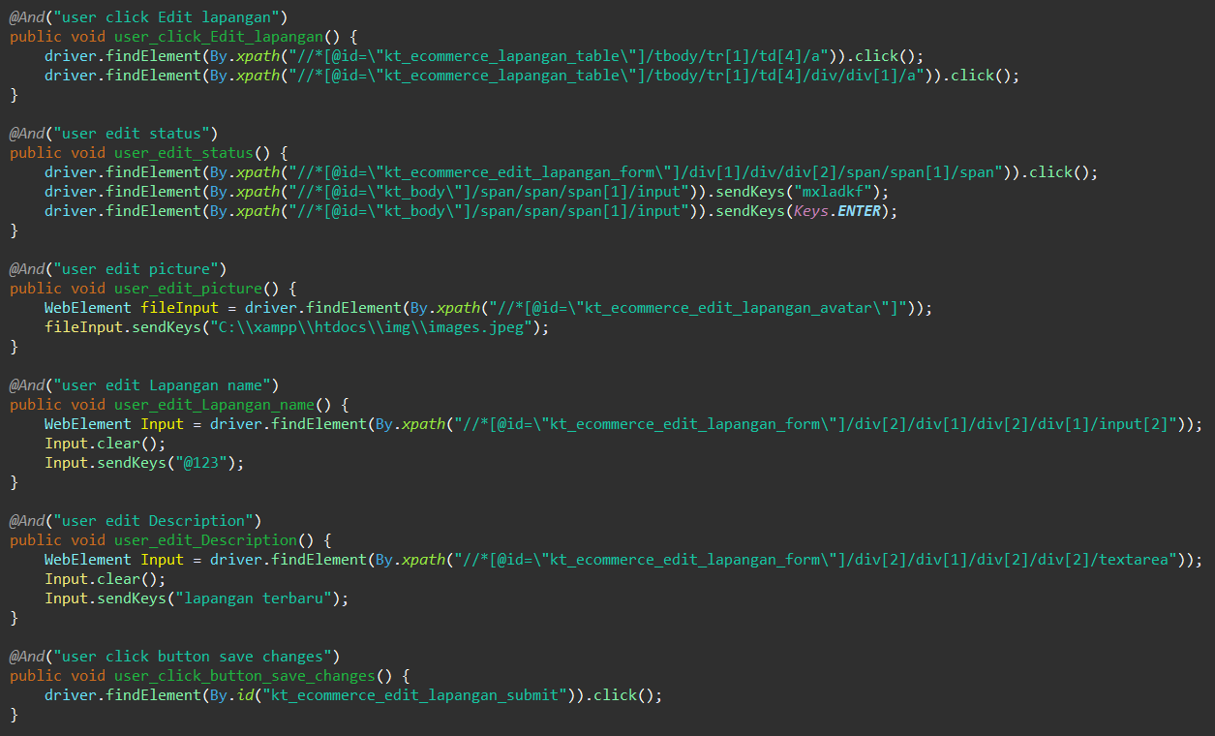

1. The test runner



1. The console after running

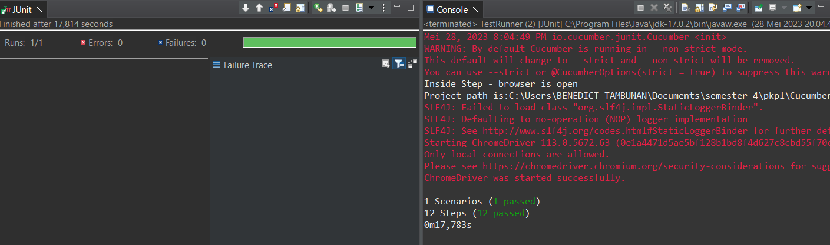

1. The browser while testing

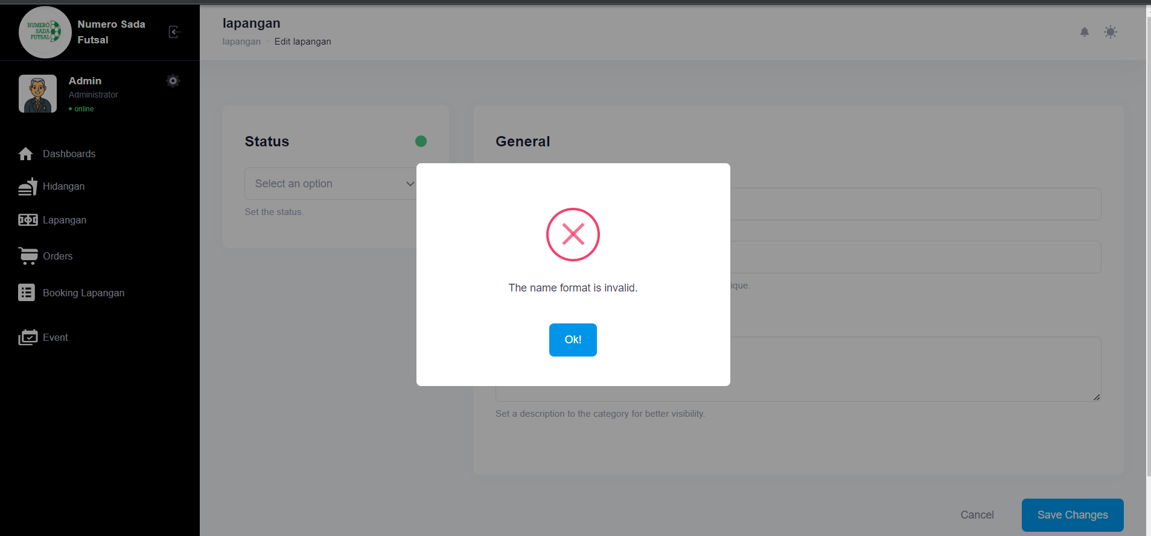

Fungsi edit Lapangan 3

1. The scenario



1. The Step definition



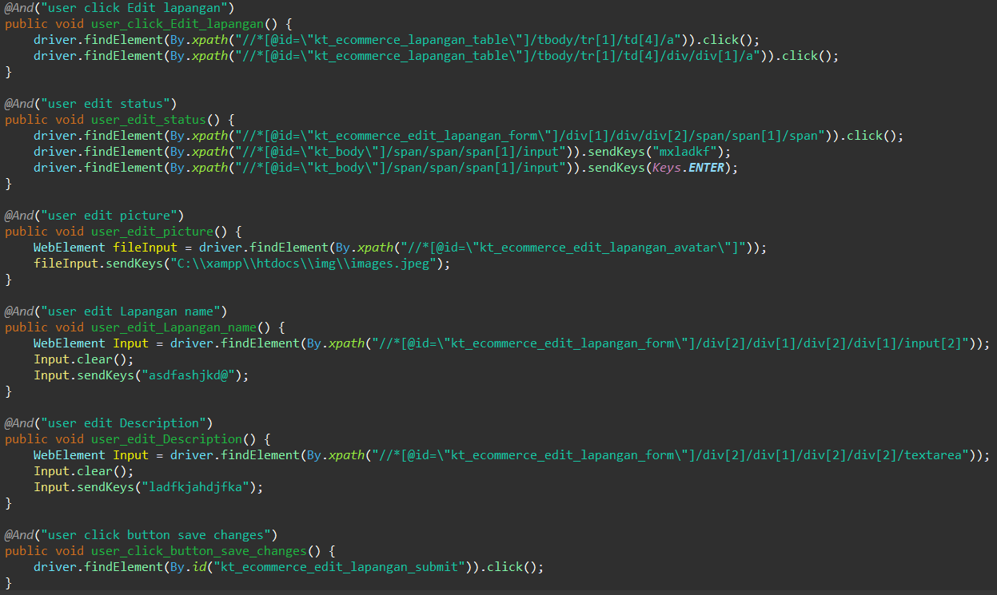

1. The test runner



1. The console after running



1. The browser while testing



Fungsi edit Lapangan 4

1. The scenario



1. The Step definition



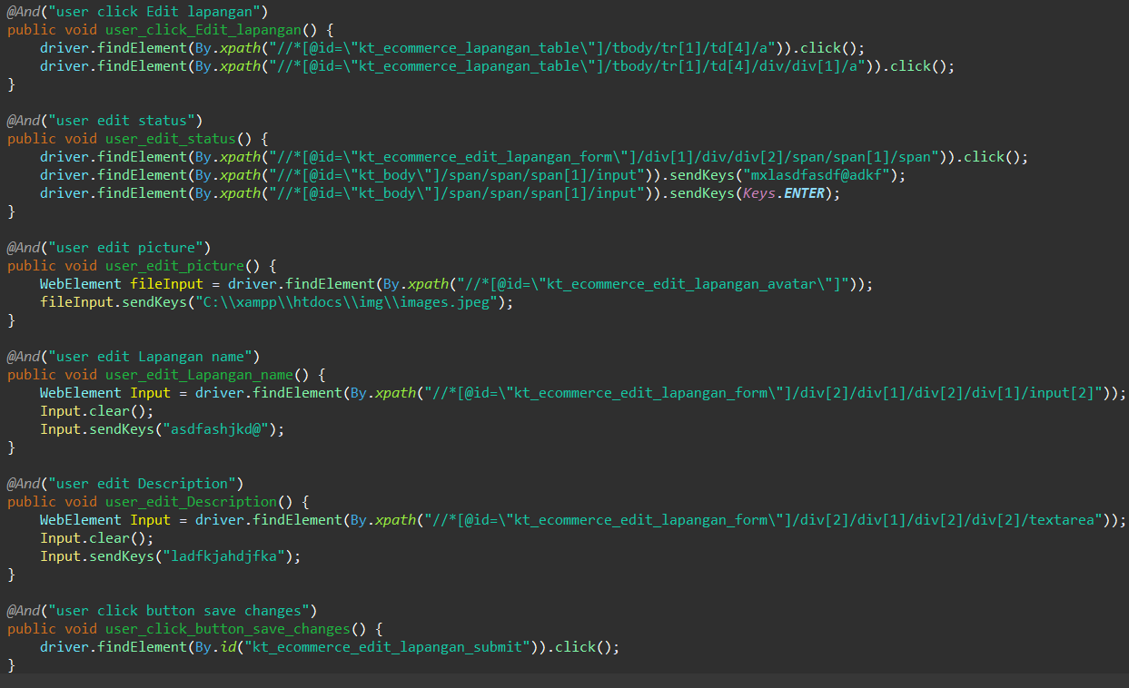

1. The test runner



1. The console after running



1. The browser while testing



Fungsi edit Lapangan 5

1. The scenario



1. The Step definition



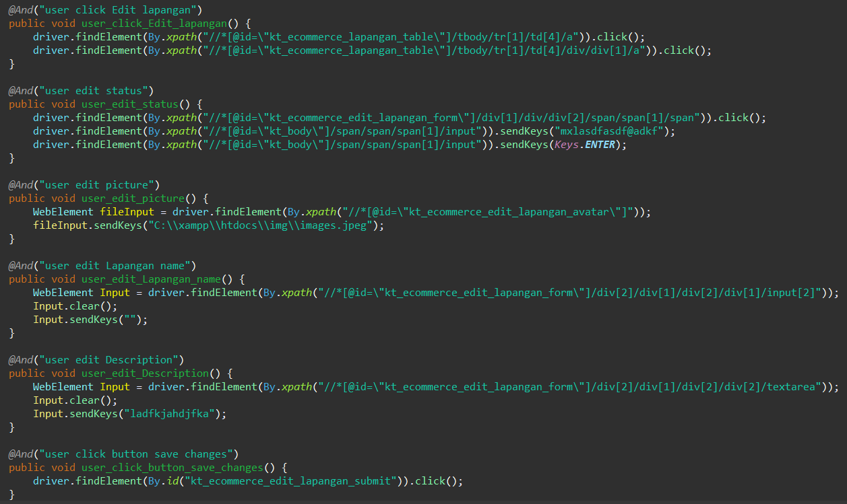

1. The test runner



1. The console after running

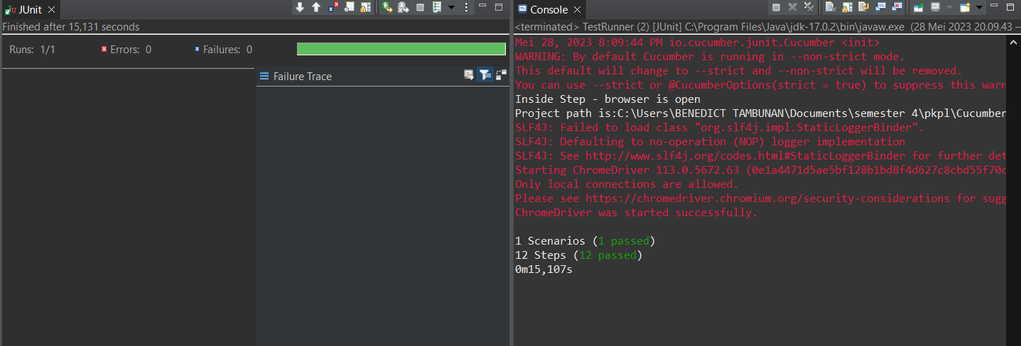

1. The browser while testing

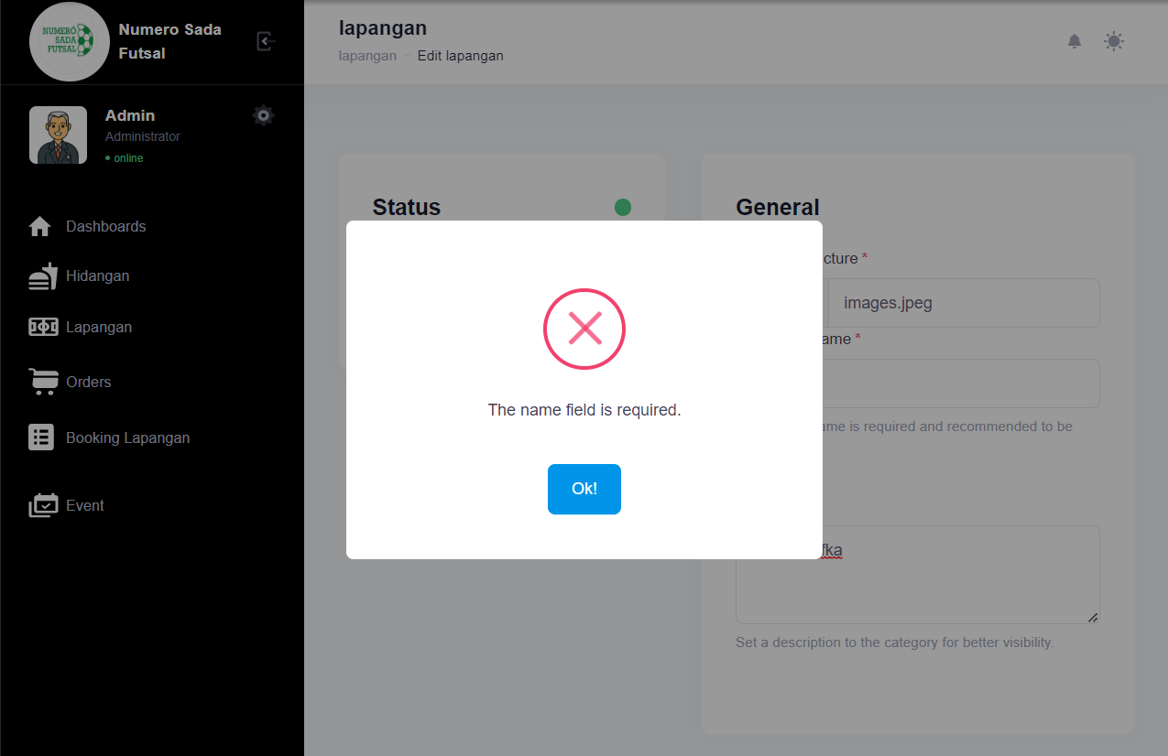

Fungsi edit Lapangan 6

1. The scenario



1. The Step definition



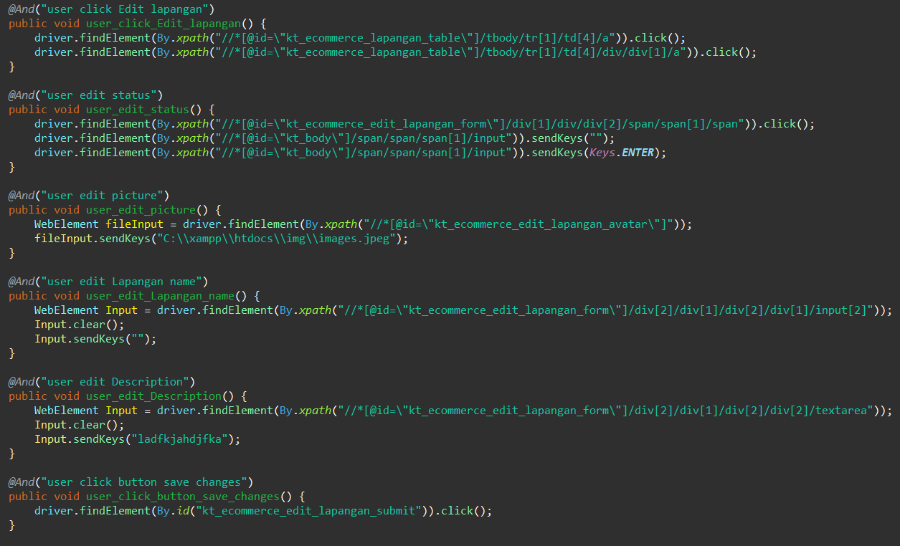

1. The test runner



1. The console after running



1. The browser while testing



1. Test Fungsi edit Lapangan Variasi 12: edit Lapangan dengan parameter 1,3,4 tidak valid namun ke 2 valid

Fungsi edit Lapangan 1

1. The scenario



1. The Step definition



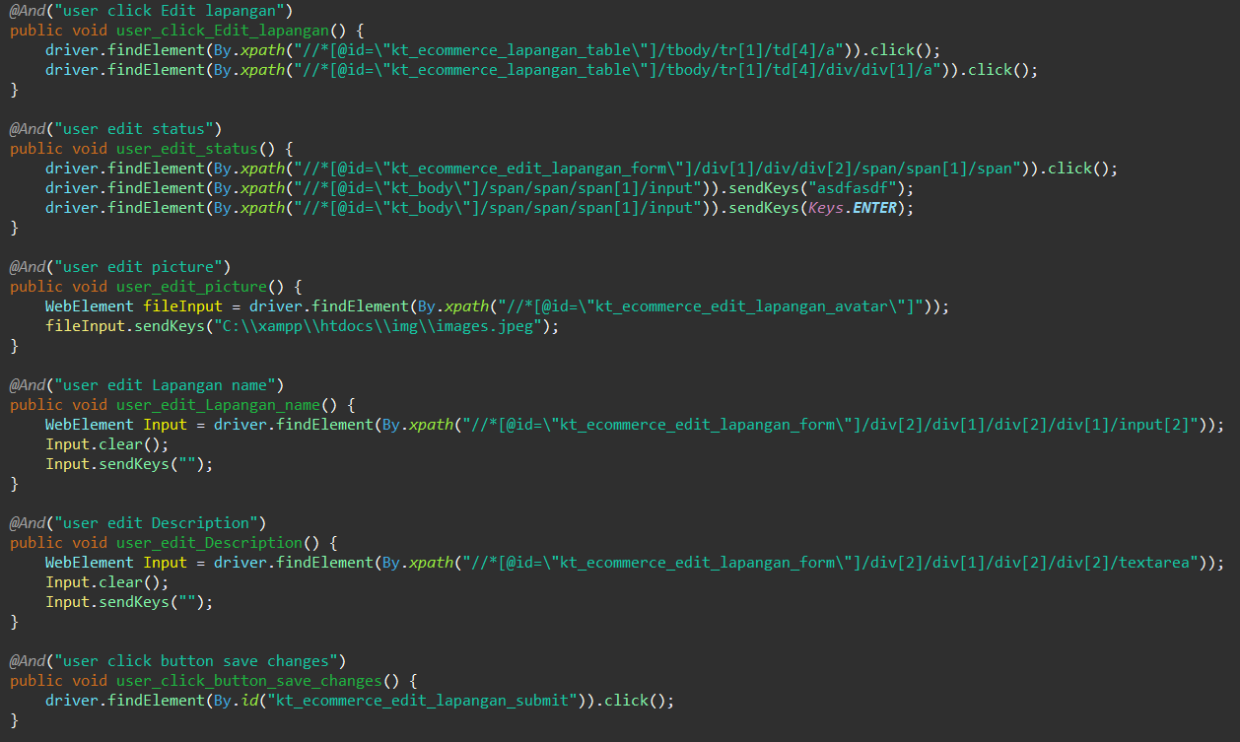

1. The test runner



1. The console after running

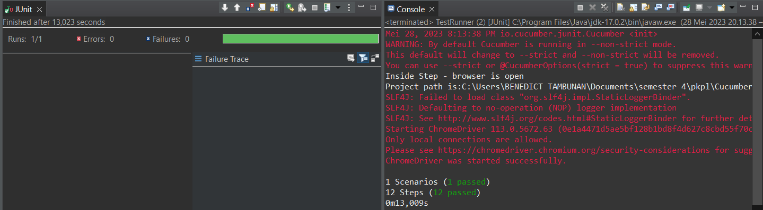

1. The browser while testing

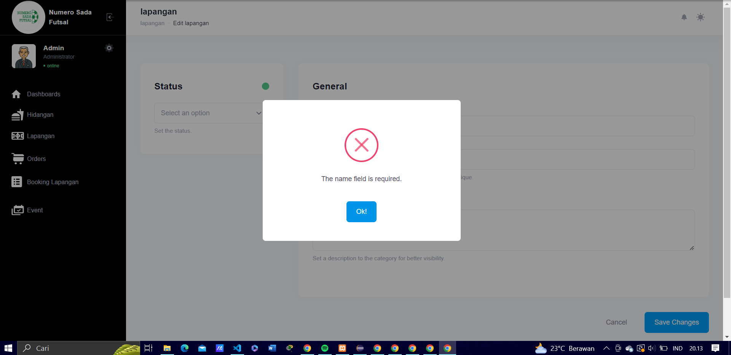

Fungsi edit Lapangan 2

1. The scenario



1. The Step definition



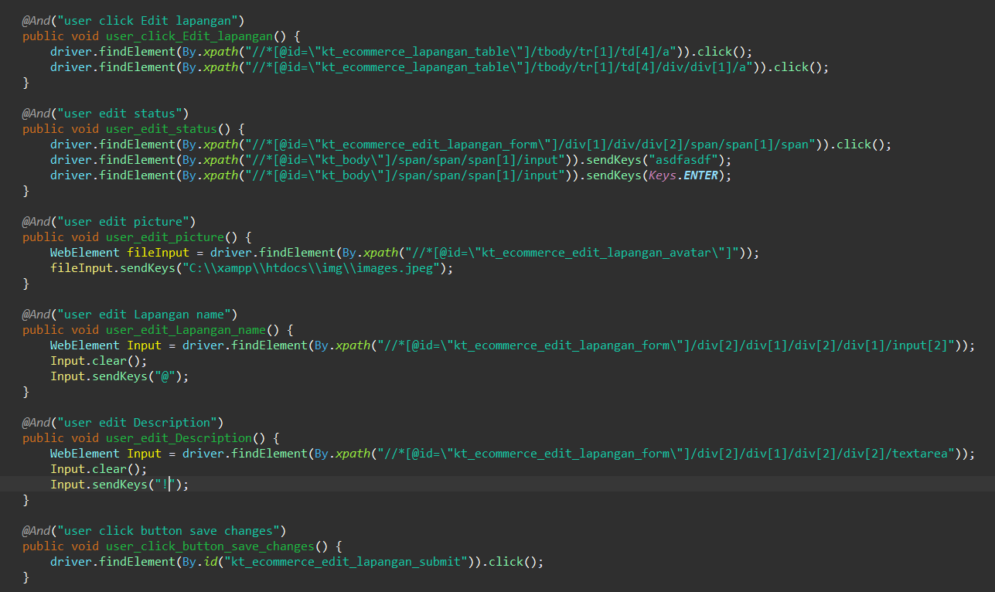

1. The test runner



1. The console after running



1. The browser while testing

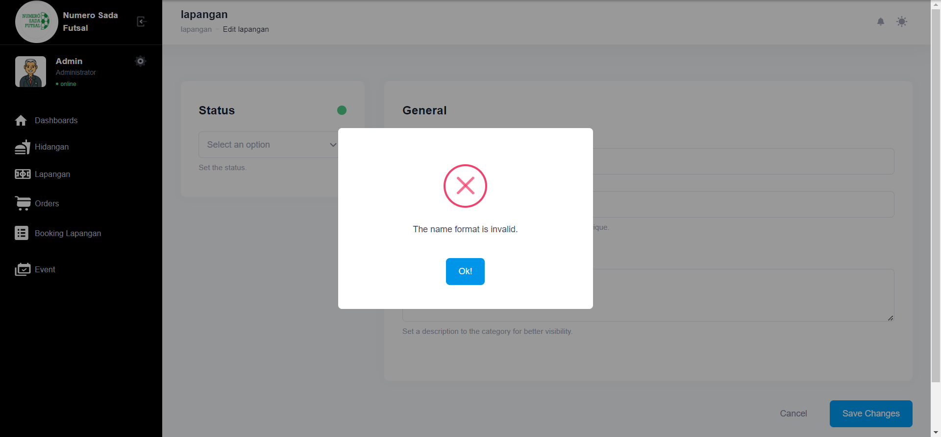

Fungsi edit Lapangan 3

1. The scenario



1. The Step definition



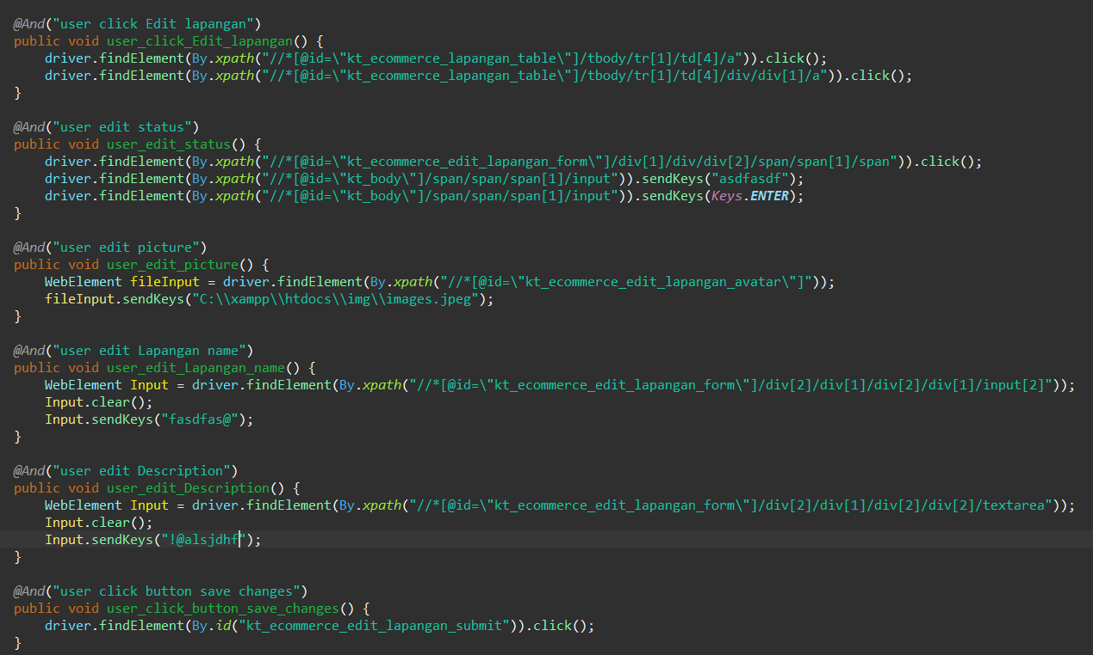

1. The test runner



1. The console after running



1. The browser while testing



Fungsi edit Lapangan 4

1. The scenario



1. The Step definition



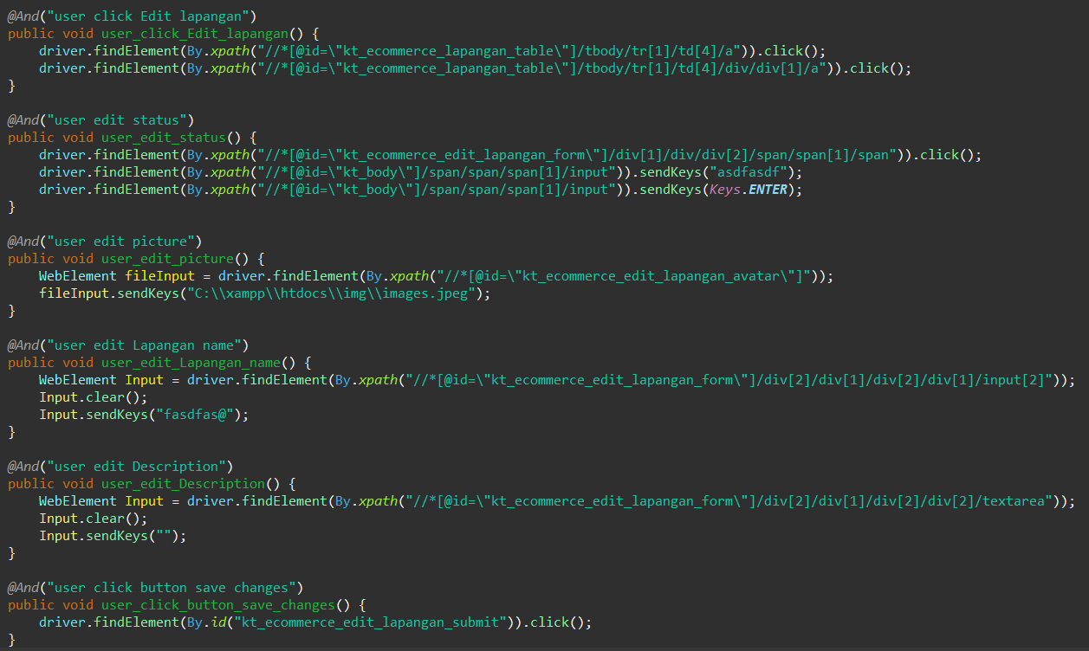

1. The test runner



1. The console after running



1. The browser while testing



Fungsi edit Lapangan 5

1. The scenario



1. The Step definition



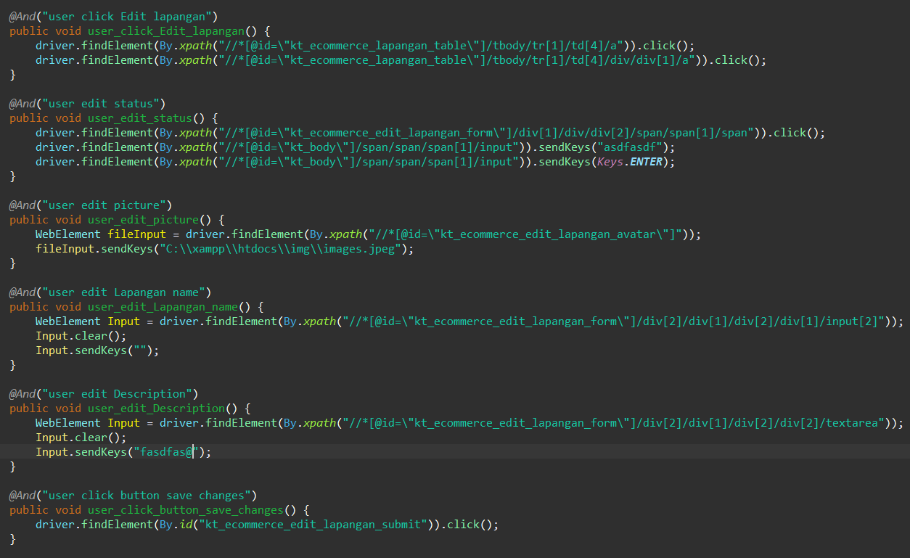

1. The test runner



1. The console after running



1. The browser while testing

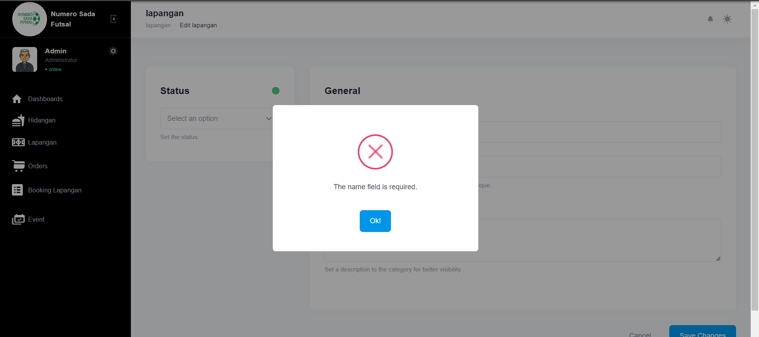

Fungsi edit Lapangan 6

1. The scenario



1. The Step definition



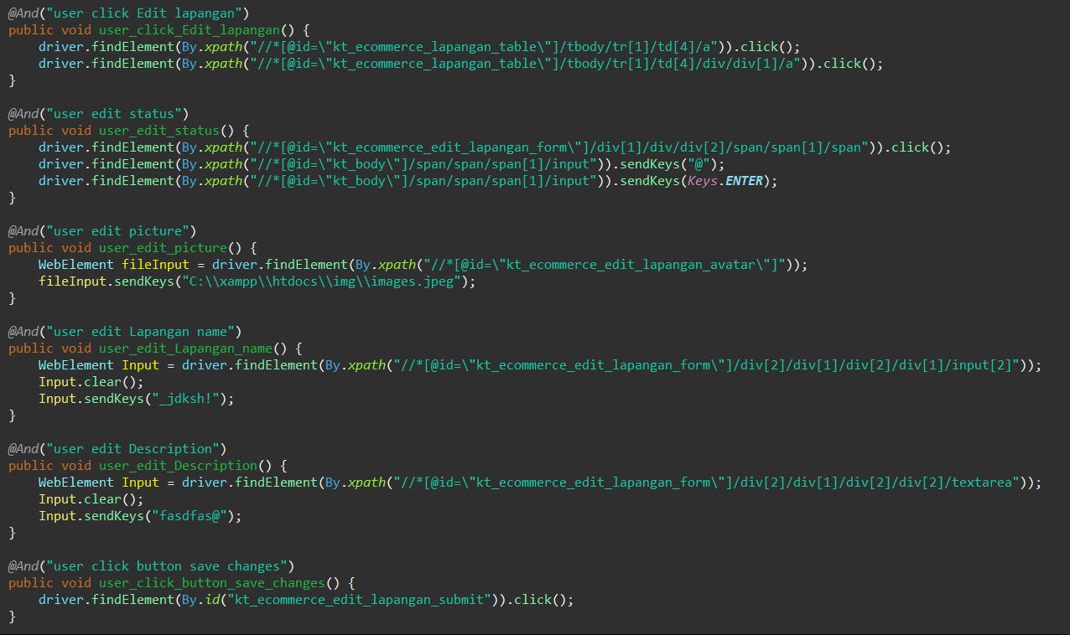

1. The test runner



1. The console after running



1. The browser while testing



1. Variasi 13: Edit Lapangan dengan parameter 1,2 tidak valid namun ke 3 , 4 valid
2. Test Fungsi edit Lapangan

Fungsi edit Lapangan 1

1. The scenario



1. The Step definition



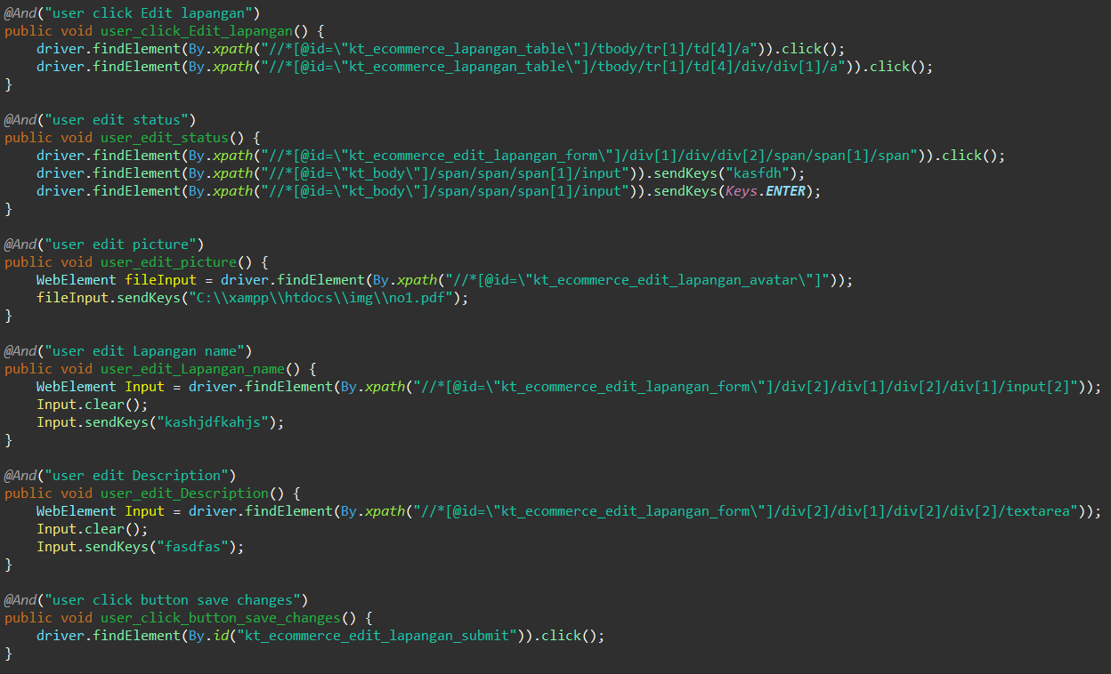

1. The test runner



1. The console after running

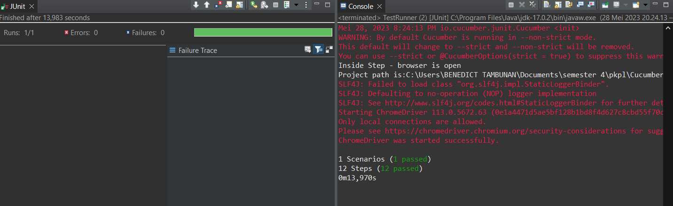

1. The browser while testing

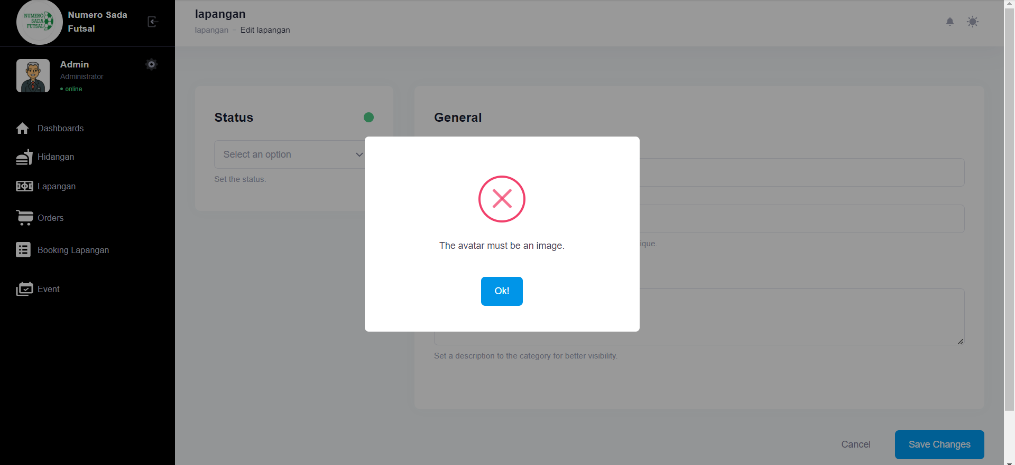

Fungsi edit Lapangan 2

1. The scenario



1. The Step definition



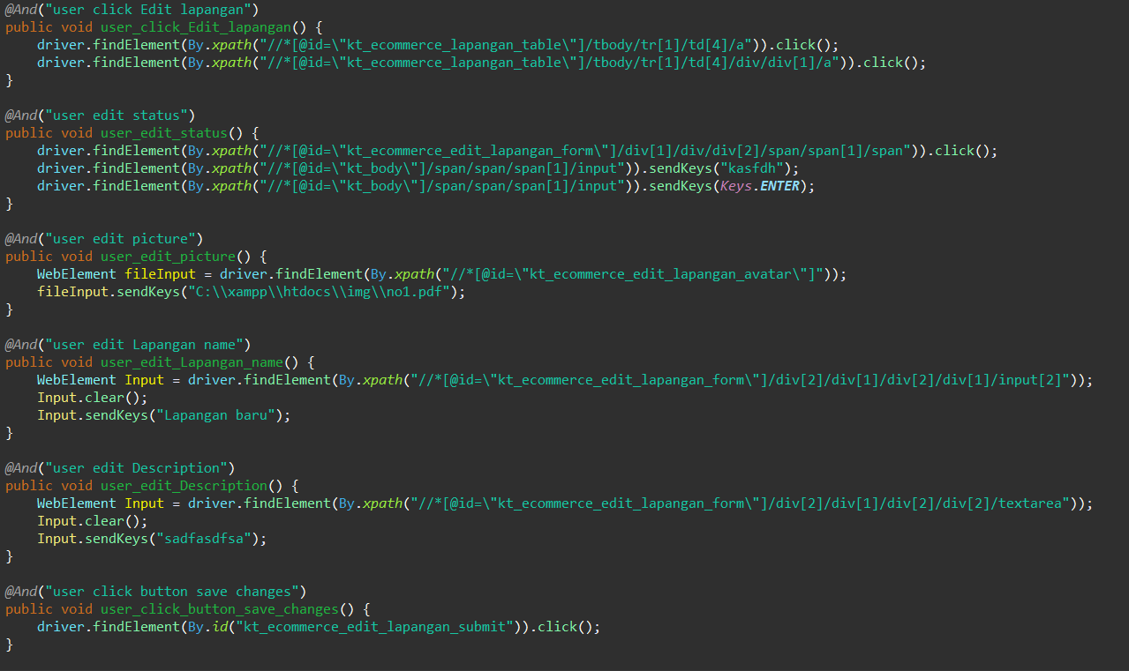

1. The test runner



1. The console after running



1. The browser while testing



Fungsi edit Lapangan 3

1. The scenario



1. The Step definition



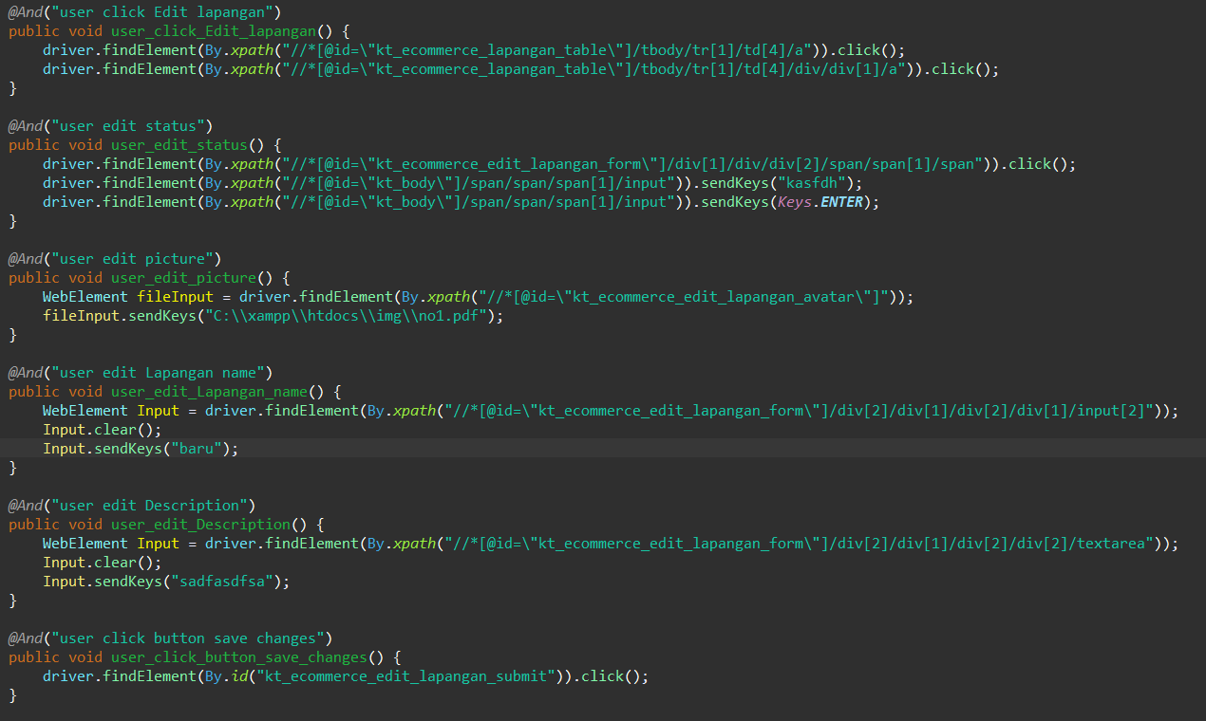

1. The test runner



1. The console after running



1. The browser while testing



Fungsi edit Lapangan 4

1. The scenario



1. The Step definition



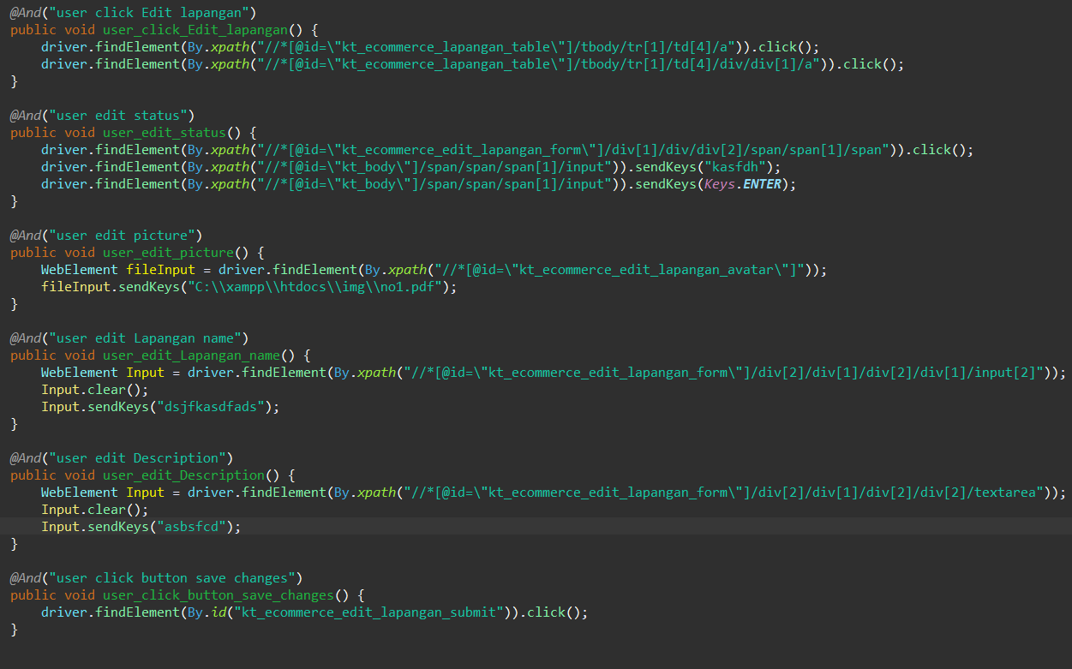

1. The test runner



1. The console after running



1. The browser while testing



Fungsi edit Lapangan 5

1. The scenario



1. The Step definition



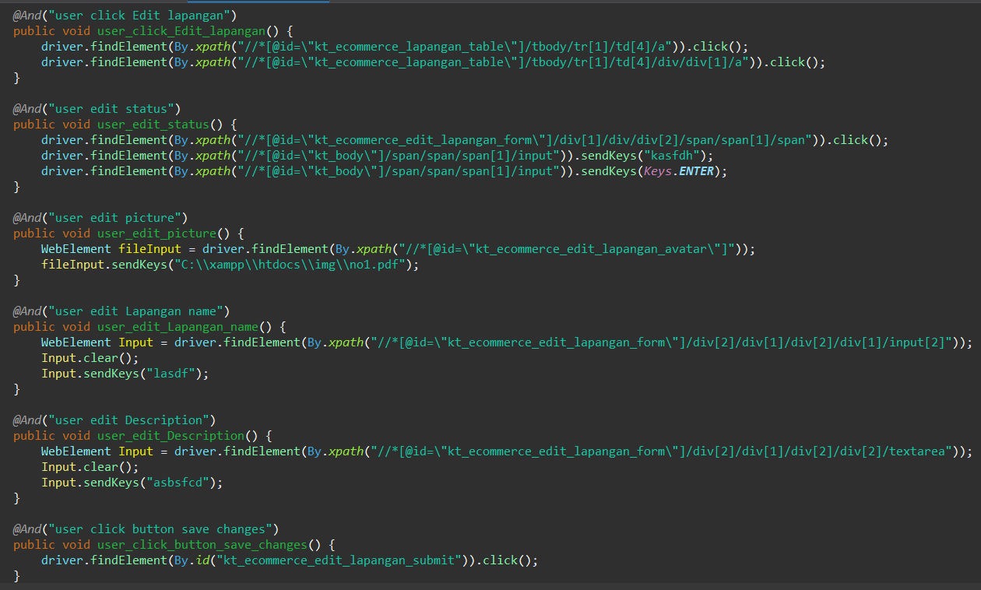

1. The test runner



1. The console after running



1. The browser while testing



Fungsi edit Lapangan 6

1. The scenario



1. The Step definition



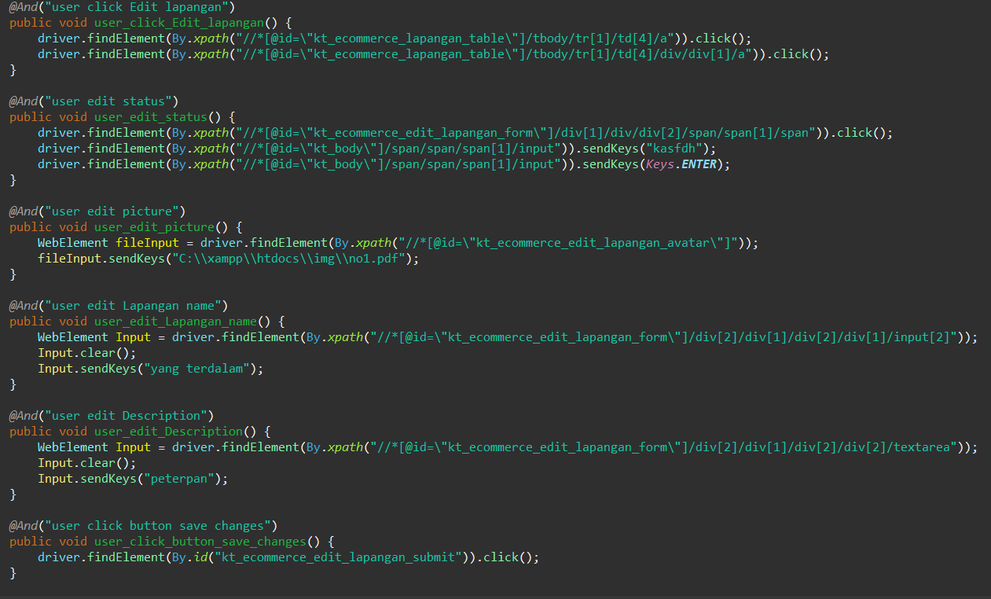

1. The test runner



1. The console after running



1. The browser while testing



1. Test Fungsi edit Lapangan Variasi 14: edit Lapangan dengan parameter 1,2,4 tidak valid namun ke 3 valid

Fungsi edit Lapangan 1

1. The scenario



1. The Step definition



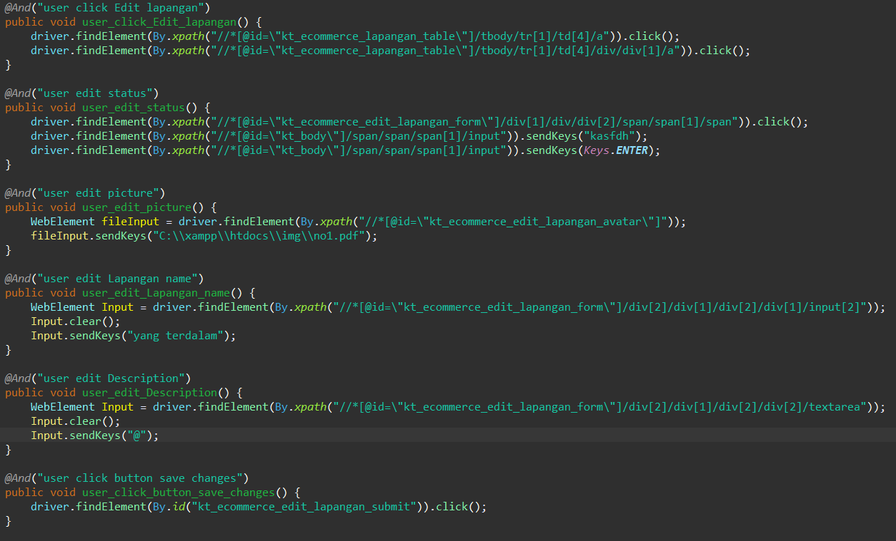

1. The test runner



1. The console after running

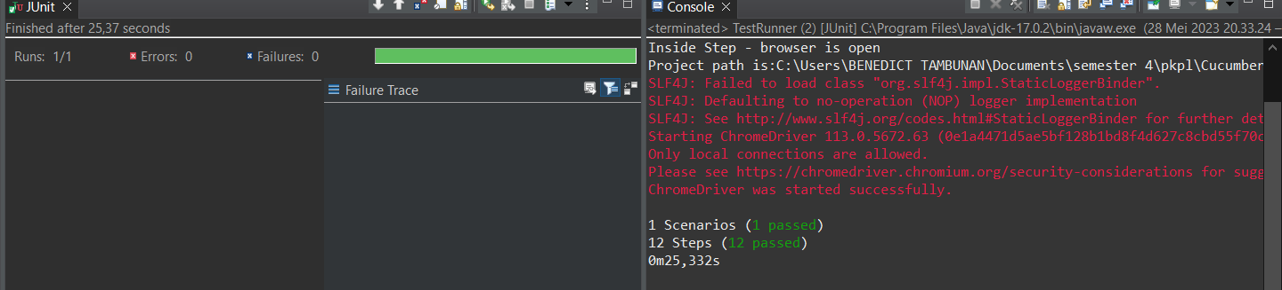

1. The browser while testing

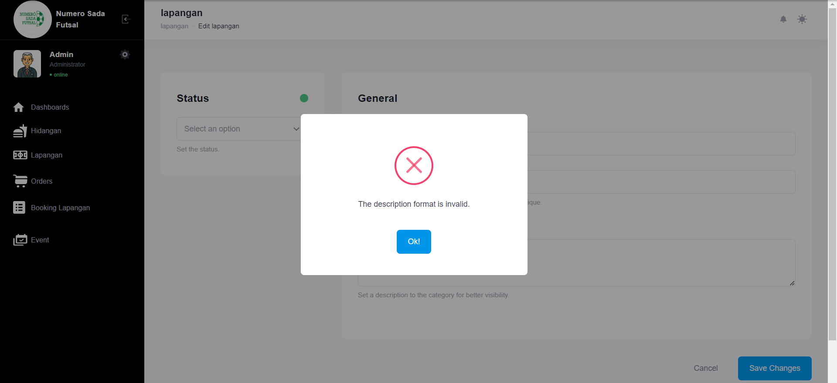

Fungsi edit Lapangan 2

1. The scenario



1. The Step definition



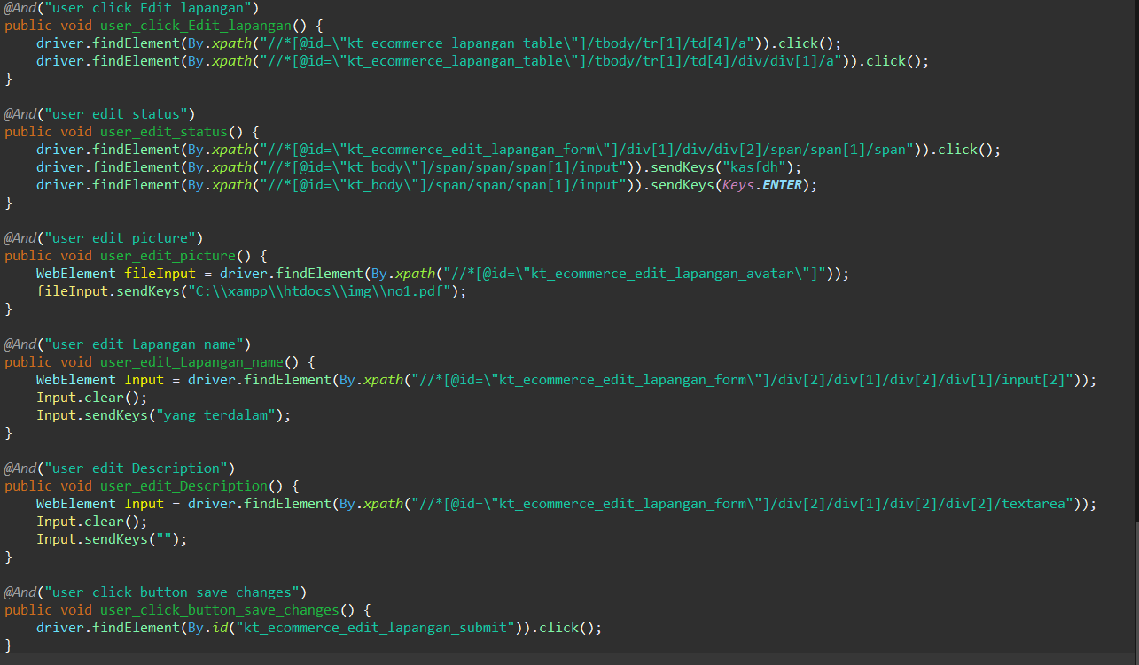

1. The test runner



1. The console after running

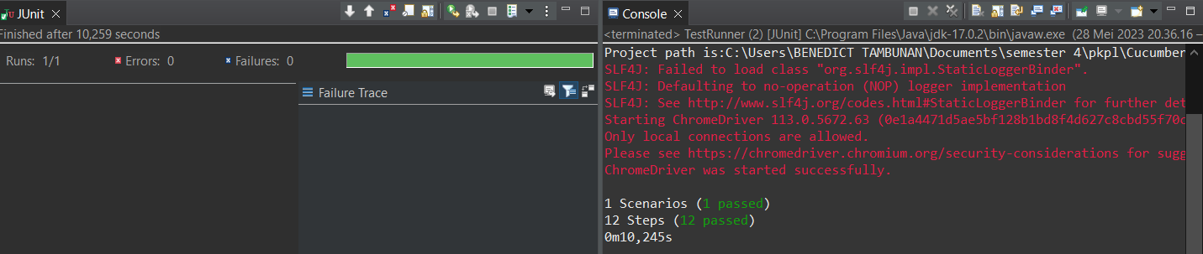

1. The browser while testing

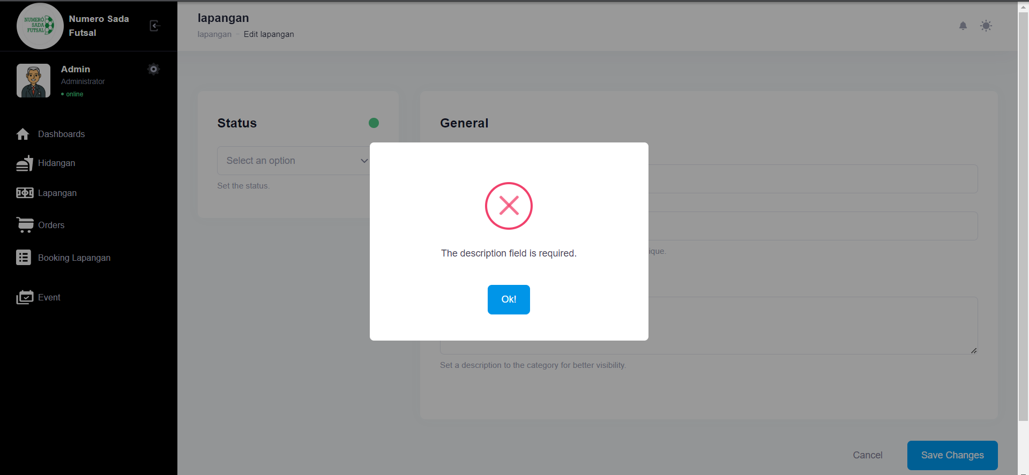

Fungsi edit Lapangan 3

1. The scenario



1. The Step definition



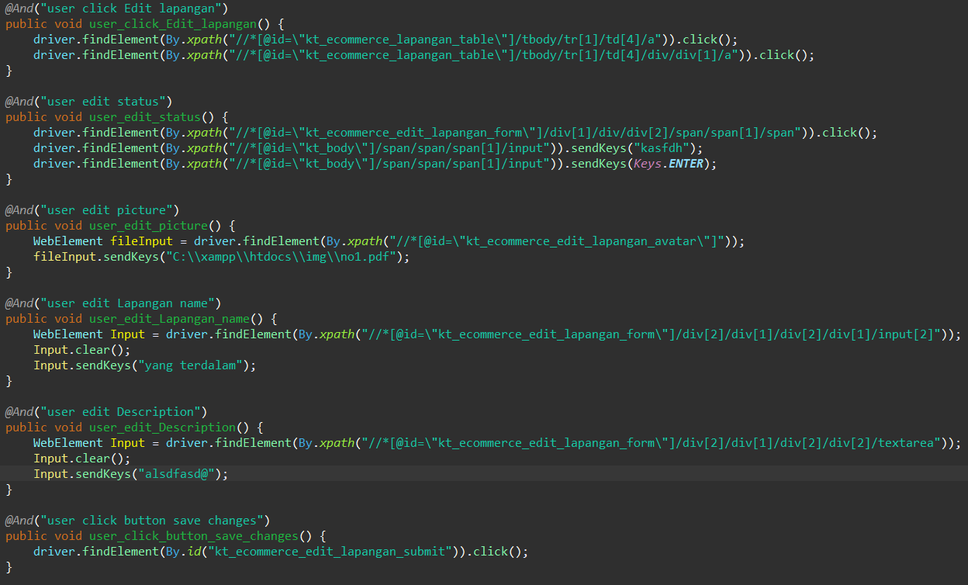

1. The test runner



1. The console after running



1. The browser while testing



Fungsi edit Lapangan 4

1. The scenario



1. The Step definition



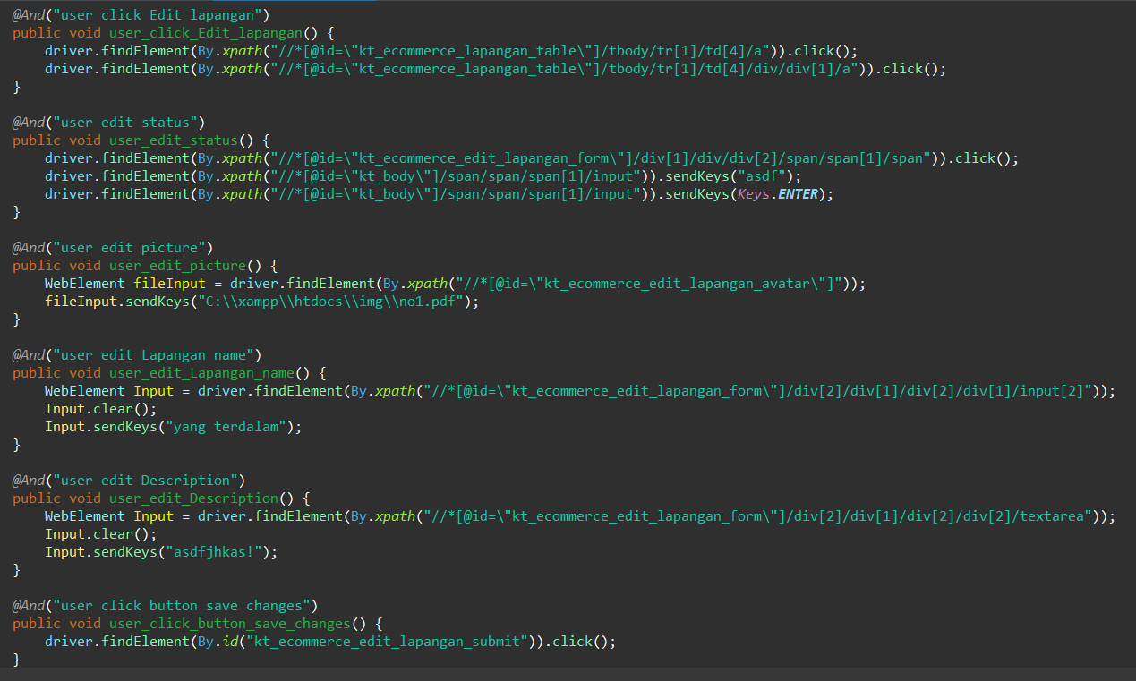

1. The test runner



1. The console after running



1. The browser while testing



Fungsi edit Lapangan 5

1. The scenario



1. The Step definition



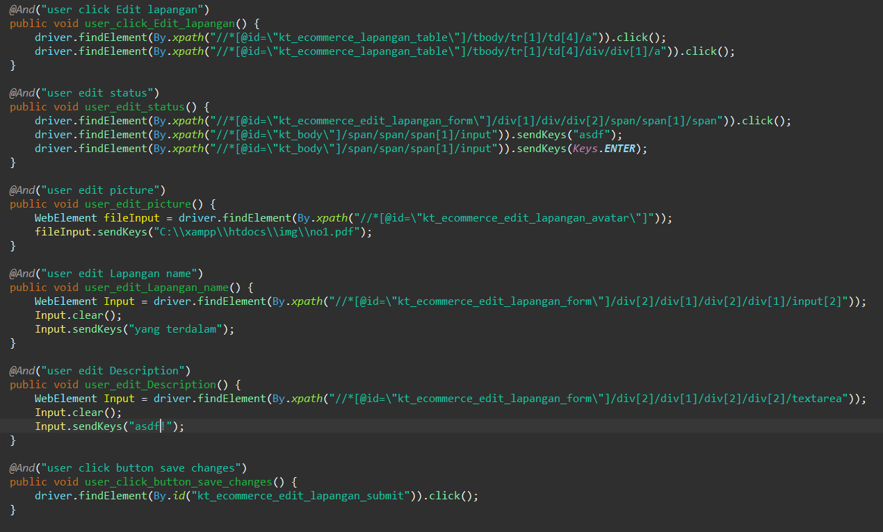

1. The test runner



1. The console after running



1. The browser while testing



Fungsi edit Lapangan 6

1. The scenario



1. The Step definition



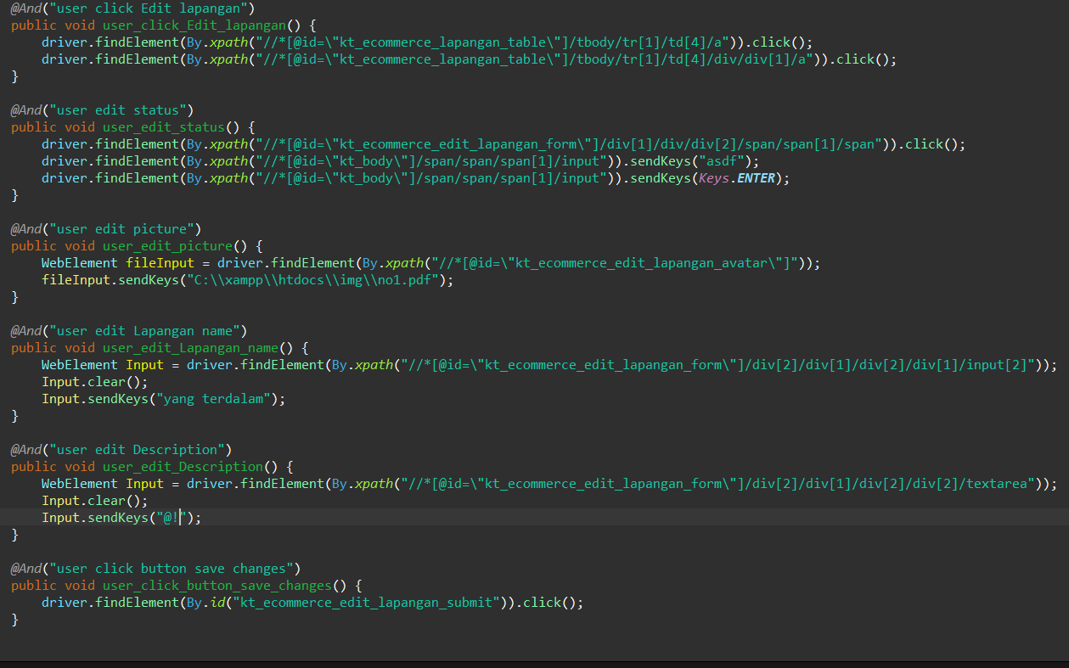

1. The test runner



1. The console after running



1. The browser while testing



1. Test Fungsi edit Lapangan Variasi 15: edit Lapangan dengan parameter 1,2,3 tidak valid namun ke 4 valid

Fungsi edit Lapangan 1

1. The scenario



1. The Step definition



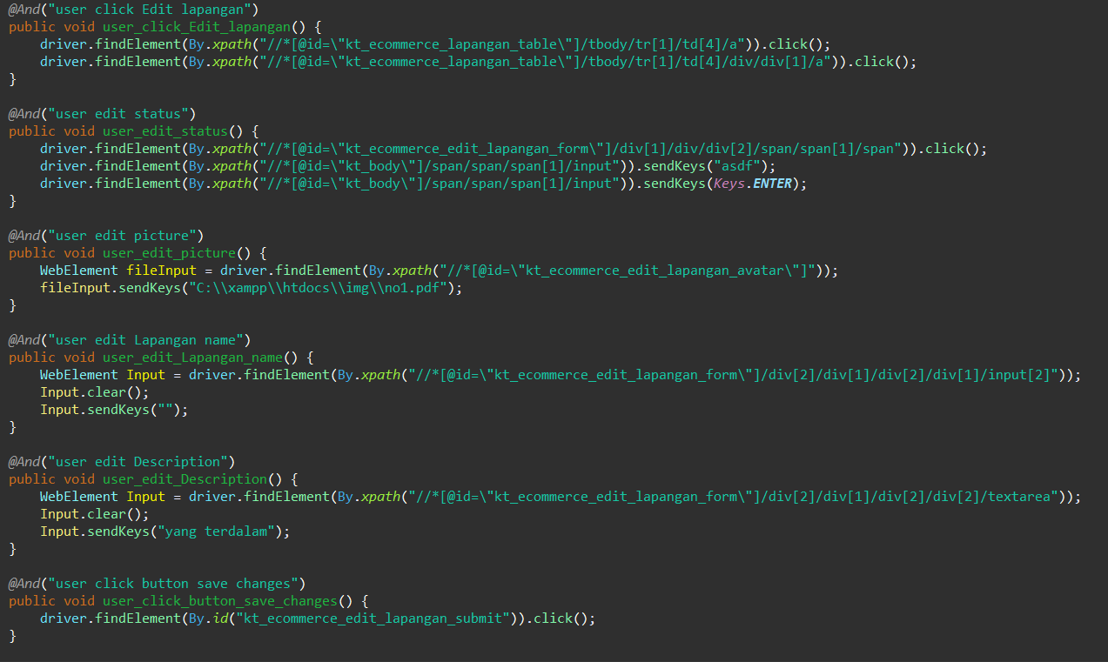

1. The test runner



1. The console after running

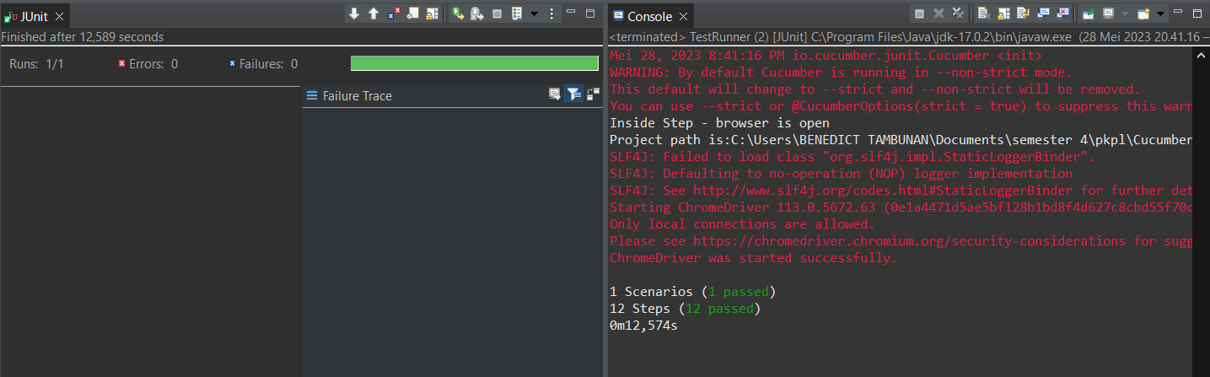

1. The browser while testing

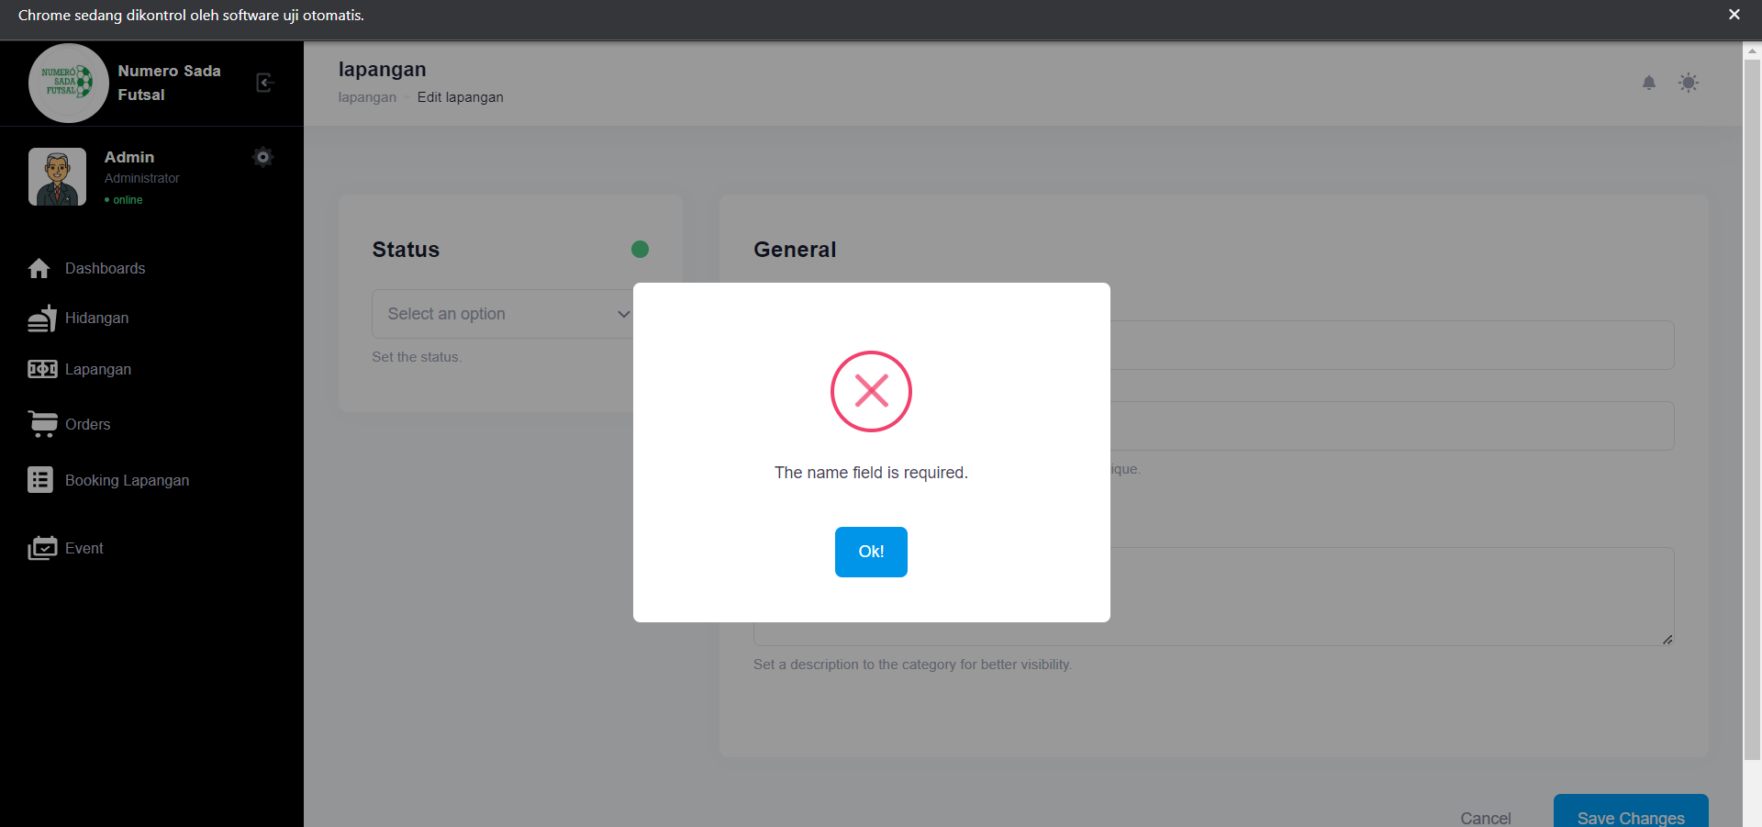

Fungsi edit Lapangan 2

1. The scenario



1. The Step definition



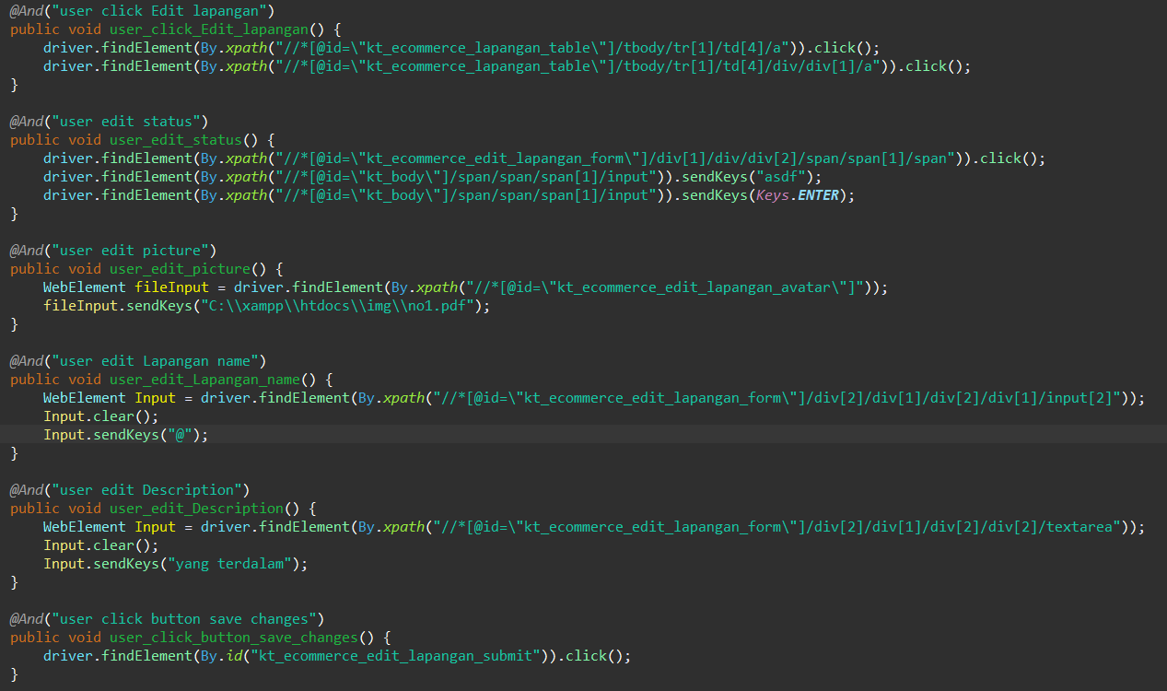

1. The test runner



1. The console after running



1. The browser while testing

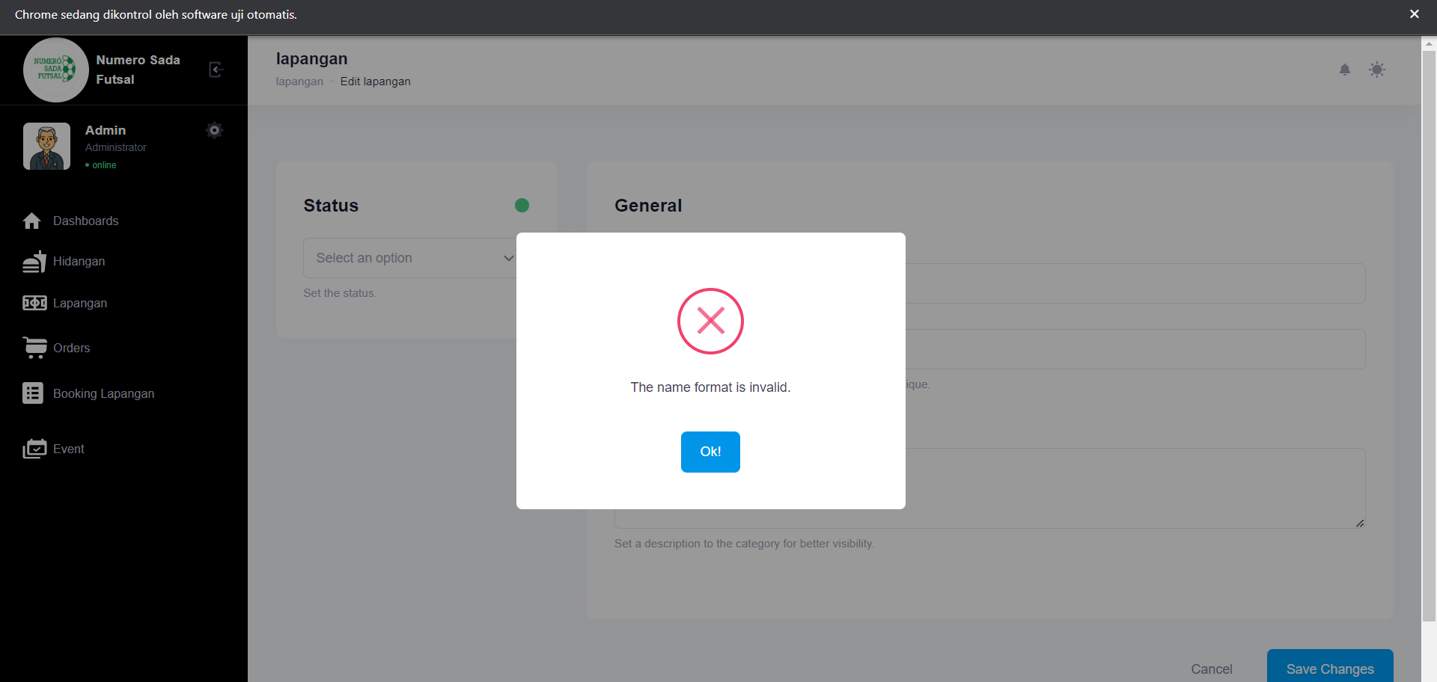

Fungsi edit Lapangan 3

1. The scenario



1. The Step definition



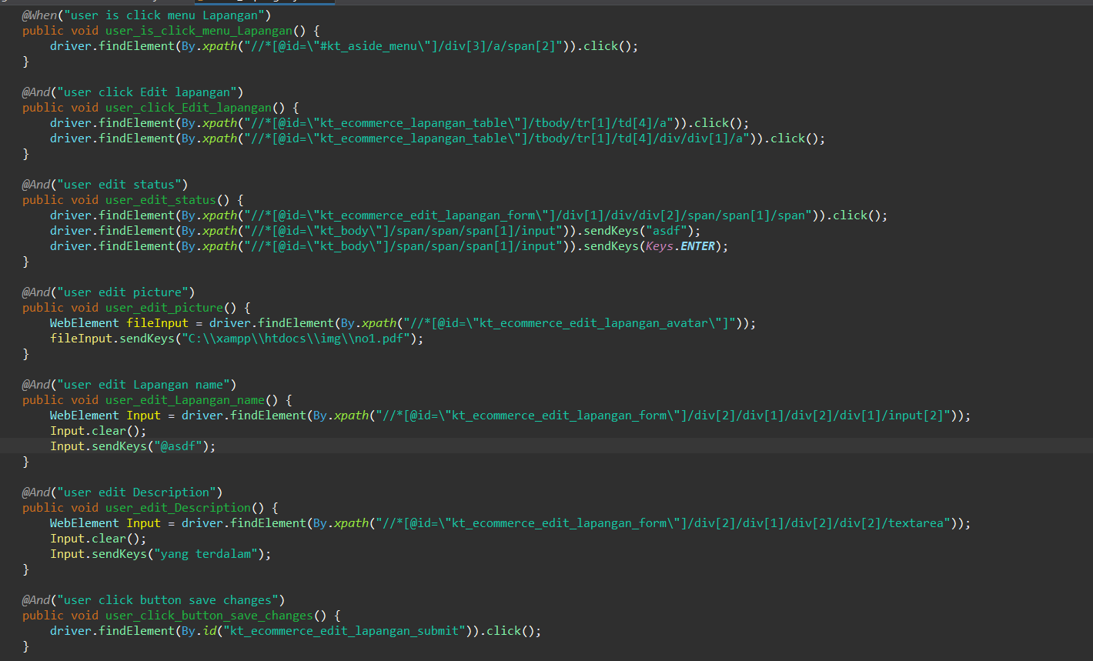

1. The test runner



1. The console after running



1. The browser while testing



Fungsi edit Lapangan 4

1. The scenario



1. The Step definition



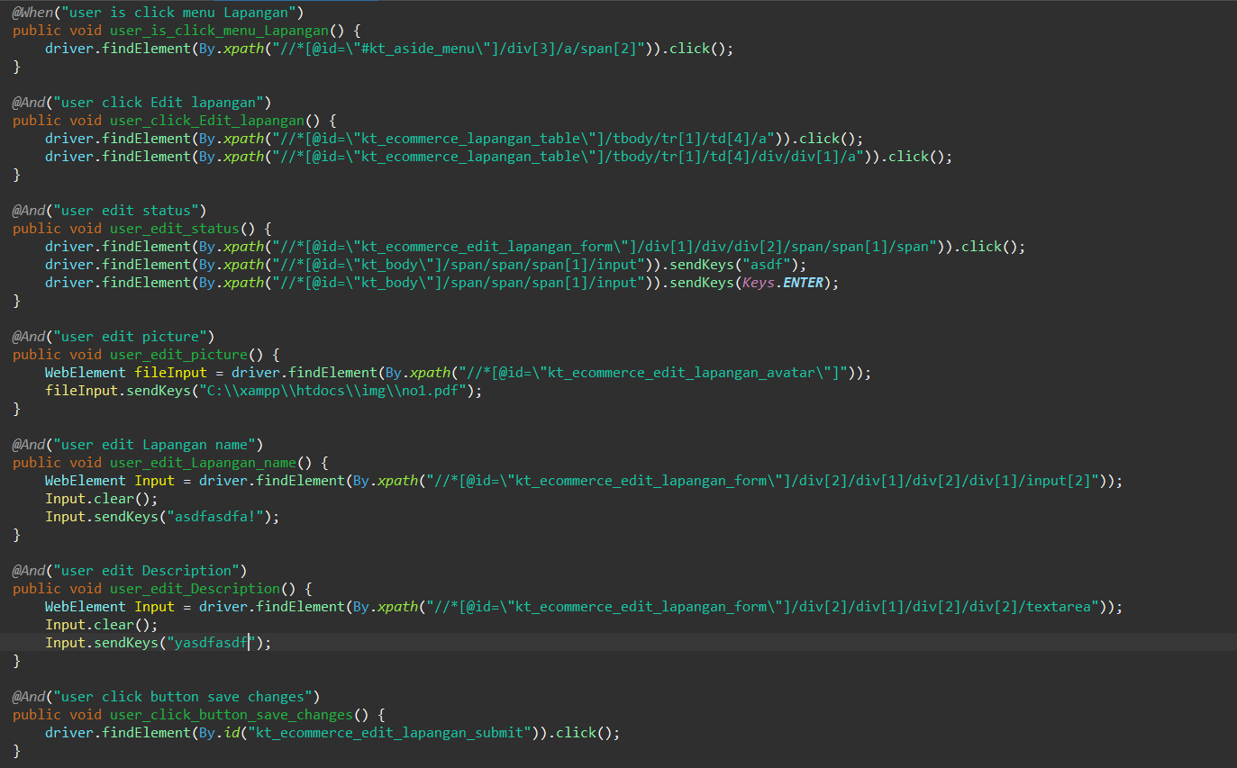

1. The test runner



1. The console after running



1. The browser while testing



Fungsi edit Lapangan 5

1. The scenario



1. The Step definition



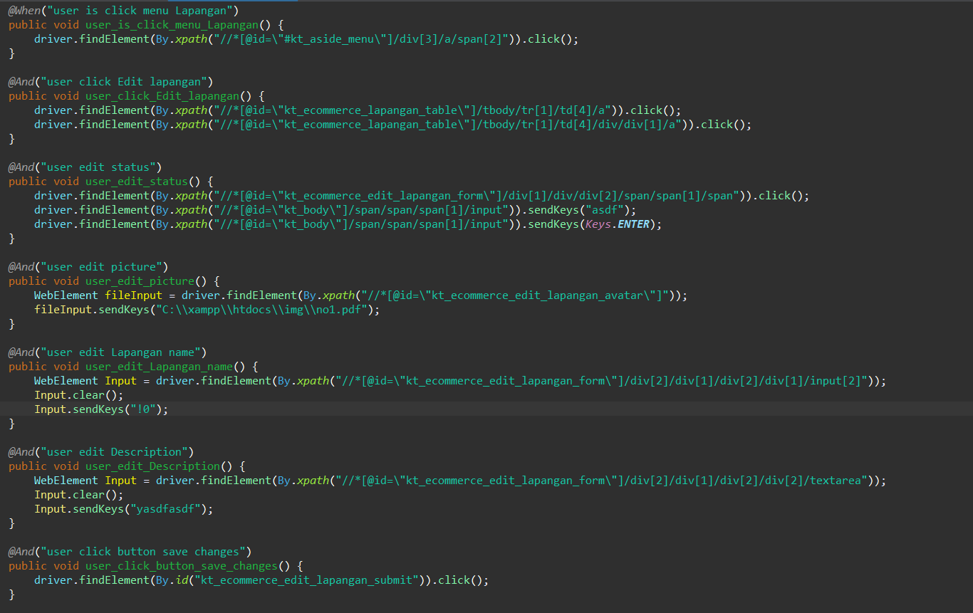

1. The test runner



1. The console after running



1. The browser while testing



Fungsi edit Lapangan 6

1. The scenario



1. The Step definition



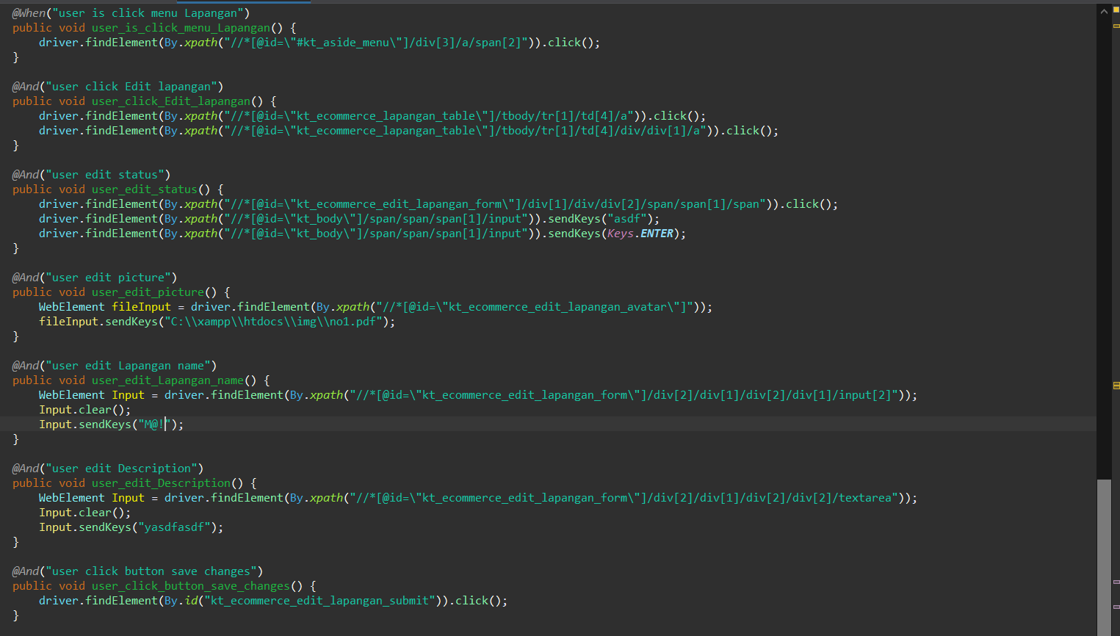

1. The test runner



1. The console after running



1. The browser while testing



1. Test Fungsi edit Lapangan Variasi 16: edit Lapangan dengan parameter 1,2,3,4 tidak valid

Fungsi edit Lapangan 1

1. The scenario



1. The Step definition



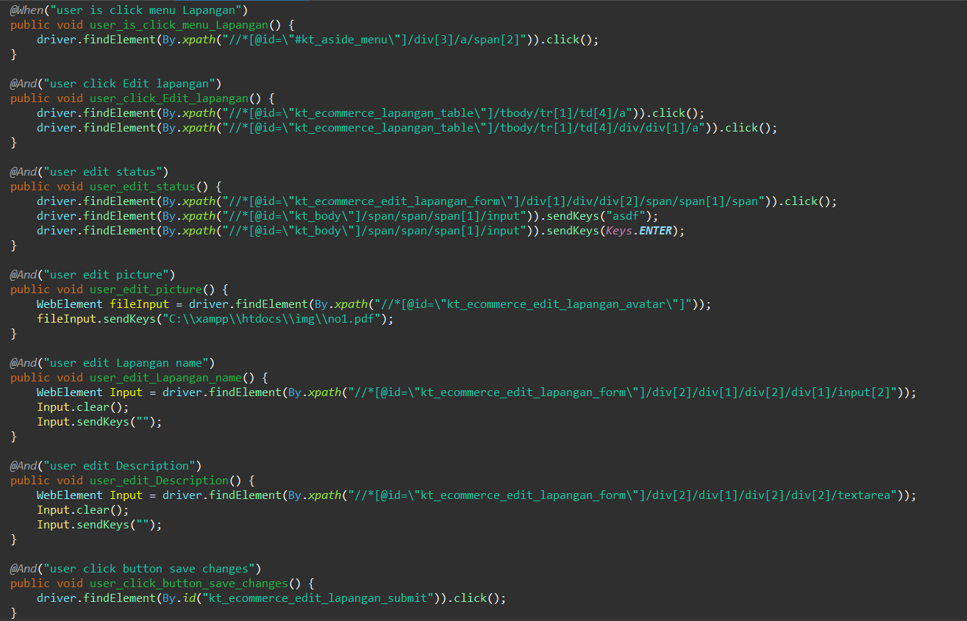

1. The test runner



1. The console after running



1. The browser while testing

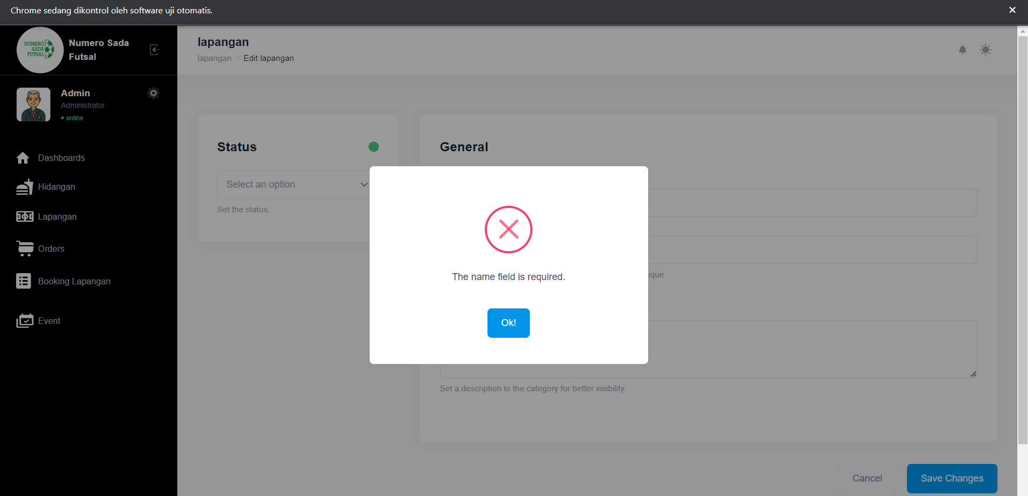

Fungsi edit Lapangan 2

1. The scenario



1. The Step definition



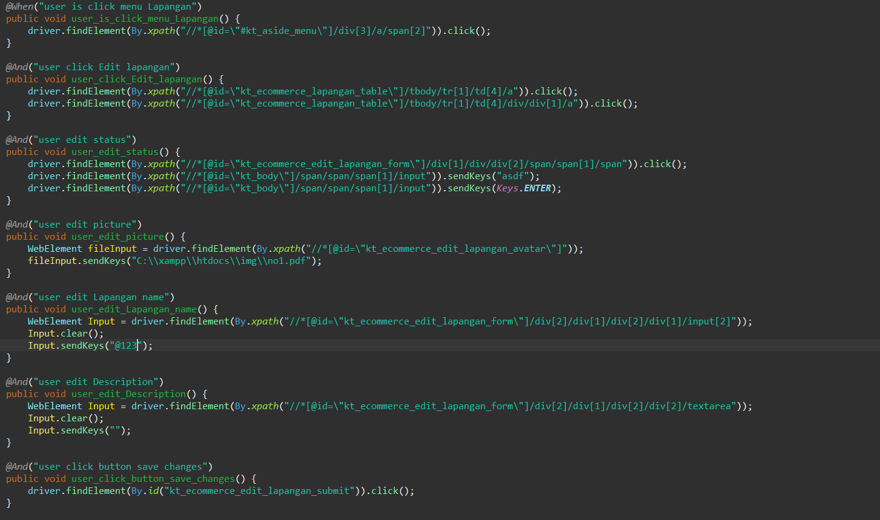

1. The test runner



1. The console after running



1. The browser while testing

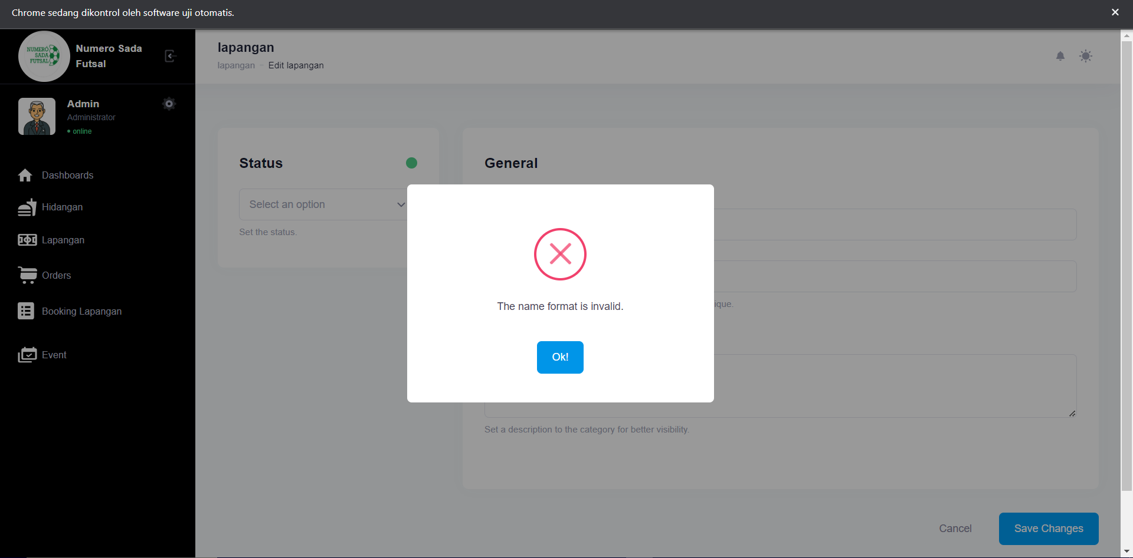

Fungsi edit Lapangan 3

1. The scenario



1. The Step definition



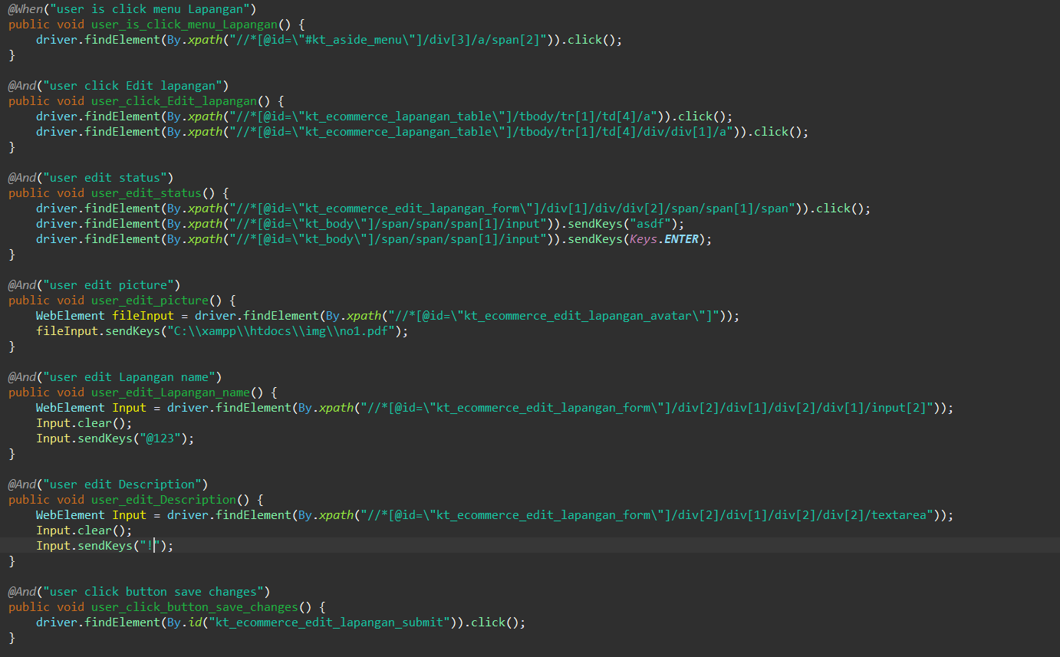

1. The test runner



1. The console after running



1. The browser while testing

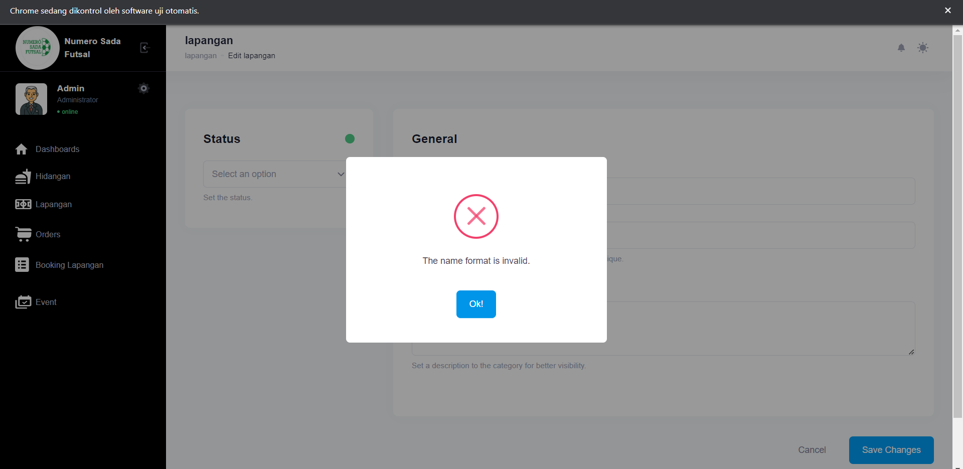

Fungsi edit Lapangan 4

1. The scenario



1. The Step definition



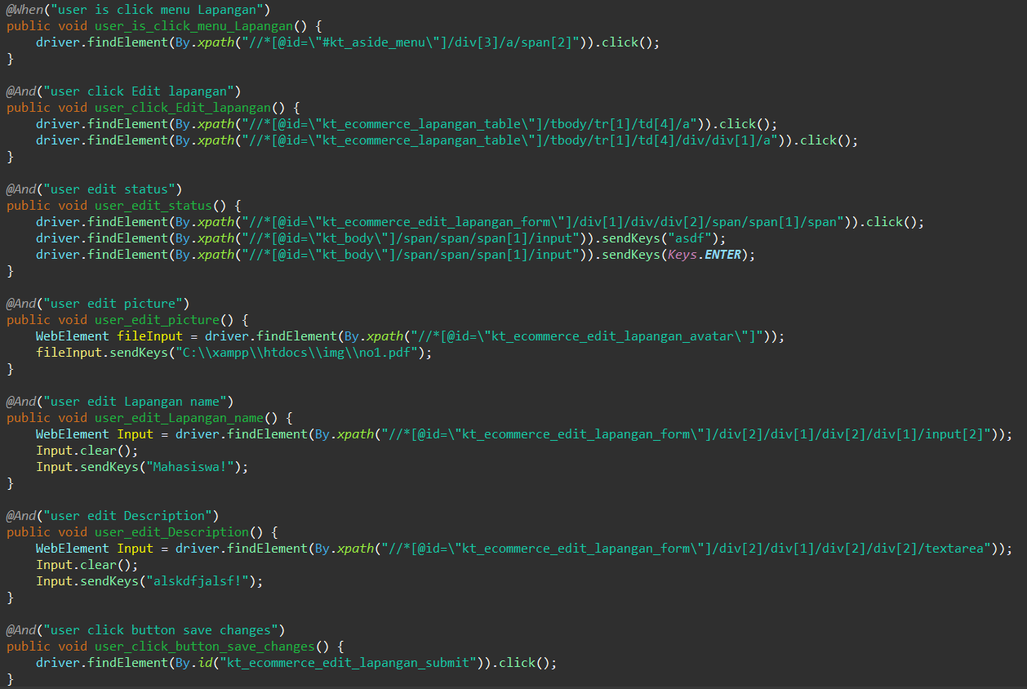

1. The test runner



1. The console after running



1. The browser while testing

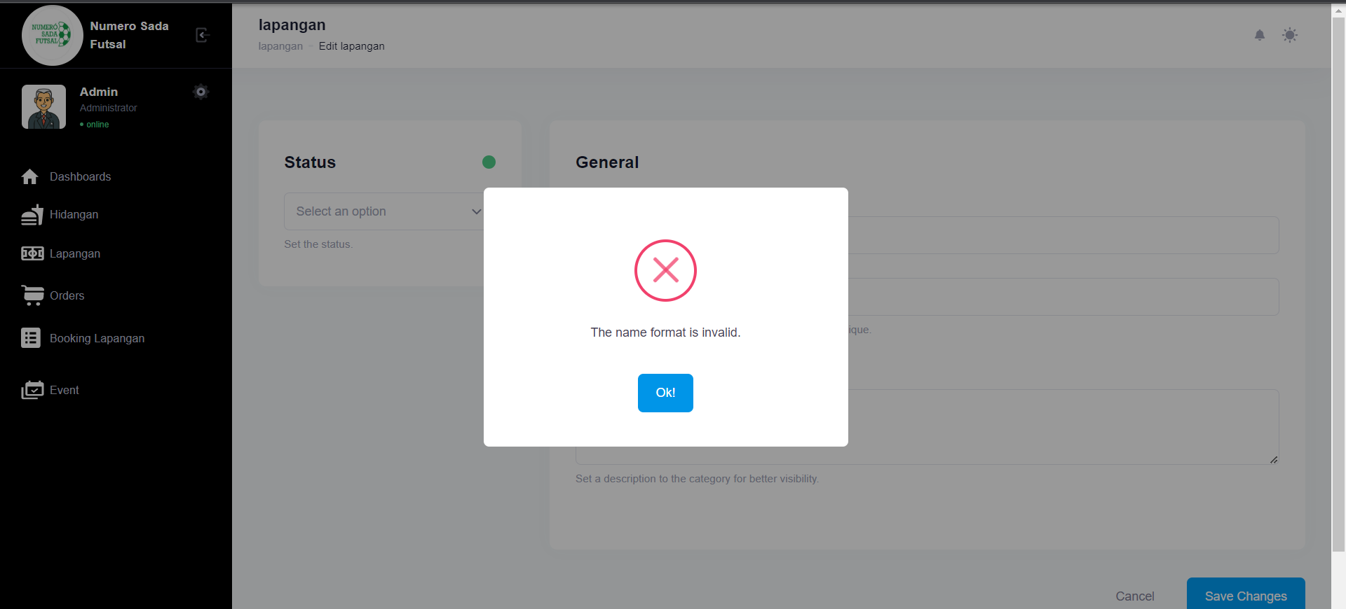

Fungsi edit Lapangan 5

1. The scenario



1. The Step definition



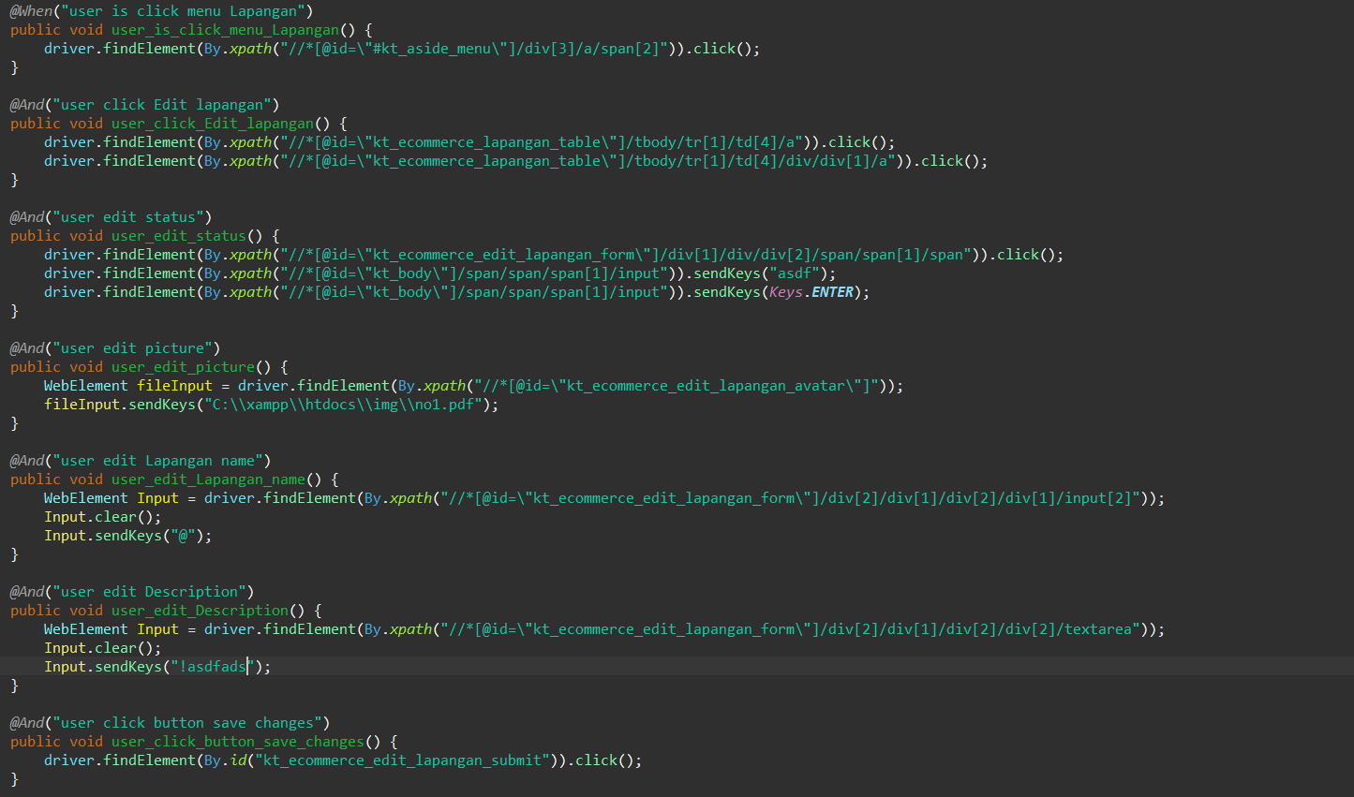

1. The test runner



1. The console after running



1. The browser while testing

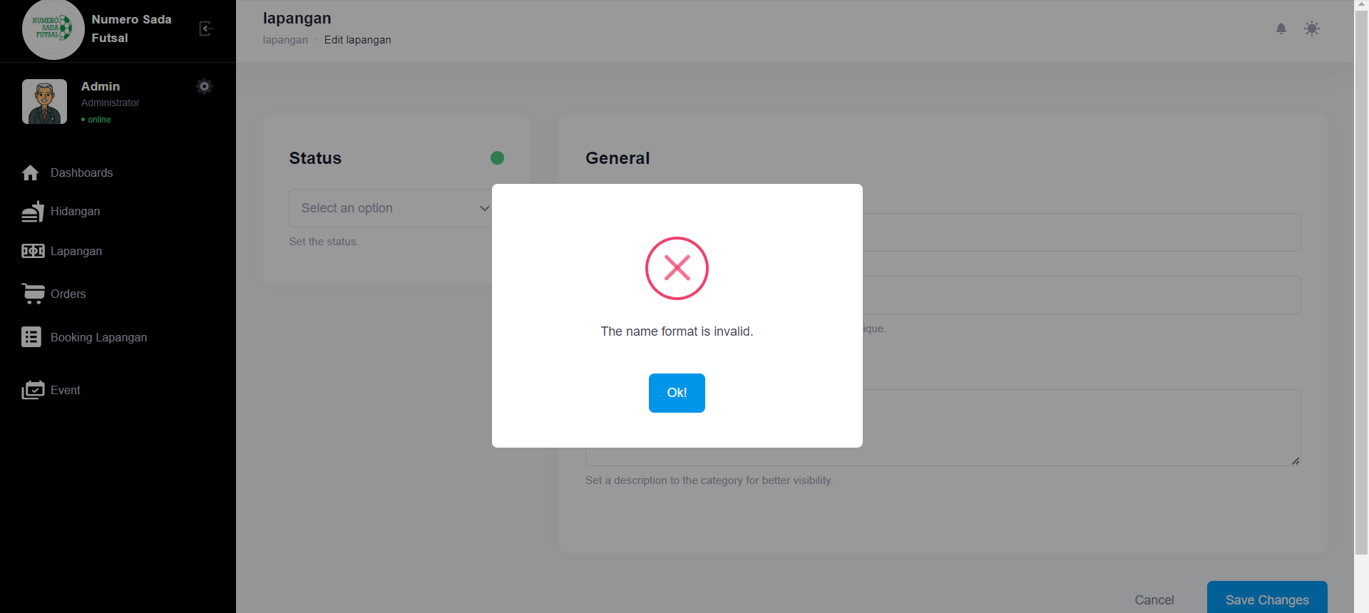

Fungsi edit Lapangan 6

1. The scenario



1. The Step definition



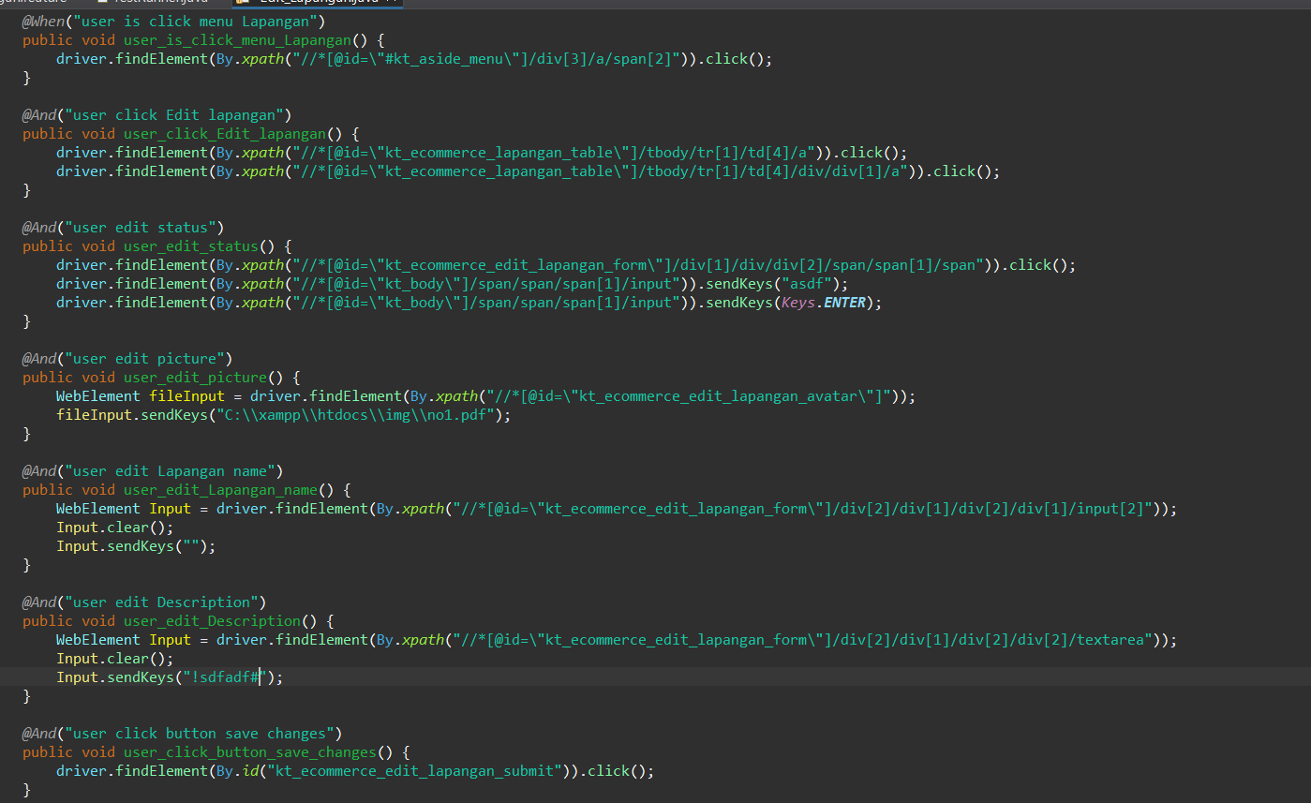

1. The test runner



1. The console after running



1. The browser while testing

